**Introduction:**

The following images are screenshots of my visUAL window after executing the emulator. In each screenshot, I have used LDR rather than MOV. I have used the LDR operation over the MOV operation for no specific reason.

After reading this thread <<https://www.raspberrypi.org/forums/viewtopic.php?t=16528>> about the difference between LDR and MOV, I am aware that “MOV can only move an 8-bit value into a register while LDR can move a 32-bit value into a register,” (DexOS).

**If Statement:**

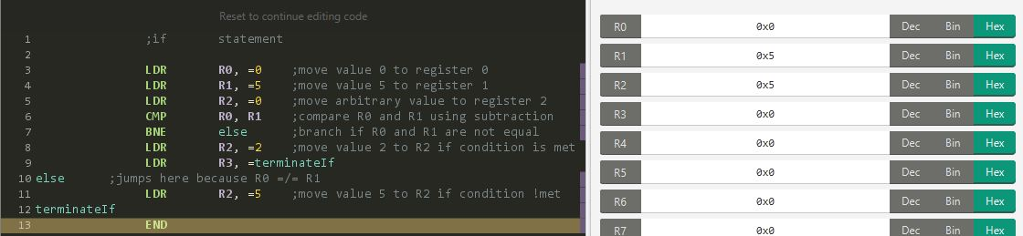

The image above shows my assembly code for an if/then/else statement. The condition is if R0 = R1. The code can end in one of two ways which is entirely dependent on whether or not the condition is met. If the condition is met, then R2 = 2. If the condition is NOT met, then R2 = 5.

In the case where the condition is not met, the code will branch from Line 6 to Line 10. By doing so, the value of 5 is moved to R2.

In the case where the condition is met, the code will not branch and execute Line 8, which moves the value of 2 to R2.

Finally, in both cases, after R2 has been changed to its appropriate value, then the if statement terminates and the emulator ends.

Below is an image of the condition being met by setting R0 = R1.

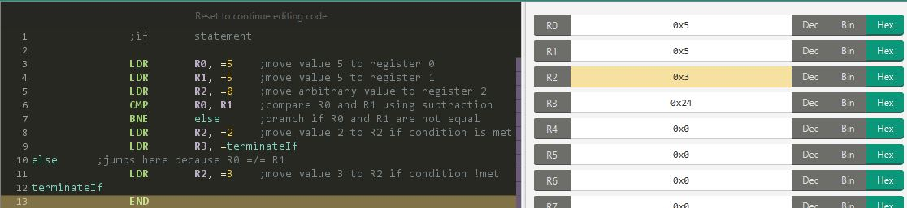

**Psuedocode (if):**

if R2 = R0

{…}

else

{…}

**While Statement:**

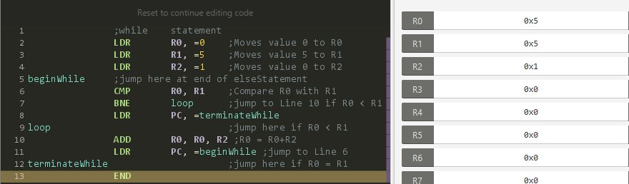

This image is an example of a while statement with the condition that R0 < R1. It starts with the 0th iteration with R0 = 0 and R1 = 5. While the condition is not met, the code will branch from Line 8 to Line 10. By doing so, Line 11 will have R0 = R0 + R2. I am using R2 as a value to increment R0 by 1 until R0 = R1.

During the 5th iteration, then the condition of R0 = R1 will be met. Then the code will no longer be branching from Line 8 to Line 10. Instead, from Line 9 to Line 13 to terminate the loop.

**Psuedocode:**

Do: {…}

While R0 < R1

**For statement:**

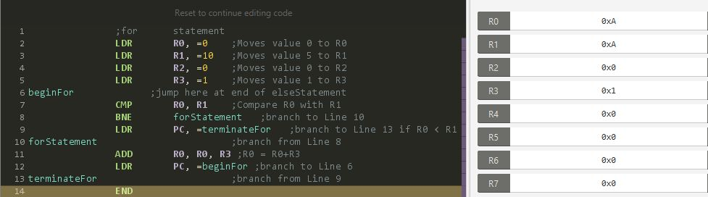

This image is an example of a for loop starting at 0 until the 10th iteration. Until R0 = R1, R0 will increment by 1 by using R3 as an incrementing unit.

**Pseudocode:**

for (i begins at 0, stop at 10, increment by 1)

{…}

