**HANDSON EXERCISES - WEEK 6**

**Skill : React**

**File : 1. ReactJS-HOL.docx**

**Exercise : My First React Application**

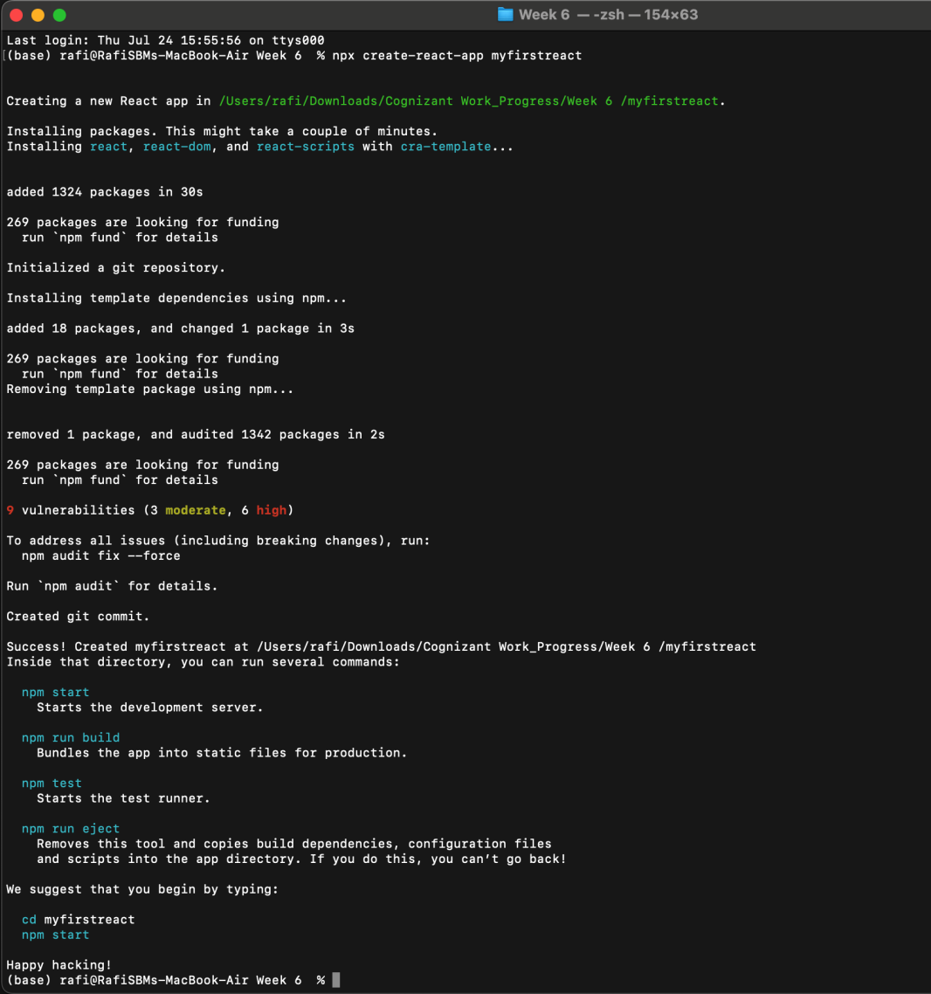

**App.js :**

import React from 'react';

function App() {

return (

<div>

<h1>Welcome to the first session of React</h1>

</div>

);

}

export default App;

**Output :**

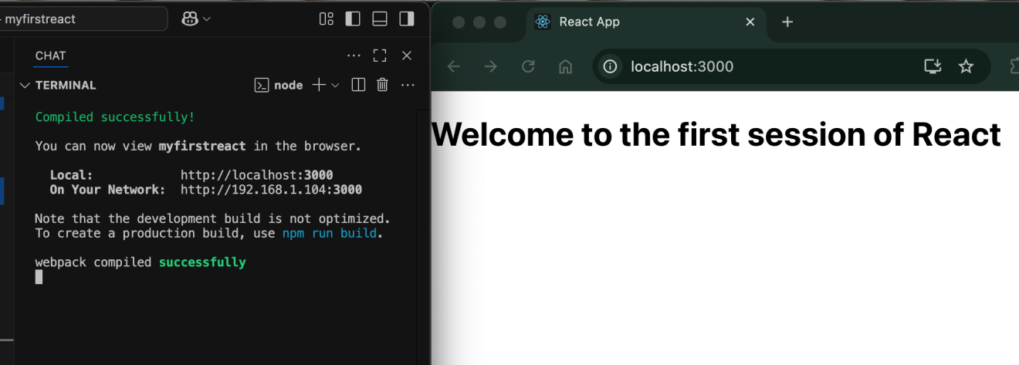

**File : 2. ReactJS-HOL.docx**

**Exercise : My First React Application**

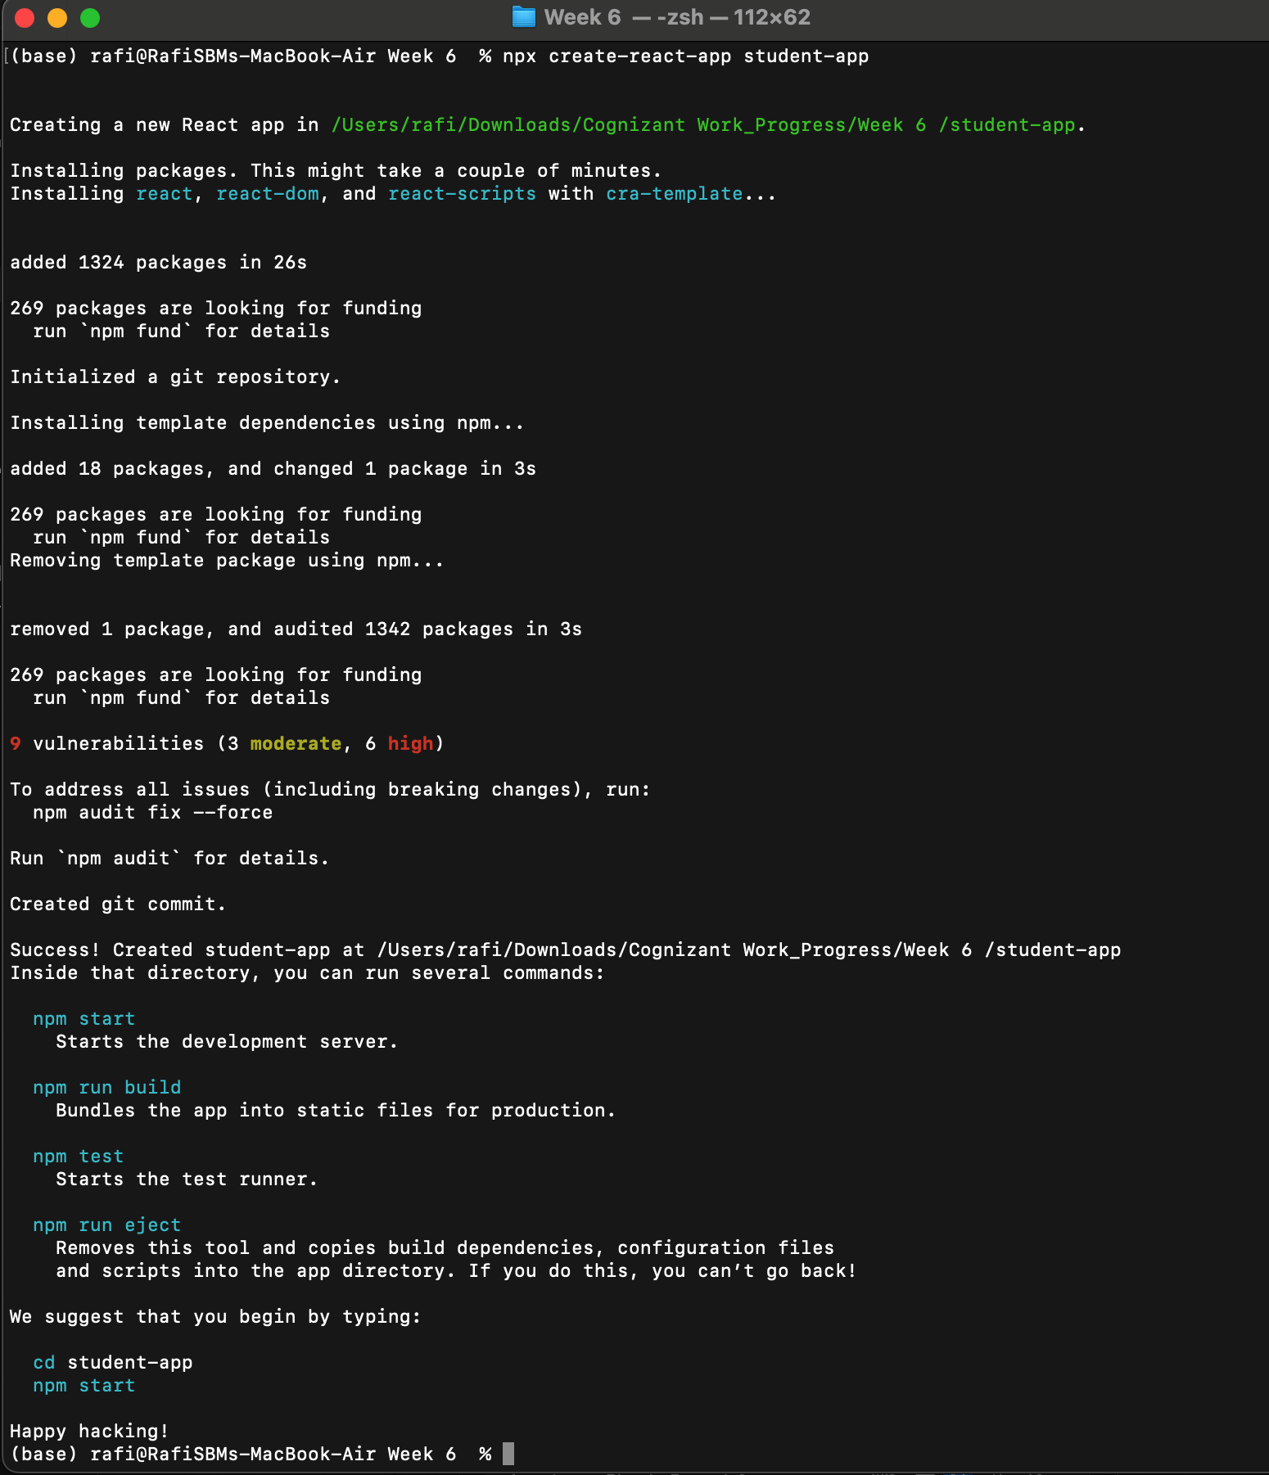

**Home.js :**import React from 'react';

function Home() {

return (

<div>

<h2>Welcome to the Home page of Student Management Portal</h2>

</div>

);

}

export default Home;

**About.js :**

import React from 'react';

function About() {

return (

<div>

<h2>Welcome to the About page of the Student Management Portal</h2>

</div>

);

}

export default About;

**Contact.js :**import React from 'react';

function Contact() {

return (

<div>

<h2>Welcome to the Contact page of the Student Management Portal</h2>

</div>

);

}

export default Contact;

**App.js :**

import React from 'react';

import Home from './Components/Home';

import About from './Components/About';

import Contact from './Components/Contact';

function App() {

return (

<div style={{

display: 'flex',

flexDirection: 'column',

alignItems: 'center', // horizontal center

textAlign: 'center',

marginTop: '40px' // spacing from the top

}}>

<h1>Student Management Portal</h1>

<Home />

<About />

<Contact />

</div>

);

}

export default App;

**OUTPUT :**

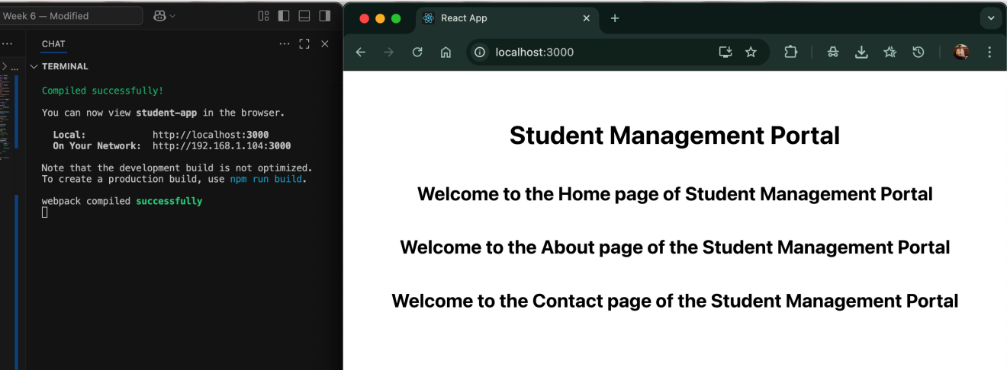

**File : 3. ReactJS-HOL.docx**

**Exercise : Funcitonal Component with Props and External Styles**

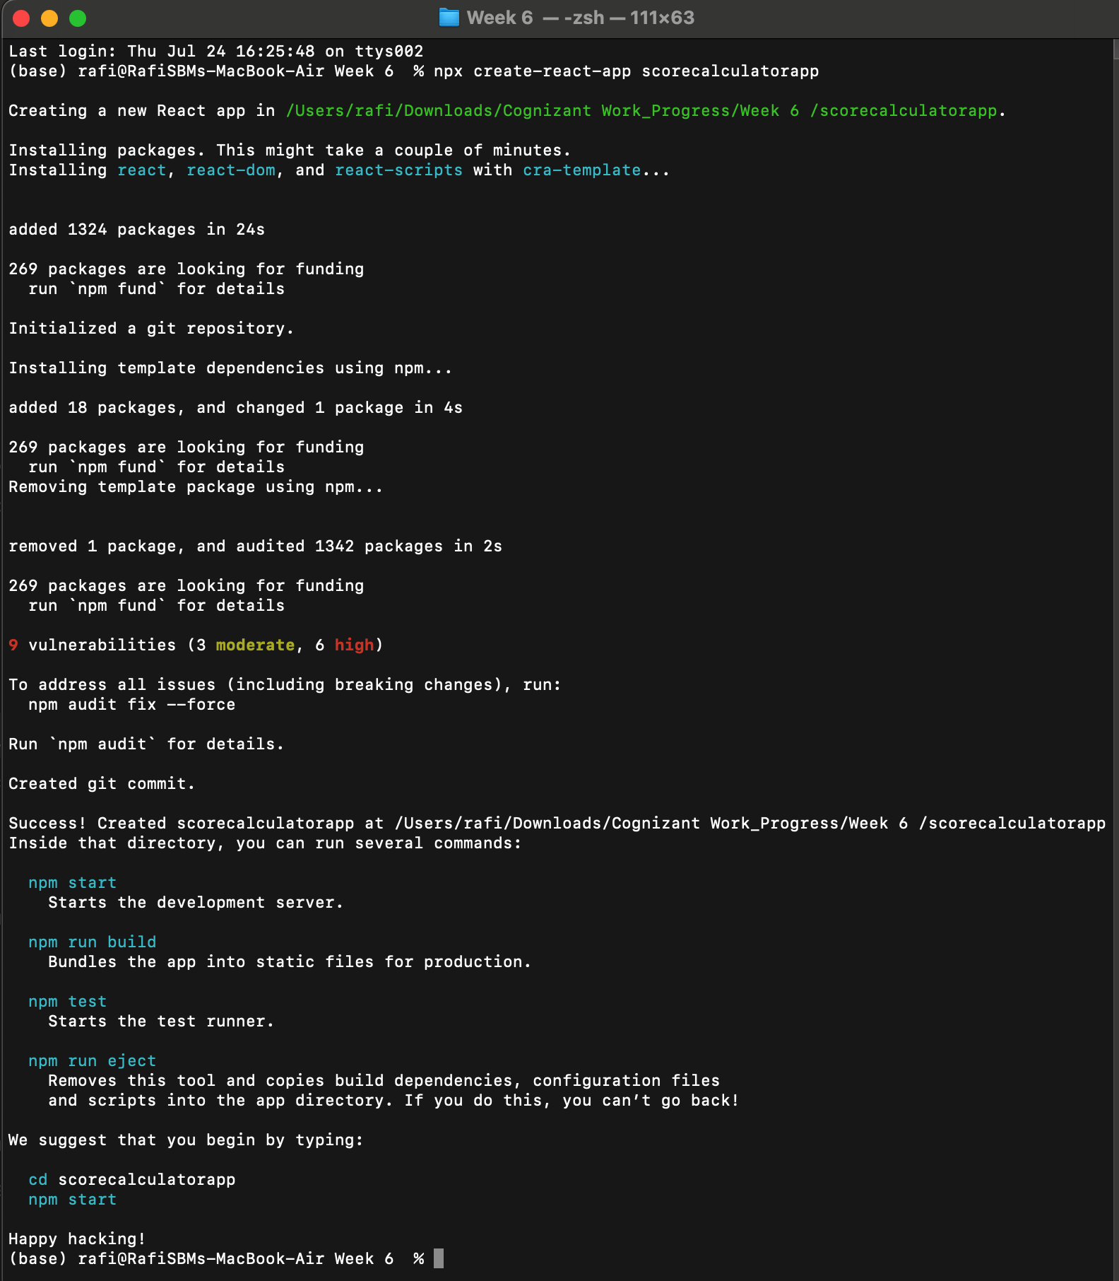

**CalculateScore.js :**

import React from 'react';

import '../Stylesheets/mystyle.css';

function CalculateScore(props) {

const average = props.Total / props.Goal;

return (

<div className="score-box">

<h2>Student Score Report</h2>

<p><strong>Name:</strong> {props.Name}</p>

<p><strong>School:</strong> {props.School}</p>

<p><strong>Total Score:</strong> {props.Total}</p>

<p><strong>Goal:</strong> {props.Goal}</p>

<p><strong>Average Score:</strong> {average.toFixed(2)}</p>

</div>

);

}

export default CalculateScore;

**mystyle.css :**

.score-box {

width: 50%;

margin: 40px auto;

padding: 25px;

background-color: #f0f8ff;

border: 2px solid #007acc;

border-radius: 10px;

box-shadow: 0 0 10px rgba(0, 0, 0, 0.1);

text-align: left;

font-family: 'Segoe UI', sans-serif;

}

.score-box h2 {

text-align: center;

color: #007acc;

}

.score-box p {

font-size: 16px;

margin: 8px 0;

}

**App.js :**

import React from 'react';

import CalculateScore from './Components/CalculateScore';

function App() {

return (

<div>

<CalculateScore

Name="Rafi"

School="JNTU CSE"

Total={450}

Goal={5}

/>

</div>

);

}

export default App;

**OUTPUT :**

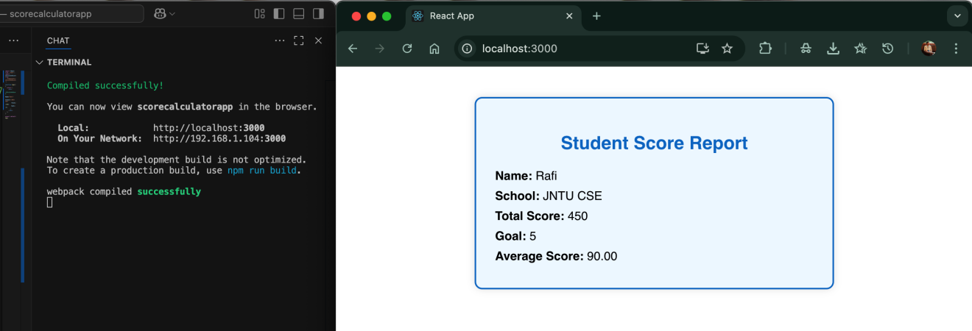

**File : 4. ReactJS-HOL.docx**

**Exercise : Working with React Lifecycle Methods**

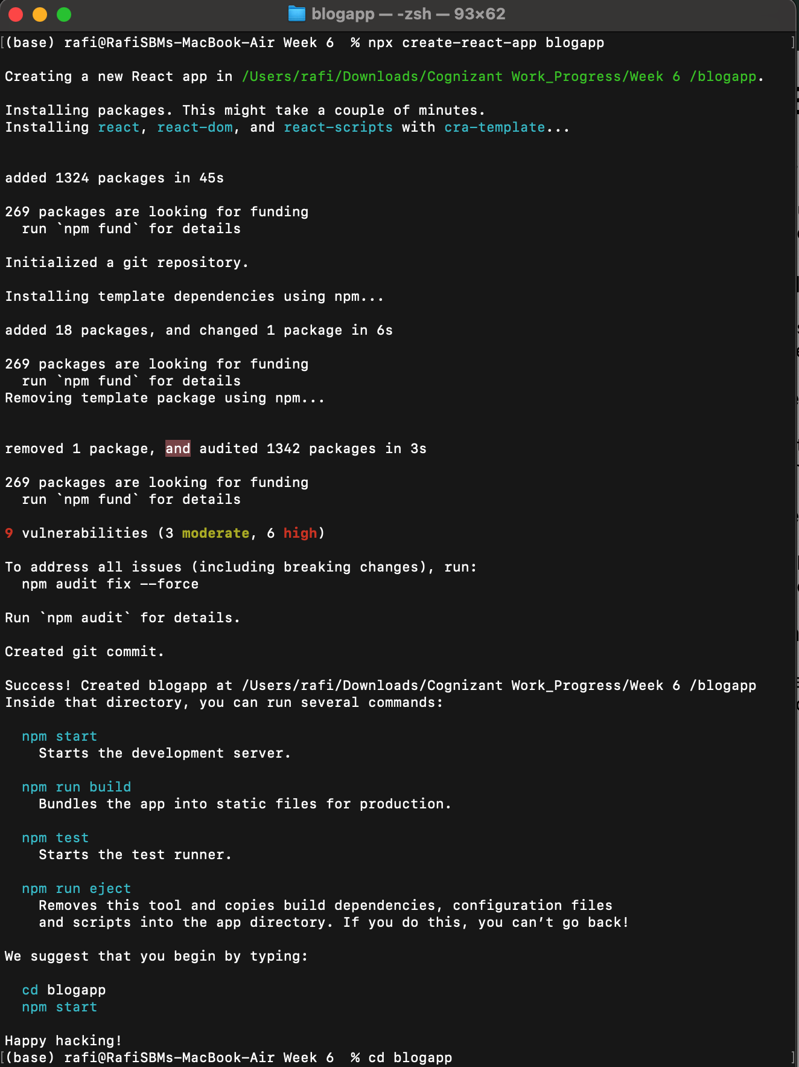

**Post.js :**

import React from 'react';

function Post({ title, body }) {

return (

<div className="post">

<h3>{title}</h3>

<p>{body}</p>

</div>

);

}

export default Post; **Posts.js :**

import React, { Component } from 'react';

import Post from './Post';

class Posts extends Component {

constructor(props) {

super(props);

this.state = {

posts: [],

hasError: false,

};

}

componentDidMount() {

this.loadPosts();

}

loadPosts() {

fetch('https://jsonplaceholder.typicode.com/posts')

.then(response => response.json())

.then(data => this.setState({ posts: data.slice(0, 5) })) // limiting to 5 for display

.catch(error => {

console.error('Error fetching posts:', error);

this.setState({ hasError: true });

});

}

componentDidCatch(error, info) {

alert("An error occurred: " + error.message);

this.setState({ hasError: true });

}

render() {

if (this.state.hasError) {

return <h2>Something went wrong while loading posts.</h2>;

}

return (

<div>

<h1>Blog Posts</h1>

{this.state.posts.map(post => (

<Post key={post.id} title={post.title} body={post.body} />

))}

</div>

);

}

}

export default Posts;

**App.js :**

import React from 'react';

import Posts from './Posts';

function App() {

return (

<div className="App">

<Posts />

</div>

);

}

export default App;

**OUTPUT :**

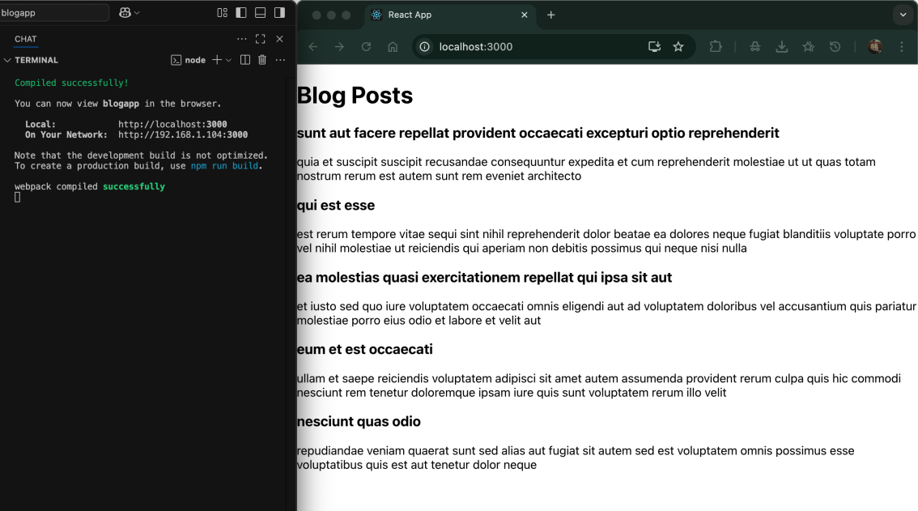

**File : 5. ReactJS-HOL.docx**

**Exercise : Styling React Components with CSS Modules & Inline Styles**

**src/components/CohortDetails.module.css :**

.box {

width: 300px;

display: inline-block;

vertical-align: top;

margin: 10px;

padding: 10px 20px;

border: 1px solid black;

border-radius: 10px;

font-family: 'Segoe UI', sans-serif;

text-align: left;

}

dt {

font-weight: 500;

margin-top: 8px;

}

**src/components/CohortDetails.js :**

import React from 'react';

import styles from './CohortDetails.module.css';

function CohortDetails({ name, status, startDate, coach, trainer }) {

const headingStyle = {

color: status.toLowerCase() === 'ongoing' ? 'green' : 'blue',

fontWeight: 'bold'

};

return (

<div className={styles.box}>

<h3 style={headingStyle}>{name}</h3>

<dl>

<dt>Started On</dt>

<dd>{startDate}</dd>

<dt>Current Status</dt>

<dd>{status}</dd>

<dt>Coach</dt>

<dd>{coach}</dd>

<dt>Trainer</dt>

<dd>{trainer}</dd>

</dl>

</div>

);

}

export default CohortDetails;

**App.js**

import React from 'react';

import CohortDetails from './components/CohortDetails';

function App() {

return (

<div style={{ padding: '20px' }}>

<h2 style={{ textAlign: 'left' }}>Cohorts Details</h2>

<div>

<CohortDetails

name="INTADMDF10 - .NET FSD"

status="Scheduled"

startDate="22-Feb-2022"

coach="Aathma"

trainer="Jojo Jose"

/>

<CohortDetails

name="ADM21JF014 - Java FSD"

status="Ongoing"

startDate="10-Sep-2021"

coach="Apoorv"

trainer="Elisa Smith"

/>

<CohortDetails

name="CDBJF21025 - Java FSD"

status="Ongoing"

startDate="24-Dec-2021"

coach="Aathma"

trainer="John Doe"

/>

</div>

</div>

);

}

export default App;

**OUTPUT :**

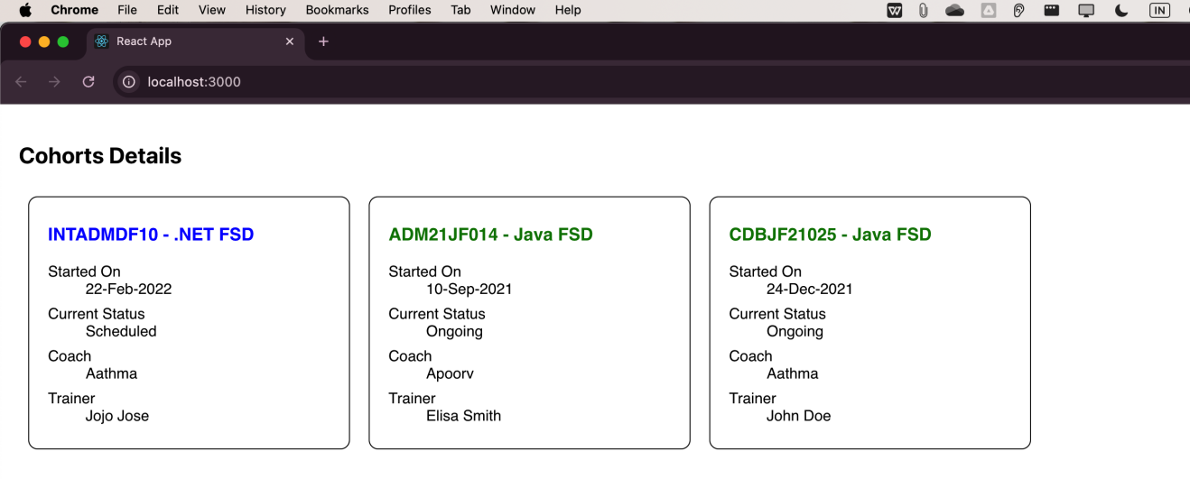

**File : 6. ReactJS-HOL.docx**

**Exercise : Implementing Navigation & Parameterized Routes in React**

**trainer.js :**

class Trainer {

constructor(TrainerId, Name, Email, Phone, Technology, Skills) {

this.TrainerId = TrainerId;

this.Name = Name;

this.Email = Email;

this.Phone = Phone;

this.Technology = Technology;

this.Skills = Skills;

}

}

export default Trainer;

**TrainersMock.js :**

import Trainer from "./trainer";

const trainers = [

new Trainer(101, "Aathma", "aathma@abc.com", "9876543210", "Java", ["Spring", "Hibernate"]),

new Trainer(102, "Jojo", "jojo@abc.com", "9876543211", "React", ["Hooks", "Redux"]),

new Trainer(103, "John", "john@abc.com", "9876543212", "Python", ["Flask", "Django"]),

];

export default trainers;

**components/Home.js :**

import React from 'react';

function Home() {

return (

<div>

<h2>Welcome to Cognizant Trainer Portal</h2>

<p>This SPA shows the list of trainers and their details.</p>

</div>

);

}

export default Home;

**components/TrainerList.js :**

import React from 'react';

import { Link } from 'react-router-dom';

import trainers from '../TrainerMock';

function TrainerList() {

return (

<div>

<h2>Trainer List</h2>

<ul>

{trainers.map((t) => (

<li key={t.TrainerId}>

<Link to={`/trainers/${t.TrainerId}`}>{t.Name}</Link>

</li>

))}

</ul>

</div>

);

}

export default TrainerList;

**components/TrainerDetails.js :**

import React from 'react';

import { useParams } from 'react-router-dom';

import trainers from '../TrainerMock';

function TrainerDetails() {

const { id } = useParams();

const trainer = trainers.find(t => t.TrainerId === parseInt(id));

if (!trainer) return <p>Trainer not found!</p>;

return (

<div>

<h2>{trainer.Name}</h2>

<p><strong>Email:</strong> {trainer.Email}</p>

<p><strong>Phone:</strong> {trainer.Phone}</p>

<p><strong>Technology:</strong> {trainer.Technology}</p>

<p><strong>Skills:</strong> {trainer.Skills.join(', ')}</p>

</div>

);

}

export default TrainerDetails;

**App.js :**

import React from 'react';

import { BrowserRouter, Routes, Route, Link } from 'react-router-dom';

import Home from './components/Home';

import TrainerList from './components/TrainerList';

import TrainerDetails from './components/TrainerDetails';

function App() {

return (

<BrowserRouter>

<div style={{ padding: "10px" }}>

<nav>

<Link to="/" style={{ marginRight: "15px" }}>Home</Link>

<Link to="/trainers">Trainers</Link>

</nav>

<hr />

<Routes>

<Route path="/" element={<Home />} />

<Route path="/trainers" element={<TrainerList />} />

<Route path="/trainers/:id" element={<TrainerDetails />} />

</Routes>

</div>

</BrowserRouter>

);

}

export default App;

**OUTPUT :**

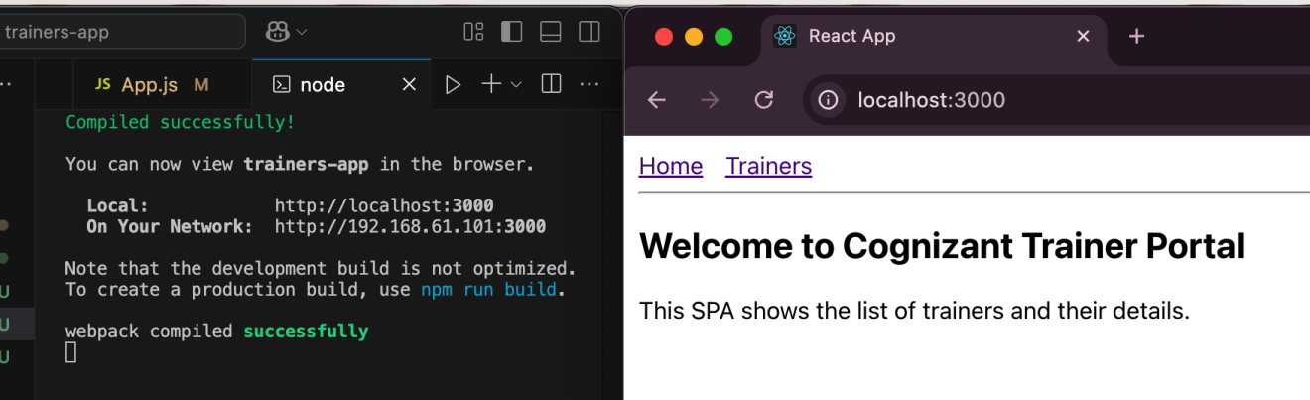

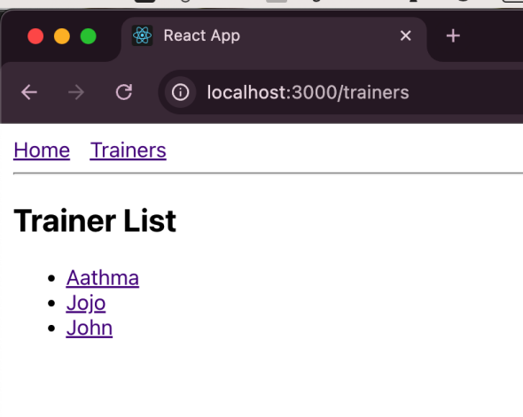 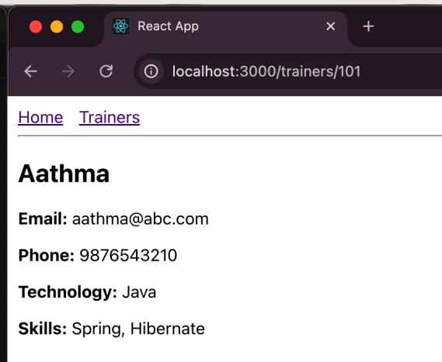

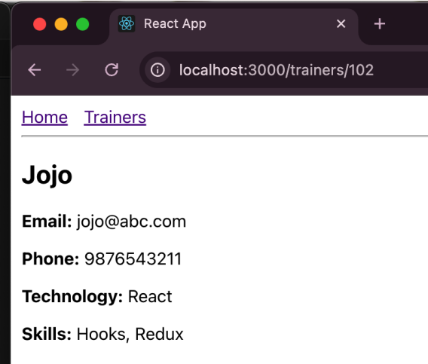 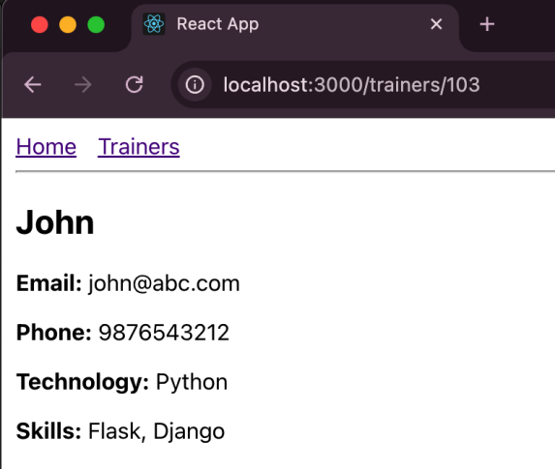

**File : 7. ReactJS-HOL.docx**

**Exercise : Building a ShoppingApp with Class Components and Props in React**

**components/OnlineShopping.js :**

import React, { Component } from 'react';

import Cart from './Cart';

class OnlineShopping extends Component {

render() {

const items = [

{ itemname: "Laptop", price: 80000 },

{ itemname: "TV", price: 120000 },

{ itemname: "Washing Machine", price: 50000 },

{ itemname: "Mobile", price: 30000 },

{ itemname: "Fridge", price: 70000 }

];

return (

<div style={{ textAlign: 'center', fontFamily: 'Segoe UI, sans-serif', marginTop: '40px' }}>

<h2 style={{

color: 'green',

fontWeight: '600',

fontSize: '22px',

marginBottom: '20px'

}}>

Items Ordered :

</h2>

<table style={{

margin: '0 auto',

borderCollapse: 'collapse',

border: '1px solid #ccc'

}}>

<thead>

<tr>

<th style={{

border: '1px solid #ccc',

padding: '6px 20px',

color: 'seagreen',

fontWeight: '600',

fontSize: '14px'

}}>

Name

</th>

<th style={{

border: '1px solid #ccc',

padding: '6px 20px',

color: 'seagreen',

fontWeight: '600',

fontSize: '14px'

}}>

Price

</th>

</tr>

</thead>

<tbody>

{items.map((item, index) => (

<Cart key={index} itemname={item.itemname} price={item.price} />

))}

</tbody>

</table>

</div>

);

}

}

export default OnlineShopping;

**index.js :**

import React from 'react';

import ReactDOM from 'react-dom/client';

import App from './App';

const root = ReactDOM.createRoot(document.getElementById('root'));

root.render(<App />);

**App.js :**

import React from 'react';

import OnlineShopping from './components/OnlineShopping';

function App() {

return (

<div>

<OnlineShopping />

</div>

);

}

export default App;

**components/Cart.js :**

import React, { Component } from 'react';

class Cart extends Component {

render() {

return (

<tr>

<td style={{

border: '1px solid #ccc',

padding: '6px 20px',

color: 'seagreen',

fontWeight: '500',

fontSize: '14px',

fontFamily: 'Segoe UI, sans-serif',

textAlign: 'center'

}}>

{this.props.itemname}

</td>

<td style={{

border: '1px solid #ccc',

padding: '6px 20px',

fontSize: '14px',

fontFamily: 'Segoe UI, sans-serif',

textAlign: 'center'

}}>

{this.props.price}

</td>

</tr>

);

}

}

export default Cart;

**OUTPUT :**

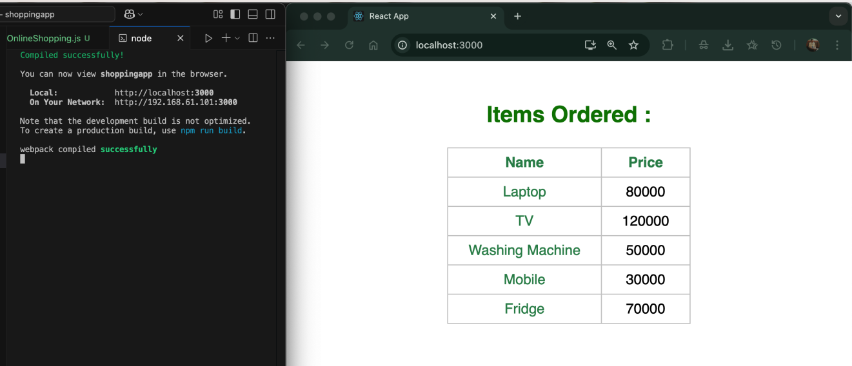

**File : 8. ReactJS-HOL.docx**

**Exercise : Implementing State Management with Class Components in React**

**App.js :**

import React from 'react';

import './App.css';

class CountPeople extends React.Component {

constructor(props) {

super(props);

this.state = {

entryCount: 0,

exitCount: 0

};

}

updateEntry = () => {

this.setState(prevState => ({

entryCount: prevState.entryCount + 1

}));

}

updateExit = () => {

this.setState(prevState => ({

exitCount: prevState.exitCount + 1

}));

}

render() {

return (

<div className="container">

<div className="counter">

<button className="login-btn" onClick={this.updateEntry}>Login</button>

<span>{this.state.entryCount} People Entered!!!</span>

</div>

<div className="counter">

<button className="exit-btn" onClick={this.updateExit}>Exit</button>

<span>{this.state.exitCount} People Left!!!</span>

</div>

</div>

);

}

}

export default CountPeople;

**App.css :**

.container {

display: flex;

justify-content: space-around;

align-items: center;

margin-top: 100px;

font-size: 18px;

font-family: sans-serif;

}

.counter {

display: flex;

align-items: center;

gap: 10px;

}

.login-btn,

.exit-btn {

background-color: lightgreen;

border: 1px solid green;

padding: 5px 10px;

font-weight: bold;

cursor: pointer;

}

.login-btn:hover,

.exit-btn:hover {

background-color: green;

color: white;

}

**OUTPUT :**

