**HANDSON EXERCISES - WEEK 8**

**Skill : GIT**

**File : 1. Git-HOL.docx**

**Exercise :** Git Setup and Repository Push to GitLab

**Git Installation Check**

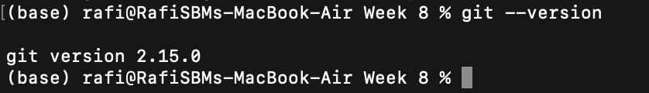

**Git Global Configuration**



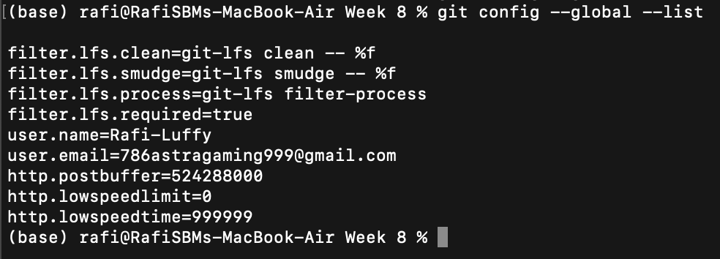

**Setting VS Code as Default Git Editor**  


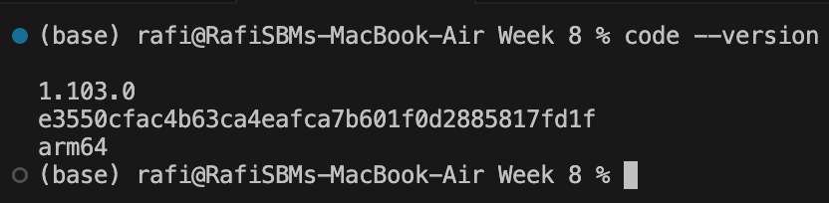

**Opening** .gitconfig **in VS Code**

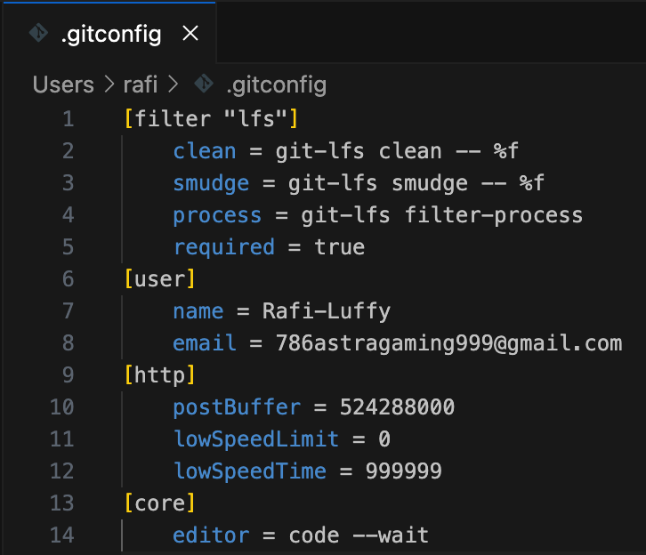

**Initializing Git Repository**  


**Creating the File & viewing its contents**

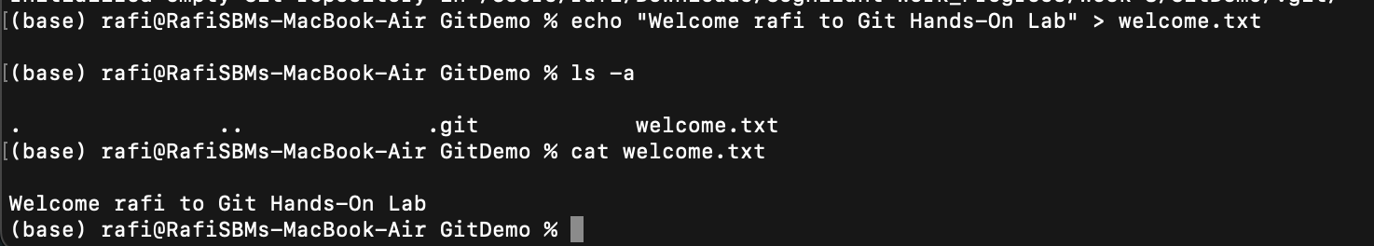

**Checking Git Status (Untracked)**

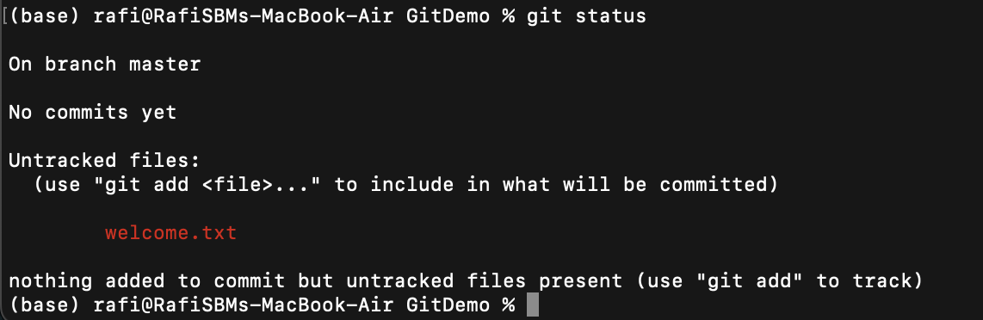

**Adding File to Staging**

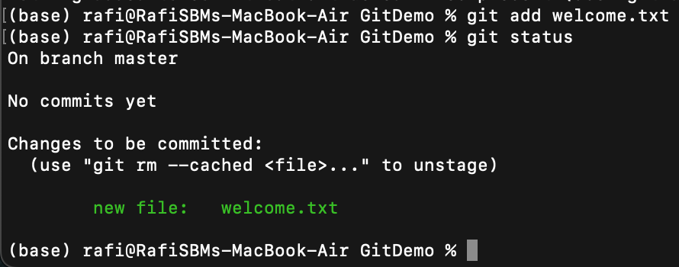

**Committing Changes with VS Code Editor**  
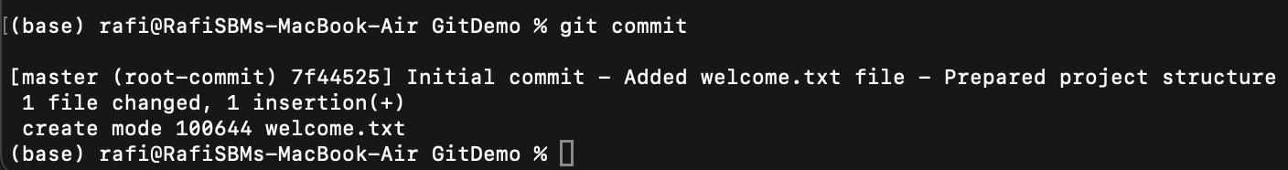

**Remote Repository Creation & Linking Remote to Local**



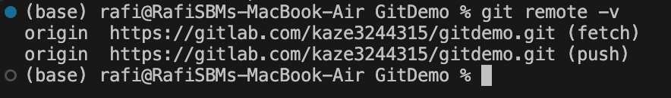

**Successful Push to Remote**  
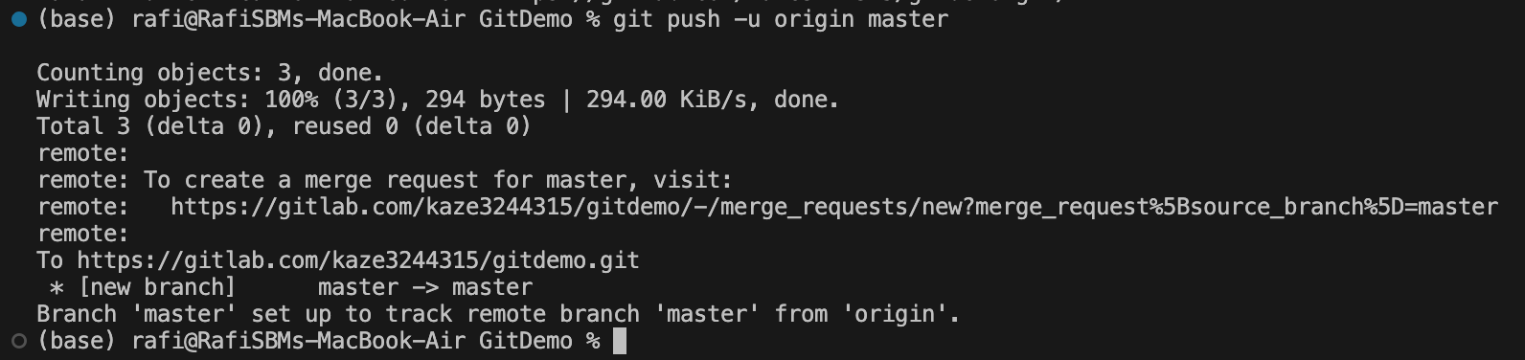

**Final Repository on GitLab**  
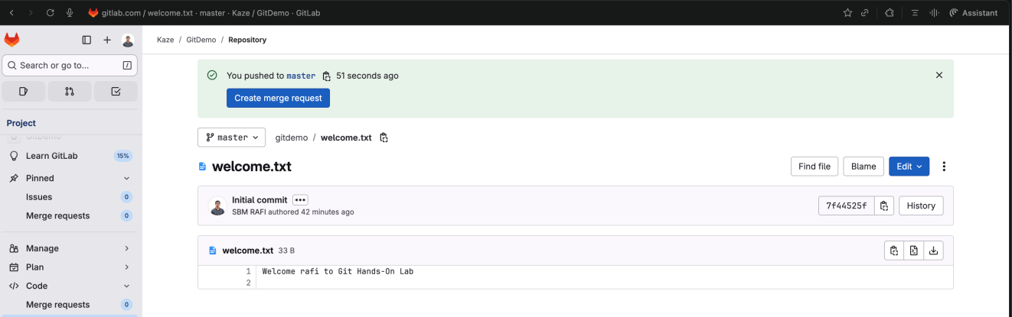

**File : 2. Git-HOL.docx**

**Exercise :** Ignoring Unwanted Files and Folders in Git using .gitignore

**Current Repository**

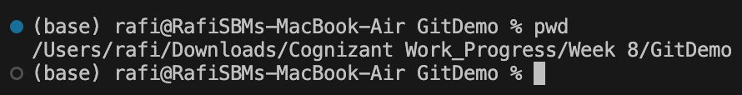

**Creating Log File and Folder**

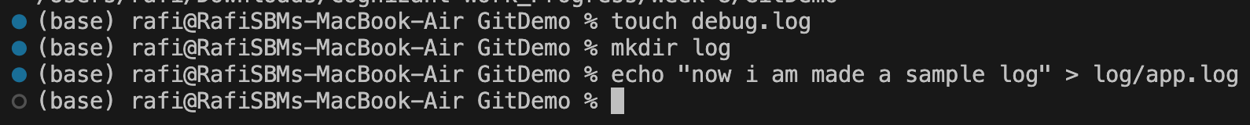

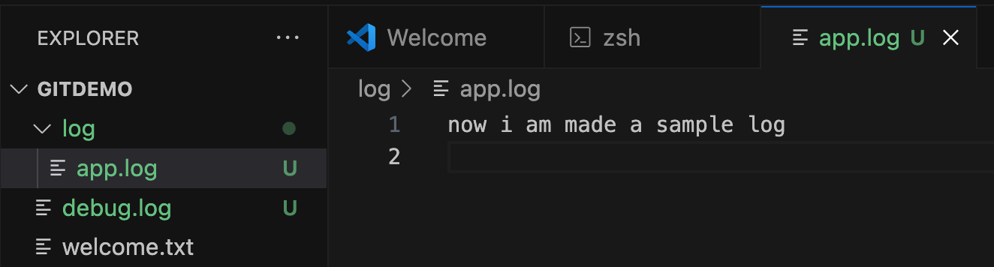

**Git Status Before Ignoring**

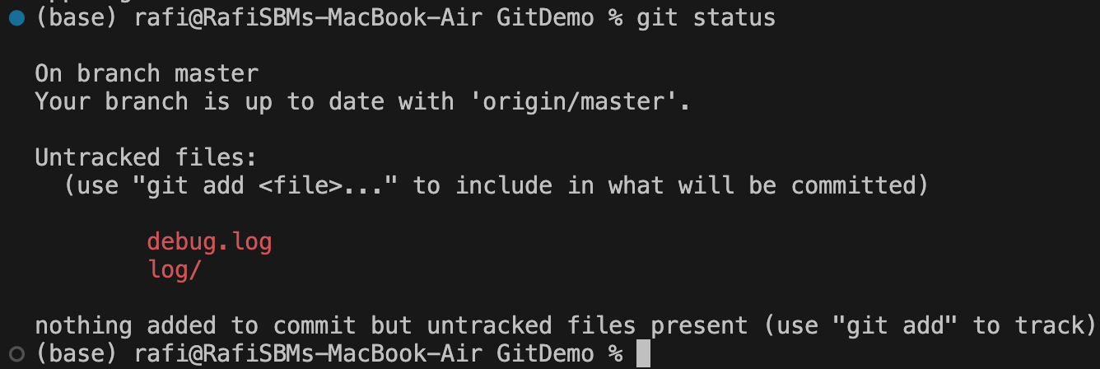

**Updating** .gitignore **File**

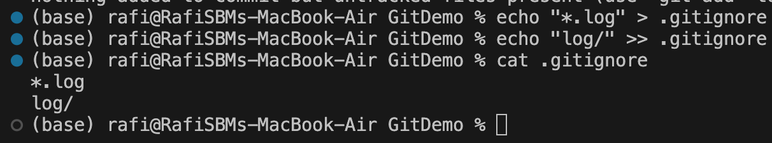

**Git Status After Ignoring**

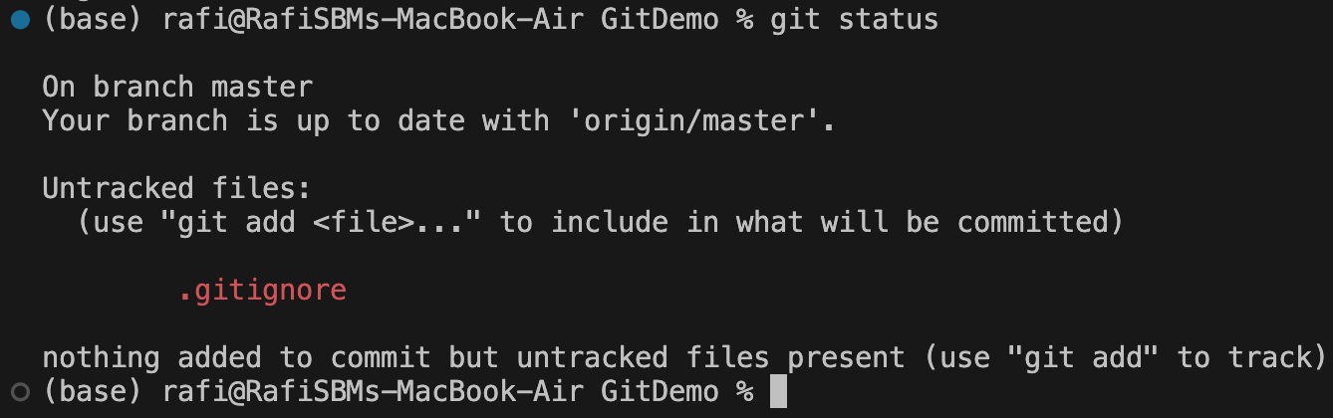

**Committing** .gitignore **File**

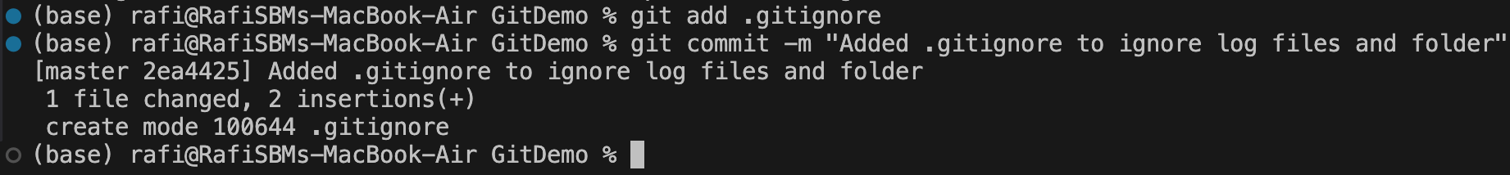

**Pushing Changes to Remote**

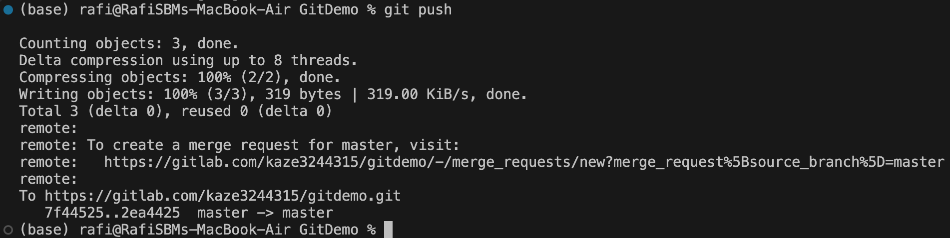

**Verifying on GitLab**

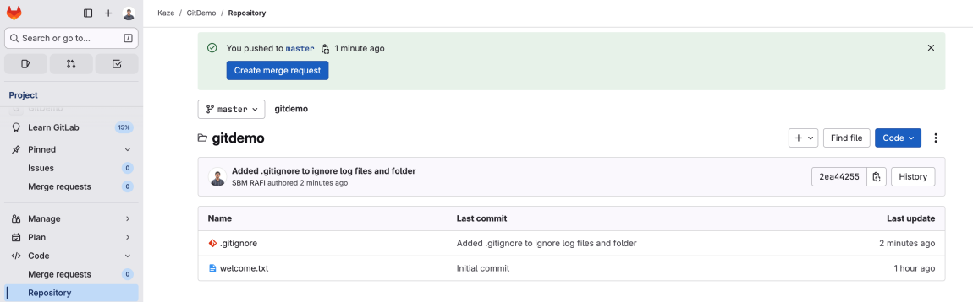

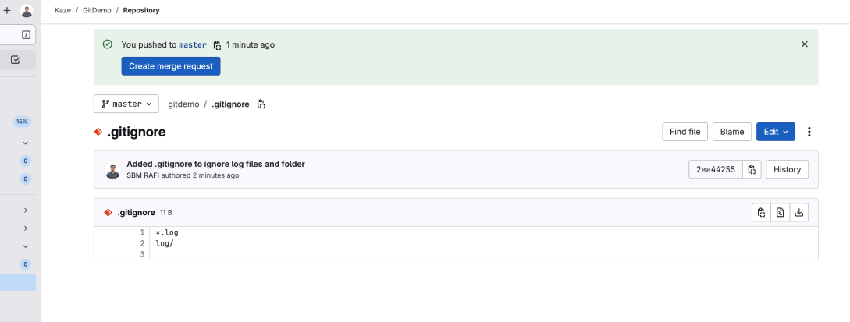

**File : 3. Git-HOL.docx**

**Exercise :** Git Branching and Merging

**Listing Local and Remote Branches**

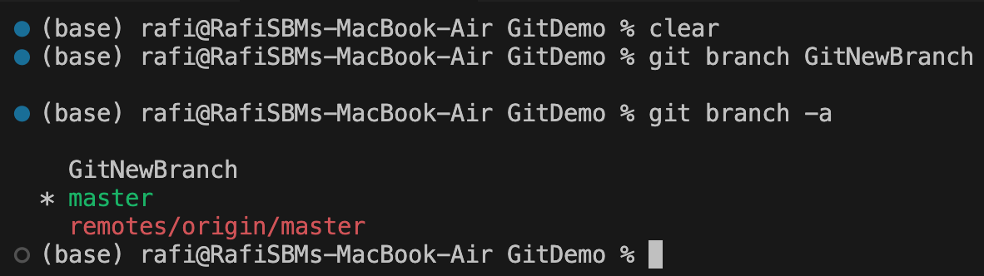

**Switching to New Branch**

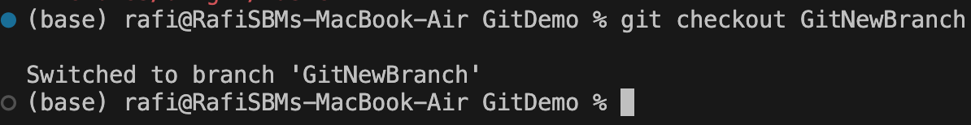

**Creating a File in New Branch**

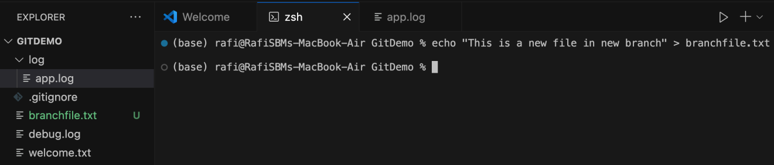

**Committing Changes in the Branch**

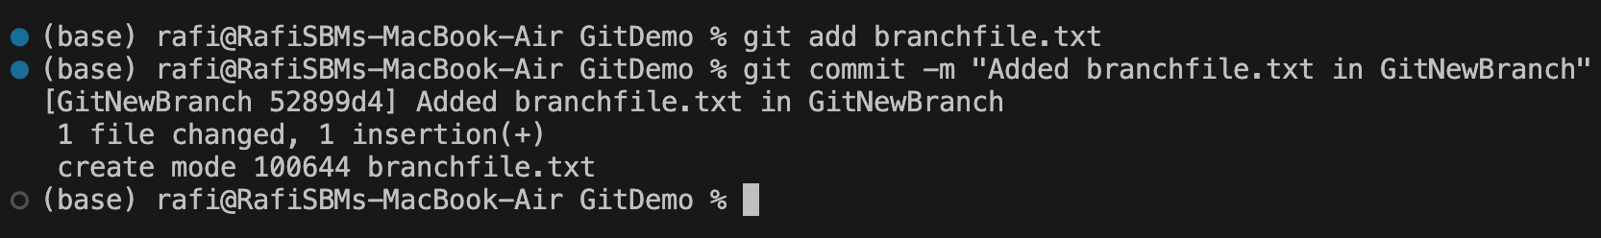

**Pushing Branch to GitLab**

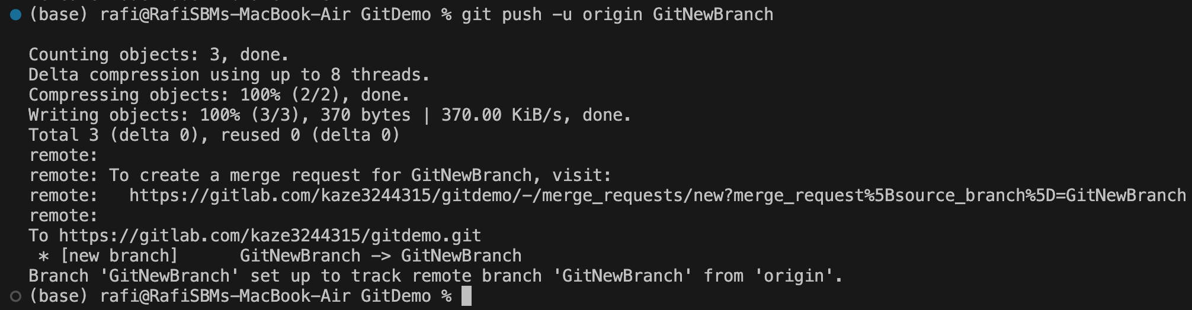

**Creating Merge Request in GitLab**

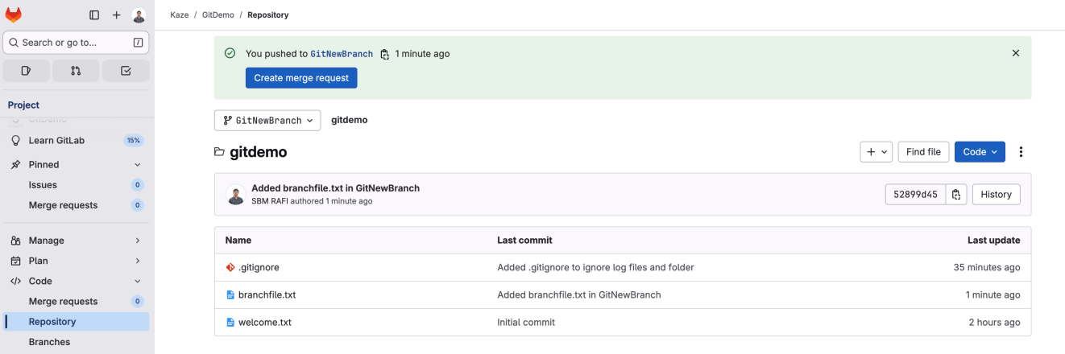

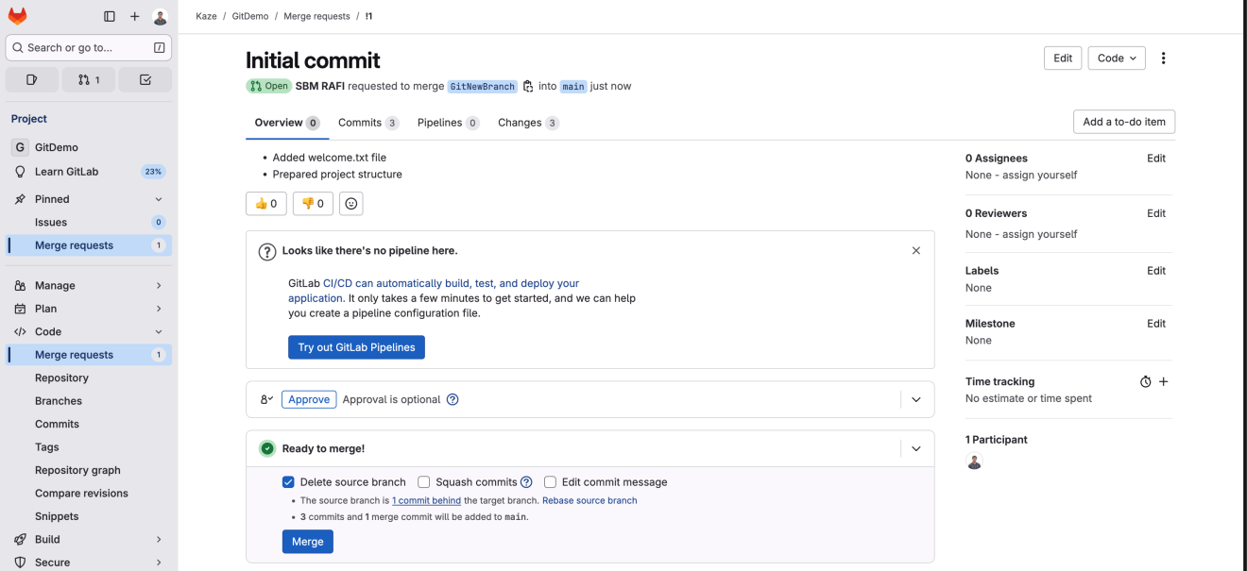

**Switching Back to Master**

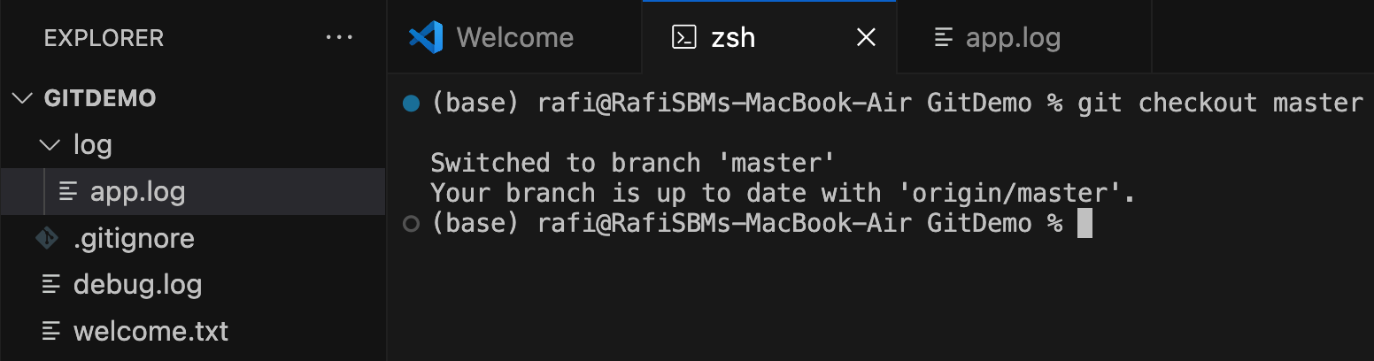

**Viewing CLI Differences Between Branch and Master**

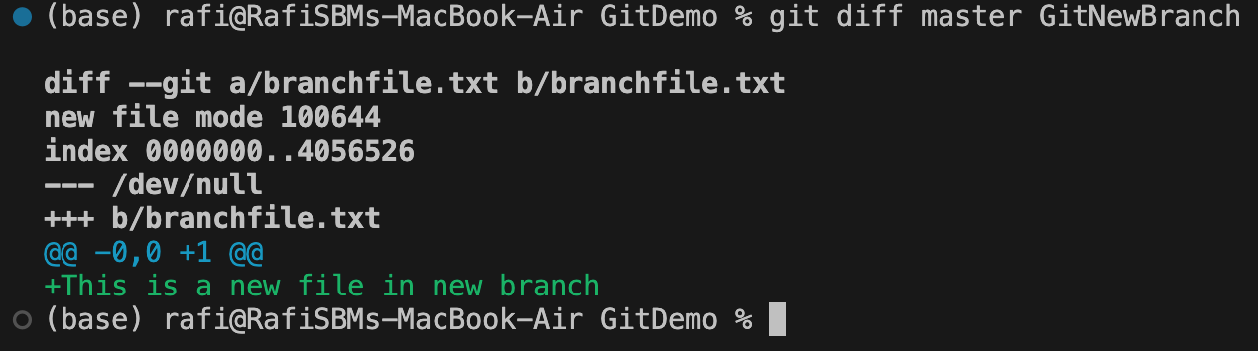

**Merging Branch into Master**

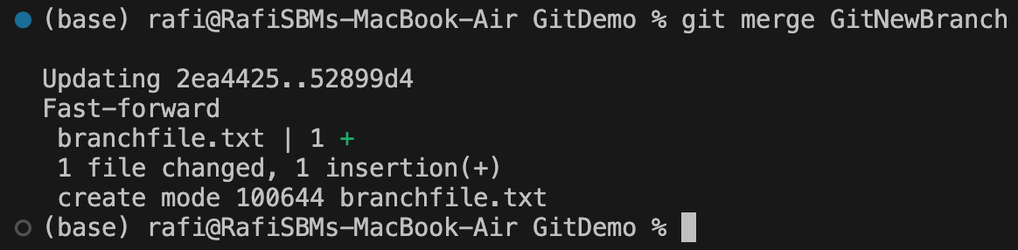

**Viewing Merge History**

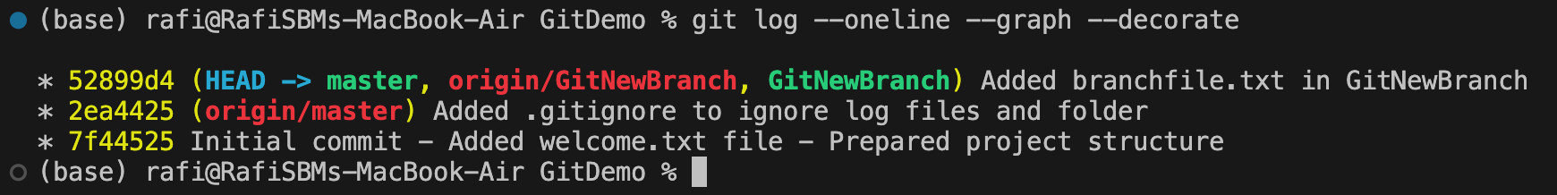

**Deleting Branch After Merge**

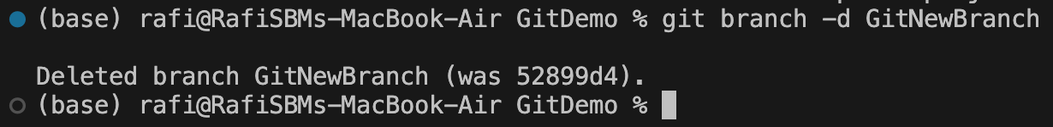

**File : 4. Git-HOL.docx**

**Exercise :** Merge Conflict Resolution in Git

**Master Branch Clean State**

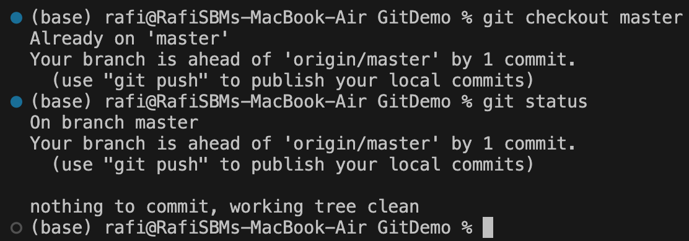

**Creating and Switching to GitWork Branch**

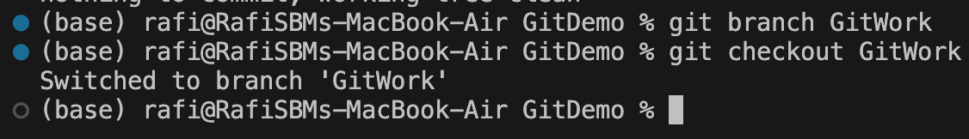

**Creating hello.xml in GitWork**

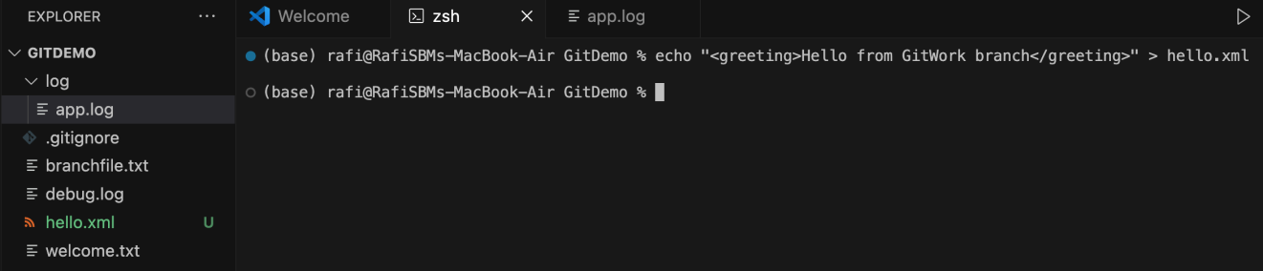

**Committing hello.xml in GitWork**

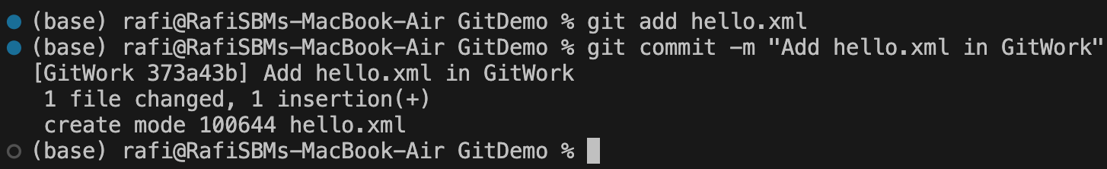

**Creating Different hello.xml in Master**

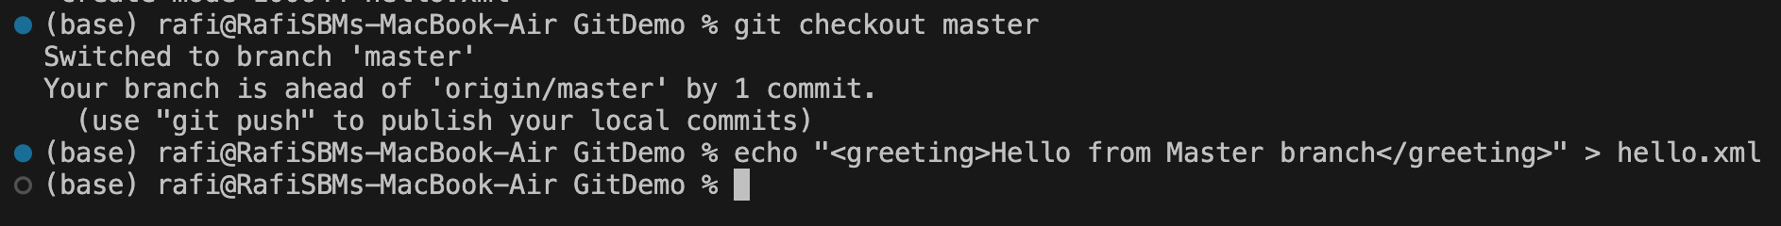

**Committing hello.xml in Master**

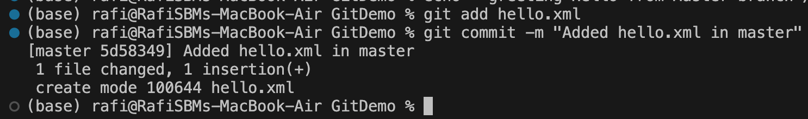

**Viewing Diverged Branch History**

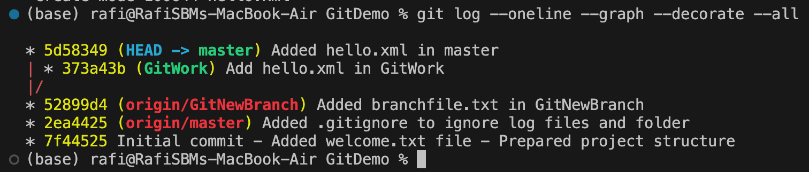

**Merge Conflict Occurs**

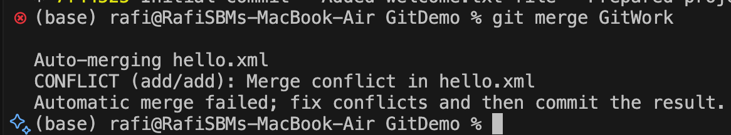

**Resolving Conflict in VS Code & Committing the Resolved Conflict**

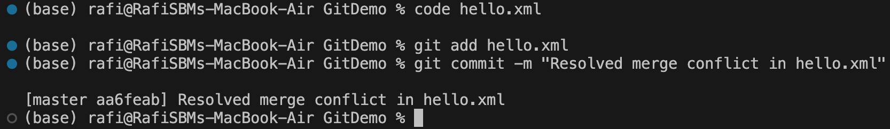

**Adding Backup File Ignore Rule**

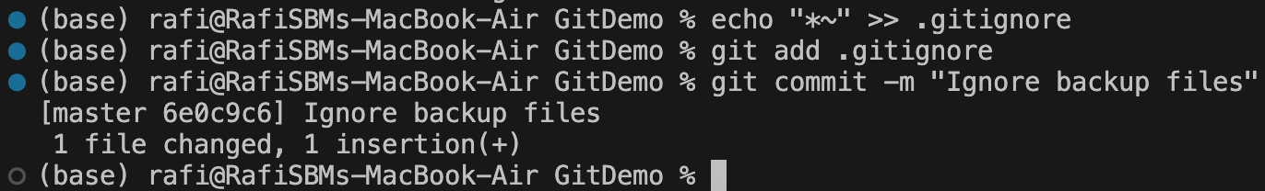

**Deleting GitWork Branch**

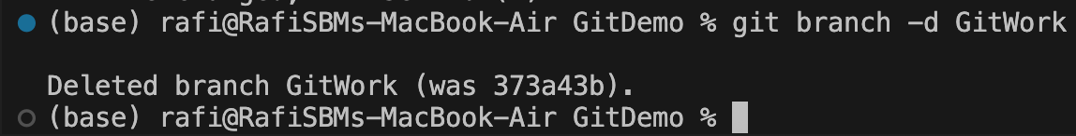

**Final Commit History After Merge**

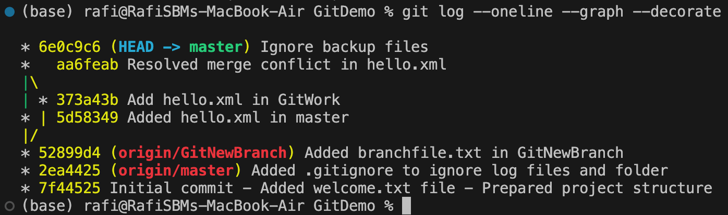

**File : 5. Git-HOL.docx**

**Exercise :** Cleaning Up and Pushing to Remote Git

**Master Branch Clean State**

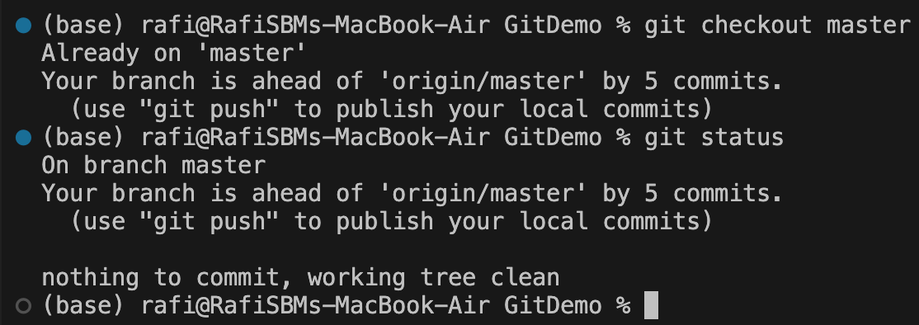

**Listing all available branches**

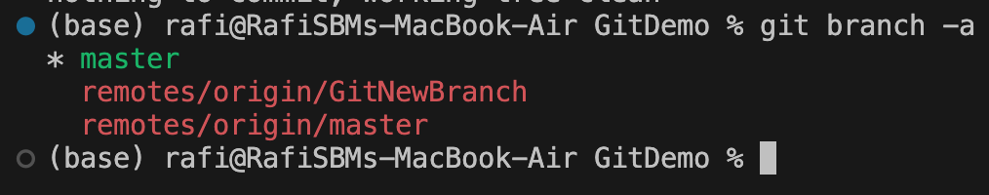

**Pulling latest changes from remote**

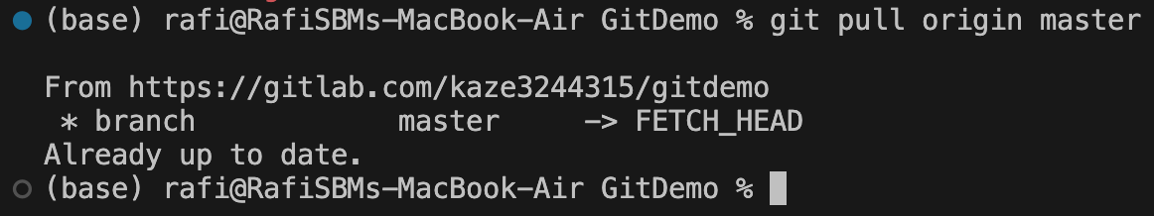

**Pushing pending changes to remote**

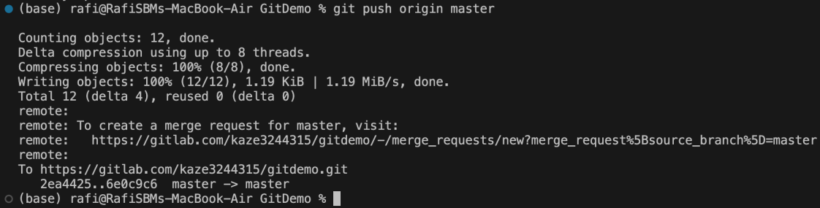

**Verifying changes on GitLab**

