**Assignment # 2**

Course: Artificial IntelligenceInstructor: RAFI ULLAH

Instruction:1. Solve assignment in group of 2 or 3  
2. Each member should participate in assignment tasks  
3. Submit assignment before 12 PM Sunday 24-11-2019  
4. Straight forward copy paste will lead to cancellation of all assignment – Negative Marking

You have to submit1. All source codes file (Coding should be in Python Language), each line should be well  
commented, otherwise assignment will be rejected  
2. You have to paste screen shots of executing program, and screen shots must contain some  
indication that you have executed on your system  
3. 1 Page document showing the contribution of each member of your group  
4. All stuff will be zipped and named AI_assign_1_student1ID_student2ID_student3ID5. Email your assignment before deadline in softcopy on rafi@pafkiet.edu.pk

**2 Research papers are attached with this assignment.**

**Question 1:** Download 3 different research papers (different than papers I have attached). Study research papers in details and then write in your own words the following:

1. Problem Definition / Objective of Research author have done
2. Step by step explanation of how they solve problem; you must explain the mathematical foundation behind each calculation
3. What are the limitation / Drawback of work already done
4. Any idea – What will you add to existing idea to make it efficient

**Question 2:** You have to study attached papers and then try to implement one of the given problems. You must send code (well documented and commented code) to me along with output screenshots when you executed on your system. You must write separate methods for each of the Genetic Algorithm Operators selection, fitness function, crossover, mutation etc.

**Question 3:** Explain in details the heuristics function for following problem; give mathematical explanation / formula in all cases.

1. **Chess Game**
2. **Sudoku Puzzle**
3. 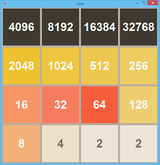**2048**

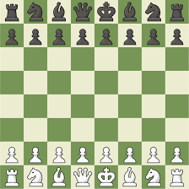 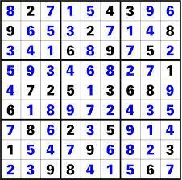

**Question 4:** Consider following maze along with hints given. You have to write program that will take initial position of agent and destination and then return shortest path from start to destination using A* Search technique. You should use Manhattan distance formula for calculating heuristics (you may use other heuristics as well). Clearly show in code how you will implement this environment. Give explanation of every notation / symbol you used. You may implement this as windows form application but not necessary.

