**Assignment # 1**

1. Assignment must be in group of 3 students
2. All codes files should be sent on [rafi@pafkiet.edu.pk](mailto:rafi@pafkiet.edu.pk)
3. Hard Copy submission includes report, solution by hand and discussion.
4. Contribution of each student should be shown in report
5. Your AI course will be dropped in case of plagiarism (direct copy paste)
6. Deadline is 15/07/2019.

**Question 1: Explain in details the heuristics function for following problem; give mathematical explanation / formula in all cases.**

1. **Chess Game**
2. **Slide Puzzle**
3. **Sudoku Puzzle**
4. 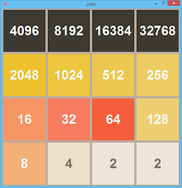**2048**

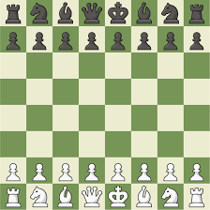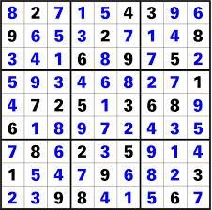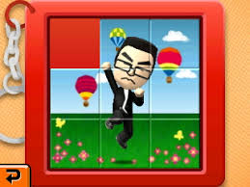

**Question 2: Search for implementation of following problems and download code from internet. Try to understand the logic, execute code on your system and paste snapshot here along with report that describe each line of code i-e line 1 is initialization of variable. In this section you have to comment each line of code you downloaded.**

1. **Depth First Search for any problem**
2. **Hit and Trial search for sliding puzzle**
3. **Hill climbing for 8-Queens problem**
4. **Genetic Algorithm for TSP (Traveling Salesman Problem)**
5. **A* search implementation of path finding**

**Question 3: Consider following graph, single initial state and multi-final state problem. Cost and heuristics values are given below. You have to apply following list of algorithms to find solution. You have to show complete steps to get full marks.**

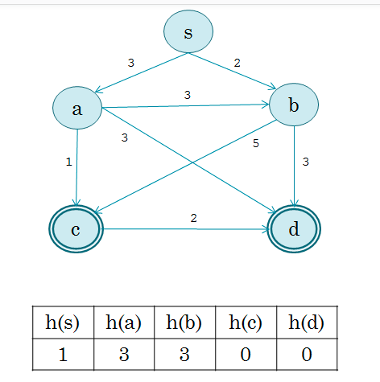

1. Breadth First Search
2. Greedy Best First Search
3. Uniform Cost Search
4. A* Search
5. Hill climbing

You have to write report that explains

1. How you distribute work among group? What is contribution of each member?
2. List all links (research paper, websites etc.) from where you get help
3. Well commented Code, each line should be commented.