**Assignment # 2**

1. Assignment must be in group of 3 students
2. All codes files should be sent on [rafi@pafkiet.edu.pk](mailto:rafi@pafkiet.edu.pk)
3. Hard Copy submission includes report, solution by hand and discussion.
4. Contribution of each student should be shown in report
5. **Your AI course will be dropped in case of plagiarism (direct copy paste)**
6. Deadline is 21/07/2019.

**Question 1:**

Following is the representation of search problem, where “A” is start node and “G” is goal node, there is also heuristics function defined in table; all heuristics are pre-defined except for “B”. (Heuristics of B is unknown).

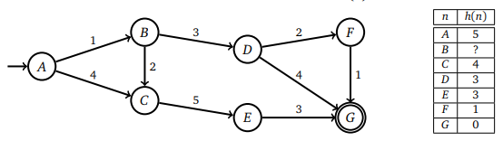

1. What do you mean by admissible heuristics?
2. What values of h(B) makes heuristics admissible?

**Question 2:**

Consider following search graph as shown, it has only three states and direct edges. “A” is start node and “G” is goal node. Four different heuristics are given in table by the name I, II, III, IV for each nodes. Answer following questions.

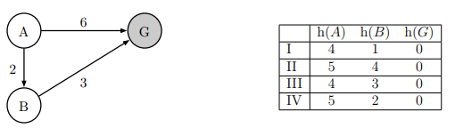

1. What do you mean by consistent heuristics?
2. For heuristics II and IV, justify whether heuristics is admissible and consistent or Not. You must show WHY.

**Question 3:**

Consider Question 1 now with heuristics of B is 15 i-e h(B) = 15. Apply A* star Search algorithm (show all steps to get full marks) to find shortest path from A to G. In computer science, A* is a computer algorithm that is widely used in pathfinding and graph traversal, which is the process of finding a path between multiple points, called "nodes". It enjoys widespread use due to its performance and accuracy. Show whether you solution is optimal or not? Write reason in case of non-optimal solution.

**Question 4:**

1. Download 8 Queen Logic solved by Hill Climbing; Understand logic; add comment to each line and execute on your system; take snapshot of output on your own system.
2. Download Travelling Salesman Problem (**TSP**) Logic solved by Genetic Algorithm; Understand logic; add comment to each line and execute on your system; take snapshot of output on your own system.
3. Download Tic-Tac-Toe solved by Alpha-beta Pruning; Understand logic; add comment to each line and execute on your system; take snapshot of output on your own system.
4. Apply CSP – Forward chaining to any problem. Explain problem, understand situation. Implement Code and take snapshot of output.

You have to write report that explains

1. How you distribute work among group? What is contribution of each member?
2. List all links (research paper, websites etc.) from where you get help
3. Well commented Code, each line should be commented.