

**Course**: Operating Systems

**Instructor**: Rafi Ullah

**Type**: Group Assignment (3 or 4 members per team)

**Task 0: (20 marks: each command and output snapshot= 1 mark)**

Write at-least 50 LINUX commands and their output. Output snapshot must show your name as given in following image. (As chris is user in given image)

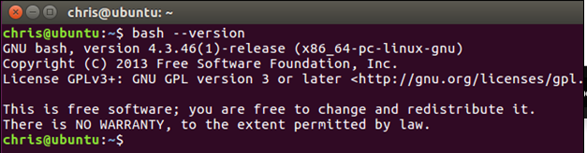

**Task 1: (30 marks: Program 1 = 10 marks, Program 2 = 10 marks, Report = 10 marks)**

First, write a program (with single process) to calculate timings for matrix addition, subtraction and multiplication. You should take large matrix such as 1024 X 1024 so you can get some noticeable amount of time or you may be required to calculate results in loop (multiple times). Comment on the scalability of this program by creating a graph of array size vs execution time. For simplicity, you can assume square arrays as input. Secondly, you should write a program (with three processes, separate for each matrix operation that are addition, subtraction and multiplication) and compare the timings with the first program. Comment on the scalability of this program by creating a graph of array size vs execution time. For simplicity, you can assume square arrays as input.

**Task 2: (70 marks: Code Implementation = 60 marks, Report = 10 marks)**

In this task, you are required to develop a unix like shell which must be able to accept commands from the user and execute them. One example shell can be like this. (10 marks)

CS_202_Shell > "commands to be typed here"

Credit will be given for implementation of the following features in the shell.

1. A history of previous commands executed should be maintained. The user can access this list through the direction keys on the keyboard. (10 marks)

2. The user can also access the history through "!!" key in reverse order. "!!" meaning that the last command should be executed. "!!1" meaning the second last command, !!2 meaning the third last command and so on. If "gcc input.cpp" is a command that has been previously executed, then doing "!!g" should execute it. (20 marks)

3. The user can also access the history through "!" key in sequence order. "!1" meaning that the first command in history should be executed. "!2" meaning the second command, !3 meaning the third command and so on. If "gcc input.cpp" is a command that has been previously executed, then doing "!g" should execute it. (20 marks)

**Instructions:**

* **All printing, input, reading (from files or the console) should be done by system calls.**
* **You cannot use any library functions.**
* **Follow Wrox Book for solution and other resources from internet**
* **You can take help from internet and others but if your code is copy, all your assignments will be canceled.**
* **Output must be submitted as following;**

|  |
| --- |
| **rafi@rafi-virtualbox $ program out** |

**Snapshot must contains your or group member names in all output.**

* **You should provide proper comments in source code to get full marks.**

**Submission:**

Deadline: October 19, 2019 till midnight.

**Required Deliverables:**

1. Task 1: two source code files, a report with code explanations and screenshots of sample executions plus the required graphs with analytical comments.
2. Task 2: source code, a report with code explanations and screenshots of sample executions. Note: You should provide proper comments in source code to get full marks.
3. 1 page report explaining the contribution of each member in group.

Submit a zip file as assignment1_os_fall2018_<your student numbers>.zip on given email.

[rafi@pafkiet.edu.pk](mailto:rafi@pafkiet.edu.pk)