

**Course**: Operating Systems

**Instructor**: Rafi Ullah

**Type**: Group Assignment (3 or 4 members per team)

**Task 0: (20 marks: each command and output snapshot= 1 mark)**

Read chapter 2 “shell programming” from “wrox book – beginning Linux programming”. Execute all commands and codes given in chapter. Output snapshot must show your name as given in following image. (As chris is user in given image). This must be executed by each member and paste output screen shots of all members.

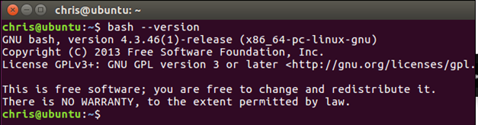

**Task 1: (50 marks: FIFOs creation = 10 marks, Online Clients Maintains = 10 marks,**

**Messaging/Execution = 10 marks, Report = 10 marks)**

In this task, you have to write two programs (a client and a server) which will do chatting with each other using FIFOs (to pass message from one process to another). The server process creates a SERVER_FIFO to receive client connections only. The server maintains the list of online clients. Each client creates its own CLIENT_FIFO to receive commands from server to be executed at client using system() system call. You can use getpid() system call to retrieve client’s process id to be concatenated in the CLIENT_FIFO name.

**The model that you are going to implement will look like as follows:**

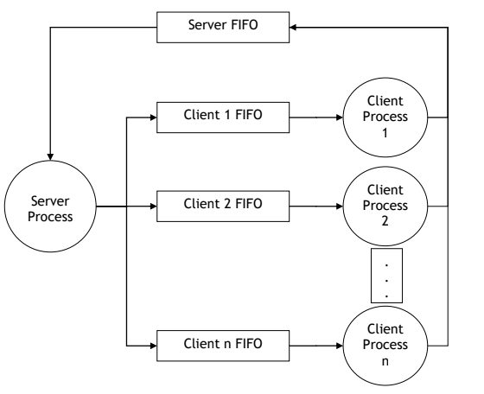**Instructions:**

* **All printing, input, reading (from files or the console) should be done by system calls.**
* **You cannot use any library functions.**
* **Follow Wrox Book for solution and other resources from internet**
* **You can take help from internet and others but if your code is copy, all your assignments will be canceled.**
* **Output must be submitted as following;**

|  |
| --- |
| **rafi@rafi-virtualbox $ program out** |

**Snapshot must contains your or group member names in all output.**

* **You should provide proper comments in source code to get full marks.**

**Submission:**

Deadline: November 17, 2019 till midnight.

**Required Deliverables:**

1. Task 1: two source code files, a report with code explanations and screenshots of sample executions plus the required graphs with analytical comments.
2. Task 2: source code, a report with code explanations and screenshots of sample executions. Note: You should provide proper comments in source code to get full marks.
3. 1 page report explaining the contribution of each member in group.

Submit a zip file as assignment1_os_fall2018_<your student numbers>.zip on given email.

[rafi@pafkiet.edu.pk](mailto:rafi@pafkiet.edu.pk)