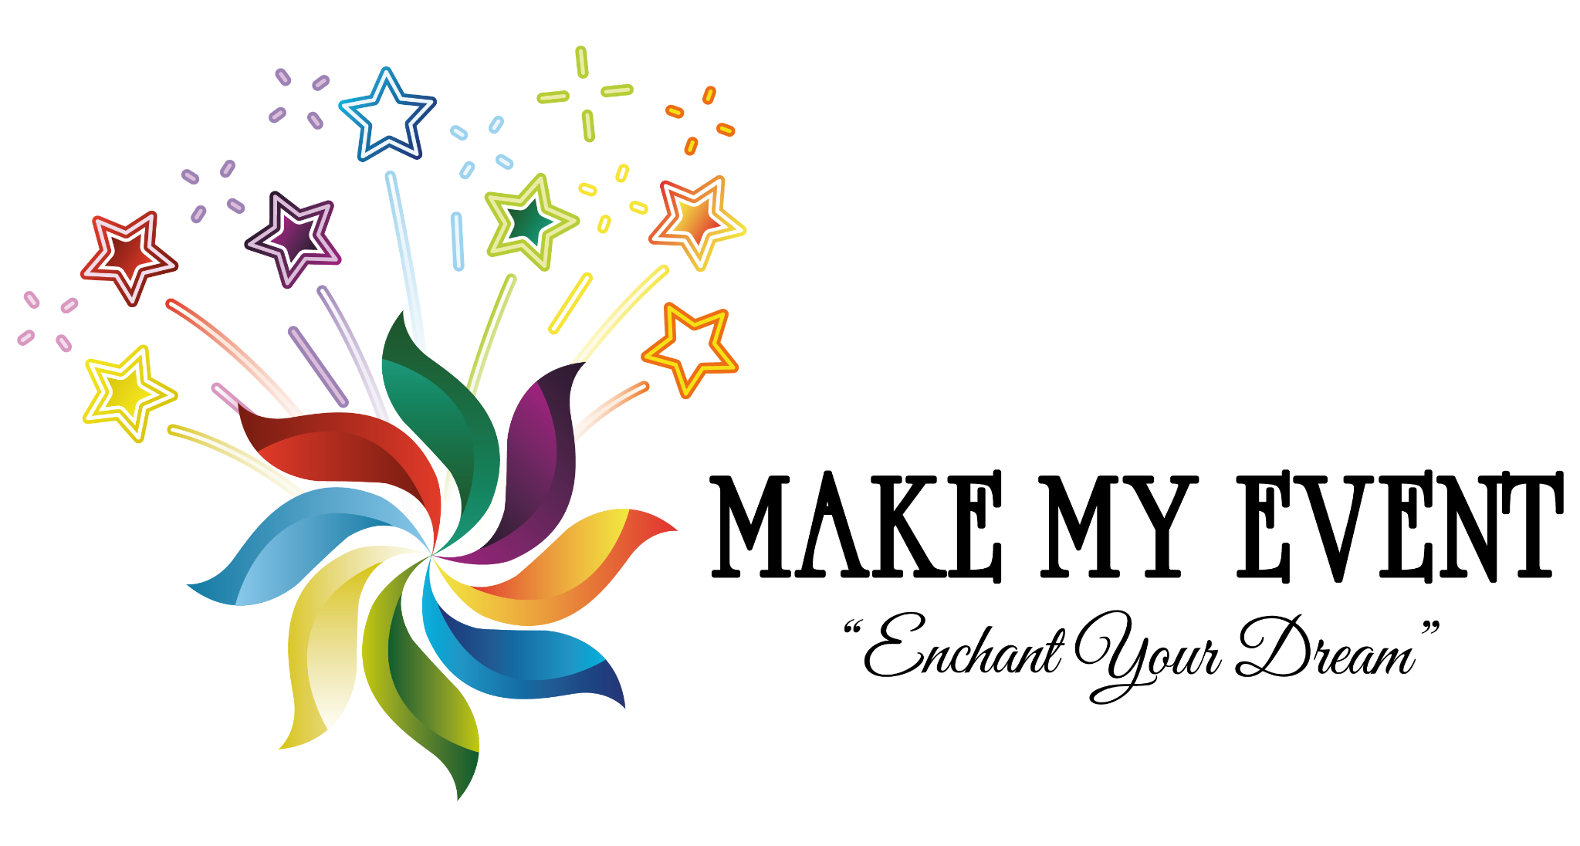
House 94, Road 2, Block a, Niketon, Gulshan - 1
makemyeventbd@gmail.com
+8801799888222
Date........................
f
MAKEMYEVENT
MAKEMYEVENTBD
WWW.MAKEMYEVENTBD.COM

