**List Of Member**

1. Deyo Irfandiantoro - 012202100037
2. Dwi Nur Lailatun Nisfi - 012202100025
3. Rafi Atha Fahero – 012202100078

**Link For Presentation Video**

Link: https://drive.google.com/drive/folders/1N9PO-ASB4Dyw7qlsqG4m7ZW1e1abmLqD

**Instruction To Set Up The Database.**

**STEP 1**

1. The first step you have to do is open phpmyadmin, then create a new database called "indekosdb".

**STEP 2**

1. On the top navigation tab, please click Import.

2. After that press the Choose File or Browse button.

3. Select your database file in the indekosdb.sql folder, then click Open. You

will see the name of the file you selected next to the Browse button.

4. Make sure you select SQL in the drop down menu.

5. After that click the Go button.

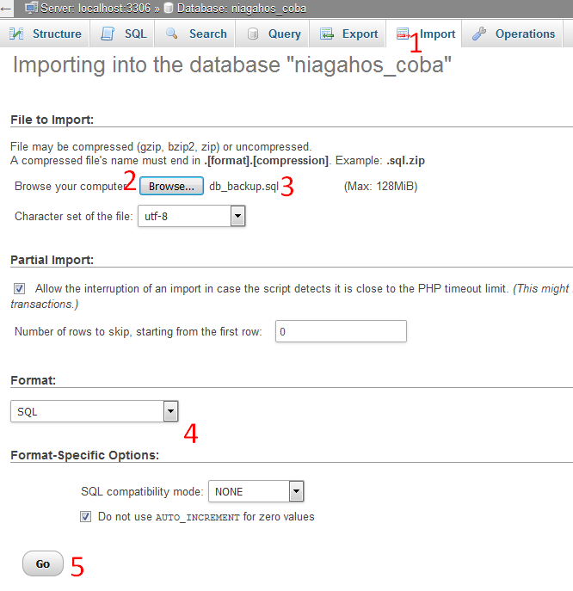

**STEP 3**

1. Import processing time depends on the size of your database file. Please wait until a successful message appears as shown below.

proses import database telah berhasil

2. If there is an error, please check again according to the instructions we have provided.

Note : The difference between Table **user** and users in databaseis Table **user** is for **Admin** and Table **users** is for **Tenant.**