Introduction to Computational Physics – Exercise Report
Issued: 2011-12-13
Handed in: 2011-12-20
Student: Rafael Kueng
StudentID: s06 707 046

Ex12:
Wave equation

Task 1

Since the innermost brackets of the exp function (x-10), (x-c*dt-10) denote the position on the x axis, and generally, (x-a) means a shift of the original curve by a in the positive direction. If c>0 (dt>0 by def) that means the wave u(t=-dt) is more on the right, positive. So the wave travels in negative direction.

Task 2
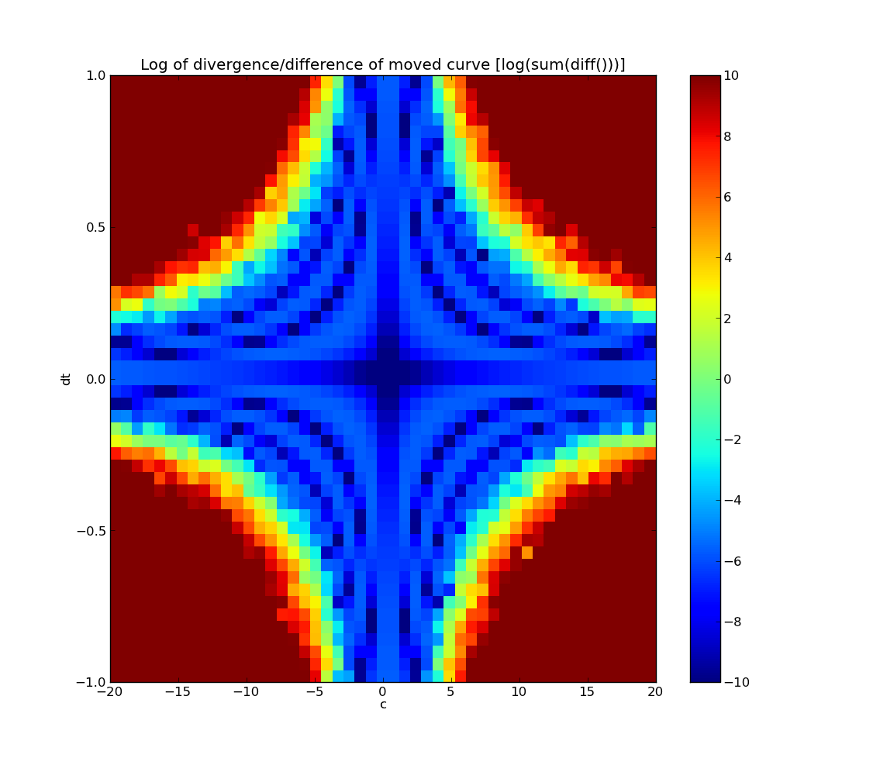
In the plot, the areas where there's little deformation of the wave during propagation are painted blue. One can see the line, where c*dt=1 (the innermost tangents to the cross, where dt or c = 0) is the strongest one, the one with the least deformation of the curve.
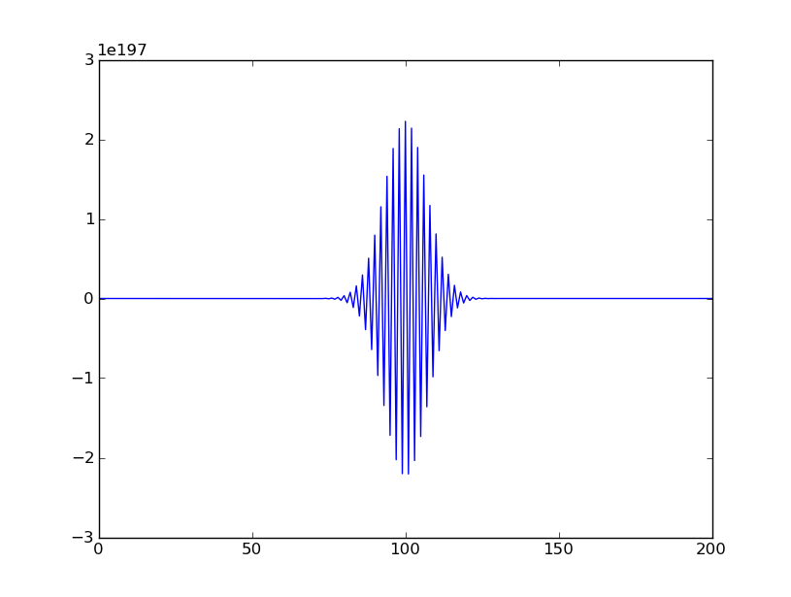
Then b>1, the wave doen't propagate anymore, it only disperses, as seen on the picture.

Task 3

please refere to the code for an example of fixed, sinusoidal waves, ect...

