Ex 2

Rafael Kueng; s06 707 046

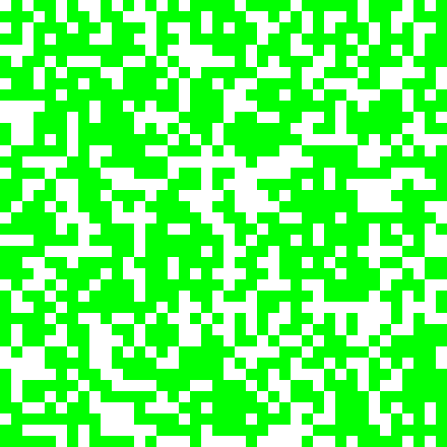
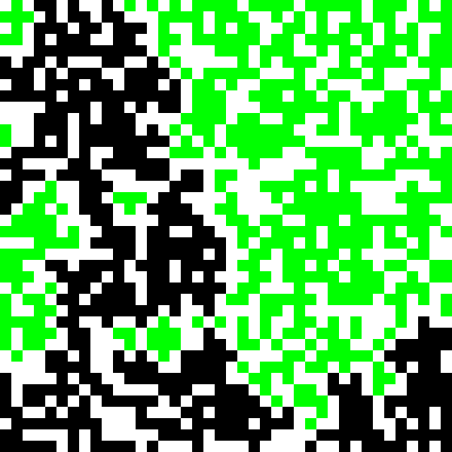

left: picture 1 task 1; right: picture 2, task 2

Task 1
see picture 1 (starting picture)and output in console

Task 2
see picture 2 (end picture) and especially the asci animation in the console. There was exactly one spanning cluster (working with N = 40, p = 0.6, seed = 1), with the properties:
- life time: 72 (how many steps was a fire on the lattice) and
- minimal path length: 65

Task 3
see plots on page 2. the threshold probability pc is estimated to lie between pc = 0.59 ... 0.6 with plots on p. 3

