|  |
| --- |
|  |
| Online Examination System |
| UNIVERSITY OF SARGODHA CS & IT department |

**Name**: Rafia Tehseen

**Roll No**: BSEF19M007

**Class**: BS Software Engineering Regular

**Subject**: Software Design and Architecture

|  |
| --- |
|  |

Contents

INTRODUCTION 2

Features 2

For Students 2

For Teachers 2

For Focal Person 2

UML Static Diagram 3

Component Diagram 3

Deployment Diagram 4

UML Behavioral Diagram 5

Activity Diagram 5

Use Case Diagram 7

Sequence Diagram 8

Advantages of Online Examination Portal Architecture 9

Disadvantages of Online Examination Portal Architecture 9

General disadvantages of online examination system includes 10

Opinion and concluding remarks 10

# INTRODUCTION

Online examination system is an internet based test system that can use to conduct papers using fewer resources like system and internet availability. It is very useful method in cases such that when it is not possible to conduct physical exams i.e. pandemic situation. It is one of the fastest methods for conducting examination as it calculates results at runtime and reduce the hassle of checking exams manually. It also saves physical accessories like pages, electricity, rooms, and invigilators. It allows different level of users e.g. students, teachers and focal person to login in their specified portal using authenticated IDs (user name and password).

## Features

Online exam portal allow user to perform variety of tasks like

### For Students

* they can check their today paper and attempt it on given schedule
* Check their date sheet
* Can also check their results

### For Teachers

* They can create paper manually
* They can also upload their paper using excel file
* They can check updates on student’s results
* They can check paper list
* They can also edit/delete questions from question bank

### For Focal Person

* They can create and edit program/class
* They can add students
* Can update student’s passwords
* Can create teacher and update teacher’s password
* Can also assign teachers to classes
* They can check student log file
* They can update students result
* Can add reappearing students
* Can promote students

# UML Static Diagram

UML static diagrams show the static view of the system using attributes, object operations etc. Static Diagrams include Class diagram, Composite Structure diagram, Component diagrams, Deployment diagram etc.

## Component Diagram

In Unified Modeling Language (UML), a component diagram depicts how components are wired together to form larger components or software systems. In our online examination system include Focal Person, Teacher, Results, Exam, University Database, and Student.



## Deployment Diagram

A deployment diagram is a UML diagram type that shows the execution architecture of a system, including nodes such as hardware or software execution environments, and the middleware connecting them. Deployment diagram of online examination system is as shown below



# UML Behavioral Diagram

This view emphasizes the dynamic behavior of the system by showing collaborations among objects and changes to the internal states of objects. E.g. Sequence diagram, Activity diagram, State Machine diagram.

## Activity Diagram

An activity diagram is a behavioral diagram i.e. it depicts the behavior of a system. An activity diagram portrays the control flow from a start point to a finish point showing the various decision paths that exist while the activity is being executed. Activity diagram of online examination system is as below:





## Use Case Diagram

A use case diagram is a graphical depiction of a user's possible interactions with a system. Users of online examination portal are student, teacher and focal person. Online Examination system use case diagram is shown below:



## Sequence Diagram

A sequence diagram shows object interactions arranged in time sequence. It depicts the objects involved in the scenario and the sequence of messages exchanged between the objects needed to carry out the functionality of the scenario. Sequence diagram of online examination system is shown below



# Advantages of Online Examination Portal Architecture

Online examination system is very advantageous in situation of ongoing global pandemic which is impacting on global education system. The main advantage of online examination portal is its understandability and learnability. It also has scalability as we can users as per our requirements by putting very little efforts. Our examination system also has a good as fault tolerance as its students face any issue during exam. System generate “log file” in case of error during paper submission. Then the student can contact focal person and verify and update their original results.

Online examination system is very testable as we can perform different test to ensure system reliability and consistency. In our online examination portal architecture, its very easy to save and submit paper as even a non-technical person can easily conduct and attempt paper. Online examination system advantages also include automation of manual processes like exam conduction, paper checking, and compiling results. Online examination system advantage is that it is more secure process as student question paper is selected randomly from a range (100/50) of questions so there is less chance of cheating.

# Disadvantages of Online Examination Portal Architecture

We can only view specific tabs of our online examination portal like date sheet and result page during specific time period which can be annoying when we want to check our paper timing.

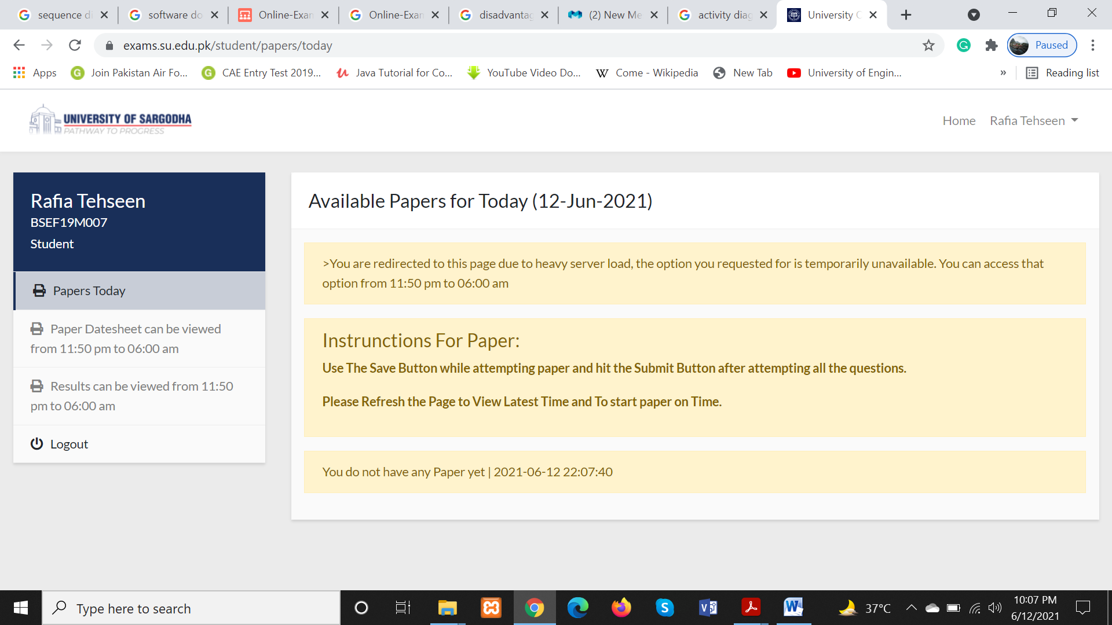

Another disadvantage of exam portal is that after attempting paper even our mid-term paper its result shows in final term result column. So this issue should be resolved.

Exam portal give very less modification control like when a student set its password after first login it cannot be change unless the student contact focal person for password modification.

When student is attempting paper, he or she has to save changes time by time which is time wasting because paper should be completed in given time period. So system should be updated to save automatically. In this way time can be saved and can be utilize in solving paper which is the main motive.

In teacher exam portal, the structure of adding question manually in question bank is very unappealing and unprofessional so it should be replaced by a more professional one.

## General disadvantages of online examination system

* Less result reliability
* Transition to open book exam
* Technology adaptation challenges
* High Chance of cheating
* Less conceptual learning
* Lack of non-verbal cues
* Security issues
* Not real connection to teacher
* Challenges of impersonation
* Low communication skills enhancement
* Unavailability of technology
* Lack of learning surroundings
* Lack of concentration

# Opinion and concluding remarks

Every technology has advantages and disadvantages so it’s up to us which way we want to make use of it. There are lots of reasons you want to use an online exam system, but the main reason is the overwhelming advantages you get form using such an online exam system instead of the good old fashioned paper exam. I think that apart from listed advantages it is also reducing the physical activity of us like we were used to go to university to take classes and there we can also have fun with our friends. According to me the main disadvantage of online exam system is its reliability. Students can easily cheat due to access of all cheating resources like notes, internet and books because the reason is no one is there to keep an eye on us during exams. I also think students are not learning, they are just trying to pass semester. But the system is getting better day by day to increase reliability and authenticity of online exams. University is introducing new features like screen recording, audio and camera recording. As good as online examining system can be but they can’t replace physical learning and examination system. As students learn more field work which is going to help them in their professional life through physical learning.