**MULTITHREADING VS MULTI TASKING**

Multitasking is also called multiprogramming whereas multi-threaded is threaded based multitasking.

The basic difference between multitasking and multithreading is that **Multitasking** is CPU intensive it allows the CPU to runs multiple task simultaneously including program, process and threads whereas **Multithreading** allows to execute multiple threads of the same process.

* In Multitasking, System needs to allocate separate memory and separate resources to each program which is executing by CPU.
* In Multi-threading, System needs to allocate the memory to process and the threads in that process shares the same memory.

In async programming we use the concept of multitasking or concurrent programming. Concurrent programming or multitasking is better suited for when the task spends a lot of time waiting, such as for a response from a server. These tasks are called IO-bound or I/O intensive means when there is too much I/O processing in our system. So, multiple tasks are running at the same time because whenever they wait for a response, they remain idle, so we allow the computer to keep running the multiple tasks at the same time without waiting.

**Multitasking**

Multitasking is when a single CPU performs several tasks such as program, process and threads at the same time. To perform multitasking, the CPU switches among these tasks very frequently so that user can interact with each program simultaneously.

As CPU rapidly switches so it requires less time to switch from one user to another user.

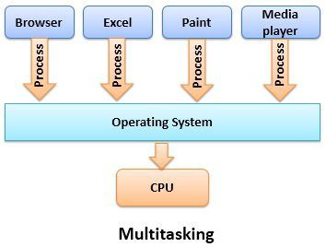

**ADVANTAGES AND DISADVANTAGES OF MULTITASKING**

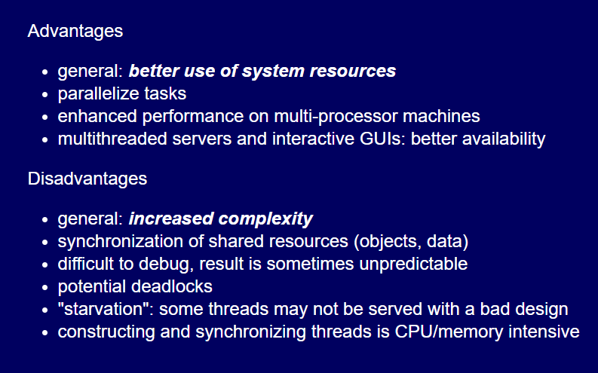

**Multithreading:**

Multithreading is different from multitasking. Multitasking allows multiple tasks at the same time, whereas, the Multithreading allows **to execute multiple threads of single task at the same time.** **CPU switches among these threads and all threads are running simultaneously, and this is called multithreading.**

