Fren N Petals Sales Analysis
- Project Overview
The Festival Sales Analysis project focuses on analysing customer purchasing behaviour, product performance, and sales trends during different festival and occasion-based sales periods. The analysis was performed using Excel Pivot Tables and data visualization techniques to identify high-performing products, top-selling occasions, customer spending patterns, and city-wise sales trends.
The main objective of this project was to understand which products, occasions, and sales periods generated the highest revenue and to identify business opportunities for improving sales performance and customer engagement.

- Dataset Summary
The dataset consists of three main tables used for analysing customer purchasing behaviour, order trends, and product performance during festival sales.
- Customers Table:
Contains customer-related information such as:
  - Customer ID
  - Customer Name
  - City
  - Customer Spending
  - Number of Orders
- Orders Table:
Contains transaction and order-related details such as:
- Order ID
- Order Date
- Occasion
- Quantity Ordered
- Revenue
- Day of Purchase

- Products Table:
Contains product-related information such as:
- Product Name
- Product Category
- Product Revenue
- Product Performance
The dataset was organized and analysed using Pivot Tables to summarize revenue, order quantity, customer spending, and sales trends across different dimensions

- Business Problems Analysed
The project focused on answering the following business questions:
- Which months generated the highest revenue?
- Which products contributed the most sales revenue?
- Which occasions generated maximum revenue?
- Which cities recorded the highest number of orders?
- Which days of the week had the highest sales?
- What is the average customer spending per order?
- Which products performed best during festival sales?
- How does order quantity impact revenue generation?

- Cleaning Data & Missing Values

- Organized raw sales data into structured tables.
- Checked for duplicate and missing records.
- Standardized product names, occasion names, and city names.
- Created Pivot Tables for revenue, orders, and customer analysis.
- Applied filters and slicers for interactive analysis.

- Data Analysis using Excel
Performed business analysis using Pivot Tables to answer key business questions:

      - Month-wise Revenue Analysis: Compared monthly revenue trends and identified February as the highest revenue-generating month.
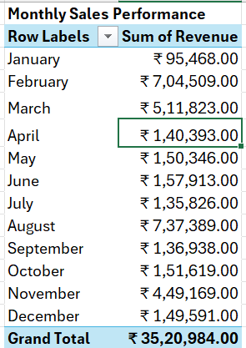

      - Top Products by Revenue: Identified Revenue by top-performing products.
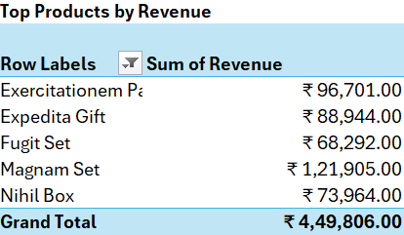

      - Occasion-wise Revenue Analysis: Analysed which occasions generated maximum revenue.

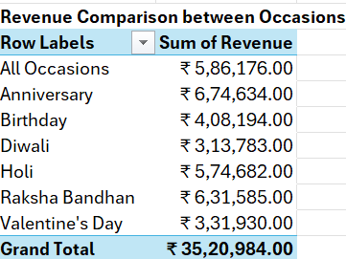

      - Customer Spending Analysis: Calculated average customer spending and average orders per customer to understand customer purchasing behaviour.
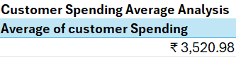
      - City-wise Order Analysis: Identified cities with the highest order counts.

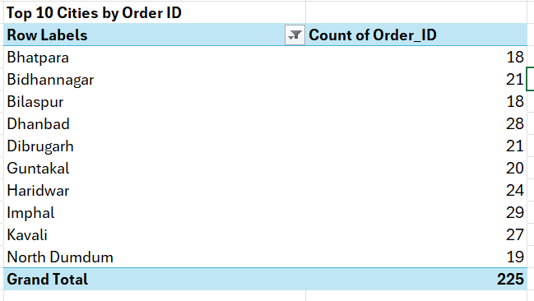

      - Sales by Day Analysis: Compared revenue generated across weekdays and weekends to identify peak sales days.

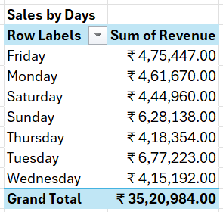

      - Product Performance Analysis: Analysed product categories contributing the highest revenue during festival periods.

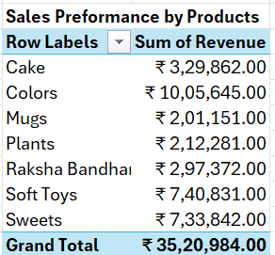

- Dashboard in Power Bi
Finally, we build an interactive Dashboard in Power BI to represent insights visually.
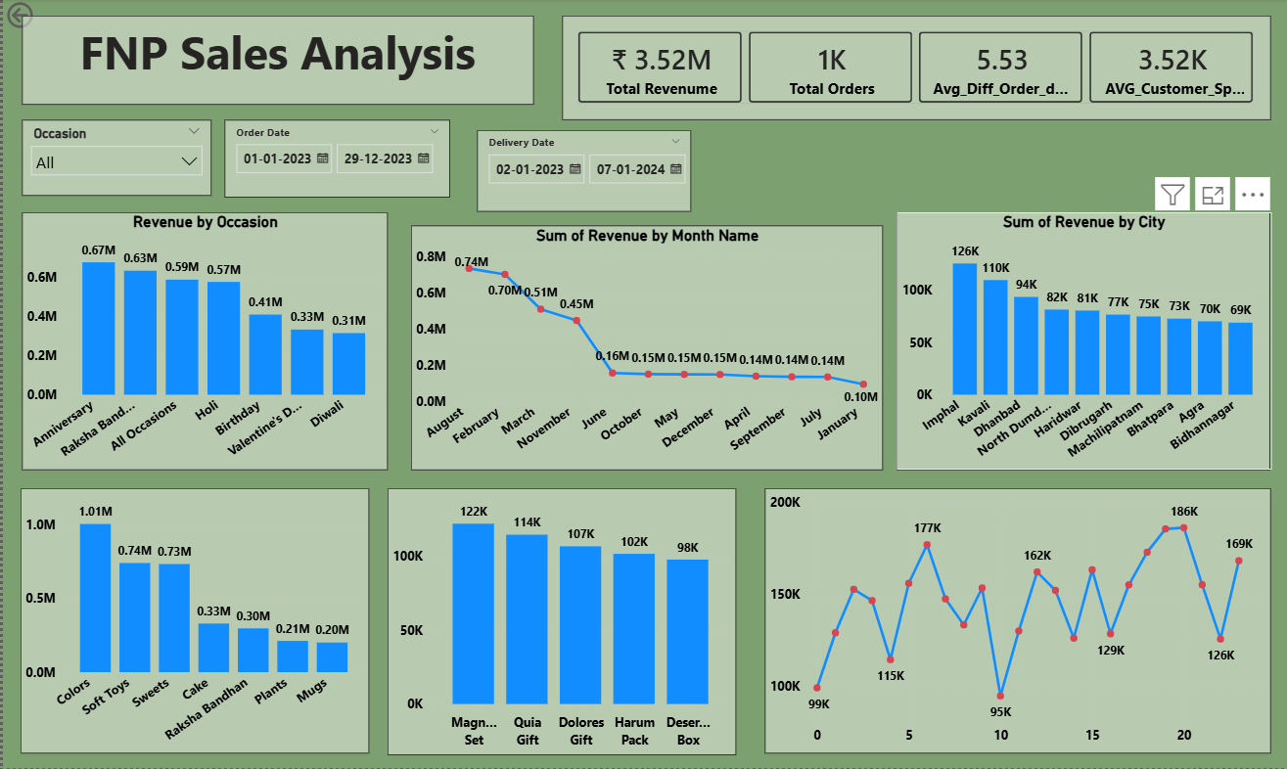

- Business Recommendation

- Focus more marketing campaigns on high-performing occasions like Anniversary, Holi, and Raksha Bandhan to maximize revenue.
- Increase inventory for top-selling products during festival seasons to avoid stock shortages.
- Target high-order cities with location-based promotions and faster delivery services.
- Improve sales during low-performing months using discounts, combo offers, and festival campaigns.
- Analyse customer spending patterns regularly to create personalized offers and improve repeat purchases.
- Promote high-performing products through bundled offers and festive packaging to increase average order value.

