

**SOUND**

SOUND

## PROJECT GROUP MEMBERS

|  |  |
| --- | --- |
| **Students ID** | **Students Name** |
| **Student1385888** | **RAFIA NAJAM** |
| **Student1383991** | **MUHAMMAD ZEESHAN** |
| **Student1340103** | **TULAIB KHAN** |
| **Student1363543** | **SYED MUDASSIR SHAH** |

|  |  |
| --- | --- |
| **CURRICULUM**  **7062** | **BATCH**  **2206B1** |
| **FACULTY**  **“Miss NEELAM MALIK”** | |
| **CO-ORDINATOR “Miss MUNAZZAH KHAN”** | |

 SOUND



### CERTIFICATE

This is to certify that the dissertation entitled **“SOUND”** is submitted by **Rafia Najam Student 1385888, Muhammad Zeeshan Student 1383991, Tulaib Khan Student 1340103 and Syed Mudassir Shah Student 1363543** in their partial fulfilment of the requirement of the award of the Aptech Computer Certified**.**

SOUND



## ACKNOWLEDGEMENT

The success and final outcome of this project required a lot of guidance and assistance from many people and I am extremely privileged to have got this all along the completion of my project. All that I have done is only due to such supervision and assistance and I would not forget to thank them.

I respect and thank Aptech for providing me an opportunity to do the project work in ACE and giving us all support and guidance, which made me complete the project duly. I am extremely thankful to Aptech for providing such a nice support and guidance.

I owe my deep gratitude to our project guide **Ms. Miss Neelam Malik** who took keen interest on our project work and guided us all along, till the completion of our project work by providing all the necessary information for developing a good system.

* Student 1385888 RAFIA NAJAM
* Student 1383991 MUHAMMAD ZEESHAN
* Student 1340103 TULAIB KHAN
* Student 1363543 SYED MUDASSIR SHAH

SOUND



ABSTRACT

This project is aimed at developing a Music website . This is an Intranet based website that can be accessed throughout the internet. This website can be used for listening music. This is an integrated system that covers different kinds of facilities like class- rooms, labs, hostels, mess, canteen, gymnasium, computer center, faculty club etc. Registered users (students, faculty, lab-assistants and others) will be able to log in a request for service for any of the supported facilities.

These requests will be sent to the concerned people, who are also valid users of the system, to get them resolved. There are features like email notifications/reminders, addition of a new facility to the system, report generators etc.

SOUND



### Contents

CERTIFICATE 3

ACKNOWLEDGEMENT 4

CHAPTER # 1 7

INTRODUCTION 7

INTRODUCTION 7

CHAPTER # 2 FUNCTION REQUIREMENT 7

FUNCTIONAL REQUIREMENT 8

CHAPTER # 3 9

REQUIREMENT SPECIFICATION 9

CHAPTER # 4 11

ANALYSIS 11

CHAPTER # 5 13

DESIGN 13

CHAPTER # 6 20

TESTING 20

CHAPTER # 7 SCREENSHOTS 24

CHAPTER # 8 31

TASK SHEET 31

TASK SHEET 32

CHAPTER # 9 33

SUBMISSION 33

CHECKLIST 33

CHAPTER # 10 35

CONCLUSION 35

SOUND



# CHAPTER # 1

**INTRODUCTION**

##### INTRODUCTION:

SOUND



FUNCTIONAL REQUIREMENT

* Every online booking needs to be associated with an account
* One account cannot be associated with multiple users
* Search results should enable users to find the most recent and relevant booking options
* System should enable users to book / pay for their tickets only in a timeboxed manner after tickets being added to the cart
* System should only allow users to move to payment only when mandatory fields such as date, time, location has been mentioned
* System should consider time zone synchronization when accepting bookings from different time zones
* User should be able to change password.

SOUND



# CHAPTER # 3

**REQUIREMENT SPECIFICATION**

SOUND



#### HARDWARE:

* A minimum computer system that will help you access all the tools in the courses is a Pentium 166 or better
* 128 Megabytes of RAM or better

#### OPERATING SYSTEM:

* LINUX / Windows 2000 Server (or higher if possible)

#### SOFTWARE:

* PHP
* MySQL
* PERL
* Apache

SOUND

# CHAPTER # 4 ANALYSIS

SOUND



**PROPOSED SYSTEM:** In the proposed system, in this software once the timer is being arranged, it put up updates and uploads automatically and does not need anyone to do so. Also, it is easily available due to its speed and programming part and using it is quite an easy task and well as due to its speed the information which will be available by one or two clicks, will get available in few seconds only.

**FEASIBILITY STUDY:** The feasibility of the project is analyzed in this phase and business proposal is put forth with a very general plan for the project and some cost estimates. During system analysis the feasibility study of the proposed system is to be carried out. This is to ensure that the proposed system is not a burden to the company. For feasibility analysis, some understanding of the major requirements for the system is essential. Three key considerations involved in the feasibility analysis are:

**Economic Feasibility:** This study is carried out to check the economic impact will have on the system will have on the organization. The amount of fund that the company can pour into the research and development of the system is limited. The expenditures must be justified. Thus, the developed system as well within the budget and this was achieved because most of the technologies used are freely available. Only the customized products have to be purchased.

**Technical Feasibility:** This study is carried out to check the technical feasibility, that is, the technical requirements of the system. Any system developed must not have a high demand on the available technical resources. This will lead to high demands being placed on the client. The developed system must have a modest requirement, as only minimal or null changes for the implementing this system.

**Operational Feasibility:** The aspect of study is to check the level of acceptance of the system by the user. This includes the process of training the user to use the system efficiently. The user must not feel threatened by the system, instead must accept it as a necessity. The level of acceptance by the users solely depends on the methods that are employed to educate the user about the system and to make him familiar with it. His level of confidence must be raised so that he is also able to make some constructive criticism, which is welcomed, as he is the final user of the system.

SOUND

# CHAPTER # 5 DESIGN

Online Movie Booking System



##### SYSTEM DESIGN:

**INTRODUCTION TO UML:**

UML Design the Unified Modelling Language (UML) is a standard language for specifying, visualizing, constructing, and documenting the software system and its components. It is a graphical language, which provides a vocabulary and set of semantics and rules. The UML focuses on the conceptual and physical representation of the system. It captures the decisions and understandings about systems that must be constructed. It is used to understand, design, configure, maintain, and control information about the systems. The UML is a language for:

* Visualizing ❖ Specifying ❖ Constructing ❖ Documenting

##### Visualizing:

Through UML we see or visualize an existing system and ultimately, we visualize how the system is going to be after implementation. Unless we think, we cannot implement. UML helps to visualize, how the components of the system communicate and interact with each other.

##### Specifying:

Specifying means building, models that are precise, unambiguous and complete UML addresses the specification of all the important analysis design, implementation decisions that must be made in developing and deploying a software system.

##### Constructing:

UML models can be directly connected to a variety of programming language through mapping a model from UML to a programming language like JAVA or C++ or VB. Forward Engineering and Reverse Engineering is possible through UML.

##### Documenting:

The Deliverables of a project apart from coding are some Artifacts, which are critical in controlling, measuring and communicating about a system during its developing requirements, architecture, desire, source code, project plans, tests, prototypes releasers, etc.

##### UML Approach UML Diagram

Online Movie Booking System



A diagram is the graphical presentation of a set of elements, most often rendered as a connected graph of vertices and arcs. You draw diagram to visualize a system from different perspective, so a diagram is a projection into a system. For all but most trivial systems, a diagram represents an elided view of the elements that make up a system. The same element may appear in all diagrams, only a few diagrams, or in no diagrams at all. In theory, a diagram may contain any combination of things and relationships. In practice, however, a small number of common combinations arise, which are consistent with the five most useful views that comprise the architecture of a softwareintensive system. For this reason, the UML includes nine such diagrams: 1. Class diagram 2. Object diagram 3. Use case diagram 4. Sequence diagram 5.

Collaboration diagram 6. State chart diagram 7. Activity diagram 8. Component diagram 9. Deployment

##### USE CASE DIAGRAM:

A use case diagram in the Unified Modelling Language (UML) is a type of behavioral diagram defined by and created from a use-case analysis. Its purpose is to present a graphical overview of the functionality provided by a system in terms of actors, their goals (represented as use cases), and any dependencies between those use cases. Use case diagrams are formally included in two modelling languages defined by the OMG: the unified modelling language (UML) and the systems modelling language (sysML)

##### Use case diagram of our project:

**Flow Chart:**

A flowchart is a type of diagram that represents a workflow or process. A flowchart can also be defined as a diagrammatic representation of an algorithm, a step-by- step approach to solving a task. The flowchart shows the steps as boxes of various kinds, and their order by connecting the boxes with arrows

Online Movie Booking System

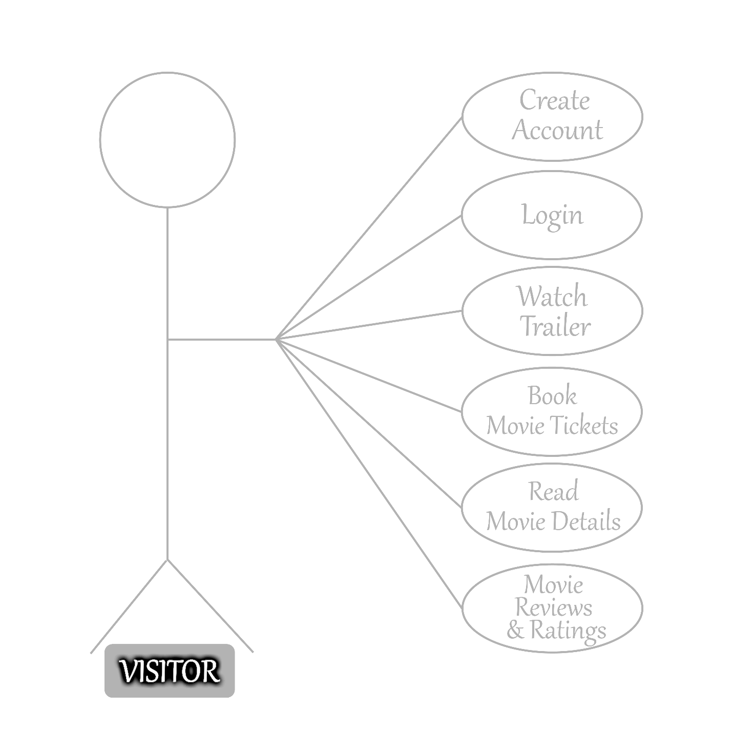

Online Movie Booking System

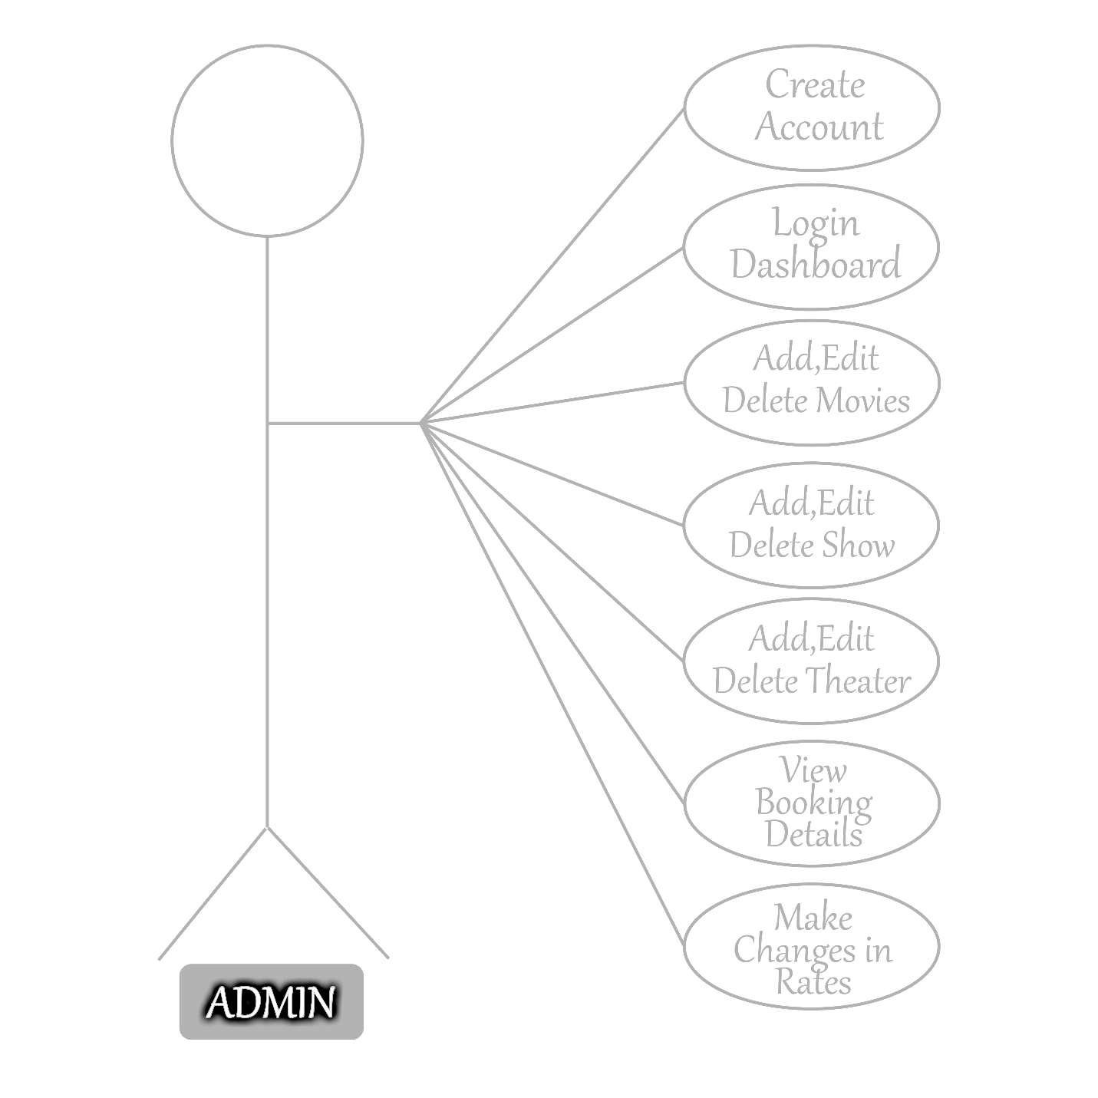

Online Movie Booking System

##### Activity Diagram:

An activity diagram is a behavioral diagram i.e., it depicts the behavior of a system. An activity diagram portrays the control flow from a start point to a finish point showing the various decision paths that exist while the activity is being executed.

YES NO

REGISTER

USER

ADMIN

Watch Trailer

Read Movie Details

Book Movie Tickets

Movie Review & Ratings

Add, Edit, Delete

Add, Edit, Delete

View booking details

Make changes in rates



Add, Edit, Delete Show

Online Movie Booking System

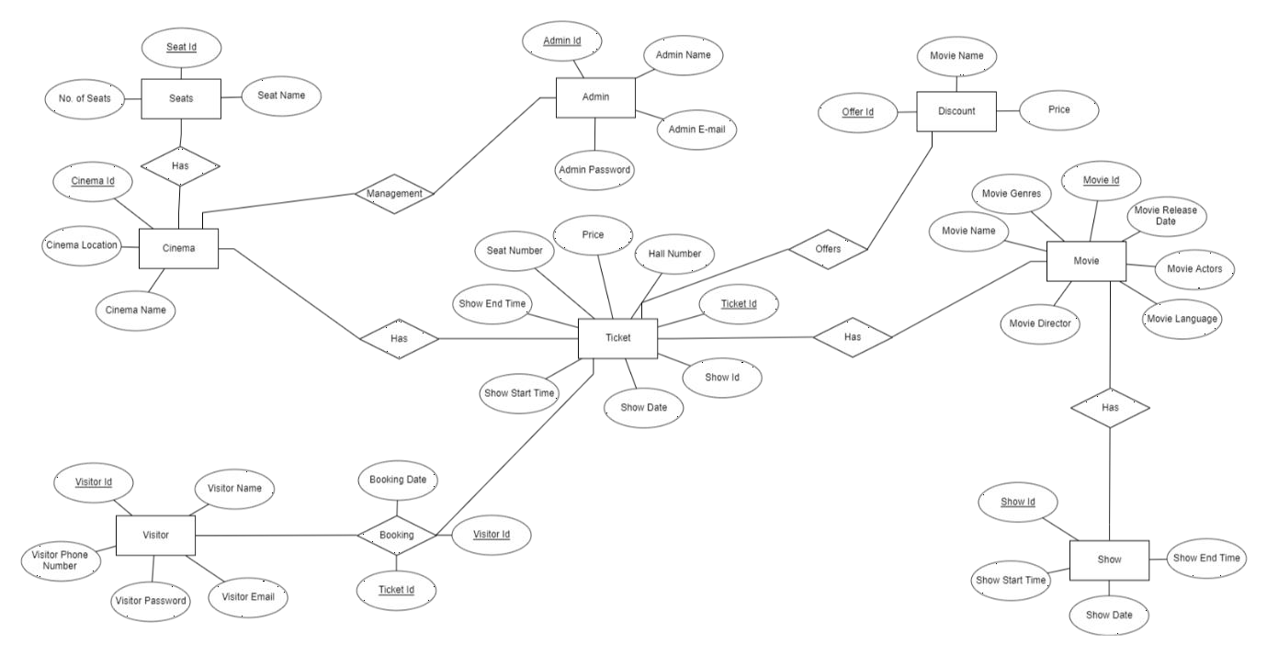

##### ERD Diagram:

An entity–relationship model describes interrelated things of interest in a specific domain of knowledge. A basic ER model is composed of entity types and specifies relationships that can exist between entities

Online Movie Booking System

# CHAPTER # 6 TESTING

Online Movie Booking System



##### INTRODUCTION TO SYSTEM TESTING:

The purpose of testing is to discover errors. Testing is the process of trying to discover every conceivable fault or weakness in a work product. It provides a way to check the functionality of components, sub- assemblies, assemblies and/or a finished product It is the process of exercising software with the intent of ensuring that the Software system meets its requirements and user expectations and does not fail in an unacceptable manner. There are various types of test. Each test type addresses a specific testing requirement**.**

##### TYPES OF TESTING:

**Unit testing:**

Unit testing involves the design of test cases that validate that the internal program logic is functioning properly, and that program inputs produce valid outputs. All decision branches and internal code flow should be validated. It is the testing of individual software units of the application .it is done after the completion of an individual unit before integration. This is a structural testing, that relies on knowledge of its construction and is invasive. Unit tests perform basic tests at component level and test a specific business process, application, and/or system configuration. Unit tests ensure that each unique path of a business process performs accurately to the documented specifications and contains clearly defined inputs and expected results.

**Integration testing:** Integration tests are designed to test integrated software components to determine if they actually run as one program. Testing is event driven and is more concerned with the basic outcome of screens or fields. Integration tests demonstrate that although the components were individually satisfaction, as shown by successfully unit testing, the combination of components is correct and consistent. Integration testing is specifically aimed at exposing the problems that arise from the combination of components

##### Functional test:

Functional tests provide systematic demonstrations that functions tested are available as specified by the business and technical requirements, system documentation, and user manuals. Functional testing is centered on the following items: Valid Input: identified classes of valid input must be accepted. Invalid Input: identified classes of invalid input must be rejected. Functions: identified functions must be exercised. Output: identified classes of application outputs must be exercised. Systems/Procedures: interfacing systems or procedures must be invoked. Organization and preparation of functional tests is focused on requirements, key functions, or special test cases. In addition, systematic coverage pertaining to identify Business process flows; data fields, predefined processes, and successive processes must be considered for testing. Before functional testing is complete, additional tests are identified and the effective value of current tests is determined.

Online Movie Booking System



**System Test:** System testing ensures that the entire integrated software system meets requirements. It tests a configuration to ensure known and predictable results. An example of system testing is the configuration-oriented system integration test. System testing is based on process descriptions and flows, emphasizing pre-driven process links and integration points.

**White Box Testing:** White Box Testing is a testing in which in which the software tester has knowledge of the inner workings, structure and language of the software, or at least its purpose. It is purpose. It is used to test areas that cannot be reached from a black box level.

**Unit Testing:** Unit testing is usually conducted as part of a combined code and unit test phase of the software lifecycle, although it is not uncommon for coding and unit testing to be conducted as two distinct phases.

**Black Box Testing:** Black Box Testing is testing the software without any knowledge of the inner workings, structure or language of the module being tested. Black box tests, as most other kinds of tests, must be written from a definitive source document, such as specification or requirements document, such as specification or requirements document. It is a testing in which the software under

test is treated, as a black box. you cannot “see” into it. The test provides inputs and responds to outputs

without considering how the software works**.**

##### Test strategy and approach

Field testing will be performed manually and functional tests will be written in detail.

##### Test objectives

* All field entries must work properly.
* Pages must be activated from the identified link.
* The entry screen, messages and responses must not be delayed.

##### Features to be tested

* Verify that the entries are of the correct format
* No duplicate entries should be allowed
* All links should take the user to the correct page.

##### Integration Testing:

Online Movie Booking System



Software integration testing is the incremental integration testing of two or more integrated software components on a single platform to produce failures caused by interface defects. The task of the integration test is to check that components or software applications, e.g., components in a software system or – one step up – software applications at the company level – interact without error. Test Results: All the test cases mentioned above passed successfully. No defects encountered

Online Movie Booking System

# CHAPTER # 7 SCREENSHOTS

****Online Movie Booking System

## HOME PAGE

**IN THEATER**

Online Movie Booking System

## TRAILER

**LATEST NEWS**

Online Movie Booking System

## MOVIES

**SERIES**

Online Movie Booking System

## CELEBRITY

**COMING SOON**

Online Movie Booking System

## LOGIN

**SIGNUP**

Online Movie Booking System

## FOTER

**MOVIE BOOKING**

Online Movie Booking System

# CHAPTER # 8 TASK SHEET

Online Movie Booking System

## TASK SHEET

|  |  |  |  |
| --- | --- | --- | --- |
| S.NO | TASK | TEAM MEMBERS NAME | STATUS |
| 01. | Analysis | Muhammad Umair  Muhammad Saleh Shakeel | ✓ |
| 02. | Design | Syed Muhammad Abdullah  Muhmmad Ahtasham nawab | ✓ |
| 03. | Development | Syed Muhammad Abdullah  Muhammad Umair | ✓ |
| 04. | Documentation | Muhammad Ahtasham nawab  Muhammad Saleh Shakeel | ✓ |
| 05. | Finalization | Everyone | ✓ |

Online Movie Booking System

# CHAPTER # 9 SUBMISSION CHECKLIST

Online Movie Booking System

### CHECKLIST

|  |  |  |  |
| --- | --- | --- | --- |
| S.NO | LIST OF ITEM | REMARKS | CHECK |
| 01. | Do All Page Linked Together | **YES** | ✓ |
| 02. | Authorization | **YES** | ✓ |
| 03. | Crud Operation | **YES** | ✓ |
| 04. | Database Connection | **YES** | ✓ |
| 05. | Feedback Form Included | **YES** | ✓ |
| 06. | Project Zip File | **YES** | ✓ |

Online Movie Booking System

# CHAPTER # 10 CONCLUSION

Online Movie Booking System



### CONCLUSION

Finally, in Online movies ticket booking, we have developed a secure, user-friendly online movie ticket Management reservation System. This System can take care of each member whether its Owner or viewer. This System will help them to properly manage the system and aid in growth without creating and hassle. This System is completely secure since every user is provided with user ID and Password, so there is no chance of any unauthorized access. Online Payment, Booking, and cancellation make it easier to use. So, using this system will help in reducing the labor and provide more facility for viewers who will increase their level of ease as they can do everything from anywhere at any time. So, the system is beneficial for the viewers.