

Group Members

Process Name | Stakeholders | Concerns (Problems) | Analysis (Reason of the problem) | Proposed Solution
CO are calculated manually by the instructors and stored in excel files | 1)Instructors | Since all calculations are done manually by the instructors, so this process is prone to errors | The process is very hectic, time consuming and prone to many errors | Create a system that takes all the marks of the student automatically outputs the CO
Performance comparison between departments, school and students | 1)System admin | Comparing large amounts of data manually is very time consuming and effective | The process is very time consuming | Build a system that takes the data and produces a performance graph

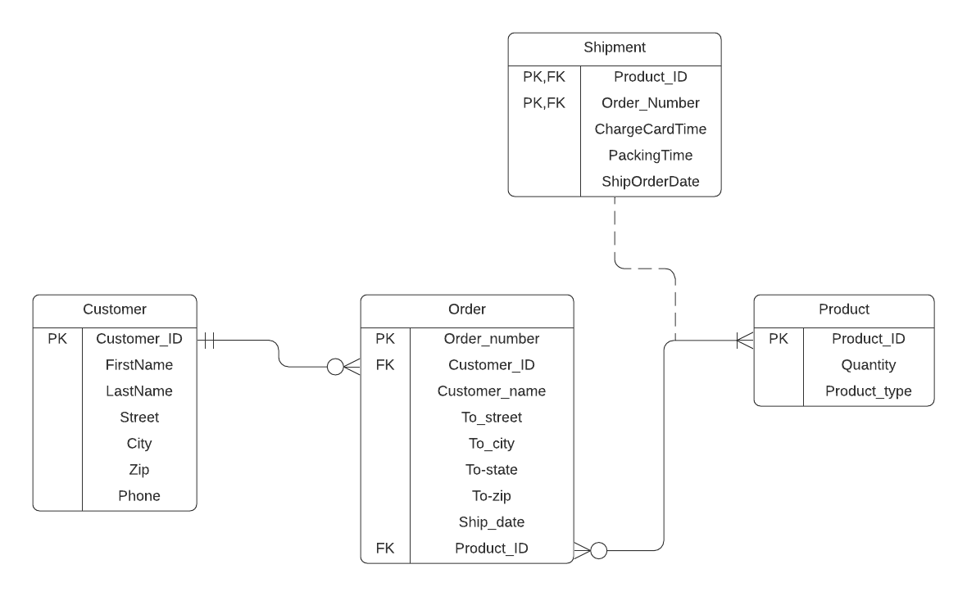

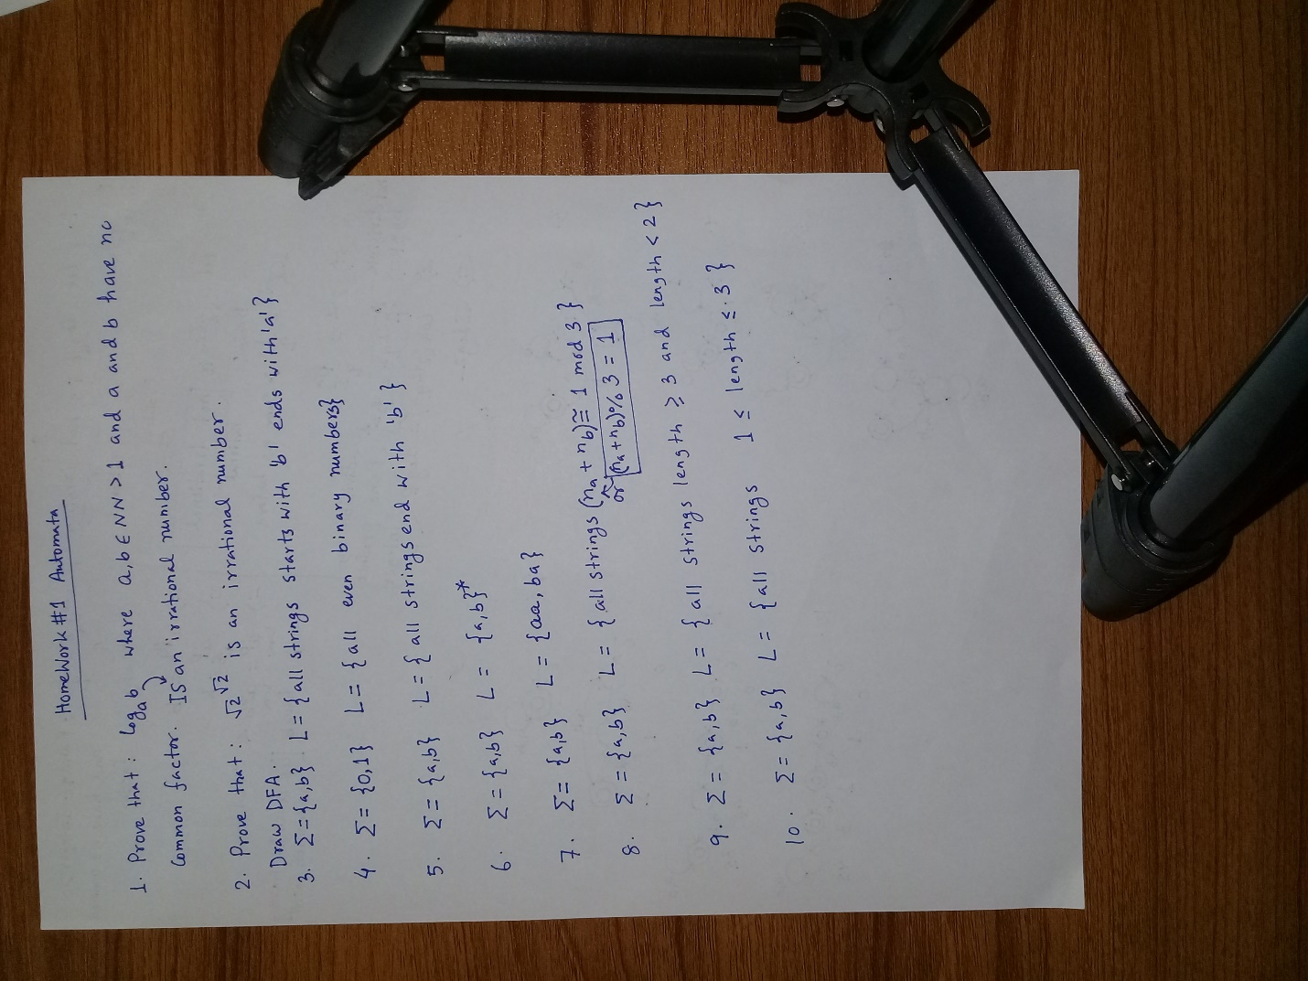

This is just a picture for testing. Do not take it seriously. I am just kidding. Haha.

Iam trying a lot pls help. Haha.

This is a new doc.Your are welcomed to write.

