

**Student Performance Monitoring System**

**Database Management**

**Group-4**

**Business Rules:**

**1)**The University has Schools that have multiple Departments under it. A Department can belong to only one Schools.

**2)**A Student must belong to only one department, and a department may have many students.

**3)**A Department offers many Courses, but a Course offered by exactly one Department.

**4)**Each Student may register for multiple Offered Courses. An Offered Course may be registered by multiple Students. Students can only register for exactly one Section of an Offered Course. A Faculty may be assigned to multiple Sections of multiple Offered Courses.

**5)**Course have a course Id, course title that uniquely identifies the course. Each individual course has their respective Cos.

**6)**In a specific course must have a PLO. A course may have several Cos. Student can be able to retake a course if the student want. Student can get enrolled in many courses.

**7)** Instructor have academic qualifications (i.e. highest degree certificate so far), area/s of specialization, job position (e.g. Lecturer, Professor), salary.

**8)**Instructor must input scores for each individual assessment in input form for each student.

**9)** The system will collect all the PLOs(Program Learning Outcome) and Cos(Course Outcome) for every single course. The instructor can update the CO for each course and each semester. Student will be able to see their achievement for PLO & CO.

**10)** Student can get their CO based on that PLO.

ENTITY RELATIONSHIP DIAGRAM

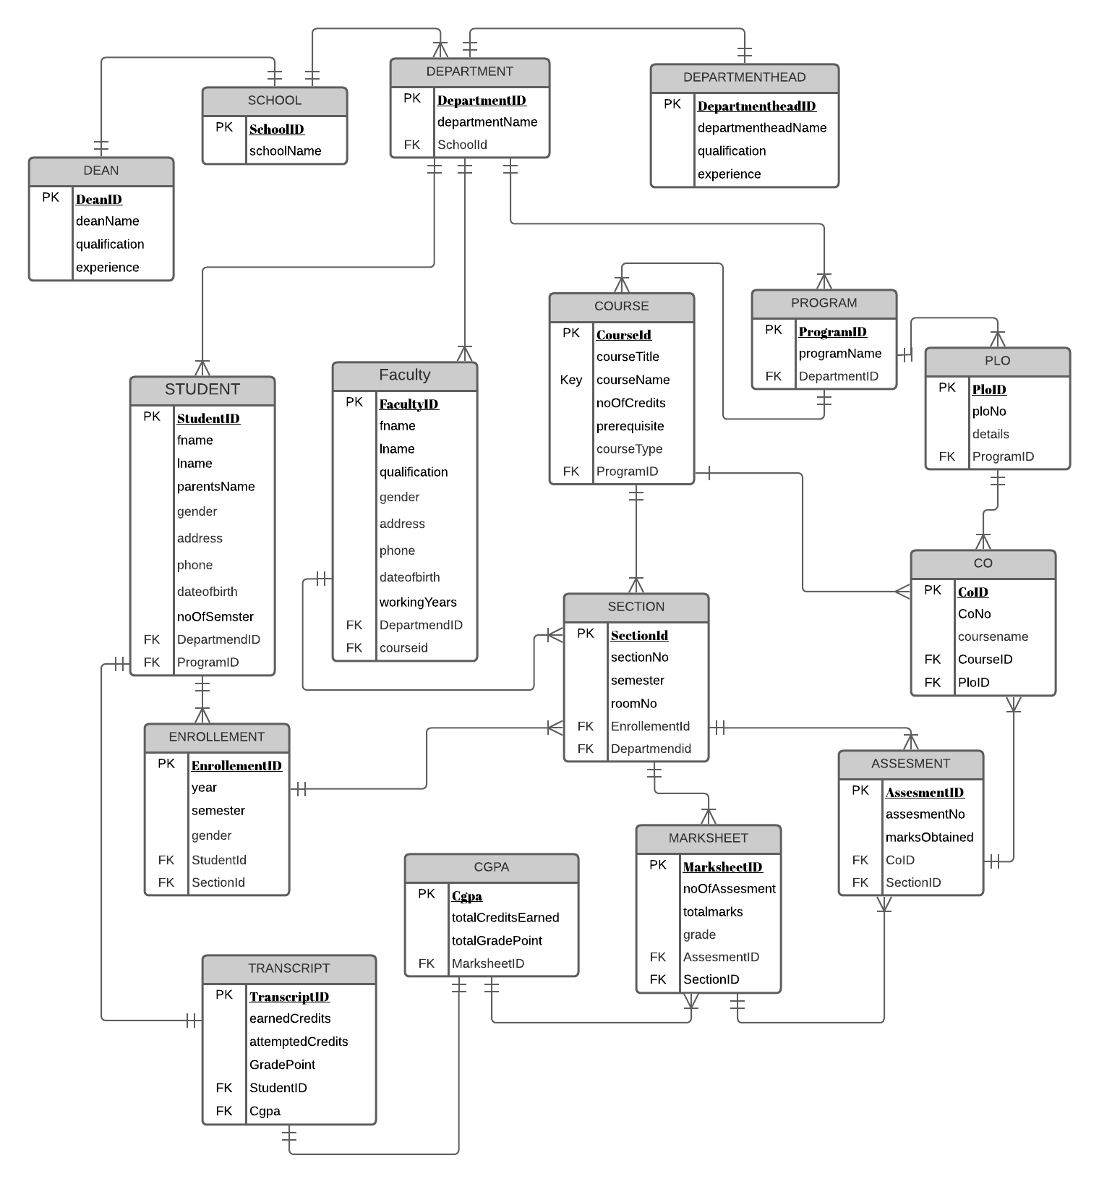

Entity relationship diagram to Relational schema

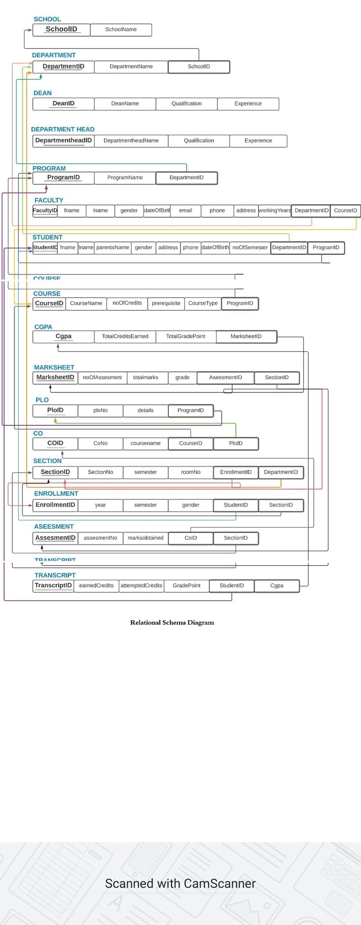

NORMALIZATION

|  |  |  |  |  |  |
| --- | --- | --- | --- | --- | --- |
| ENROLLEMENT | EnrolmentID | e1 | Dean | DeanID | Z1 |
| Year | e2 | DeanName | Z2 |
| Semester | e3 | Qualification | Z3 |
| Gender | T5 | Experience | Z4 |
| StudentID | T1 | DepartmentHead | DepartmentHeadID | Y1 |
| SectionID | S1 | DepartmentHeadName | Y2 |
| Section | SectioID | S1 | Qualification | Y3 |
| SectionNo | S2 | Experience | Y4 |
| Semester | S3 | Student | StudentID | t1 |
| RoomNo | S4 | fName | t2 |
| EnrollementID | E1 | lName | t3 |
| DepartmentID | D1 | parentsName | t4 |
| Course | CourseID | C1 | Gender | t5 |
| courseTitle | C2 | Address | t6 |
| courseName | C3 | Phone | t7 |
| noOfCredits | C4 | dateOfBarth | t8 |
| Prerequisite | C5 | noOfSemester | t9 |
| courseType | C6 | departmentID | D1 |
| ProgramID | P1 | ProgramId | P1 |
| Program | ProgramID | P1 | Faculty | FacultyID | F1 |
| ProgramName | P2 | fName | F2 |
| DepartmentID | D1 | lName | F3 |
| School | SchoolID | S1 | Qualification | F4 |
| SchoolName | S2 | Gender | F5 |
| Department | DepartmentID | D1 | Address | F6 |
| DepartmentName | D2 | Phone | F7 |
| SchoolId | S1 | dateOfBarth | F8 |
| CO | CoID | O1 | workingYear | F9 |
| CoID | O2 | DepartmentId | D1 |
| CourseName | C3 | CourseID | C1 |
| CourseId | C1 | CGPA | Cgpa | G1 |
| PloID | L1 | totalCreditEarned | G2 |
| PLO | PloID | L1 | totalGradePoint | G3 |
| PloNo | L2 | MarksheetID | M1 |
| Details | L3 | Transcript | TranscriptID | R1 |
| ProgramID | P1 | totalEarnedCredit | G2 |
| Marksheet | MarksheetID | M1 | attemptedCredits | R2 |
| NoOfAssesment | A2 | totalGradePoint | G3 |
| totalMarks | M2 | StudentID | T1 |
| Grade | M3 | CGPA | G1 |
| assesmentID | A1 | Assesment | AssesmentId | A1 |
| SectionID | S1 | AssesmentNo | A2 |
|  |  |  | MarksObtained | A3 |
|  |  |  | CoId | O2 |
|  |  |  | SectionID | S1 |
|  |  |  |  |  |  |