

**Student Performance Monitoring System**

**Database Management**

**Group-4**

**Group Members**

**Misbahur Rashid – 1721911**

**Rafid Al Ahsan – 1722006**

**Sadia Afroz Alma - 1730407**

**Md.Sakimuzzaman – 1721527**

**Puja Bhowmik – 1730791**

**Md.Musfiqur Rahaman – 1721684**

**Elan Md Taseen - 1831050**

Background of the organization :

Independent University, Bangladesh (IUB) is one of the leading and oldest private university in Bangladesh where academic excellence is a tradition, teaching a passion and lifelong learning a habit .It was established in 1993. It has an explicit focus on Research and Global partnerships. The IUB campus sprawling over 3 acres, has an amphitheater, the state-of-the-art laboratories, well-equipped library with online access to journals and books, above 70 classrooms, lecture galleries, auditorium, gymnasium, food court, playground, medical Center, counseling Center and an alumni office.

IUB has world-class undergraduate and graduate program accredited by professional national 7 international accreditation bodies, such as University Grants Commission of Bangladesh (UGC), Accreditation Council for Business Schools and Programs (ACBSP), USA, and Institution of Engineers, Bangladesh (IEB). IUB prepares graduates for a successful career and this is central to the design of courses and the support we provide. The programs and the courses are designed in such a way that prepare the students for a successful career. The faculty members of IUB are actively engaged in research and publish regularly in peer-reviewed journals. Along with conventional classroom based teaching, students are engaged in research relatively early in their studies. IUB has academic research collaborations with various universities including Harvard University, Stanford University, University of Colorado at Boulder, Brown University, McMaster University, University of Heidelberg . IUB also participate in various national level inter-university sports, robotics, debates and similar competitions.

Background of the project:

The Student Performance Monitoring System focuses on performance monitoring of student’s continuous assessment (tests) and examination scores in order to predict their final achievement status upon graduation.

The main theme of this project is to find the systemic problems and limitation we have in our current system in few areas and how can we improve it . The aim of our project is to design, build and deliver a developed software that we believe will help universities everywhere to promote a more productive and effective way of evaluating students. Also there need to be some functional changes in the system and department . We also analyze individual processes that take place under the current system of monitoring student performance and the concerns and problems with those process from start to finish.

Objective of the project :

We want to develop the the existing software iras in such way that can be more user friendly and helpful .it will help the institution to improve the quality of education . where the students and the faculty can use the system and find information more easily .in a short passage of time they can find all the information related to student enrollment , student grades , students CGPA and also CO and PLO.it will also benefit all the departments of the institution . this development will boost the the workrate of everyone .. it will be more productive and effective .not only the iras but also in different aspect few things need to be changed where we worked on . Monitoring semester wise student performance report by an Instructor and also analyze how to Department head submit grades of the students instead of faculty.

Scope of the project:

Project scope is a prerequisite to guarantee the success of a project. We have to make sure that the new system can be more successful than the present one when we are modifying an existing system.

We build an interface for faculties to able to see grades of another courses of a Student . Department can also access the systems for uploading grades instead of Instructor. If for some reason the instructor cannot upload the grade, then the Department can do it . On the other hand,Department head will be able to view different activities according to the different courses and sections of the instructor like Instructor’s Attendance,

Course wise Student performance etc .

Data will also, be protected and each user will be shown only that data which is relevant to them.

RICH PICTURE(AS-IS)

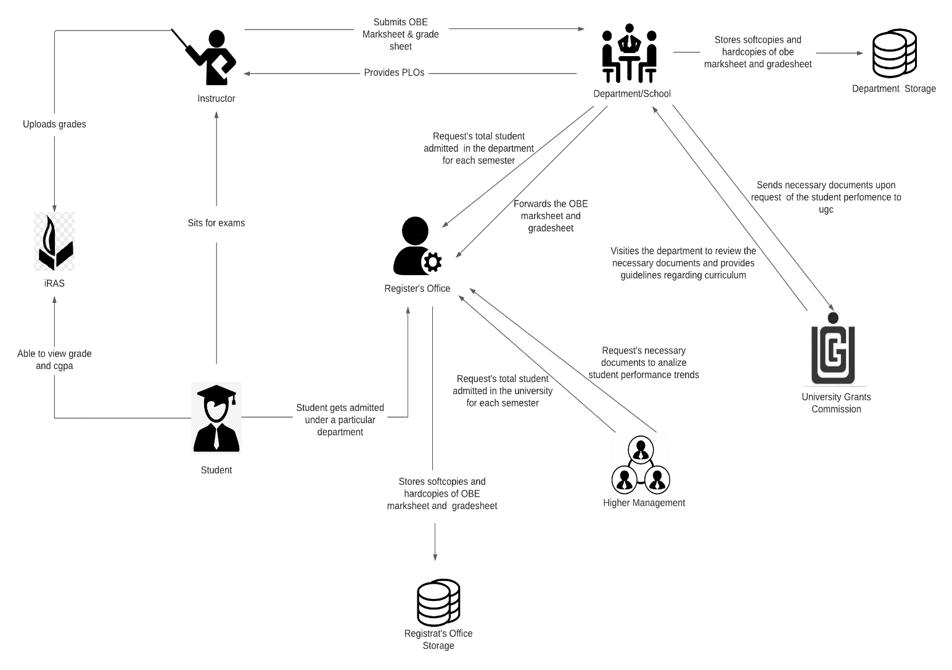

SIX ELEMENT(AS-IS)

|  |  |  |  |  |  |  |
| --- | --- | --- | --- | --- | --- | --- |
| **Process** | **System Roles** | | | | | |
| **Human** | **Non-Comp**  **Hardware** | **Computing**  **Hardware** | **Software** | **Database** | **Network &**  **Commination** |
| Student sits for exam | **Instructors**  1) Map course content to course outcome    2) Prepare question according to the mapped COs.  3) Give a particular time and date for the exam  4) Prepare SODs and invigilators  **Students**  1) Attempt the examination | **Stationery**  1) Pen and paper for writing.  2) Compass, ruler and other stationery for drawing diagrams  **Chairs and Table**  1) For using during exam.  **Classroom**  1) A space for conducting the exams  **Stapler**  1) For attaching all the extra paper, rough work and answers | **Computer/**  **Laptop**  1) Some courses require a computer for coding or open book exam.  **Calculators**  1) Some exams require the use of calculators  **Printers & photocopy machine**  1) Instructors use it for printing question papers | **Microsoft Word**  1) Typing the question and generating a printable pdf.  **Operating System**  1) Any OS may be used. e.g. Windows, MacOS.  **Adobe Acrobat Reader**  1) For viewing the question paper in pdf format | **Microsoft Excel**  1) Used for storing exam marks and calculating final grade | **Internet**  1) Used by students during open book exam |

|  |  |  |  |  |  |  |
| --- | --- | --- | --- | --- | --- | --- |
| **Process** | **System Roles** | | | | | |
| **Human** | **Non-Comp**  **Hardware** | **Computing**  **Hardware** | **Software** | **Database** | **Network &**  **Commination** |
| Student are able to view grades, cgpa and download transcript | **Student**  1) Students have to login to iras by entering the student id and password  2) Select a specific semester  3) View grades for specific semester  4) Click on the transcript button to download a copy of transcript | **Paper**  1) Used for printing and keeping a hardcopy of transcript | **Computer/**  **Smart Phone**  1) Used for accessing iras.  **Printer**  1) For printing the transcript | **iRAS**  1) Provides user interface for view grades and download transcript.  **Browser**  1) Any browser an be used to access iras. e.g. edge, chrome, Firefox  **Adobe Acrobat Reader**  1) For viewing the transcript which is in pdf format.  **Operating System**  1) Any OS may be used. e.g. Windows, MacOS. | **iRAS database server**  1) iras database server is used for storing and receiving student grade information in iras | **Internet**  1) Internet is required for accessing iras |

|  |  |  |  |  |  |  |
| --- | --- | --- | --- | --- | --- | --- |
| **Process** | **System Roles** | | | | | |
| **Human** | **Non-Comp**  **Hardware** | **Computing**  **Hardware** | **Software** | **Database** | **Network &**  **Commination** |
| Instructors uploads grades to iras | **Instructors**  1) Instructors types in user id and password for logging into the system  2) The instructor clicks to the submit grade section and is taken into the grade submission page  3) The instructor selects grade for each of the student  4) Clicks on the submit button to submit the grades |  | **Computer/**  **Smart Phone**  1) Used for accessing iras and submitting the grade | **iRAS**  1) Provides user interface for submitting the grades  **Browser**  1) Any browser an be used to access iras. e.g. edge, chrome, firefox  **Operating System**  1) Any OS may be used. e.g. Windows, MacOS | **iRAS database server**  1) iras database server stores all the grades | **Internet**  1) Internet is required for accessing iras and submitting the grades |

|  |  |  |  |  |  |  |  |  |  |  |  |  |
| --- | --- | --- | --- | --- | --- | --- | --- | --- | --- | --- | --- | --- |
| **Process** | | **System Roles** | | | | | | | | | | |
| **Human** | | **Non-Comp**  **Hardware** | | **Computing**  **Hardware** | **Software** | | **Database** | | **Network &**  **Commination** | |
| Instructors produce OBE marksheet and grades sheet and submits it to the department | | **Instructors**  1) Instructor takes quizzes and exam  2)Checks the exam script  3) Records the mark for each exam in an excel sheet  4) Calculates the final grades and    5) Calculate total marks received for each CO  6) Declare if a student has achieved a specific CO  7) Declare if a student has received a PLO for a related CO  8) Make a verdict and analysis of how many students were able to receive a certain CO and PLO  9) Sends the final version of OBE marksheet to department office  **Department**  1) Receives a copy of the OBE marksheet and grade sheet from the instructors  2) Stores a copy of the OBE marksheet and grade sheet in department storage  3) Sends a copy of the OBE marksheet to the register’s office  **Register’s Office**  1) Receives the OBE marksheet from department  2) Store the OBE marksheet in register’s office storage | | **Paper**  1) Used for storing hardcopies of OBE marksheet | | **Computer**  1) Computer is used for making softcopies of OBE marksheets  **Printer**  1) To print the hardcopies of the OBE marksheet and grade sheet | **Microsoft Excel**  1) Used by instructors to calculate the PLO and CO achievement | | **Department Storage**  1) A hardcopy of OBE marksheet and grade sheet is stored in the department storage  **Register’s Office Storage**  1) A hardcopy of OBE marksheet and grade sheet is stored in the register’s office storage | | **Internet**  1) Online platform such as- google sheets may be used for producing OBE marksheet | |
| **Process** | | **System Roles** | | | | | | | | | | | | |
| **Human** | | **Non-Comp**  **Hardware** | | **Computing**  **Hardware** | | | **Software** | | **Database** | | **Network &**  **Commination** | |
| Map Course Outcomes  (COs) to Program Learning Outcomes  (PLOs) | | **UGC**  1) Provides guide line to the department about the curriculum  **Department**  1) Comes with the PLOs  2) Sends the PLOs to the instructor  **Instructor**  1) List the course content and course outcome  2) Maps the course content to the COs  3)Maps the PLOs  4)Prepares question paper according to the COs | | **Pen and Paper**  1) Used for brainstorming and rough works | | **Computer/Smart devices**  1) Course coordinators use computers to make softcopies of course outcomes (COs)  **Printers**  1) Used for print hardcopies of course outcomes (COs) | | | **Microsoft Word**  1) Course coordinators use MS word for making course outline and course assessment report with COs mapping to the PLOs | |  | | **Internet**  1) Internet is used to communicate with ugc and other stakeholders to discuss topics related mapping COs and PLOs | |

|  |  |  |  |  |  |  |
| --- | --- | --- | --- | --- | --- | --- |
| **Process** | **System Roles** | | | | | |
| **Human** | **Non-Comp**  **Hardware** | **Computing**  **Hardware** | **Software** | **Database** | **Network &**  **Commination** |
| Student gets admitted under a particular department | **Student**  1) Fills up the admission form for taking admission under a particular department  2) Receive an email regarding successful admission form submission  **Register’s Office**  1) Receives the admission form  2) Analyze the admission  3) Check if the student fulfills all the requirements for getting admitted  4) If the student fulfills all the requirements then admit the student under the requested department.  6) Generate a student id number  5) Sends the total number of students enrolled in a semester under a particular department to the department.  6) Send the total number of students enrolled in the university to the higher management.  **Department**  1) Request total student enrolled in the department  2) Receive information about total student enrolled in department  **Higher Management**  1) Request total student enrolled in the university  2) Receive information about total student enrolled in department. | **Paper**  1) Register’s office keeps a hardcopy of student information. e.g. student blood group, emergence contact number, address | **Computer**  1) Used for accessing iras and filling admission form  **Printers**  1) For printing hardcopies of student information | **iRAS**  1) Provides user interface for filling the admission form  **Browser**  1) Any browser an be used to access iras. e.g. edge, chrome, Firefox  **Operating System**  1) Any OS may be used. e.g. Windows, MacOS. | **iRAS database server**  1) iras database server is used for storing all the admission information. | **Internet**  1) Internet is required for accessing the online admission form. |

|  |  |  |  |  |  |  |
| --- | --- | --- | --- | --- | --- | --- |
| **Process** | **System Roles** | | | | | |
| **Human** | **Non-Comp**  **Hardware** | **Computing**  **Hardware** | **Software** | **Database** | **Network &**  **Commination** |
| Request for review and change of grades | **Student**  1)Request an Instructor for grade change by sending an application via email.  **Instructor**  1)Receive a grade change mail from the student.  2)Check exam  Papers and other assessment upon request.  3)If change needs to be made, then the instructor informs the department.  4) If not, end the process. Mail the student that his request has been denied.  **Department**  1) Receives information regarding grade change of a specific student in a course.  2) Sends a request to the register’s office for grade change  3)Updates the OBE marksheet and grade sheet with the new grade and stores it in the department storage  **Register’s office**  1)Receive a request from the department for the changing the grade of a student in a specific course.  2)Changes the grade of the particular student in the requested course.  3)Updates the register’s office storage with the new grade | **Pen and Paper**  1)used to note down key points or marks on the students’ answer sheets. | **Computer/**  **Laptop**  1) Used for sending email to the instructor | **iRAS**  1)Used by the Register office for changing the grade  **Operating System**  1) Any OS may be used. e.g. Windows, MacOS. | **iRAS database server**  1) Update student grade data.  **Department Storage**  1)Update student grade data**.**  **Register office’s Storage**  1)Update student grade data. | **Internet**  1) Internet is needed to the mail a grade change request. |

|  |  |  |  |  |  |  |
| --- | --- | --- | --- | --- | --- | --- |
| **Process** | **System Roles** | | | | | |
| **Human** | **Non-Comp**  **Hardware** | **Computing**  **Hardware** | **Software** | **Database** | **Network &**  **Commination** |
| View Records OBE Marksheets and Course  Assessment Reports | **UGC**  1. Inform the university head of a deadline within which OBE Marksheets, Course Assessment Reports and other documents are needed for quality inspection to make necessary improvements to degree programs.  2. Inform the university head if an UGC personnel will visit the campus or softcopies will suffice.  3. Visit university heads and relevant schools to receive the necessary documents and reports if that is what was informed.  **Department**  1) Request to view records of OBE Marksheets, Course Assessment Reports to analyze students’ performance trends.  2) Direct Department Staff to gather necessary documents, OBE Marksheets and Assessment report for a given time-period specified by UGC.  3) Receive the necessary documents gathered by the Department  4) Evaluate the need to change/ improve the department’s educational resources based on students’ performance trends.  5) Send necessary documents to ugc.  **Higher Management**  1) Requests the register’s office to send records of OBE Marksheets, Course Assessment Reports to analyze students’ performance trends.  **Register’s Office**  1) Receive a request from higher management for sending OBE marksheet and grade sheets.  2) Sends the requested OBE marksheets and grade sheets to the register’s office. | **Paper and Pen**  1)Used for noting/marking down key points of the report. | **Computer**  1) Used for viewing softcopies of OBE marksheet and grade sheet.  2) Used for send softcopies of OBE marksheet to the ugc officials. | **Microsoft Excel**  1) Used for viewing softcopies of marksheet  **Operating System**  1) Any OS may be used. e.g. Windows, MacOS. | **Department Storage**  1) Used for retrieval of OBE marksheet and grade sheet when needed  2) Stores hardcopies and softcopies of OBE marksheet and grade sheet | **Internet**  1) Softcopies of OBE marksheet and grade sheet may be mailed to the ugc officials.  2) Online platforms such as google sheet may be use for displaying softcopies of marksheet. |

PROCESS DIAGRAM(AS-IS)

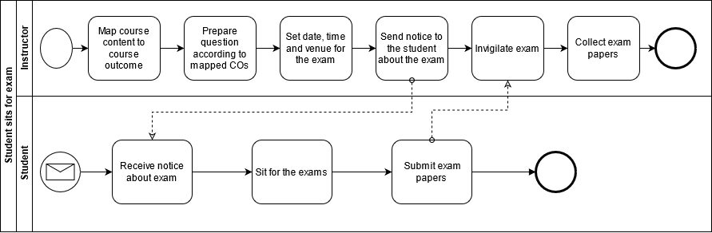

**FIGURE 2.1 Process Diagram for Student Sits for exam**

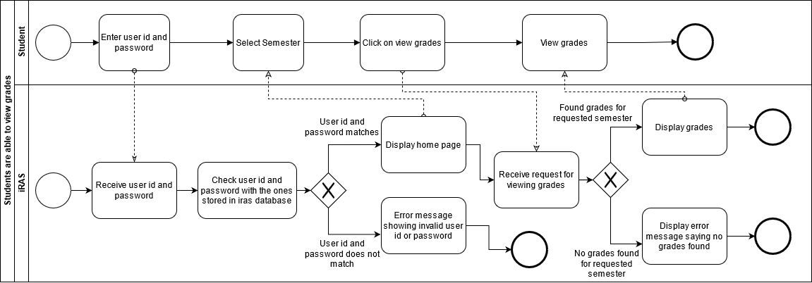

**FIGURE 2.2 Process Diagram for Student are able to view grades and CGPA**

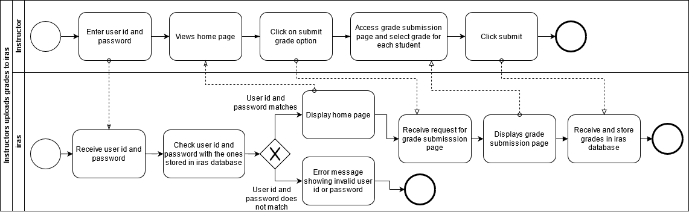

**FIGURE 2.3 Process Diagram for Instructor uploading grade to iras**

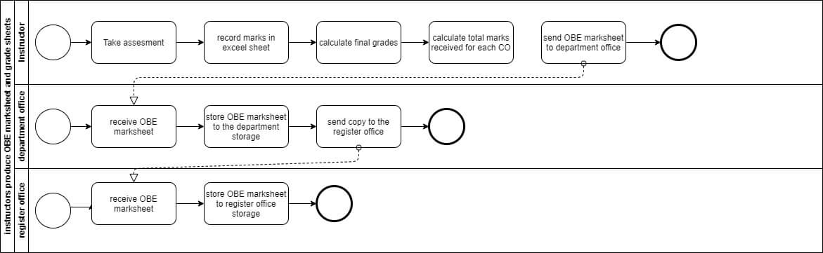

**FIGURE 2.4 Process Diagram for Instructor produces OBE marksheet**

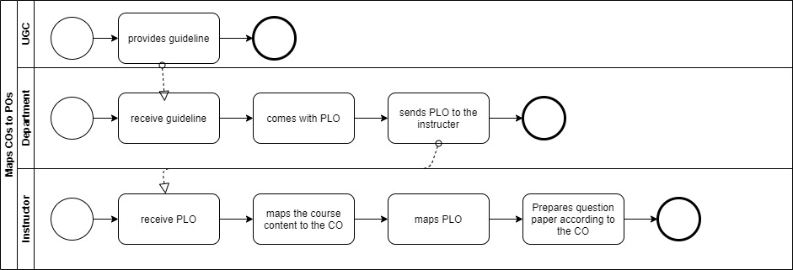

**FIGURE 2.5 Process Diagram for Map COs and Pos**

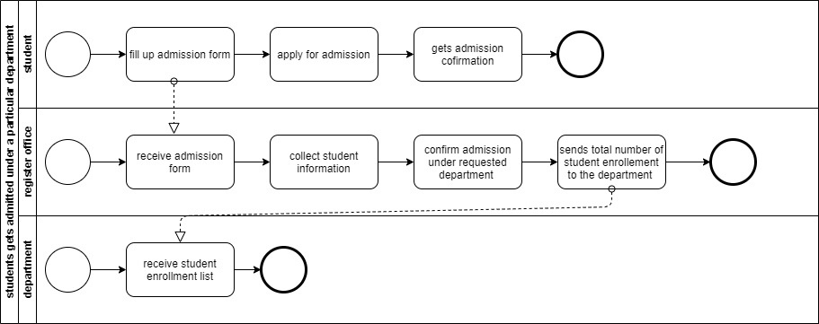

**FIGURE 2.6 Process Diagram for Student gets admitted under particular department**

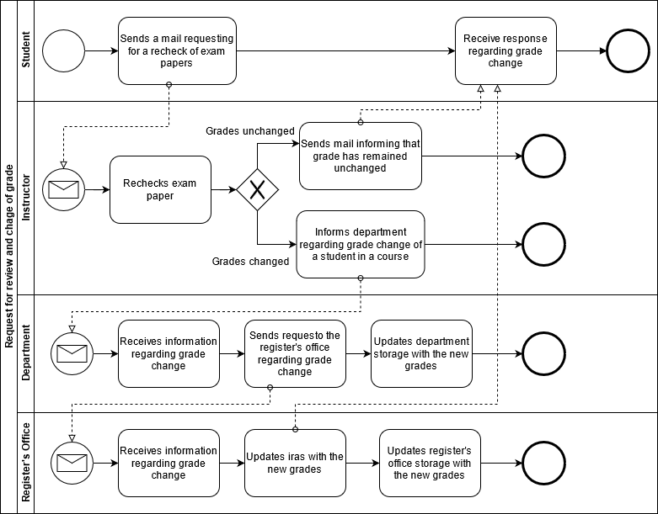

**FIGURE 2.7 Process Diagram for request for review and change of grades**

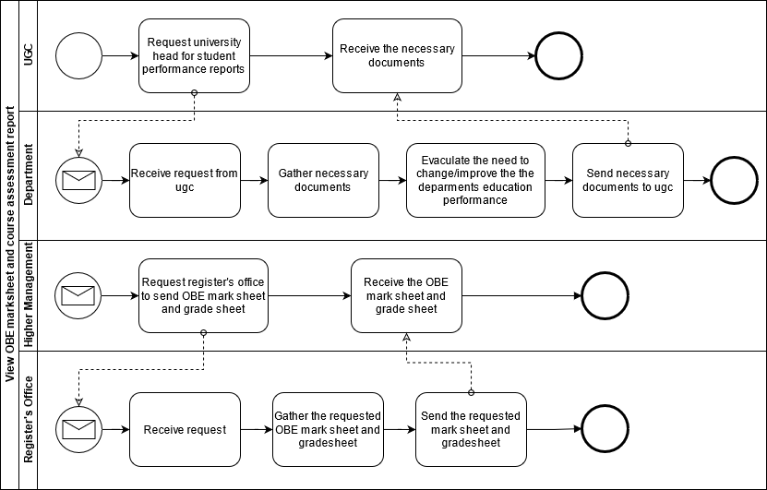

**FIGURE 2.8 Process Diagram for view obe marksheet and course assessment report**

**Business Rules**

1) A student may register under one or more programs. A program many have multiple students.

2) A department may have multiple programs. A program must be exactly under one department.

3) A school may have multiple departments. A department must be exactly under one school.

4) A department may have multiple instructors. An instructor must be exactly under one department.

5) A department must have exactly one head.

6) A school must have exactly one dean.

7) A program may have multiple PLOs. A PLO many be under multiple programs.

8) An instructor may teach multiple courses. A course must have exactly one instructor.

9) A course may have multiple sections. A section must be under exactly one course.

10) A student may tale multiple assessments. A particular assessment must be taken exactly by one student.

11) A section may have multiple assessments. An assessment must have one exact section.

**Entity-Relationship Diagram**

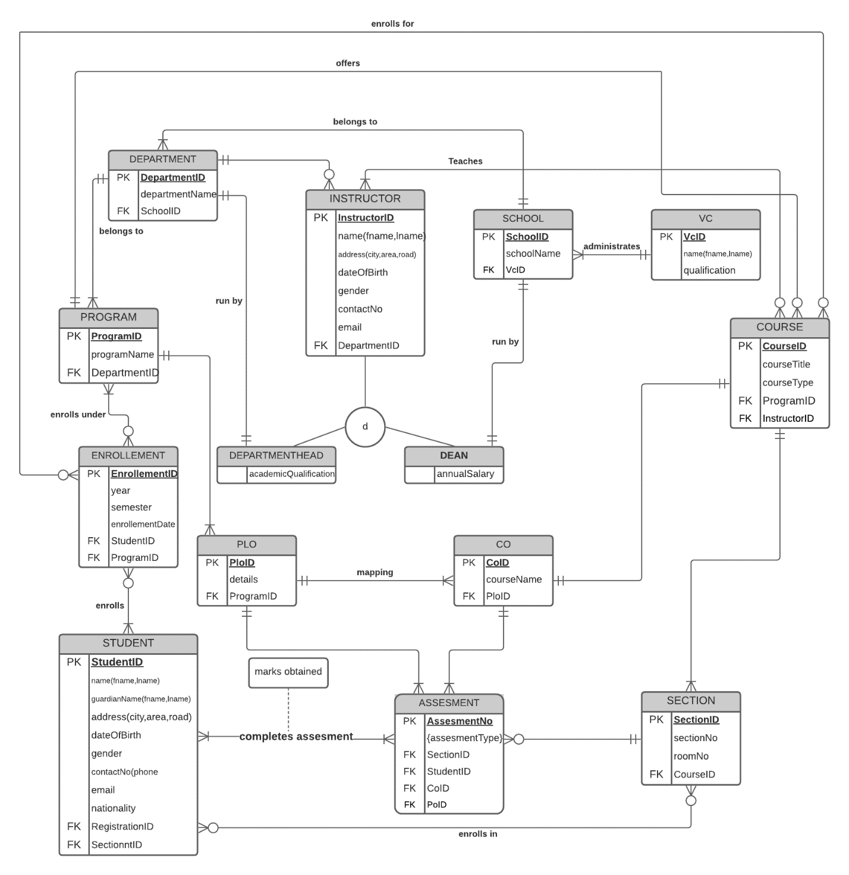

NORMALIZATION

|  |  |  |  |  |  |
| --- | --- | --- | --- | --- | --- |
| ENROLLEMENT | EnrolmentID | e1 | Dean | DeanID | Z1 |
| Year | e2 | DeanName | Z2 |
| Semester | e3 | Qualification | Z3 |
| Gender | T5 | Experience | Z4 |
| StudentID | T1 | DepartmentHead | DepartmentHeadID | Y1 |
| SectionID | S1 | DepartmentHeadName | Y2 |
| Section | SectioID | S1 | Qualification | Y3 |
| SectionNo | S2 | Experience | Y4 |
| Semester | S3 | Student | StudentID | t1 |
| RoomNo | S4 | fName | t2 |
| EnrollementID | E1 | lName | t3 |
| DepartmentID | D1 | parentsName | t4 |
| Course | CourseID | C1 | Gender | t5 |
| courseTitle | C2 | Address | t6 |
| courseName | C3 | Phone | t7 |
| noOfCredits | C4 | dateOfBarth | t8 |
| Prerequisite | C5 | noOfSemester | t9 |
| courseType | C6 | departmentID | D1 |
| ProgramID | P1 | ProgramId | P1 |
| Program | ProgramID | P1 | Faculty | FacultyID | F1 |
| ProgramName | P2 | fName | F2 |
| DepartmentID | D1 | lName | F3 |
| School | SchoolID | S1 | Qualification | F4 |
| SchoolName | S2 | Gender | F5 |
| Department | DepartmentID | D1 | Address | F6 |
| DepartmentName | D2 | Phone | F7 |
| SchoolId | S1 | dateOfBarth | F8 |
| CO | CoID | O1 | workingYear | F9 |
| CoID | O2 | DepartmentId | D1 |
| CourseName | C3 | CourseID | C1 |
| CourseId | C1 | CGPA | Cgpa | G1 |
| PloID | L1 | totalCreditEarned | G2 |
| PLO | PloID | L1 | totalGradePoint | G3 |
| PloNo | L2 | MarksheetID | M1 |
| Details | L3 | Transcript | TranscriptID | R1 |
| ProgramID | P1 | totalEarnedCredit | G2 |
| Marksheet | MarksheetID | M1 | attemptedCredits | R2 |
| NoOfAssesment | A2 | totalGradePoint | G3 |
| totalMarks | M2 | StudentID | T1 |
| Grade | M3 | CGPA | G1 |
| assesmentID | A1 | Assesment | AssesmentId | A1 |
| SectionID | S1 | AssesmentNo | A2 |
|  |  |  | MarksObtained | A3 |
|  |  |  | CoId | O2 |
|  |  |  | SectionID | S1 |
|  |  |  |  |  |  |