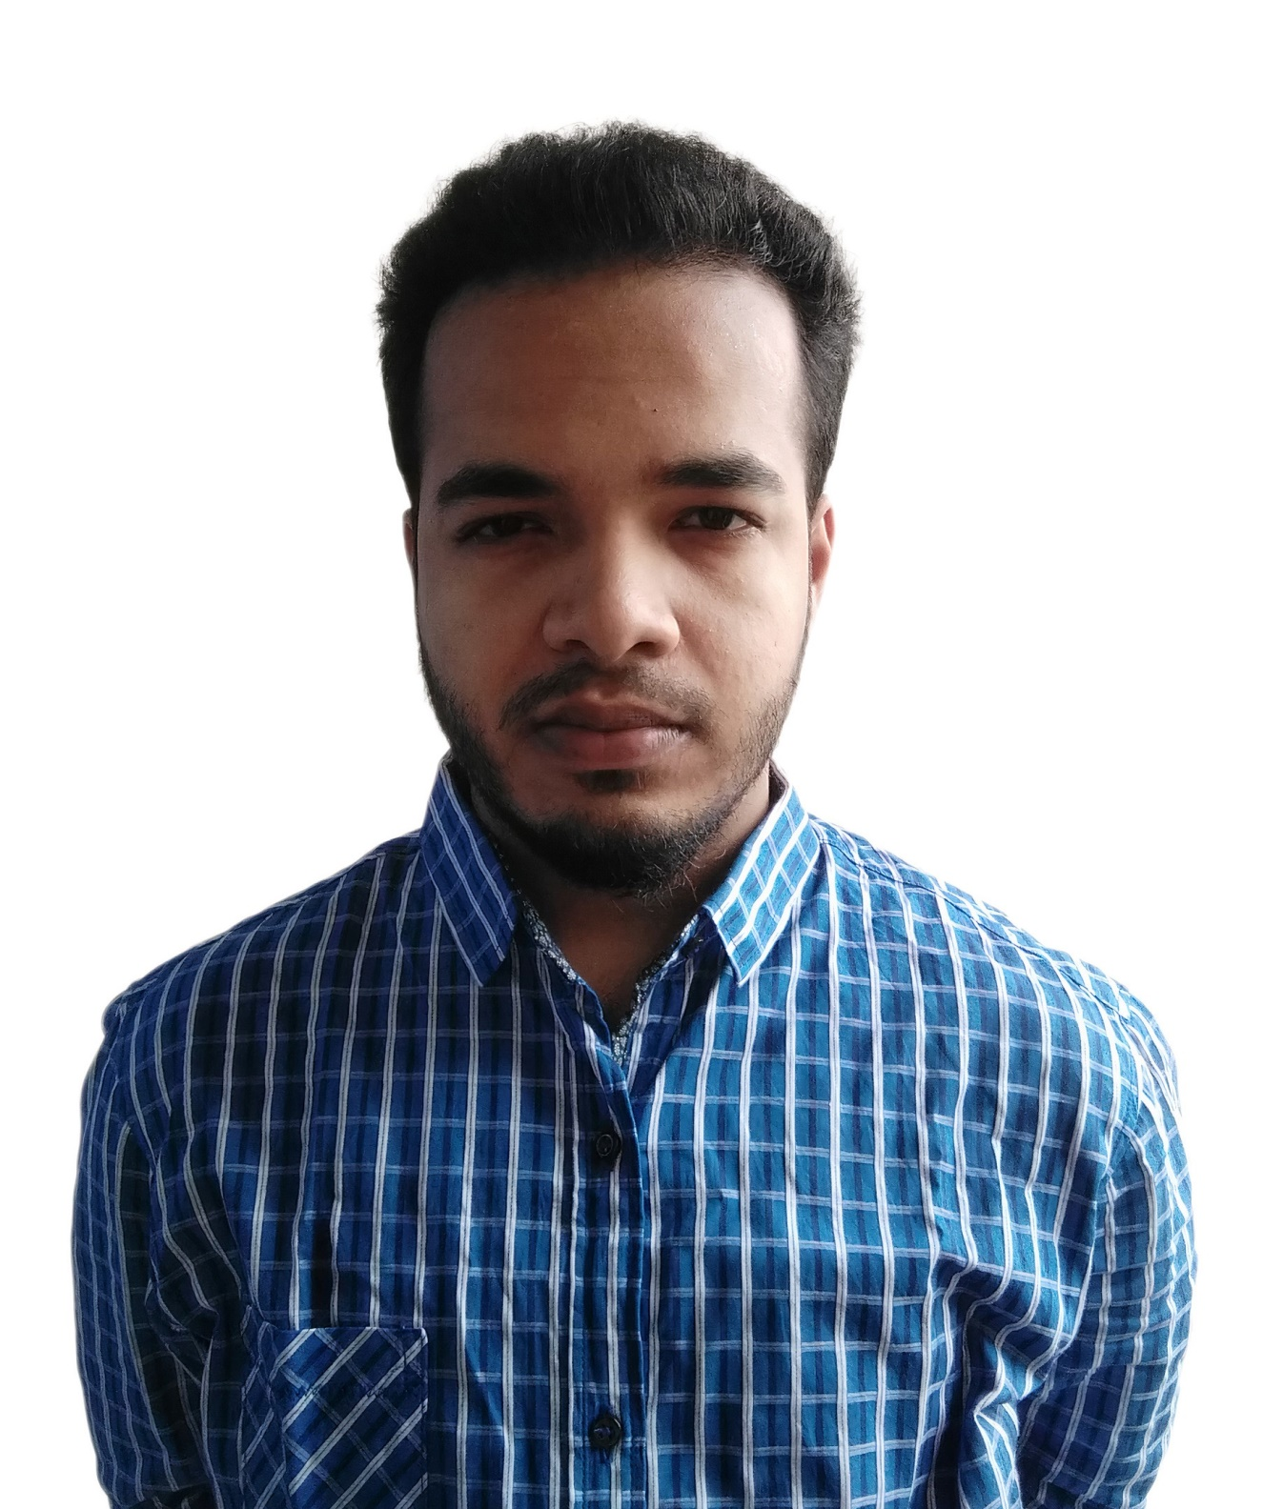

**Tawhidur Rahman Rafid**

Computer Engineer

Address: S.A Khalek avenue,road-4,house-60,kollanpur

Mobile No 1: 01682832598

e-mail: rafidtawhid@gmail.com

**Career Objective:**

Exceptionally hardworking and dependable Entry Level Developer with a stellar customer service record and superb work ethic. Basics of knowledge in a wide variety of computer languages as well as

The techniques of website construction and maintenance. Highly adept at conveying complex technical information to a variety of professional and lay audiences in a clear and understandable manner.

**Academic Qualification**

***Bachelor of Science (B.Sc.) Honors***

Institute : Stamford University Bangladesh Subject : Computer Science & Engineering (CSE) CGPA : 3.70(out of 4)

Year : 4th year [Last Trimester (January, 2020 to April, 2020)]

***Higher Secondary Certificate (H.S.C)***

Institute : Birshreshtha Munshi Abdur Rouf Public College.

Subject : Science

GPA : 4.00(out of 5)

Pas.Year : 2015

***Secondary School Certificate (S.S.C)***

Institute : Armanitola government high school

Subject : Science

GPA : 5.00(out of 5)

Pas.Year : 2013

**1. Android Application & Development**

**(February 2020-continuing)**

at - BASIS Institute of Technology & Management

(BITM), Pencilbox-IT, Kawran Bazar, Dhaka.

**2. Oracle Certified Professional (OCP) Java SE8**

**(June-2019 – August-2019)**

at- It Bangla

Chottogaram vabon,Topkhana Road,Dhaka

**Programming Skill**

**Languages :** C, C#, Php(Basic), Java (Basic), SQL, firebase

**IDE :** Visual Studio, Eclipse ,Subline, IntelliJ IDEA, Android

**Web Development Skill**

**Tools & Technologies :** HTML, CSS, JavaScript, Bootstarp.

**Frameworks :** php(Back-end), Bootstrap (Front-end), Android(Layout),

**Server :** xampp, Microsoft SQL Server,firebase

Father's Name : A.K.M Shafiqul Mobin

Mother's Name : Afroja Begum

Date of Birth : Sept-6,1997

Gender : Male Marital Status : Single Nationality : Bangladeshi National Id No. : 6902443826

Religion : Islam

Permanent Address : Noguan,Kishorganj. Current Location : Dhaka

.