VI. Implementation
This phase is that bridges the gap between problem domain and the existing system in a manageable way. This phase focuses on the solution domain, how to implement. Where the conceptual prototype is converted into a format that can be implemented and decides how the system will operate.

System Module
In this section we will be describes the conceptual design of our system and the methodology adopted for this work including the systematically organized different stages of the research in conjunction with the detailed implementation features of the proposed system. In addition, it clarifies the structural components of the proposed system and their integration to achieve the research aim. Also, the complex activity of system development is divided into several smaller sub-activities, which coordinate with each other to achieve the main objective of system development.

Database Design
The database schema of a database is its structure described in a formal language supported by the database management system (DBMS). The term "schema" refers to the organization of data as a blueprint of how the database is constructed (divided into database tables in the case of relational databases) on previous chapter [figure: 3.5]. The formal definition of a database schema is a set of formulas (sentences) called integrity constraints imposed on a database. These integrity constraints ensure compatibility between parts of the schema. All constraints are expressible in the same language. A database can be considered a structure in realization of the database language. The states of a created conceptual schema are transformed into an explicit mapping, the database schema. This describes how real-world entities are modeled in the database.
A database generally stores its schema in a data dictionary. Although a schema is defined in text database language, the term is often used to refer to a graphical depiction of the database structure. In other words, schema is the structure of the database that defines the objects in the database
Our system data are integrated within Firebase Database. That is a cloud-hosted database. Data is stored as JSON and synchronized in real-time to every connected client. When you build cross-platform apps with our Android, and JavaScript SDKs, all of your clients share one Real-time Database instance and automatically receive updates with the newest data. When data handled over microcontroller, that’s update our android apps also real time within JSON data, which is very fastest data preprocess decode script.

App Design
Design should organize the user interface purposefully, in meaningful and useful ways based on clear, consistent models that are apparent and recognizable to users, putting related things together and separating unrelated things, differentiating dissimilar things and making similar things resemble one another. Here we design our app through android SDK within XML is used to layout design and Java processes that layout with backend programming. The structure principle is concerned with overall user interface architecture. The design should make simple, common tasks easy, communicating clearly and simply in the user’s own language, and providing good shortcuts that are meaningfully related to longer procedures. Our app is flexible and tolerant, reducing the cost of mistakes and misuse by allowing undoing and redoing, while also preventing errors wherever possible by tolerating varied inputs and sequences and by interpreting all reasonable actions. Now we will be discuss about this app design portion bellow.

i. Admin
Already we define role of admin several time, where by admin able to add new patient by adding patient phone no as patients ID after verification (By sending OTP). Then filled up all patient personal information and necessary medical history. After registered, admin configured patient medical related data, such as current health info, report-documents, prescriptions, and profile panel. The role of admin methods are define bellow.

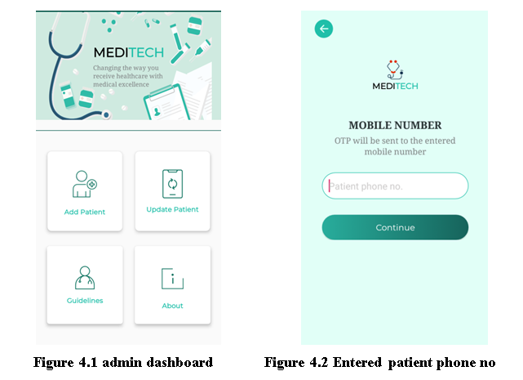

Here (figure 4.1) admin can add any user manually or one can create an account through his Mobile number and other information an OTP (one-time password) is send to confirm the Mobile number and other information.
Only admin can sign-up for a user through verification this is for security reasons and reducing the complication if any user can sign-up online by his own it will be difficult to serve and organize the whole system. Our system will serve only the authentic patient verified from any hospital or doctor. And finally for the existence we use OTP confirmation for authenticate the users. Here cloud database meet up as bridge adapter within admin backend and system front end. The aim of the OTP authentication is, the user can’t be able to register for multiple accounts, as for each account a unique phone number is needed. When we have all the users verified by a phone number the value of your user base increases and fraud account avoided. Nowadays more people using apps and remembering passwords are a headache for many users, so they end up using weak passwords. Using phone authentication increases security and user experience, as the user does not need to create and remember passwords, they will enter their number and then they can receive a temporary authentication code by SMS. As security concern, Authentication using only a phone number, while convenient, is less secure than the other available methods, because possession of a phone number can be easily transferred between users. Also, on devices with multiple user profiles, any user that can receive SMS messages can sign in to an account using the device's phone number.
If we use phone number based sign-in in your app, you should offer it alongside more secure sign-in methods, and inform users of the security tradeoffs of using phone number sign-in.
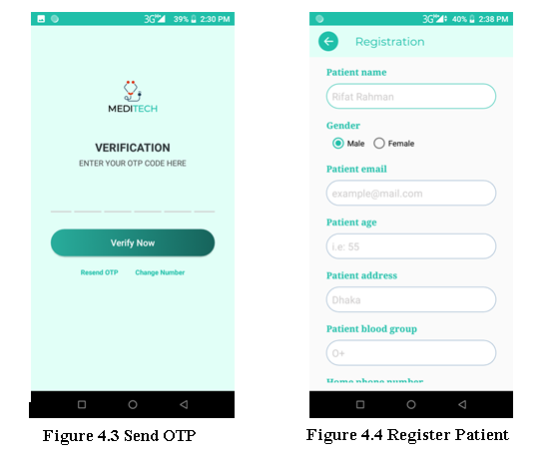
(Figure 4.3) user has to confirm his identity through giving the proper OTP code .Admin can add any user or update his information. Admin has the full access to set the guidelines and upgrade features. About panel has manufacturing and developer information.
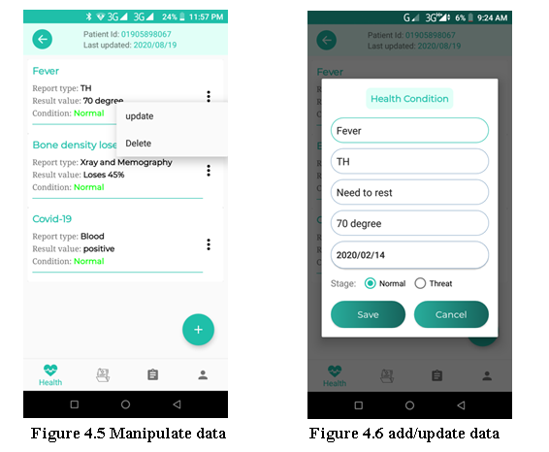
So, according to these criteria patient all about data manipulate and maintenance over the admin. Such a Health, Documents, Prescription, and profile information respectively within application. All of the data are hocked into cloud database.
Here Admin have access to one’s all information he can check and update the health info, personal info and other all necessary information which is necessary to maintain control over all the system. To upgrade the whole data admin panel has the highest priority access to all authentic information and backend side.
- Authentication

One of the core parts of the system is this. In this case healthcare institution able to identified valid patients more efficiently within patient’s health card. Moreover doctors able to explore patient’s previous medical records by scanning health cards. Medical records fetched from cloud database and current patients also sensing from real-time cloud data. Now the overall methodology behind this part presented bellow. System authentication is defending on IOT device. Such as authentication part is completed either microcontroller send RFID card information to database. Then app fetches the card information from database.
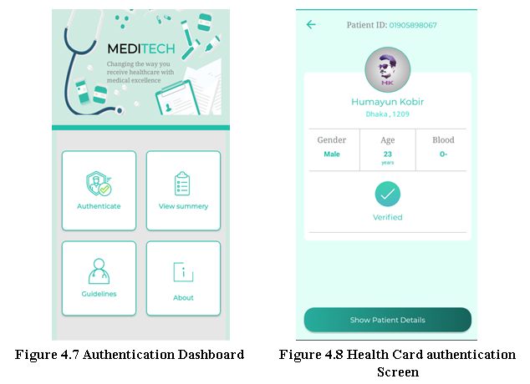
In Figure 4.7 it is the dashboard of our patient and having a successful registration login. He may have the authentication information summary of his health conditions attribute like reports, prescription & instruction given by doctor. He also may read our rules and regulation of this system and proper guideline how to make the best use of our system. Figure 4.8 is the face of our patient profile after the verification. There have only few basic things like gender, age, blood group nothing details yet.
- Users (Patients/Guest)
Here user role has been divided into two parts. Patients able to register themselves after admin authorized. Then patients able to explore all own medical records after sign in. On the other hand a guest user might be scan QR code (printed to health card) to find out patients current health condition and patients profile respectively. In this role also able to find out nearby emergency place according to rout and direction in order to help patients. They will have an own profile panel where he can find his dashboard panel (figure: 4.9), Where he can find his authentication information, his health summary, reports and own profile (figure: 4.10). he may get update of his health condition , he/she can see his reports & prescriptions authorised by verified doctors. Patient can see and download all reports and precripation if necessary. Then by the passage of time doctor will upgrade his health conditions patient may see his progress result. Patient can find the nearby hospitals and pharmacies location and root plan if necessary. In this case should be noted that a patient should be registered before sign in and he/she only able to might be registration if already authenticated by admin. So, during registration at first validate either valid patient.

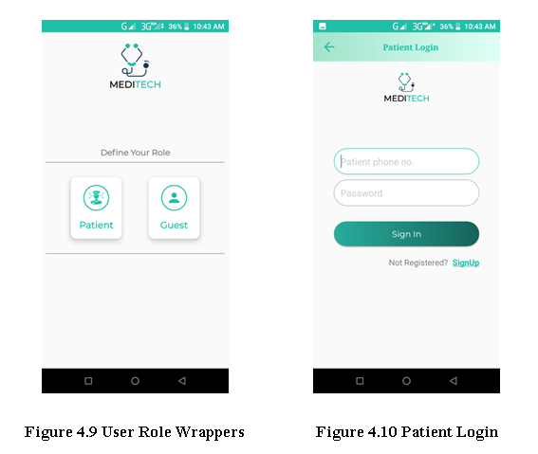
We also have a dashboard panel for a guest or unregister users (figure 4.9) .Here one can scan the Health card (figure 4.10) of users and get nearby locations, our guideline and our system related information.
Here in signup no outsider is allowed only admin can register a user after completing his verification through his authentic information. But one can allow to checkout our system basic structure as a guest. No information and anything are needed to be a guest user you just have to install our system. On the other hand guest user couldn’t able to login or registration and view all the data of patient. Patients ready to enroll themselves after administrator approved. At that point patients ready to investigate all own clinical records after sign in. Then again a visitor client may be check QR code (printed to wellbeing card) to discover patients current ailment and patients profile individually. In this job additionally ready to discover close by crisis place as per defeat and bearing so as to support patients. He/she can see his reports and medicines approved by confirmed specialists. The patient can see and download all reports and solutions if essential. At that point by the progression of time specialist will overhaul his ailments patient may see his improvement result. Understanding likewise may have the validation data synopsis of his medical issue characteristic like reports, medicine and guidance given by a specialist. He additionally may peruse our principles and guideline of this framework and appropriate rules on the best way to utilize our framework. Figure 4.8 is the substance of our patient profile after the check. There have just a couple of essential things like sex, age, blood bunch nothing subtleties yet.

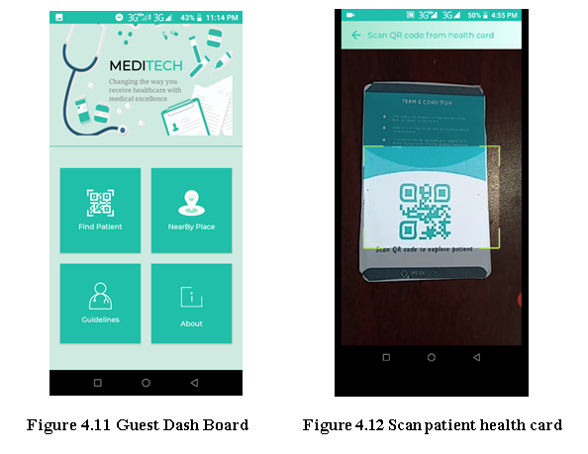
Guest user can find the nearby hospitals and pharmacies location (figure 4.11) and root plan (figure 4.12) without being a register user which may help in case of emergency situation.
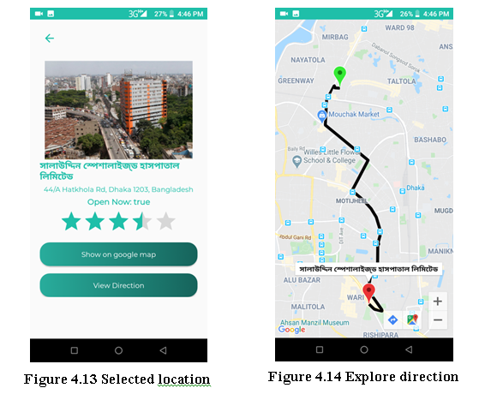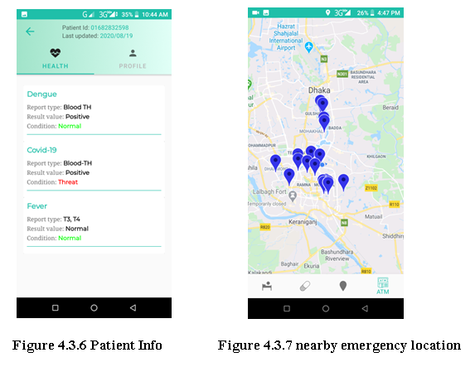

Figure 4.13 we can rate the hospital after being served as like Google map rating. One can easily find out the root plan and exploring around without any complication.
Now we describe the way to add Google's rich, local information to our app maps. This turnkey solution lets you show accurate details for nearby places, so users can see ratings, reviews, photos, and directions without ever leaving your web app. plus, you can customize it to match your brand. User can give his feedback as expectations in one can rate the hospital after being served as like Google map rating. One can easily find out the root plan and exploring around without any complication. The Places API is a service that returns information about places using HTTP requests. Places are defined within this API as establishments, geographic locations, or prominent points of interest. Each of the services is accessed as an HTTP request, and returns either a JSON or XML response. All requests to a Places service must use the https:// protocol, and include an API key. The Places API uses a place ID to uniquely identify a place. For details about the format and usage of this identifier across the Places API and other APIs, see the Place IDs documentation.

IOT implementation
Our intent in this document is to identify the issues we ran into while creating this project, the answers and solutions we discovered and some of the customizations we tried.
The next step for this project is building the peripheral hardware to extend the Node MCU & RFID into a target Android Things IOT device. The system where Android Things First Device app will interact with this device. While the peripheral hardware is a very simple circuit it was obvious to us. We were going to need to do some research to come up to speed on how to build this circuit.
The peripheral hardware for the First Device, as defined in the Connect the Hardware section of the Android Things documentation, is two distinct circuits RFID Module and Node-MCU. One circuit for provide information input and a second circuit for Analysis the input with firebase data and giving the proper feedback. This wasn’t immediately apparent to us. Once we understood there were two separate circuits involved the peripheral hardware layout and the app code made sense. The Android Things documentation shows the layout for a generic Android Things hardware platform connected to a breadboard with both the button and LED circuits. In the following sections we have broken down the two circuits individually as well as the final combined circuit configuration. The schema of the portion is describing bellow.
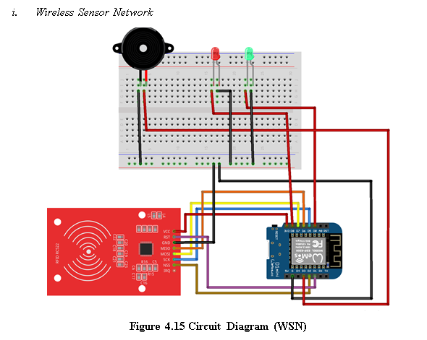
Breadboard, Jumper wires, LED, Microcontroller (NodeMCU R1 D1 Mini), RFID Rc-522, resistor 470k/10k, GPIO Breakout board, Ribbon cables, etc components are needed for the system circuit implementation.
- Health Card Demo
This will be our demo health card one can easily scanned this card and get the basic information. A information should be follow that, this Card is the label version of system RFID card.
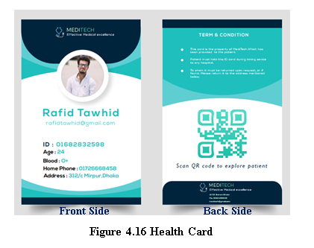

Chapter Summary
How we turned our whole project into a reality. This chapter describes in detail the combined workings of such system structures, the communication between hardware and software.

Conclusion

In this paper, we have presented IoT based Health Care System (HCS), which could be a more efficient patient management system, compare to manually handled existing systems using in Bangladesh. The proposed PHS system authenticate patient automatically and provide a live update of a patient health condition on the web as well as an android application to the reception, doctor, and public user based on data abstract label. It can also helpful for patients as they can track their health condition, prescription, reports, etc more proficiently rather than the traditional process. This system may operate more accurately by using a powerful low-cost RFID and Wi-Fi module along with heavy bandwidth. The proposed system is easy to adapt and the methods we have implemented could provide precise results to fetch patients' information. On the other hand, outside of health care in the emergency situation, this system will play a very much vital role, such as any people can find out a patient by scanning QR code label from health-card through android app then able to explore the nearby emergency place with direction such as hospital, pharmacy, etc.
In the future, we will in-cooperate a fully automatic patient management system through a patient health-card that additionally consists of managing patient health monitoring, payment methods, and doctor appointments. The proposed IOT based automated Personal Health Card system can be a significant step towards the development of future digital health services.

References

- Kohn, L.T., Corrigan, J.M., Donaldson, M.S.: To Err Is Human: Building a Safer Health System. The National Academies Press (2000).

- Preventable Medical Errors – The Sixth Biggest Killer in America, American Association for Justice.

- H. G. Inc., Patient Safety in American Hospitals (2004).

- Claudia Hildebrand, “Current state and future of health smart cards in Europe”, German Research Center for Environmental Health.

- Roberti, M.: Does RFID Create Negative Effects in Hospitals? RFID Journal (2008).

- Moessner, M., Khan, G.N.: Secure authentication scheme for passive C1G2 RFID tags. Computer Networks 56(1), 273–286 (2012).

- Ngai, Eric WT, et al. "Mobile commerce integrated with RFID technology in a container depot." Decision Support Systems 43.1 (2007): 62-76.

- Swedberg, Claire. "Crown saves manufacturing costs via RFID." RFID Journal November 10 (2006).

- Fisher, Jill A, and Torin Monahan. “Tracking the social dimensions of RFID systems in hospitals.” International journal of medical informatics vol. 77,3 (2008): 176-83. doi:10.1016/j.ijmedinf.2007.04.010

- Chowdhury, Belal, and Rajiv Khosla. "RFID-based hospital real-time patient management system." 6th IEEE/ACIS international conference on computer and information science (ICIS 2007). IEEE, 2007.

- Turcu, Cristina Elena, Cornel Turcu, and Valentin Popa. "An RFID-based system for emergency health care services." 2009 International Conference on Advanced Information Networking and Applications Workshops. IEEE, 2009.

- Chia, S., Zalzala, A., Zalzala, L., & Karim, A. (2013). Intelligent technologies for self-sustaining, RFID-based, rural e-health systems. IEEE Technology and Society Magazine, 32(1), 36-43.

- Turcu, Cristina, et al. "An RFID and multi-agent based system for improving efficiency in patient identification and monitoring." WSEAS Trans. Inf. Sci. Appl 6.11 (2009): 1792-1801.

- Cao, Yan, Lina Yang, and Yanli Yang. "EPR management system development based on B/S architecture." 2008 International Seminar on Future BioMedical Information Engineering. IEEE, 2008.

- Memon, Qurban A., and Shakeel A. Khoja. "RFID–based patient tracking for regional collaborative healthcare." International Journal of Computer Applications in Technology 45.4 (2012): 231-244.

- Saha, Mr Kishan. "Application of RFID Technology in Patient Management System." age 26: 1.

- ME, S. Padmapriya, et al. "RFID based centralized patient monitoring system and tracking (RPMST)." IOSR Journal of Computer Engineering 16.2 (2014): 8-15.

- Ngai, Eric WT, et al. "Design of an RFID-based healthcare management system using an information system design theory." Information Systems Frontiers 11.4 (2009): 405-417.

- Turcu, Cristina, et al. "Application of RFID Technology in eHealth." Deploying RFID: Challenges, Solutions, and Open Issues (2011): 103.

- Guinard, Patrik Fuhrer Dominique. "Building a smart hospital using RFID technologies." European Conference on eHealth 2006. Gesellschaft für Informatik eV, 2006.

- Giorgio, A. "An RFID based device for innovating the patients management." International Journal of Bioinformatics Research 4.1 (2012): 254.

- Thomas, Eric J., et al. "Incidence and types of adverse events and negligent care in Utah and Colorado." Medical care (2000): 261-271.

- Turcu, Cristina Turcu. "RFID-based Solutions for Smarter Healthcare." arXiv preprint arXiv:1705.09855 (2017).

- Wang, Shang-Wei, et al. "RFID application in hospitals: a case study on a demonstration RFID project in a Taiwan hospital." Proceedings of the 39th Annual Hawaii International Conference on System Sciences (HICSS'06). Vol. 8. IEEE, 2006.

- Chen, Po-Jen, et al. "Implementation of an RFID-based management system for operation room." 2009 International Conference on Machine Learning and Cybernetics. Vol. 5. IEEE, 2009.

- "Wemos D1 Mini ESP8266 Arduino Wifi Board — Maker Portal". Maker Portal, 2020.

- "Buy RC522 RFID Module Card Reader 13.5 Mhz Online At Lowest Price". Robu.In | Indian Online Store | RC Hobby | Robotics, 2020.

