**CSE 404: Digital System Design Sessional**



**4-Bit PC Instructions Implementation**

**Block Diagram**

**Section:** A1 **Group Members:**

**Group:** 41405009

1405013

1405014 1405015

1405016

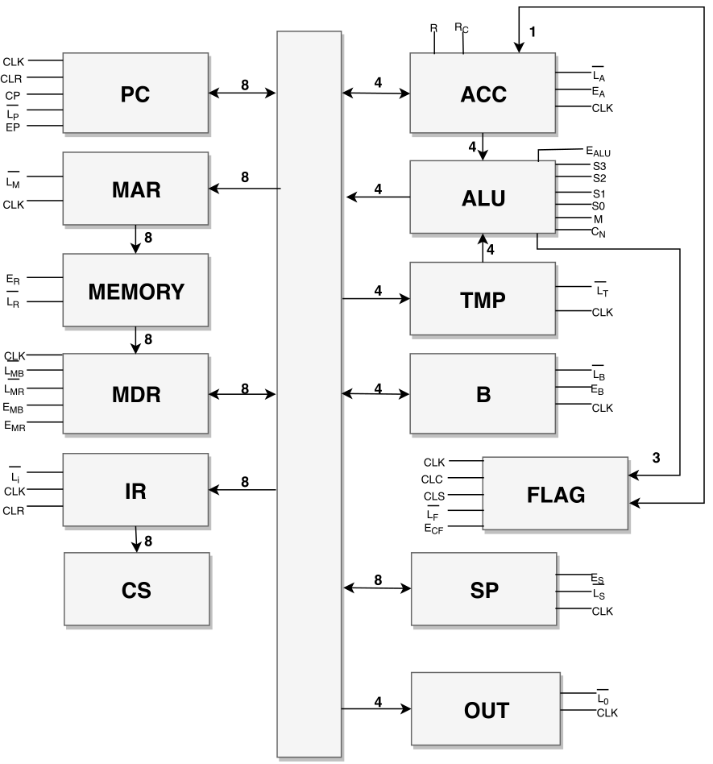

|  |  |
| --- | --- |
| CLR | Clear Register |
| CLK | Clock Pulse |
| Cp | Increment PC |
| $$\overline{L_{P}}$$ | Load PC from bus |
| Ep | Output PC from bus |
| $$\overline{L_{M}}$$ | Load MAR from bus |
| ER | Output RAM[MAR] to MDR line |
| $$\overline{L_{R}}$$ | Load RAM[MAR] from MDR |
| $$\overline{L_{MB}}$$ | Load MDR from bus |
| $$\overline{L_{MR}}$$ | Load MDR from RAM |
| EMB | Output MDR to bus |
| EMR | Output MDR to RAM |
| $$\overline{L_{I}}$$ | Load IR from bus |
| $$\overline{L_{A}}$$ | Load ACC from bus |
| EA | Output ACC to bus |
| R | Rotate Left |
| RC | Rotate with Carry |
| EALU | Output ALU value to bus |
| S0, S1, S2, S3, CIN, M | ALU mode selection |
| $$\overline{L_{T}}$$ | Load Temp from bus |
| $$\overline{L_{B}}$$ | Load Reg. B from bus |
| EA | Output Reg. B to bus |
| CLC | Clear Carry flag |
| CLS | Clear Sign flag |
| $$\overline{L_{F}}$$ | Load flag from ALU |
| ECF | Output Carry flag |
| ES | Output SP to bus |
| $$\overline{L_{S}}$$ | Load SP from bus |
| $$\overline{L_{0}}$$ | Load Output Reg from bus |

**Instructions:**