Study Communication Platform



Submitted By
MOSTAFA AL RAFID TANJIMA AKTER
Reg no: 19502003930 Reg no: 19502003902
Session: 2019-20 Session: 2019-20

Bachelor of Science in

Computer Science & Engineering

DEPERTMENT OF COMPUTER SCIENCE & ENGINEERING
NATIONAL UNIVERSITY OF BANGLADESH
Year 2025

DECLARATION
We, hereby to declare that the work “A digital communication and management system that connects teachers and students for seamless study interaction.” presented in this project paper is the outcome of the investigation performed by us under the supervision of Shirin Nahar Sathi , Associate Professor, Department of CSE, National University, Gazipur, Bangladesh .We also declare this project paper that has been submitted to national university for the award of bachelor degree that is Bachelor of Science and Engineering
EXAMINERS

Shirin Nahar Sathi (Internal)
Associate Professor, Dept. of CSE Supervisor
Dhaka City College, Dhaka

Ms. Kanija Muntarina (Internal)
Associate Professor, Dept. of CSE Head of Department
Dhaka City College, Dhaka

Name of External-1: External
Designation:
Institute Name

Name of External-1: External
Designation:
Institute Name

Declaration:
It is hereby declared that this project and any part of it have not been submitted elsewhere for the award of any degree or diploma.

Signature Signature
………………………. …………………………..
Mostafa Al Rafid Tanjima Akter

APPROVAL
This project paper “A digital communication and management system that connects teachers and students for seamless study interaction” submitted by Mostafa Al Rafid, Roll No: 58, Reg.No: 19502003930 And Tanjima Akter, Roll No:185, Reg No :19502003902 to department of Computer Science And Engineering, Dhaka City College, National University, Bangladesh has approved a satisfactory for the partial fulfillment of the requirement for the degree of bachelor of science in computer science and engineering .

Supervisor Head of the Department
Shirin Nahar Sathi Ms. Kanija Muntarina
Associate Professor, Dept. of CSE Associate Professor & Head,
Dhaka City College, Dhaka Dept. of CSE Dhaka City College

ACKNOWLEDGEMENT
First of all, we would like to thanks the Almighty ALLAH. we are successfully completed our work up to design section of our project as a partial fulfilment of the requirement for the degree of Bachelor of Science & Engineering because Almighty Allah give us the ability, chance and a cooperation environment with our supervisor.
We would like to take the opportunity to express my gratefulness to our respected supervisor, Shirin Nahar Sathi. She trained us in such a way that we were never in uncertainty. She always tried to give us motivation and grow confidence in us to work hard. The depth of her working is always an extra asset to our project. Without her encouragement and constant guidance, we couldn’t have finished this part of our project and able to carry out our work.
We would like to thanks Ms. Kanija Muntarina, Associate professor & Head of the department of CSE, Dhaka City College, whose co-ordination and effective decision steps helped and inspired us in every state. We would also thank him for giving us an opportunity to participate in this project.
We also thankful to all our respected teachers of the department, Specially to our respected guide teacher Mr. Md. Tanzim Hossain, Associate professor and former head of the department of CSE in Dhaka City College ,who helped us in a number of ways by providing resources and moral supports.
At last grateful to our family members who supported us in every steps of our life.

ABSTARCT
This is a web-based academic communication platform designed to streamline interaction between teachers and students within a digital learning environment. The system allows users to create accounts as either teachers or students, with teachers having the exclusive ability to establish academies that students can join. Within each academy, teachers can post modules such as syllabi or study materials, create notices with optional attachments, and assign activities consisting of questions and supporting files. Students can submit answers privately, ensuring that only the submitting student and the teacher can view them. The platform includes a real-time visual graph that tracks activity submissions against deadlines, providing valuable insights into student participation. Additionally, Acadizo features a centralized dashboard for an at-a-glance overview of academic content and interactions. Developed using React.js, TypeScript, Tailwind CSS, Ant Design, TanStack Query, Zustand, and Mongoose, and hosted on Netlify, Acadizo offers a modern, scalable, and user-friendly solution for enhancing collaborative learning in educational institutions.

List of Figures

1. Introduction ............................................................................................................................ 8
1.1 Motivation ....................................................................................................................... 8
1.2 Main Contributions ........................................................................................................ 8
1.3 Research Objectives .........................................................................................................9
1.4 Organization of Project ................................................................................................... 9
1.5 Summary ........................................................................................................................... 10

2. Related Works ......................................................................................................................... 12
2.1 Overview of Acadizo .........................................................................................................12
2.1.1 Applications ....................................................................................................................12
2.1.2 Classification .................................................................................................................. 13
2.1.3 Core Components ............................................................................................................13
2.2 Types of Communication in Academic Systems ...............................................................13
2.3 Types of Academic Information Systems ..........................................................................14
2.3.1 Transaction Processing System (TPS) ............................................................................14
2.3.2 Management Information System (MIS) .......................................................................14
2.3.3 Decision-Support System (DSS) ......................................................................................14
2.3.4 Learning Management System (LMS) ...........................................................................14
2.4 Advantages of Academic Communication Systems ..........................................................14
2.5 Limitations of Current Systems .........................................................................................14
2.6 Challenging Issues ..............................................................................................................15

3. Proposed System ....................................................................................................................... 16
3.1 Introduction ............................................................................................................................. 16
3.2 Background .............................................................................................................................. 16
3.3 Objective .................................................................................................................................. 16
3.4 Scope ......................................................................................................................................... 17
3.5 Significance .............................................................................................................................. 21
3.6 Methodology ........................................................................................................................... 21
3.6.1 Introduction ........................................................................................................................... 21
3.6.2 System Study and Analysis ................................................................................................... 21
3.6.3 Requirements Determination ................................................................................................22
3.6.4 Requirements Analysis ..........................................................................................................22
3.6.5 System Design ........................................................................................................................ 22
3.7 System Implementation ............................................................................................................ 22
3.8 System Testing ............................................................................................................................22
3.9 System Validation .................................................................................................................. 22
3.10 Summary .............................................................................................................................. 23

4. System Design, Analysis and Implementation ...........................................................................24
4.1 Introduction………………………………............................................................................ 24
4.2 System Design Objectives .....................................................................................................24

4.2.1 System Design……............................................................................................................... 24
4.2.2 Logical Design ......................................................................................................................25
4.2.3 Conceptual Design ............................................................................................................... 25
4.2.4 Physical Design .....................................................................................................................25
4.3 Functional Requirements ......................................................................................................25
4.4 Non-functional Requirements ...............................................................................................25
4.5 Entity Relationship Diagram (ERD) ....................................................................................26
4.6 Data Flow Diagrams (DFD) ................................................................................................. 27
4.6.1 Use Case Diagram .............................................................................................................. 27
4.7 Implementation .................................................................................................................... 28
4.7.1 Implementation Requirements ........................................................................................ 28
4.7.2 Sequence of System Execution ....................................................................................... 28

CHAPTER - 1

1 Introduction
Acadizo is an innovative platform designed to enhance seamless communication and collaboration between teachers and students within academic environments. This introduction provides the foundational context, significance, and roadmap of the project.

1.1 Motivation
The motivation behind Acadizo stems from the growing need to simplify and improve communication channels in education. Traditional academic communication methods are often fragmented and inefficient, leading to delays, misunderstandings, and reduced student engagement. Acadizo aims to bridge these gaps by providing an integrated digital solution that fosters real-time, organized, and transparent communication, thus enhancing the overall learning experience.

1.2 Main Contributions
Acadizo delivers a comprehensive platform where teachers can create academies, post modules, notices, and activities, while students can join academies, access study materials, submit assignments, and receive timely notifications. Key contributions include role-based access control, activity tracking with deadline awareness, data visualization for engagement monitoring, and a centralized dashboard for quick oversight—all built with a modern, scalable tech stack.

1.3 Research Objectives
The primary objectives of the Acadizo project are:
- To develop a secure and user-friendly platform that supports dynamic interaction between teachers and students.
- To enable efficient management of academic content and activities within academies.
- To implement data-driven features such as activity submission tracking and graphical insights into student participation.
- To ensure scalability and maintainability using cuttingedge technologies like React, TypeScript, and MongoDB.

1.4 Organization of Project
This project is structured into five main chapters:
- Introduction: Provides background, motivation, and scope.
- Related Works: Reviews existing academic communication systems and their limitations.
- Proposed System: Details the design, objectives, and methodology of Acadizo.
- System Design, Analysis and Implementation: Covers technical architecture, diagrams, and development process.
- Conclusion and Future Work: Summarizes achievements and suggests directions for enhancement.
- 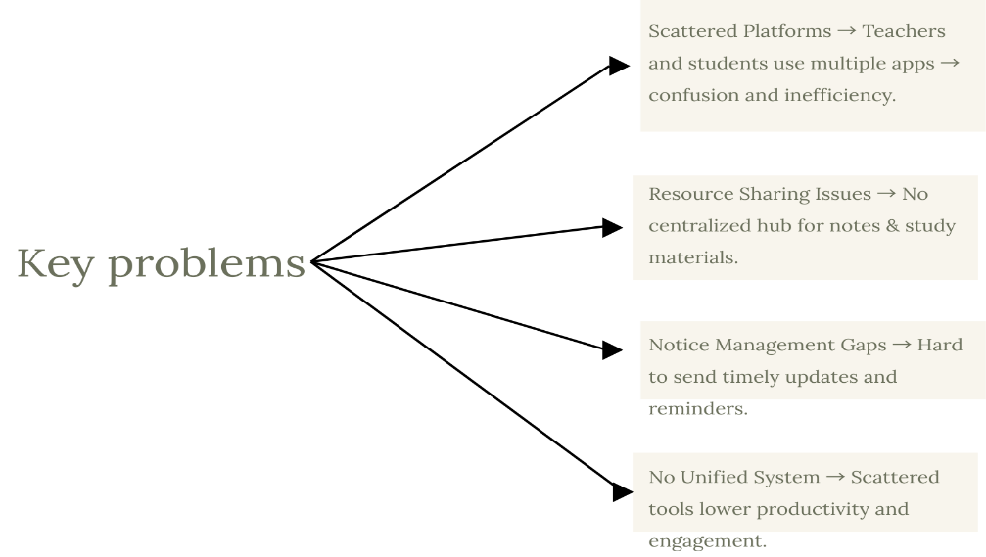

1.5 Summary
This introduction outlines the pressing need for a seamless academic communication platform and positions Acadizo as a strategic solution. It establishes the motivation, core contributions, objectives, and structure guiding the development and presentation of the project.

CHAPTER 2

2 Related Works
This chapter explores the context in which Acadizo is developed, reviewing existing systems, their applications, classifications, and limitations. It also identifies the gaps that Acadizo aims to fill, discusses types of academic communication and information systems, and highlights relevant research in the domain.

2.1 Overview of Acadizo
Acadizo is a web-based platform designed to streamline communication between teachers and students within an academic setting. It allows teachers to create academies, post study modules, share notices, assign activities, and monitor student engagement. Students can join academies, access learning materials, and submit responses to activities, ensuring that academic collaboration remains organized and transparent.
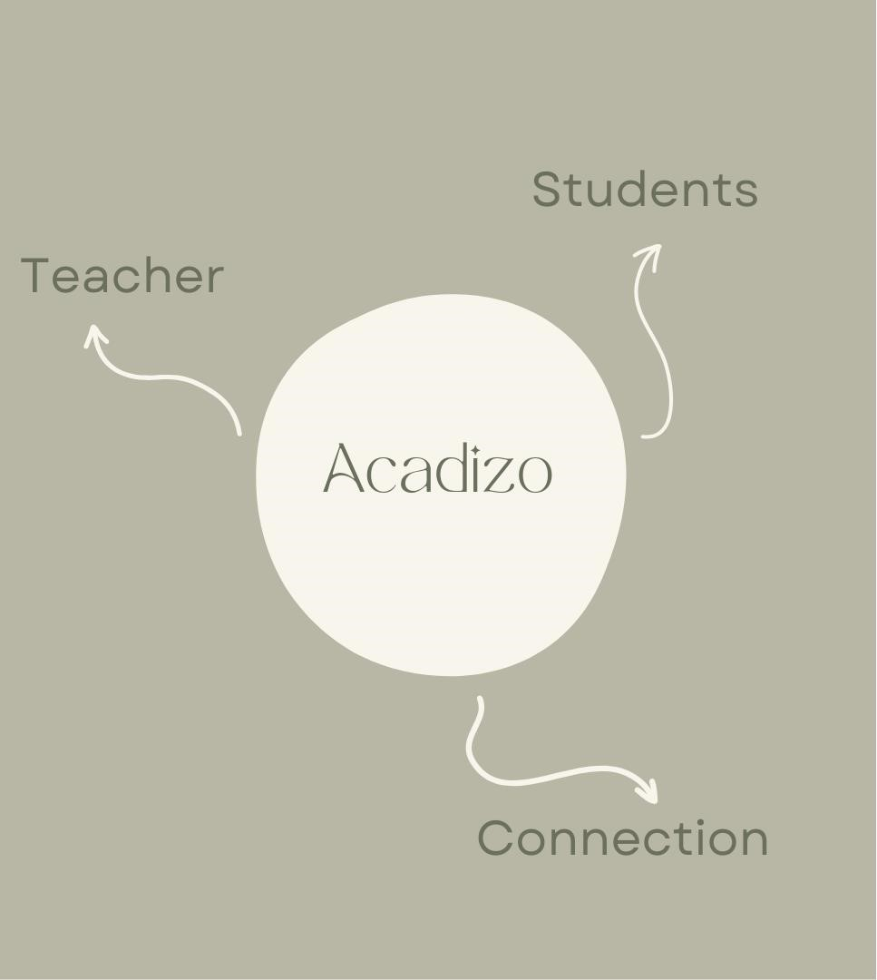

2.1.1 Applications
Acadizo can be used in a variety of academic contexts:
- Schools & Colleges: To manage class announcements, homework, and assignments.
- Private Coaching Centers: For sharing syllabi, test schedules, and results.
- University Departments: For academic notices, research collaboration, and coursework management.
- Distance Learning Programs: To keep communication seamless between instructors and remote students.

2.1.2 Classification
Acadizo can be classified under:
- Educational Communication Systems – Facilitates structured information exchange between academic stakeholders.
- Web-Based Collaborative Platforms – Provides online interaction spaces for group-based learning.
- Role-Based Academic Management Systems – Differentiates access and capabilities based on user roles (teacher/student).

2.1.3 Core Components
- User Management: Account creation, authentication, and role-based access.
- Academy Management: Teachers create and manage academic environments.
- Module Posting: Share syllabi, course outlines, and resources.
- Notice Board: Distribute time-sensitive information with attachments.
- Activity Management: Post assignments with deadlines and attachments.
- Answer Submission & Review: Students submit, teachers review.
- Engagement Tracking: Graphical insights into activity participation.
- Dashboard: Centralized view of all academy data.

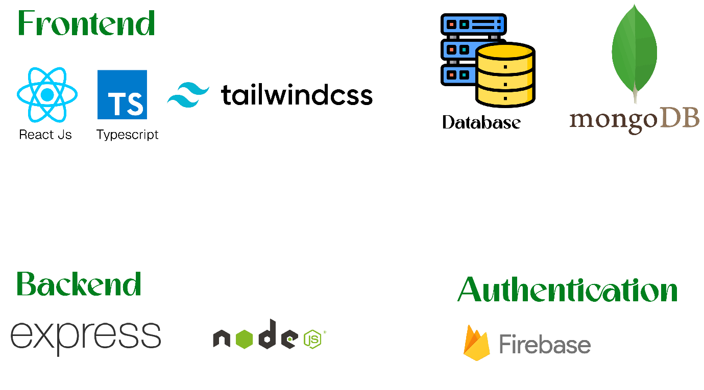

2.2 Types of Communication in Academic Systems
- Synchronous Communication: Real-time interactions such as live classes or chat systems.
- Asynchronous Communication: Time-independent exchanges like notices, posted activities, and discussion boards.
- Hybrid Communication: A combination of real-time and delayed communication, suitable for modern learning environments.

2.3 Types of Academic Information Systems

2.3.1 Transaction Processing System (TPS)
Handles basic academic transactions such as registering users, posting notices, and submitting assignments.

2.3.2 Management Information System (MIS)
Generates organized reports for teachers and administrators, including student participation analytics.

2.3.3 Decision-Support System (DSS)
Provides data-driven insights—such as graphs of activity submissions—to help teachers plan interventions.

2.3.4 Learning Management System (LMS)
Functions as an online platform where learning content, assessments, and communication are centralized.

2.4 Advantages of Academic Communication Systems
- Improves accessibility and transparency.
- Reduces communication delays.
- Encourages structured learning and engagement.
- Enhances teacher-student collaboration.
- Supports tracking and analysis of participation.

2.5 Limitations of Current Systems
- Lack of integrated task tracking and analytics.
- Poor role-based access control in some platforms.
- Complex interfaces that hinder usability. • Limited real-time feedback mechanisms.

2.6 Challenging Issues
- Ensuring secure data storage and privacy.
- Designing an intuitive interface that meets diverse user needs.
- Maintaining scalability for large academies.
- Integrating real-time and asynchronous communication effectively.

2.8 Summary
Existing academic communication systems provide valuable functions but are often fragmented or limited in scope. Acadizo addresses these gaps by offering an integrated, role-based, and analytics-driven platform, tailored to the needs of both teachers and students.

CHAPTER - 3

3 Proposed System
This chapter outlines the proposed design and operational flow of Acadizo. It explains the background of the project, its objectives, scope, significance, methodology, and the steps taken to ensure the system’s proper implementation, testing, and validation.

3.1 Introduction
The proposed system, Acadizo, is designed to provide a centralized and efficient platform for communication between teachers and students. It integrates multiple academic functions—such as syllabus distribution, notice sharing, activity posting, and submission tracking—into one user-friendly interface. The system is built using a modern tech stack, ensuring scalability, responsiveness, and a seamless user experience.

3.2 Background
Traditional academic communication relies on fragmented tools such as email, messaging apps, and physical notices. This approach often leads to delays, missed updates, and poor organization of academic tasks. The growing need for a unified, role-based, and interactive platform motivated the creation of Acadizo, which leverages technologies like React.js, TypeScript, and MongoDB to offer a secure, real-time, and accessible solution.

3.3 Objective
The main objectives of Acadizo are:
- To provide a streamlined communication platform between teachers and students.
- To enable role-specific functions for teachers (academy creation, module posting, notice management, activity assignment) and students (academy joining, task submission).
- To incorporate visual analytics for tracking student engagement.
- To ensure a scalable, secure, and maintainable academic system.

3.4 Scope
The scope of Acadizo includes:
- User Management: Role-based registration and login.
- Academy Management: Teachers create academies, students join them.
- Content Sharing: Posting of modules, notices, and activities.
- Submissions & Tracking: Students submit answers, teachers review and track participation.
- Analytics Dashboard: Graphical representation of student engagement per activity.
The system will initially serve educational institutions, but can later expand to corporate training environments and online learning platforms.

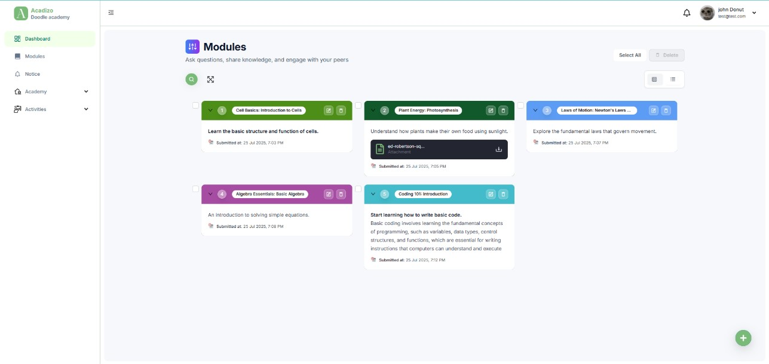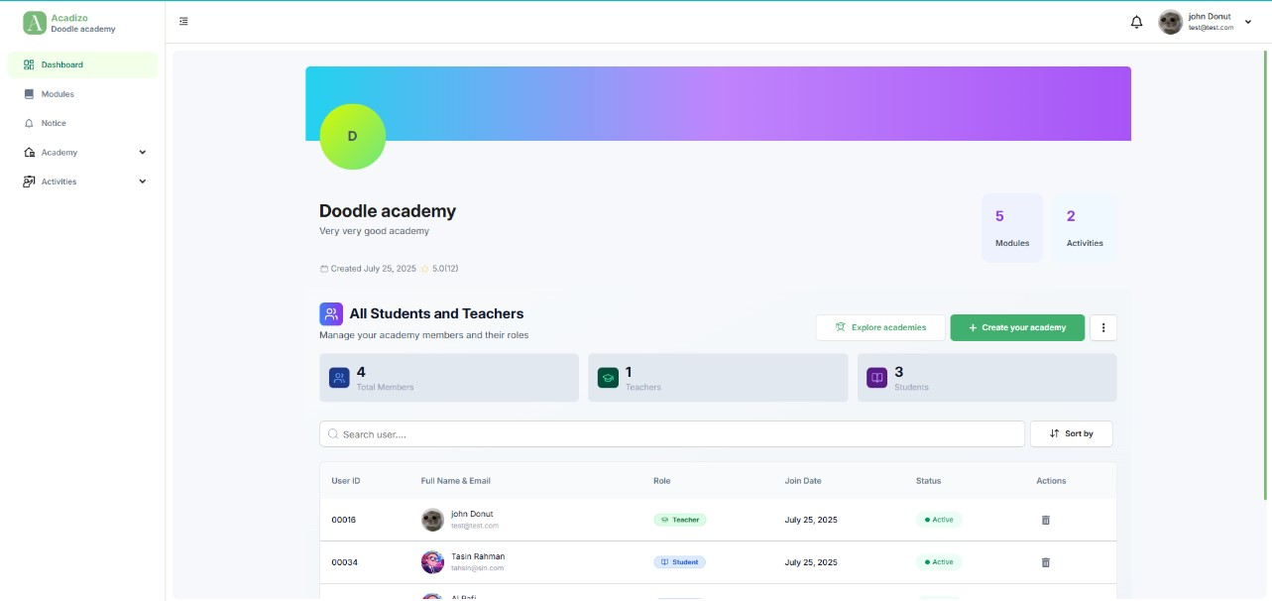
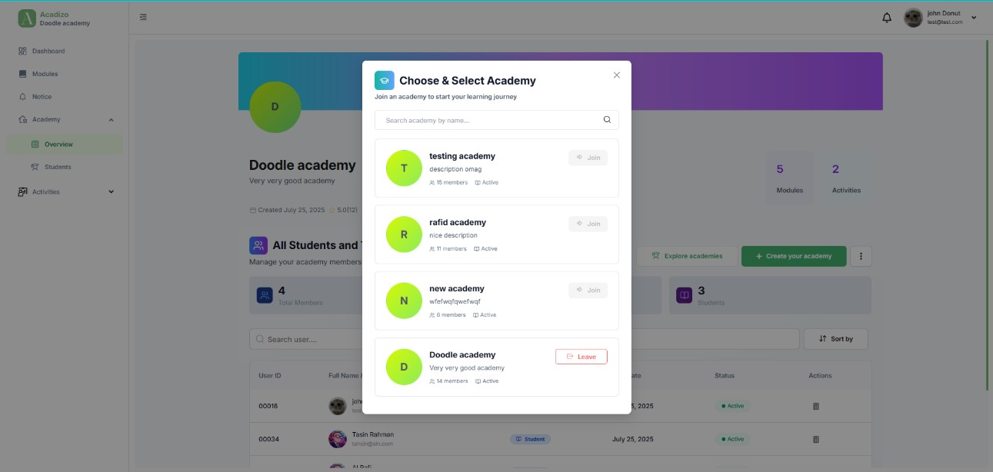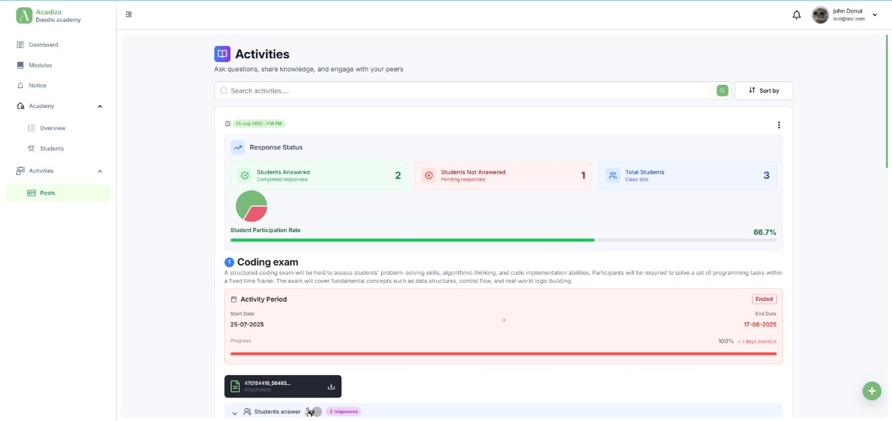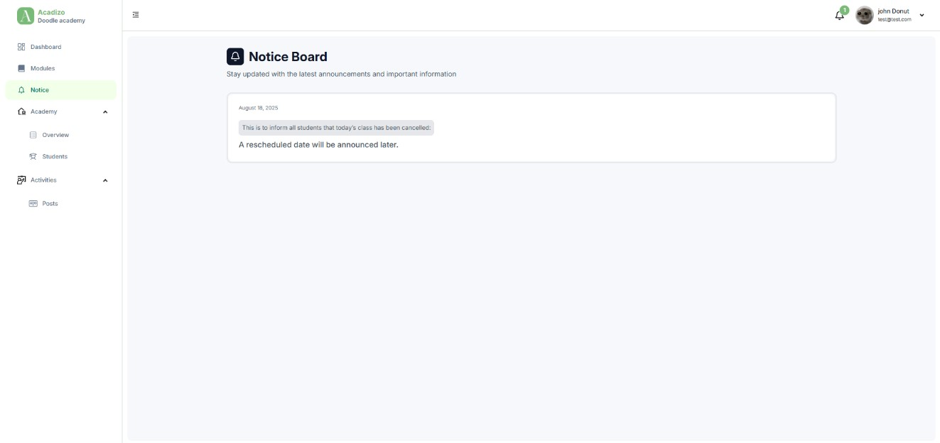

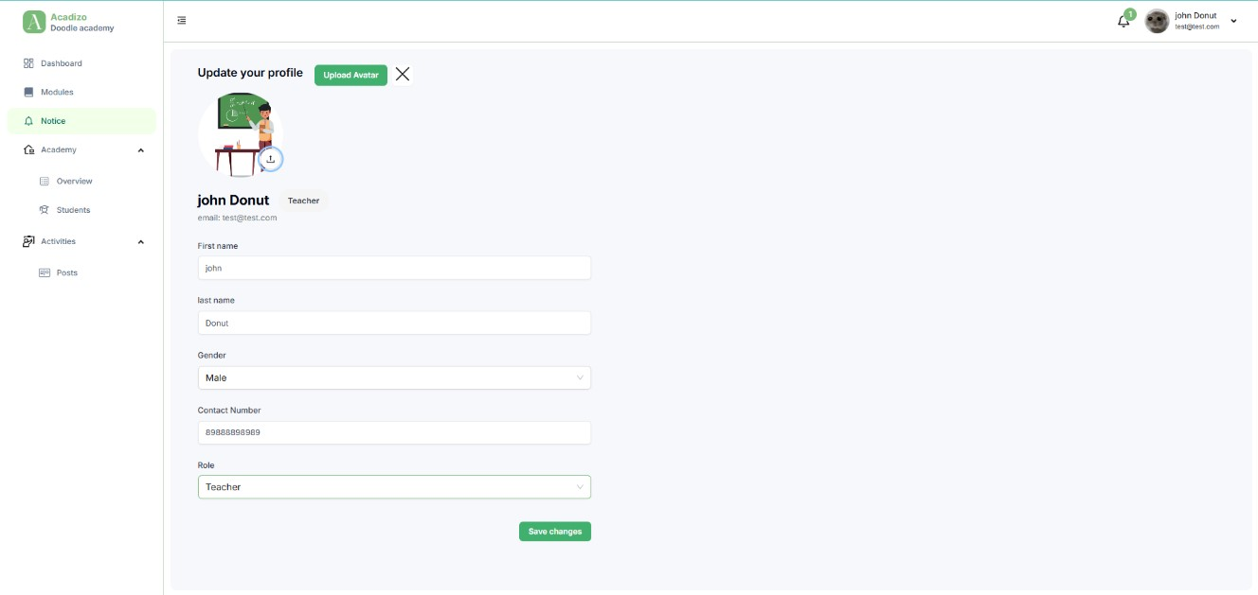

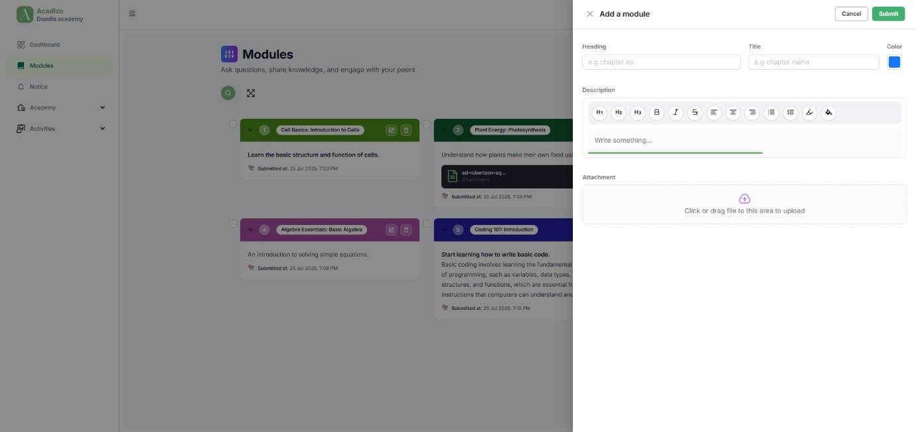
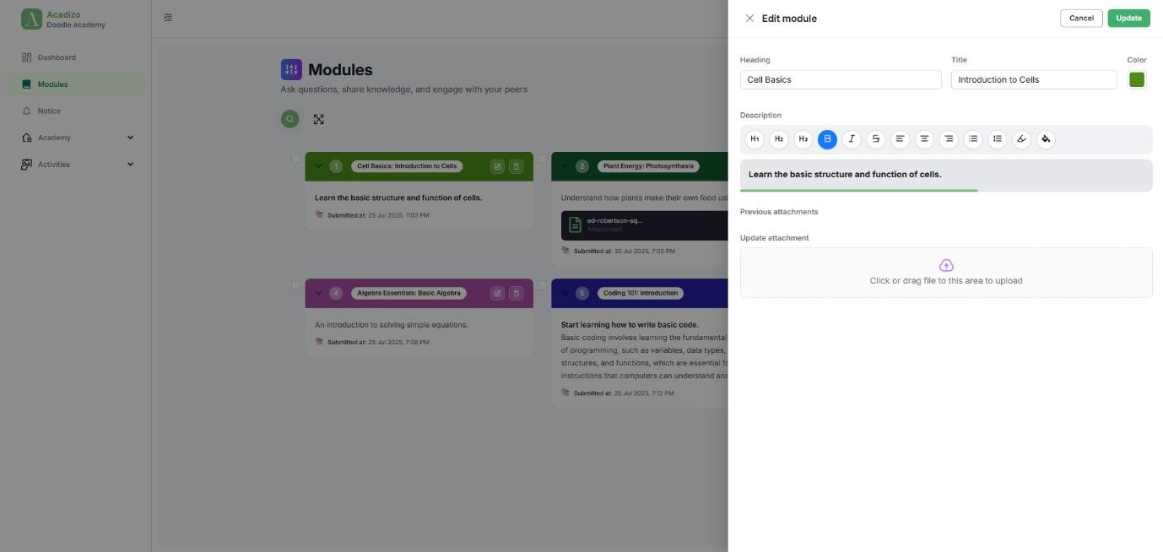

3.5 Significance
Acadizo addresses the inefficiencies in academic communication by:
- Centralizing all study-related communication.
- Improving accountability through role-based permissions.
- Reducing delays in disseminating important updates.
- Enabling teachers to monitor participation effectively.
- Offering a digital-first platform that’s accessible from anywhere.

3.6 Methodology

3.6.1 Introduction
The development of Acadizo followed a systematic approach, incorporating both analytical and design phases to ensure functionality and usability.

3.6.2 System Study and Analysis
A review of existing academic communication tools was conducted to identify gaps and gather requirements. User interviews with teachers and students were carried out to refine feature priorities.

3.6.3 Requirements Determination
Key functional and non-functional requirements were documented, focusing on accessibility, security, and ease of use.

3.6.4 Requirements Analysis
Requirements were analyzed to create a feasible system design, ensuring compatibility with the chosen tech stack and hosting environment.

3.6.5 System Design
The design process included database schema creation (using Mongoose), interface prototyping (with Ant Design + Tailwind CSS), and state management planning (using Zustand and TanStack Query).

3.7 System Implementation
The system was developed in modules, starting with authentication and user roles, followed by academy management, content posting, activity management, and analytics visualization. React.js and TypeScript were used for frontend logic, while MongoDB handled backend data storage.

3.8 System Testing
Testing involved unit tests for individual components, integration tests for data flow between frontend and backend, and user acceptance testing with sample teacher-student accounts.

3.9 System Validation
Validation confirmed that the system met its stated objectives— ensuring smooth communication, secure role-based access, and effective activity tracking.

3.10 Summary
The proposed system provides a robust, scalable, and user friendly solution for academic communication. With its modular architecture, it is well-positioned for future enhancements and broader adoption.

CHAPTER- 4

4 System Design, Analysis and Implementation

4.1 Introduction
System design, analysis, and implementation play a vital role in transforming Acadizo from an idea into a functional academic communication platform. This chapter details the design objectives, the types of design considered (logical, conceptual, and physical), functional and non-functional requirements, as well as visual representations like ER diagrams, data flow diagrams, and use case diagrams. It also explains the implementation requirements and execution flow to make Acadizo seamless, scalable, and user-friendly.

4.2 System Design Objectives
The system design objectives for Acadizo are:
- Ensure smooth communication between teachers and students.
- Provide a structured architecture for managing academies, modules, notices, and activities.
- Guarantee scalability, security, and maintainability.
- Deliver a user-friendly interface with responsive design.
- Maintain data consistency and reliability.

4.2.1 System Design
Defines the overall architecture, including frontend (React, Tailwind, Ant Design), backend (Node.js, Express), and database (MongoDB with Mongoose).

4.2.2 Logical Design
Logical design explains the relationships between users (teachers, students) and entities (academies, modules, notices, activities). It shows how data flows logically without focusing on physical implementation.

4.2.3 Conceptual Design
Conceptual design provides an overview of system components, their relationships, and how they interact (e.g., teacher creates academy → students join → activities posted → students respond).

4.2.4 Physical Design
Physical design includes database schema (MongoDB collections for users, academies, modules, notices, activities, submissions) and actual deployment setup (Netlify for frontend, backend hosted on Node.js server, MongoDB Atlas for database).

4.3 Functional Requirements
- User registration and login (teacher/student).
- Teachers create academies, students join.
- Teachers post modules, notices, and activities with attachments.
- Students submit answers to activities.
- Teachers view and evaluate submissions.
- Graphical analytics for participation (e.g., number of submissions vs. total students).
- Dashboard overview for all entities.

4.4 Non-functional Requirements
- Scalability: Handle increasing users and academies.
- Reliability: Ensure consistent access to data.
- Security: Authentication, authorization, and secure file uploads.
- Performance: Fast response times via React + TanStack Query.
- Usability: Simple UI with Ant Design + Tailwind.

4.5 Entity Relationship Diagram (ERD)
Entities include:
- User (teacher/student)
- Academy
- Module
- Notice
- Activity
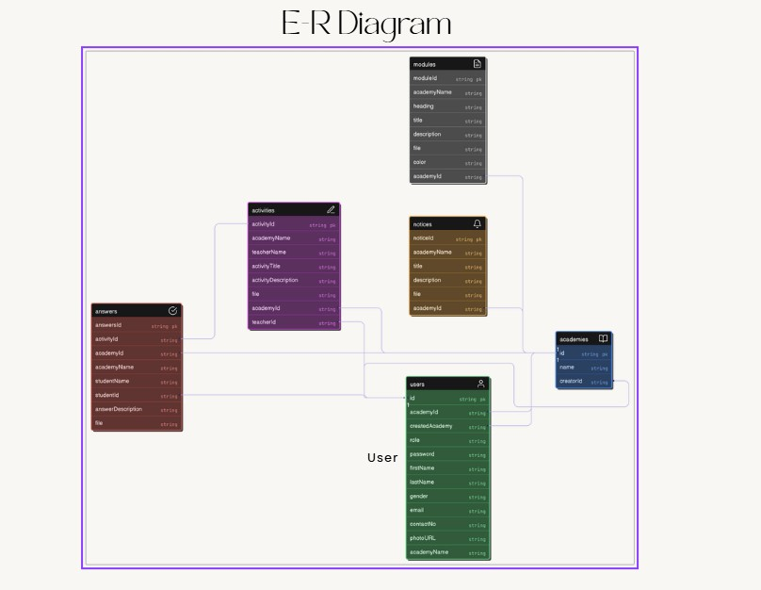
Relationships:
- A teacher can create many academies.
- Students can join an academy.
- Each academy can have many modules, notices, and activities.
- Each activity can have multiple student submissions.
(Figure 4.2: ER Diagram shows detailed entity relations)

4.6 Data Flow Diagrams (DFD)
- Level 0 (Context Diagram): Shows users (teacher/student) interacting with Acadizo.
- Level 1: Teacher posts modules, notices, and activities; students receive and respond.
- Level 2: Data flows between system components (academy database, activity database, submissions).

4.6.1 Use Case Diagram
Actors: Teacher, Student.
Use Cases: Create Academy, Join Academy, Post Module, Post Notice, Create Activity, Submit Answer, View Dashboard.

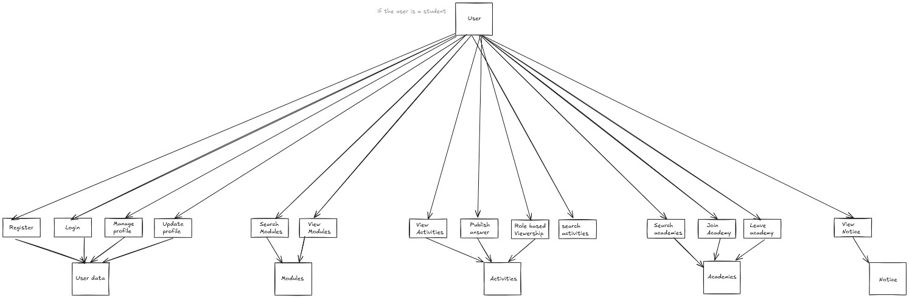
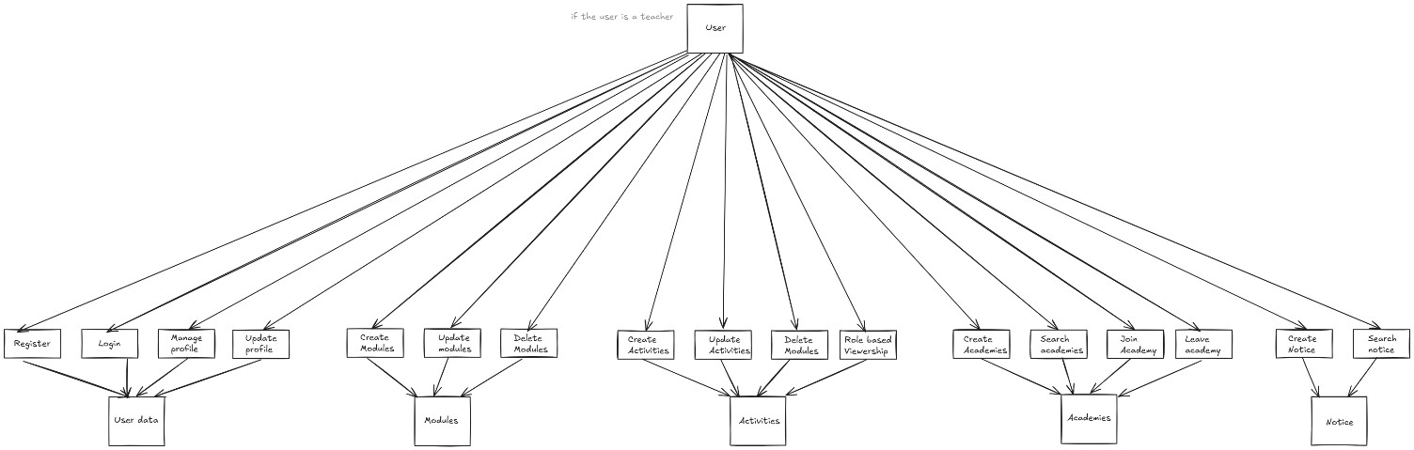

4.7 Implementation

4.7.1 Implementation Requirements
- Frontend: React.js, TypeScript, Tailwind CSS, Ant Design.
- State Management: Zustand.
- Data Fetching: TanStack Query.
- Backend: Node.js, Express.js.
- Database: MongoDB with Mongoose.
- Hosting: Netlify (frontend), MongoDB Atlas (DB), Node backend (server).
- Version Control: GitHub.
- IDE: VS Code.

4.7.2 Sequence of System Execution
- User registers/logs in → chooses role (teacher/student).
- Teacher creates academy → students join using code/invite.
- Teacher posts modules, notices, and activities.
- Students view academy updates in dashboard.
- Students submit answers to activities before deadline.
- Teacher reviews all submissions, analytics graph updates.
- Notifications keep students updated with new posts.

Bibliography:
- Proakis, John G., and Masoud Salehi. Communication Systems Engineering. Pearson, 2002.​
- Carlson, A. Bruce, and Paul B. Crilly. Communication Systems. McGraw-Hill, 2009.​
- Kovačević, Jelena. Introduction to Communication Systems. Cambridge University Press, 2014.​
- “Learning Management System.” Wikipedia, Wikimedia Foundation, accessed 28 November 2025, https://en.wikipedia.org/wiki/Learning_management_system.​
- Smartcat. “Learning Management System Guide: Features, Benefits.” Smartcat Blog, accessed 28 November 2025, https://www.smartcat.com/blog/learning-management-systems-complete-guide/.​
- OECD. Learning Management Systems and Other Digital Tools for Education. OECD Digital Education Outlook, 2023.​

Conclusion and Future Work:
Acadizo successfully demonstrates how a centralized, web-based platform can make academic communication more organized, transparent, and efficient for both teachers and students. By combining academy management, content sharing, notice publishing, and activity submission in a single system, it reduces the fragmentation and delays common in traditional communication methods. The use of a modern tech stack with React.js, TypeScript, and MongoDB ensures that the platform remains scalable, secure, and user-friendly as the number of users and academies grows.​
Through features like role-based access control, graphical analytics of submissions, and a dashboard overview, Acadizo not only supports routine academic tasks but also enables better monitoring of student engagement and performance. The modular design and clear architecture make the system suitable for future enhancements, such as richer real-time interactions or integration with other educational tools, positioning Acadizo as a practical foundation for next-generation digital learning environments.

