AMRAP
Ant Market Research Action Protocol

Product Specification Document

Version: 1.0
Date: April 2026
Status: Draft
Classification: Confidential

Executive Summary

AMRAP (Ant Market Research Action Protocol) is a premium, subscription-based market research platform that delivers daily expert analysis across five key domains: Global Markets, Crypto, Economic Calendar, News, and Polymarket predictions. Subscribers pay a single monthly fee via Xendit/Midtrans to access a web-based dashboard where a team of 2-5 analysts publish individual category posts and a consolidated daily digest. The platform features an automated news recycling pipeline that ingests articles from premium sources (via RSS feeds, web scraping, or manual input), rewrites the content using AI to produce original text, and redraws all images and charts with AI to avoid copyright issues — all of which goes through a mandatory author review queue before publishing. A built-in referral system allows any subscriber to earn a one-time fixed commission for each new paying user they bring in, tracked via unique referral links. The admin dashboard provides full control over user management, subscription pricing, referral commission rates, payout processing, news source configuration, and platform analytics including subscriber growth, revenue trends, and content engagement. Content access is strictly binary — active subscribers get full access, and expired subscribers lose all access immediately with no archive. The entire platform is designed to be built and deployed within 1.5 weeks using Next.js, Supabase, and Vercel, with a total project cost of IDR 20,000,000.

Table of Contents

Executive Summary
1. Platform Overview
2. Content Structure
3. Core Features
4. User Flows
5. User Roles & Permissions
6. Key Screens
7. System Architecture
8. Key Business Rules
9. Admin Dashboard
10. Project Pricing
11. Development Timeline (1.5 Weeks)
12. Tech Stack
13. Open Questions

1. Platform Overview

AMRAP (Ant Market Research Action Protocol) is a subscription-based daily market research platform. A small team of analysts publishes daily intelligence covering global markets, crypto, economic events, curated news, and prediction markets. Content is delivered exclusively through a web application.
Attribute | Detail
Platform Name | AMRAP — Ant Market Research Action Protocol
Business Model | Subscription-based paid research group
Subscription | Single-tier monthly plan
Payment Gateway | Xendit / Midtrans (bank transfer, e-wallet, VA, cards)
Content Delivery | Web app only (landing page + subscriber dashboard)
Content Team | Small team of 2-5 authors, each covering different domains
Subscriber Access | Read-only — no comments, forums, or community features

2. Content Structure

Daily Content Categories
Category | Description
Global Market | Daily analysis of global equity markets, indices, commodities, forex
Crypto | Cryptocurrency market analysis, on-chain data, token movements
Economic Calendar | Upcoming economic events, central bank decisions, earnings releases
News Digest | Curated and recycled news from premium sources (AI-rewritten)
Polymarket | Prediction market insights, trending bets, probability analysis

Post Format
- Individual posts per category — subscribers can browse and filter by topic
- Daily digest — a combined summary post aggregating all categories into one overview

3. Core Features

A. Author Dashboard
- Create, edit, and publish posts by category
- Save drafts and schedule posts for future publishing
- Generate daily digest from individual category posts
- Review queue for auto-recycled news (approve / reject / edit before publishing)

B. Auto News Recycler
Automated pipeline that ingests premium news from multiple sources, rewrites content with AI, redraws images to avoid copyright, and queues everything for author review.

Input Sources
- RSS / API feeds (e.g., Bloomberg, Reuters, CoinDesk)
- Web scraping (premium sites the team has access to)
- Manual copy-paste by authors

AI Processing Pipeline
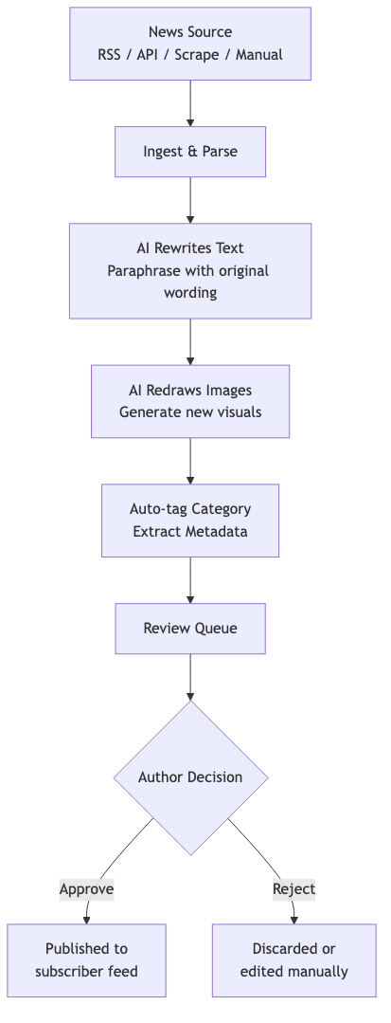
Figure 1: Auto News Recycler Pipeline
All recycled content requires author approval before publishing. Nothing is auto-published.

C. Subscriber Dashboard
- Daily feed of all published posts
- Browse by category (Global Market, Crypto, Calendar, News, Polymarket)
- Daily digest view
- Access policy: Lose ALL access when subscription expires — no archive access

D. Subscription & Payments
- Single tier, monthly billing
- Payment via Xendit / Midtrans (Indonesian payment gateway)
- Supported: bank transfer, e-wallet (OVO, GoPay, Dana), virtual account, credit/debit card

E. Referral System
- Model: Commission-based, one-time payout per successful referral
- Each registered user gets a unique referral link/code
- Referrer earns a fixed IDR amount when referred user completes first payment
- Commission amount configurable by admin

Referral Flow
Figure 2: Referral System Flow
Referral Dashboard (for referrers):
- Unique referral link + copy button
- Total people referred & successful conversions
- Total earnings & payout history

F. Landing Page
- Public marketing site to convert visitors into subscribers
- Platform value proposition & content previews/teasers
- Pricing information & sign-up CTA
- Referral link support — tracks which referrer brought the visitor

4. User Flows

Flow A: New Subscriber
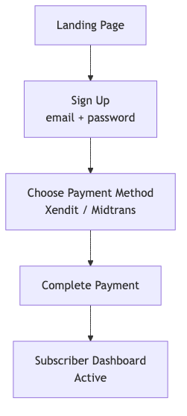
Figure 3: New Subscriber Registration Flow

Flow B: Referred Subscriber
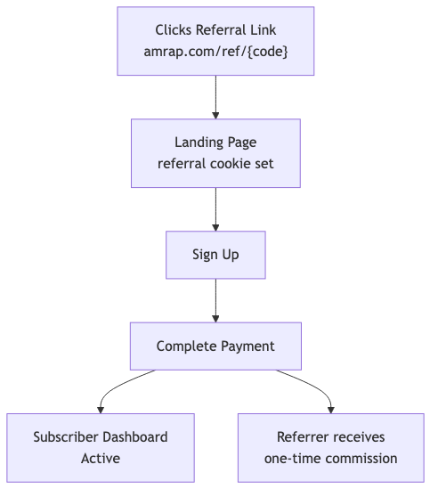
Figure 4: Referred Subscriber Flow

Flow C: Subscription Renewal / Expiry
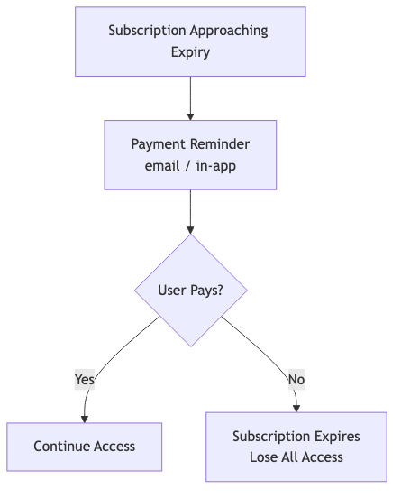
Figure 5: Subscription Renewal / Expiry Flow

Flow D: Author Publishing
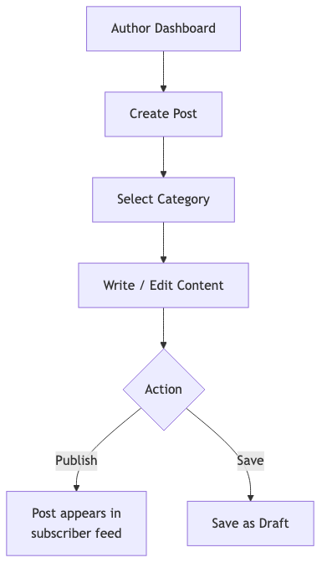
Figure 6: Author Publishing Flow

Flow E: Auto News Recycling

Figure 7: Auto News Recycling Pipeline

Flow F: Daily Digest Generation
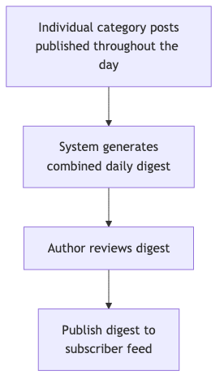
Figure 8: Daily Digest Generation Flow

5. User Roles & Permissions

Role | Capabilities
Subscriber | View posts, browse by category, view daily digest, manage own subscription, share referral link, view referral dashboard
Author | All subscriber capabilities + create/edit/publish posts, review auto-recycled news in queue, manage drafts, schedule posts
Admin | All author capabilities + manage users & authors, set subscription pricing, configure referral commissions, manage payouts, configure news sources

6. Key Screens

# | Screen | Description
1 | Landing Page | Marketing site — value prop, pricing, sign-up CTA, referral support
2 | Auth Pages | Sign up, login, forgot password, reset password
3 | Subscriber Feed | Daily posts feed with category filters
4 | Daily Digest | Combined summary of all categories for the day
5 | Post Detail | Full article view with category tag
6 | Author Dashboard | Create/manage posts, view drafts, access review queue
7 | Review Queue | Auto-recycled news awaiting approval — approve/reject/edit
8 | Referral Dashboard | Referral link, stats, conversions, earnings, payout history
9 | Subscription Mgmt | Plan status, payment history, renewal, cancel
10 | Admin Panel | User mgmt, pricing, referral config, news sources, payouts

7. System Architecture

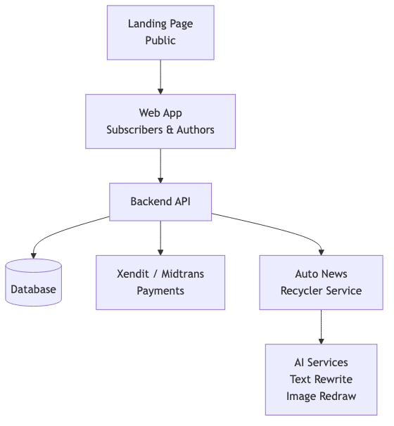
Figure 9: High-Level System Architecture

8. Key Business Rules

1. Content access is binary — Active subscription = full access. Expired = zero access. No partial access, no archive for expired users.
2. All auto-recycled content must be reviewed — Nothing from the news recycler pipeline goes live without explicit author approval.
3. Referral commission is one-time — Paid only on the referred user's first successful payment. Not recurring.
4. Images must be redrawn — Never republish original images from premium sources. AI generates new visuals conveying the same information.
5. Daily digest is curated — Auto-generated from individual posts but reviewed by an author before publishing.

9. Admin Dashboard

The admin dashboard provides complete platform management capabilities. Only users with the Admin role can access this section.

User Management
- View all registered users (subscribers, authors, admins)
- Activate / deactivate user accounts
- Promote users to Author or Admin role
- View individual user subscription history and status

Subscription & Revenue
- Set and update monthly subscription price
- View total active subscribers and revenue metrics
- View payment history and transaction logs
- Handle failed payments and manual subscription adjustments

Referral Management
- Set and update referral commission amount (fixed IDR)
- View all referral activity — who referred whom, conversion status
- Process commission payouts (manual or batch via bank transfer)
- View payout history and pending payouts

Content Management
- View all published posts across categories
- Unpublish or delete posts if needed
- Manage content categories

News Source Configuration
- Add / remove / edit RSS feed URLs
- Configure web scraping targets
- Set ingestion frequency and scheduling
- Monitor recycler pipeline health and error logs

Analytics Overview
- Subscriber growth over time
- Revenue trends (MRR)
- Top referrers leaderboard
- Content engagement metrics (views per post/category)
- Churn rate and renewal rate

10. Project Pricing

Total Project Cost: IDR 20,000,000 (Dua Puluh Juta Rupiah)

Price Breakdown
Deliverable | Description | Cost (IDR)
Landing Page | Public marketing site with pricing, CTA, referral support | 2,000,000
Auth System | Sign up, login, password reset, session management | 1,500,000
Subscriber Dashboard | Content feed, category browsing, daily digest, post detail | 3,000,000
Author Dashboard | Post CRUD, drafts, scheduling, rich text editor | 3,000,000
Auto News Recycler | News ingestion, AI text rewrite, AI image redraw, review queue | 4,000,000
Payment Integration | Xendit/Midtrans checkout, webhooks, subscription management | 2,500,000
Referral System | Referral codes, tracking, commission logic, referral dashboard | 2,000,000
Admin Dashboard | User mgmt, pricing config, referral config, analytics, news sources | 2,000,000

Payment Terms
- 50% upfront before development begins (IDR 10,000,000)
- 50% upon completion and deployment (IDR 10,000,000)

What's Included
- Full source code ownership
- Deployment to production (Vercel + Supabase)
- 1 week post-launch bug fix support
- Documentation for content management

11. Development Timeline

Total development time: 1.5 weeks (10-11 working days). This timeline excludes payment gateway approval/verification process, which is handled separately and may take additional time depending on Xendit/Midtrans review.
Note: Payment gateway approval timeline is NOT included. Xendit/Midtrans account verification and API access approval is handled separately and may take 3-7 business days.

Week 1: Core Platform
Day | Focus | Deliverables
Day 1 | Foundation | Project setup, Supabase schema (users, posts, subscriptions, referrals), auth system (sign up / login / reset), base layout & navigation
Day 2 | Landing Page | Public marketing page, value proposition sections, pricing display, sign-up CTA, referral link landing support, responsive design
Day 3 | Content System | Author dashboard, post CRUD, category system, rich text editor, draft & schedule functionality
Day 4 | Subscriber Experience | Subscriber feed, category filtering, daily digest view, post detail page, access gating (subscription check)
Day 5 | Payments | Xendit/Midtrans integration, subscription checkout flow, payment webhooks, subscription status management, renewal logic

Week 2: Advanced Features & Launch
Day | Focus | Deliverables
Day 6 | Referral System | Referral code generation, tracking & attribution, commission logic, referral dashboard for users
Day 7 | Admin Dashboard | User management, subscription/revenue overview, referral management & payouts, content management
Day 8 | News Recycler | News ingestion (RSS + manual), AI text rewriting (OpenAI), review queue UI, approve/reject workflow
Day 9 | AI Image Redraw | Image detection in source articles, AI image regeneration, integration with review queue, news source configuration in admin
Day 10-11 | Polish & Deploy | Bug fixes, mobile responsiveness, end-to-end flow testing, performance optimization, production deployment (Vercel + Supabase)

12. Tech Stack

Layer | Technology | Purpose
Frontend | Next.js 14 (App Router) | React framework with SSR, API routes
UI Components | Tailwind CSS + shadcn/ui | Rapid UI development, consistent design system
Backend / DB | Supabase (PostgreSQL) | Auth, database, storage, row-level security
Payments | Xendit | Indonesian payment gateway integration
AI - Text | OpenAI GPT-4o | News article rewriting and paraphrasing
AI - Images | OpenAI DALL-E 3 | Chart and image redrawing for copyright avoidance
Deployment | Vercel | Frontend hosting, edge functions, CI/CD
Rich Text | Tiptap / Novel | WYSIWYG editor for author post creation

13. Open Questions / Future Considerations

[ ] Exact monthly subscription price (IDR)
[ ] Exact referral commission amount (IDR)
[ ] Attribution model for referrals (first-click vs last-click)
[ ] Specific premium news sources to integrate
[ ] Domain name (amrap.com or alternative)
[ ] Mobile app in the future?
[ ] Telegram / WhatsApp notifications in the future?
[ ] Free trial period before requiring payment?

AMRAP — Ant Market Research Action Protocol | Product Specification v1.0 | April 2026

