Nama : Rafie aydin ihsan

Kelas : XI Rpl 1

Tabel Beli

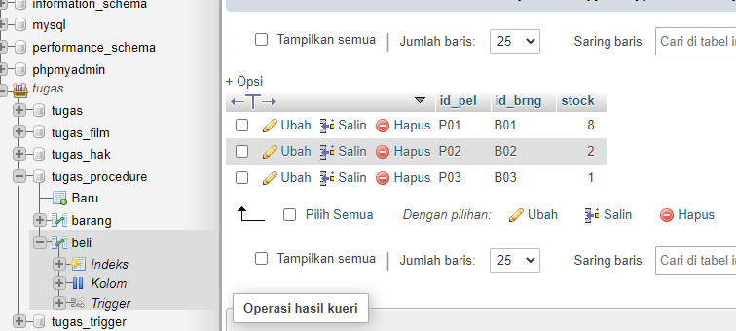

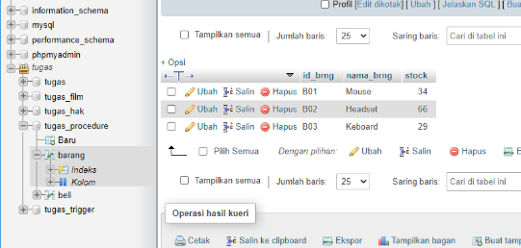Tabel barang

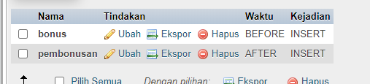Nomor 1 :

Tabel :

Codingan : bonus : CREATE TRIGGER bonus BEFORE INSERT ON beli FOR EACH ROW BEGIN

IF (NEW.stock>=5) THEN

SET NEW.stock=NEW.stock+1;

END IF;

IF (NEW.stock>=10) THEN

SET NEW.stock=NEW.stock+2;

END IF;

END$

Pembomusan : CREATE TRIGGER pembonusan AFTER INSERT ON beli

FOR EACH ROW BEGIN

UPDATE barang SET

stock = stock - NEW.stock

WHERE

id_brng= NEW.id_brng;

END$$

Nomor 2 : DELIMITER $$

CREATE PROCEDURE jumlahbrg (pelanggan varchar(5))

BEGIN

SELECT MAX(barang.stock)

FROM barang

WHERE id_brng=pelanggan;

END$$

DELIMITER

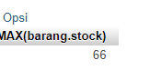Panggil Procedure : CALL jumlahbrg('B02')

Nomor 3 : DELIMITER $$

CREATE PROCEDURE jumlahbarang (pelanggan varchar(5))

BEGIN

SELECT SUM(beli.stock)

FROM beli

WHERE id_pel=pelanggan;

END$$

DELIMITER

Panggil Procedure : CALL jumlahbarang('P01')

