# Unit3 – Lab1

## Sections of each object & size of each section:

### Startup.o:

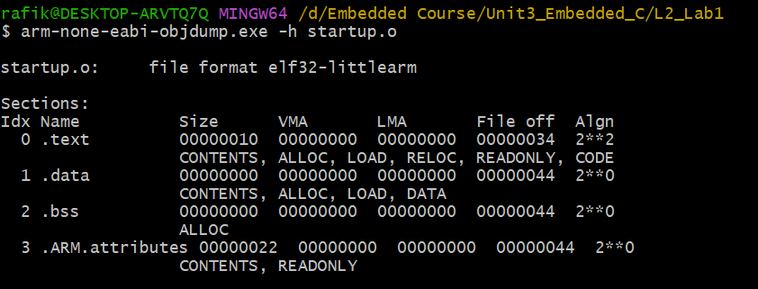

### App.o:

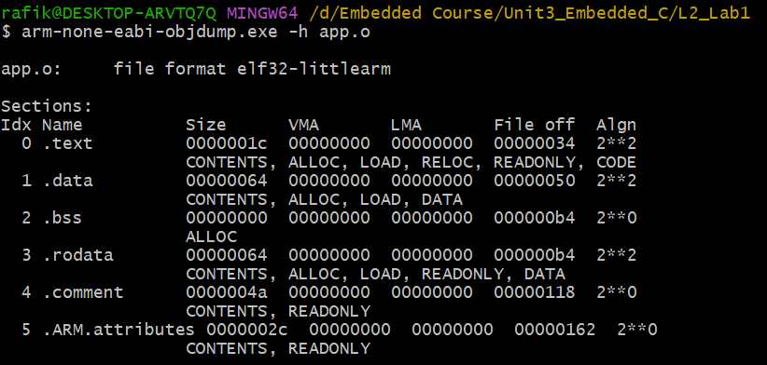

### Uart.o:

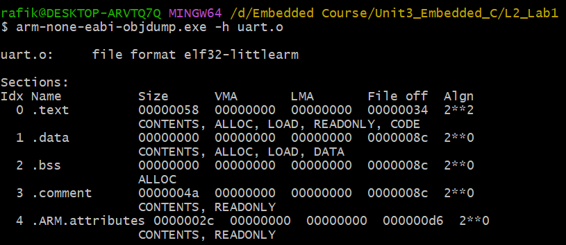

## Symbols & What was unresolved in each section:

### Startup.o:

### App.o:

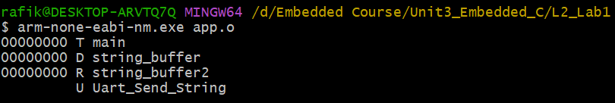

### Uart.o:



## Entry point:

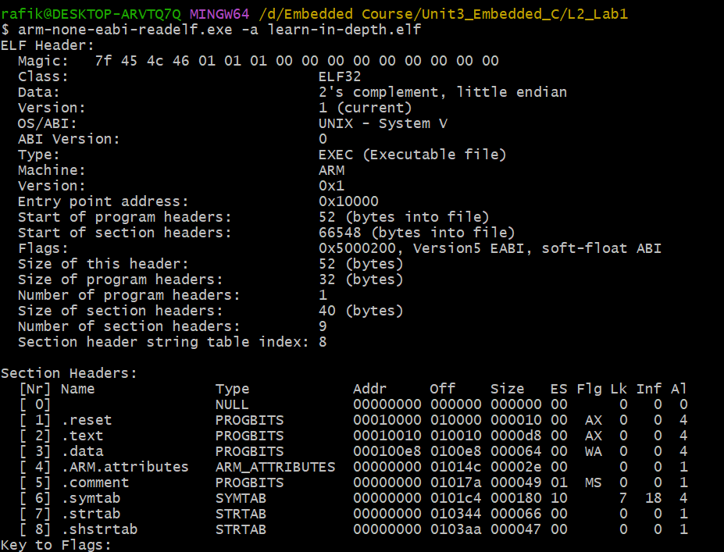

## Section addresses after executable file:

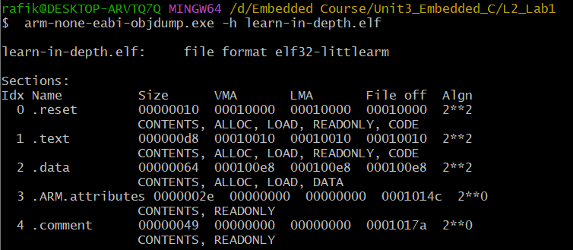

## Symbol table of executable file:

