Freight Rate Prediction Challenge
Validation and data split report | 7 November 2026
Summary
CatBoost was selected on a pre-holdout August comparison. A compact rolling search selected a direct-rate CatBoost model. On the untouched September-October holdout, it achieved $130.25 MAE, $640.59 RMSE, and R² = 0.8238. The final model was refit on all 48,000 labeled loads before producing 12,000 future-load predictions.
Chronological validation design
The labeled data span 1 January through 31 October 2025. The final 61 calendar days were reserved as a holdout; every fit row predates every holdout row. No random split was used. Model-family selection and hyperparameter tuning used earlier dates only.
Stage | Training rows / through | Validation rows / period
June rolling fold | 24,023 / 31 May | 4,783 / 1-30 June 2025
July rolling fold | 28,806 / 30 June | 4,912 / 1-31 July 2025
August rolling fold | 33,718 / 31 July | 4,759 / 1-31 August 2025
Final holdout | 38,477 / 31 August | 9,523 / 1 September-31 October 2025
The August fold also served as the CatBoost-versus-XGBoost comparison, so its model-family result is a selection result, not an independent final test. The September-October holdout was kept outside candidate selection. Iteration counts were frozen from earlier folds before final-gate fits; early stopping was disabled in the final gate.
Measured validation results
Evaluation | Model | MAE | RMSE | R²
August selection | CatBoost | $123.18 | $618.47 | 0.8241
August selection | XGBoost | $175.80 | $643.33 | 0.8097
Final holdout | Selected CatBoost | $130.25 | $640.59 | 0.8238
Final holdout | CatBoost baseline | $131.63 | $638.92 | 0.8247
Final holdout | Reduced-feature CatBoost | $131.72 | $641.52 | 0.8233
Six CatBoost candidates were compared across the June-August folds. The selected direct-rate candidate averaged $126.35 MAE across those folds and used 315 frozen iterations. It improved final-holdout MAE by $1.38 versus the baseline (about 1.0%); the baseline had slightly lower RMSE and higher R². MAE was the selection metric.

December forecast and deliverable checks
December inputs lack coordinates, market_index, and quote_signal. A separate CatBoost fit used only fields available in December, with a direct-rate target and the selected configuration. Its September-October reduced-feature holdout MAE was $131.72. The chart below is generated by Score.py from the submitted 31-row December CSV; each row holds Lexington to Fort Wayne, 360 miles, Dry Van, and 32,000 lb fixed while the date changes.
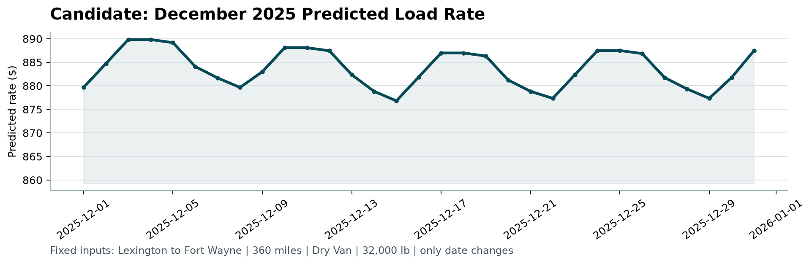
Figure 1. Candidate December 2025 predicted load rate. The current CSV contains 31 daily predictions ranging from $876.81 to $889.83; these are forecasts, not observed rates.
Validation evidence and limits
The supplied scorer validated the 12,000 unique positive load predictions and all 31 fixed December predictions, then regenerated scorer_results/candidate_december.png. The executed notebook records the chronological checks, model metrics, final refit, and output creation. Official validation targets are unavailable locally, so this report does not claim a score for the future validation set; Spotter calculates that score after submission.
Source files: notebook.ipynb, validation_predictions.csv, data/december_chart_inputs.csv, Score.py, and scorer_results/candidate_december.png.

