**FRONTEND MODULE**

# CONTENTS

## This module has the following files:

1. MODULE_FRONTEND.doc
2. MODULE_FRONTEND_MEDIA.zip

# INTRODUCTION

In this module you are required to implement the results of the REST API that you have created, Frontend using provided **JavaScript** libraries (react/angular/vue) of Society Vaccination Platform.

# DESCRIPTION OF PROJECTS AND TASKS

In this module, you can use the gui template provided in the media files to build a society platform. Implement REST API into the frontend. All response formats must be in JSON form.

You can use server side programming with framework in REST API Module, but you will only get a quarter of the total point.

# Society login and logout

To be able to enter the system, the society must first login using the ID card number and password. When the society has entered the system, the logout button will appear, and the society can exit the system by clicking the logout button

Specifications:

Feature: B1 - Society login and logout: as a visitor, i want to login into society vaccination platform and logout to exit the system.

Scenario: B1a - Society login success

Given I am on the login page

And I enter correct id_card_number and password

Then I redirected to society dashboard page

Scenario: B1b - Society login fails

Given I am on the login page

And I enter wrong id_card_number or password

Then I stay in the login page and I see error message “ID Card Number or Password incorrect”

Scenario: B1c - Society logout success

Given I am on the any page that has been logged in

And I press logout button

Then I get message “logout success” and redirected to login page

And I cannot reach the previous page by going back

# Society Dashboard

In the dashboard page, there are two sections, consultation and vaccination section. where the society must request a consultation and the consultation is approved by the doctor to be able to register for vaccination.

## Specifications:

Feature: B2 - Society Dashboard: as a society, i want to see consultation info and my vaccination list in the dashboard page.

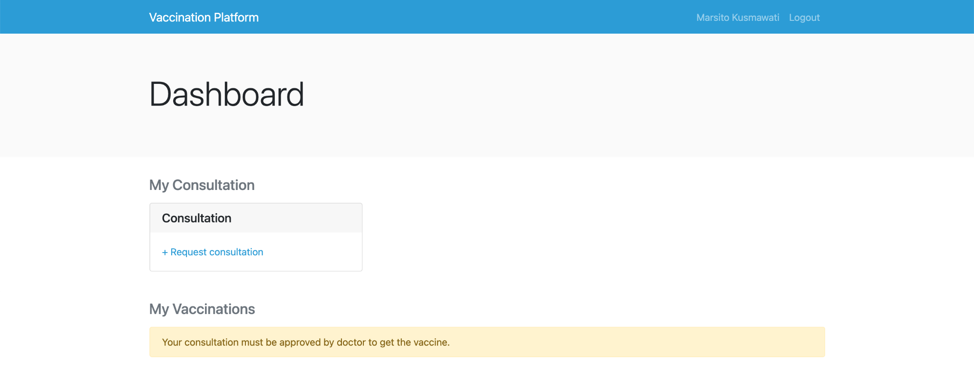

Scenario: B2a - Consultation section is displayed

Given I am on dashboard page

Then I see the consultation section with “My Consultation” title

Scenario: B2b - Link to request consultation appears when society hasn’t consultation before

Given I am on dashboard page

And I haven’t request consultation before

Then I see request consultation link in the consultation section

Scenario: B2c - Show consultation info

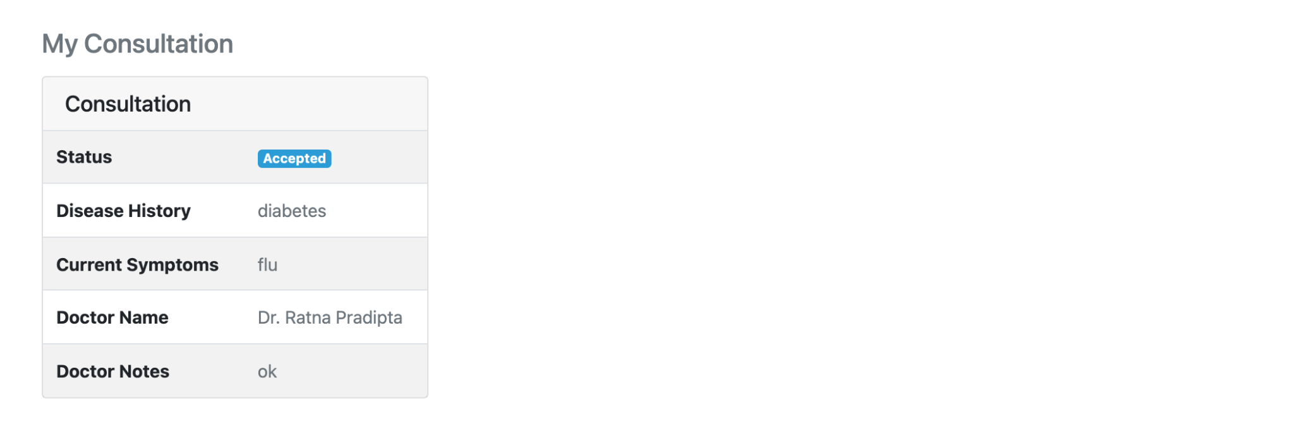

Given I am on dashboard page

And my request consultation is sent or accepted/rejected by doctor

Then I see consultation info in the consultation section

Scenario: B2d - Vaccination list section is displayed

Given I am on dashboard page

Then I see the vaccination list section with “Vaccinations” title

Scenario: B2e - Show vaccination info message

Given I am on dashboard page

And I haven’t request consultation before

Then I see “Your consultation must be approved by doctor to get the vaccine” in the vaccination list section

Scenario: B2f - The first vaccination box is displayed when society consultation have been accepted by doctor

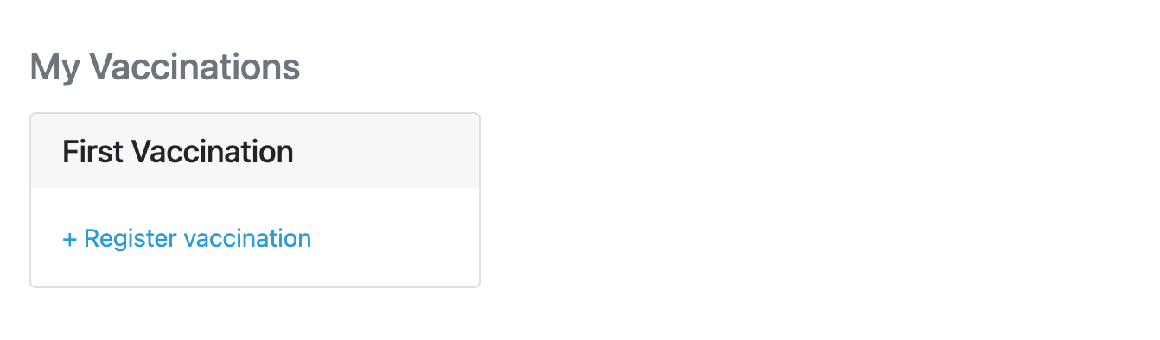

Given I am on dashboard page

And I my request consultation has been accepted by doctor

Then I see the first vaccination box with link is displayed in the vaccination list section

Scenario: B2g - The second vaccination box is displayed when the first vaccination is finished

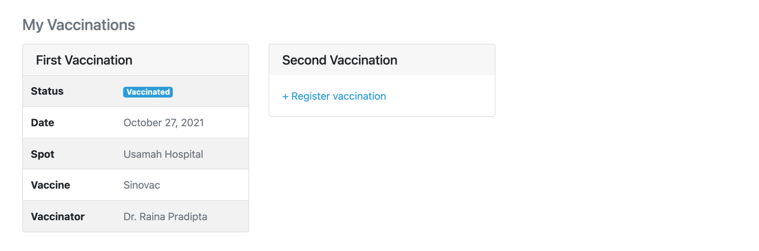

Given I am on dashboard page

And my first vaccination is finished

Then I see the second vaccination box with link is displayed in the vaccination list section

Scenario: B2h - The vaccinations box show vaccination info correctly when vaccination is finished

Given I am on dashboard page

And my first or second vaccination is finished

Then I see vaccination info (status, date, spot, vaccine, and vaccinator) in the vaccination box

# Request Consultation

In the consultation request page, the society can fill in the history of the disease and current symptoms if they have by selecting "Yes, I have" in each dropdown question.

## Specifications :

Feature: B3 - Society Consultation: as a society, i want to request consultation.

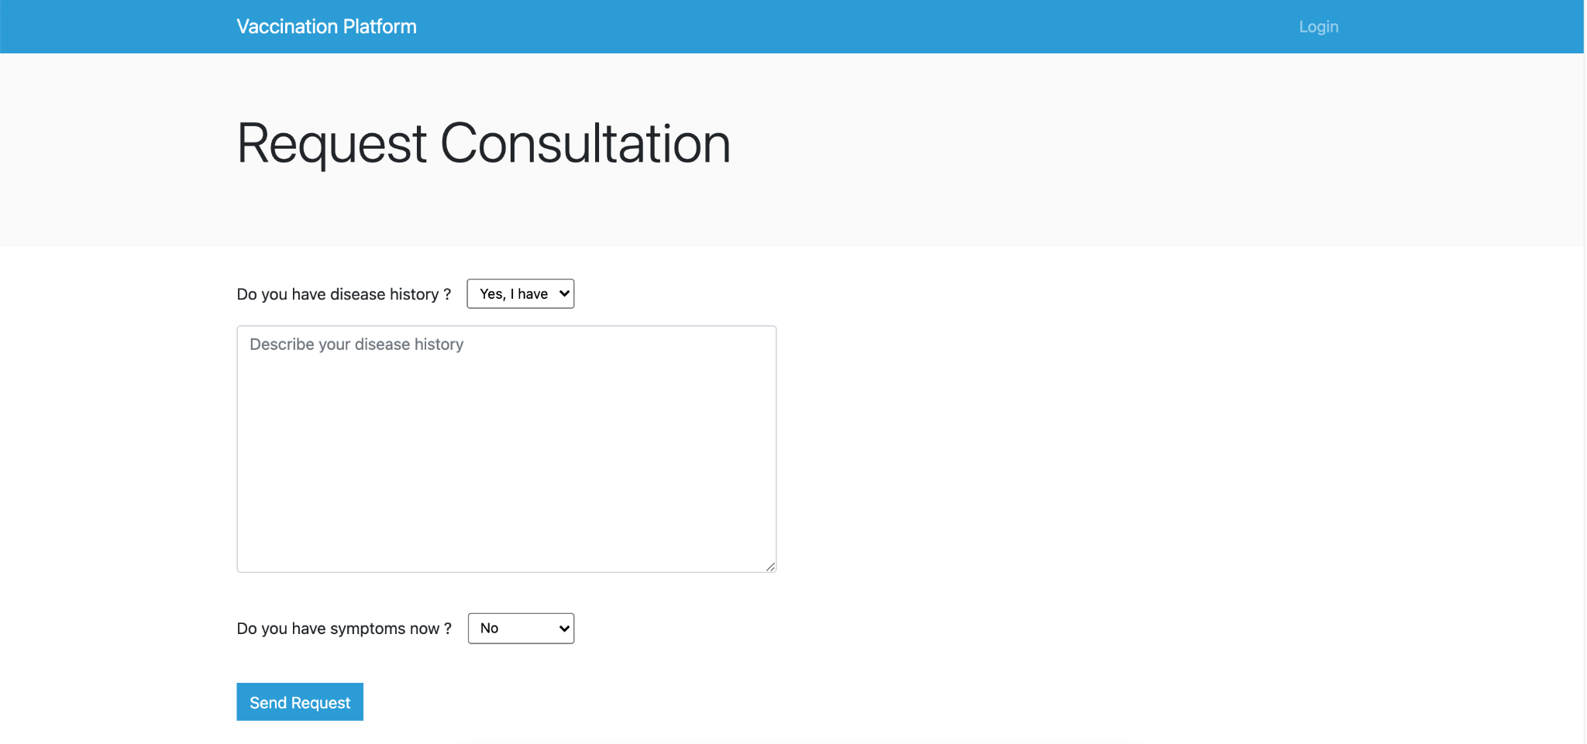

Scenario: B3a - Consultation form is displayed correctly

When I press “Request consultation” button in the dashboard page

Then I see the consultation form (disease history and current symptoms) is displayed

Scenario: B3b - Show textarea form by choosing “Yes, I have”

Given I am on request consultation page

Then I select “Yes, I have” of dropdown in each consultation form, then the textarea will be displayed.

Scenario: B3c - Request consultation successful

Given I am on request consultation page

And I press request button

Then the request consultation is sent, the “Request consultation successful” message is appear, and I redirected to dashboard page

# Vaccination Spots List

When the society registers for vaccination by pressing the "Register vaccination" button on the dashboard page, the society is directed to the list vaccination spot page to select a vaccination spot. In the item spot, display the vaccines available in that spot correctly.

Vaccination spot are displayed by society region. In each place the vaccine has a different service where :

* Serve 1 : only first vaccination
* Serve 2 : only second vaccination
* Serve 3 : both

So, make the vaccination spot unavailable when the vaccination registration cannot be served by the vaccination spot.

## Specifications :

Feature: B4 - Vaccination Spots List: as a society, I want to see a list of vaccination spots by my region.

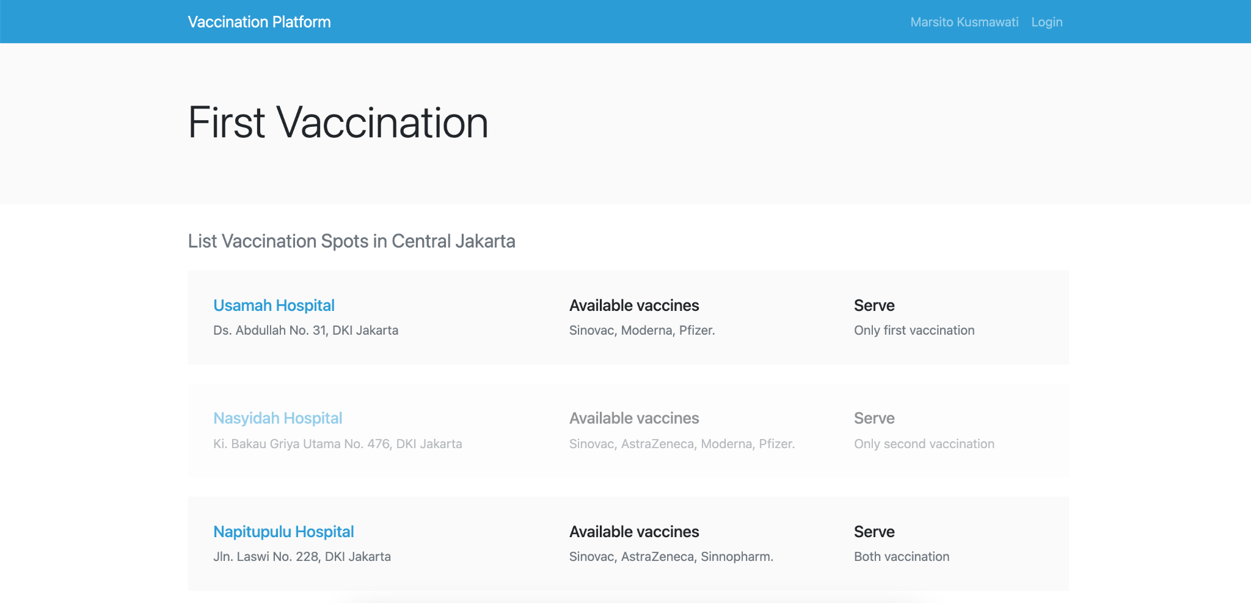

Scenario: B4a - Show list vaccination spots by society region

Given I am on vaccination spot list page

Then I see a list of vaccination spots in my region

Scenario: B4b - Show spot information for each spot item

Given I am on vaccination spot list page

Then I see spot information (spot name, address, available vaccines, and serve) in each spot item.

Scenario: B4c - Spot item unavailable when the spot can’t be serve

Given I am on vaccination spot list page

Then I see spot that can’t be serve unavailable

# Detail Vaccination Spot

In the vaccination spot detail page, there are the 3 sessions :

* Session 1 : 09.00 - 11.00
* Session 2 : 13.00 - 15.00
* Session 3 : 15.00 - 17.00

In each section box, there is a queue order that has been divided based on the number of capacity at the vaccination spot. For example, if the capacity of the vaccination spot is 15, so in each section box there are 5 slots.

## Specifications :

Feature: B5 - Detail Vaccination Spot: as a society, I want to see detail of vaccination spot and see how many registrations at the spot based on the selected date.

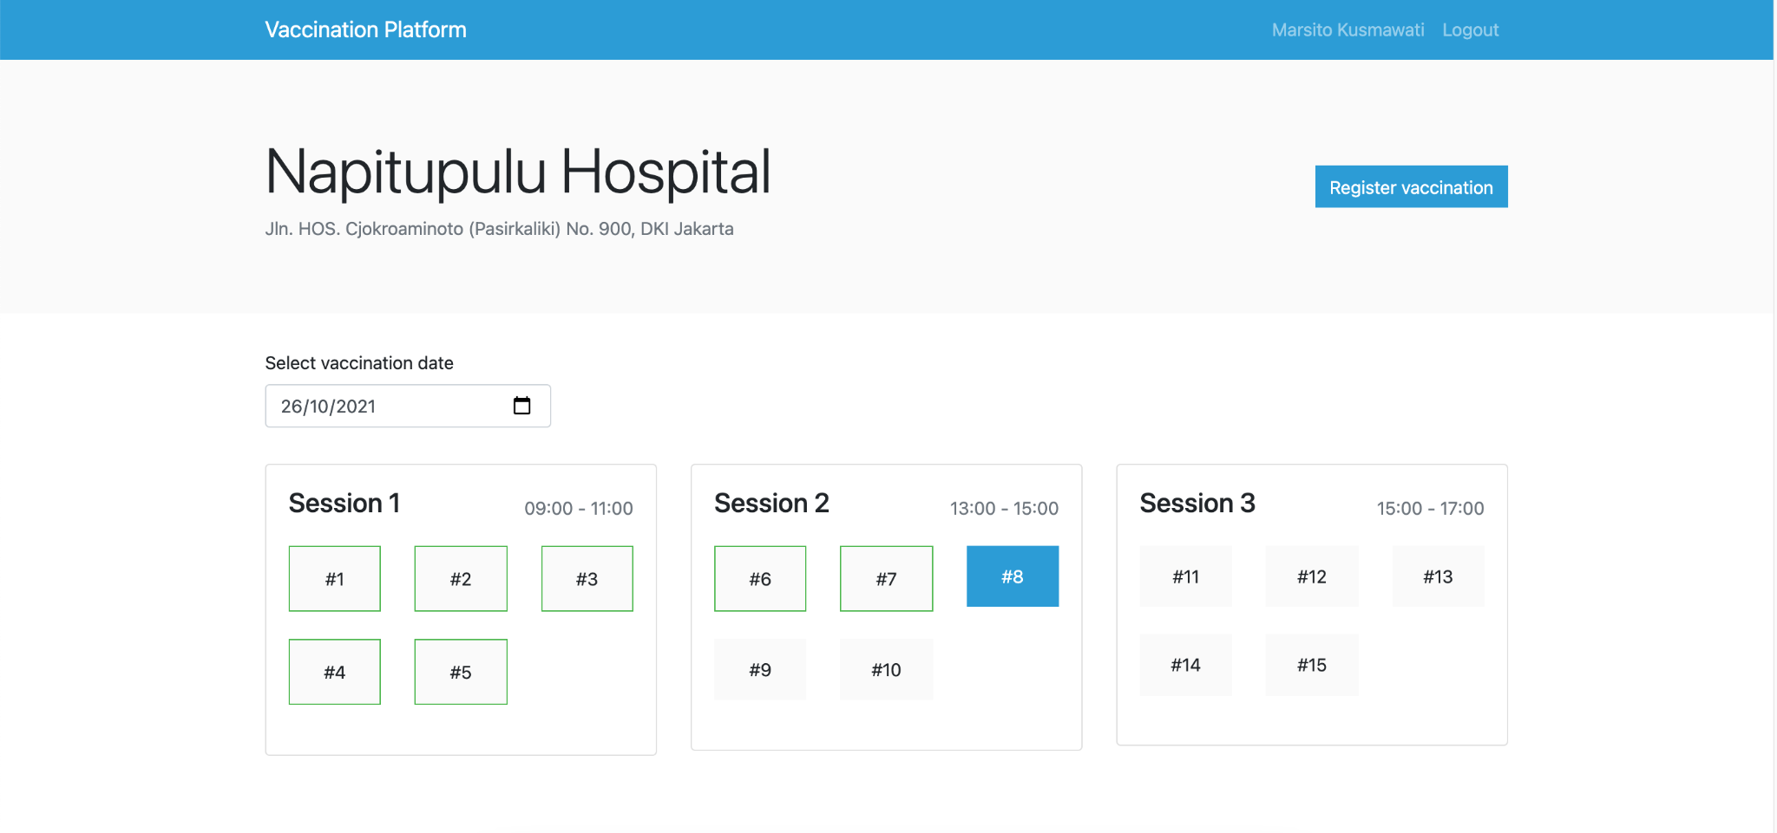

Scenario: B5a - Three sections and slots displays correctly

Given I am on vaccination spot detail page

Then I see three sections with slots that have been divided according to the capacity of the vaccine spot is displayed correctly. For example, if spot capacity is 15, so, in each section each has 3 slots.

Scenario: B5b - Can see vaccinations info by choosing date

Given I am on vaccination spot detail page

And I select a date

Then I see how many vaccination slots have been booked on the selected date at that spot

Scenario: B5c - Mark other society vaccinations by green border

Given I am on vaccination spot detail page

Then I see the slots that filled with other society’s vaccinations green border

Scenario: B5d - Mark my vaccination slot by blue background

Given I am on vaccination spot detail page

Then I see the slot that i will is blue background

Scenario: B5e - Register vaccination

Given I am on vaccination spot detail page

And I press “Register vaccination” button

Then the success or error message is appear and I redirected to dashboard page

**Notes**:

* For each response from the REST API must be displayed.

# ERD

You can use and improve ERD below:

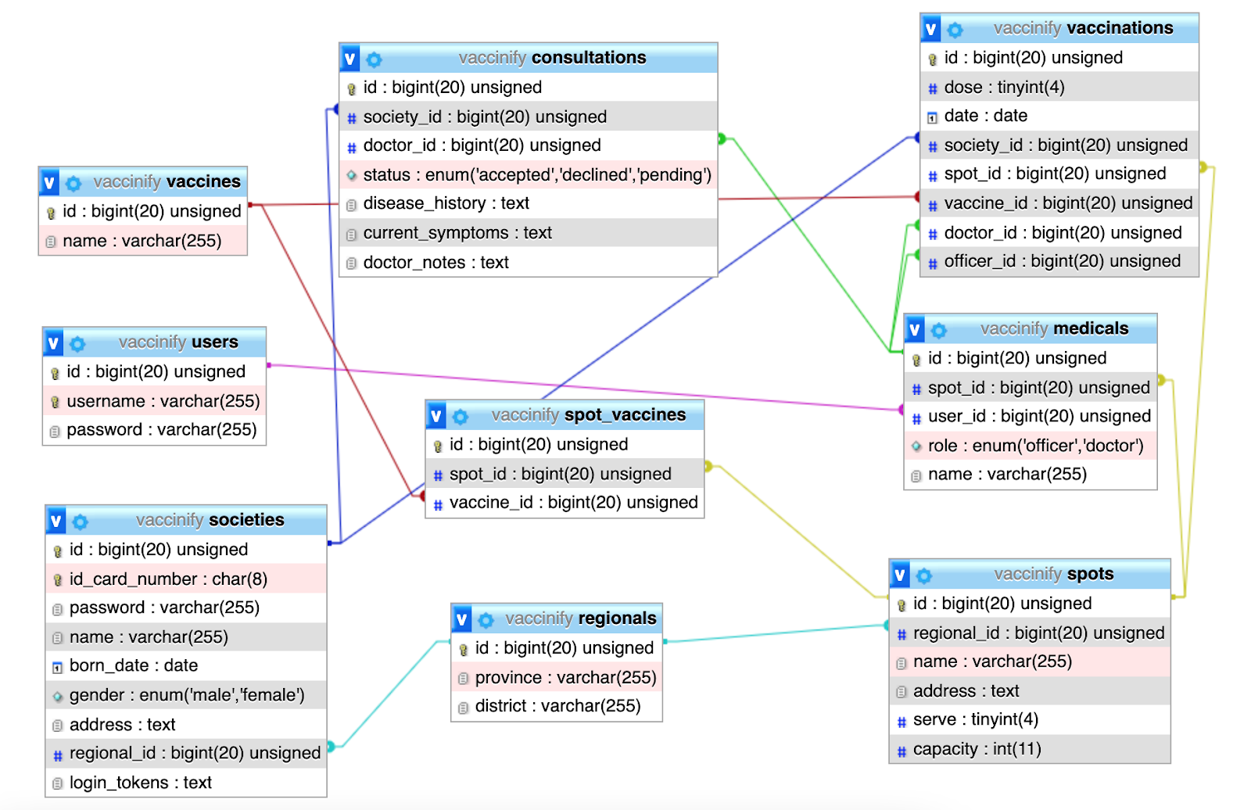

# INSTRUCTION FOR COMPETITORS

* Save your work in the "frontend" folder : **XX_module_frontend**

## Use the gui templates provided in the media files.

## For this module, you must use one of the available frameworks provided. Applications developed without use of any of these frameworks will not be considered. You should take advantage of the framework as much as possible.

Note : **XX** is competitor number.