**REST API MODULE**

# CONTENTS

## This module has the following files:

1. MODULE_REST_API.doc
2. MODULE_REST_API_MEDIA.zip

# INTRODUCTION

We know that the pandemic is not over yet and vaccination is something that must be done to be able to reduce the death rate against the COVID-19 attack. So the government appoints you as a competent person to create a vaccination registration platform.

The goal of this platform is so that societies can register vaccinations on the platform without having to come to the vaccine spot directly and can also see when and where society can come to the vaccine spot.

# DESCRIPTION OF PROJECTS AND TASKS

Vaccination registration involves the society platform (request consultation and register first/second vaccination), doctor platform (see and accept/reject consultation from society), and officer platform (update vaccination data from society such as giving vaccines and determining who the vaccinator is).

But your scope of work on this module is only to **create a society platform**. Your job is creating a Society Vaccination REST API using provided PHP frameworks (Laravel).

# REST API

## Authentication

Before a society performs any activity on the society platform, they must be logged in using their **ID card number and password**. After successfully logging in, the token will be automatically generated from the **md5 of society ID card number**.

## Specifications :

Feature: A1 - Login and Logout as society: as a visitor, i want to login so that i can enter the system and register a vaccination.

Scenario: Society Login

Request:

URL: [domain]/api/v1/auth/login

Method: POST

Header:

Body: { id_card_number: “SomeText”, password: “SomeText” }

Response:

A1a - If login success

Header: Response code: 200

Body: {

"name": "Siti Puspita",

"born_date": "1974-10-22",

"gender": "male"|”female”,

"address": "Ki. Raya Setiabudhi No. 790",

"token": "e96aaafb6f2f76460b8cc93723bd030e",

"regional": {

"id": 1,

"province": "DKI Jakarta",

"district": "Central Jakarta"

}

}

A1b - If ID Card Number or Password incorrect

Header: Response code: 401

Body: { "message": "ID Card Number or Password incorrect" }

Scenario: Society Logout

Request:

URL: [domain]/api/v1/auth/logout

Params: { token }

Method: POST

Header:

Body:

Response:

A1c - If logout success

Header: Response code: 200

Body: { "message": "Logout success" }

A1d - If logout invalid token

Header: Response code: 401

Body: { "message": "Invalid token" }

# Request Consultation

To be able to register a vaccine, the society must consult with a doctor on the platform first. The society can view consultation status and make consultation requests. The society can only make one vaccination request.

## Specifications:

Feature: A2 - Request Consultation: As a society, I want to request consultation so that I can register for vaccination when my consultation is accepted.

Scenario: Request consultation

Request:

URL: [domain]/api/v1/consultations

Params: { token }

Method: POST

Header:

Body: { disease_history: “SomeText”, current_symptoms:

“SomeText” }

Response:

A2a - If request consultation success

Header: Response code: 200

Body: { "message": "Request consultation sent successful" }

A2b - If invalid token

Header: Response code: 401

Body: { "message": "Unauthorized user" }

Scenario: Get society consultation

Request:

URL: [domain]/api/v1/consultations

Params: { token }

Method: GET

Header:

Body:

Response:

A2c - If success

Header: Response code: 200

Body: {

“consultation”: {

"id": 1,

"status": "pending”|”accepted”|”rejected",

"disease_history": "SomeText”|null,

"current_symptoms": "SomeText"|null,

"doctor_notes": “SomeText”|null,

"doctor": { DOCTOR }|null

}

}

A2d - If invalid token

Header: Response code: 401

Body: {"message": "Unauthorized user"}

# Vaccination Spot

When the consultation has been accepted by the doctor and society will register the vaccination, the society can choose the vaccination spot based on the society region. List of available vaccines at each vaccine spot should also be displayed.

In the spot detail, calculate the number of vaccination registrations at that spot and on the requested date in the date param (optional and default today).

**Specifications**:

Feature: A3 - Vaccination Spot: As a society, I want to see vaccination spots in my region.

Scenario: Get all vaccine spots by society region

Request:

URL: [domain]/api/v1/spots

Params: { token }

Method: GET

Header:

Body:

Response:

A3a - If success

Header: Response code: 200

Body: {

“spots”: [

{

"id": 1,

"name": "Purnawati Hospital",

"address": "Jr. Gotong Royong",

"serve": 1|2|3,

"capacity": 15,

"available_vaccines": {

"Sinovac": true,

"AstraZeneca": false,

"Moderna": true,

"Pfizer": true,

"Sinnopharm": false

}

},

...,

]

}

A3b - If invalid token

Header: Response code: 401

Body: { "message": "Unauthorized user" }

Scenario: Get spot detail by spot ID and date

Request:

URL: /api/v1/spots/<spot_id>

Params: { token, date (optional and default today) }

Method: GET

Header:

Body:

Response:

A3c - If success

Header: Response code: 200

Body: {

"date": "October 21, 2021",

"spot": {

"id": 1,

"name": "Purnawati Hospital",

"address": "Jr. Gotong Royong No. 264",

"serve": 2,

"capacity": 15

},

"vaccinations_count": 12

}

A3d - If invalid token

Header: Response code: 401

Body: { "message": "Unauthorized user" }

# Vaccination Registration

The society can register for vaccination if the society consultation has been accepted by the doctor. At the vaccination register, if the society has finished the first vaccination, it will automatically register the second vaccination.

Society can register for a second vaccination on condition that they have to wait 30 days after the first vaccination day and each society can only register for vaccination 2 times. Society can be said to be vaccinated if it has received a dose of the vaccine.

Spot ID and date must be filled where the date format is *YYYY-MM-DD*.

## Specifications:

Feature: A4 - Vaccination: as a society, i want to register vaccination and get all vaccination data.

Scenario: Register Vaccination

Request:

URL: /api/v1/vaccinations

Params: { token }

Method: POST

Header:

Body: { spot_id: 1, date: “2021-10-26” }

Response:

A4a - If success

Header: Response code: 200

Body: { "message": "First|Second vaccination registered

successful" }

A4b - If invalid token

Header: Response code: 401

Body: { "message": "Unauthorized user" }

A4c - If the society consultation hasn’t accepted by doctor

Header: Response code: 401

Body: { "message": "Your consultation must be accepted by doctor before" }

A4d - If invalid fields

Header: Response code: 401

Body: {

"message": "Invalid field",

"errors": {

"date": [

"The date does not match the format Y-m-d."

],

"spot_id": [

"The spot id field is required."

]

}

}

A4e - If 2nd vaccination < 30 days from 1st vaccination

Header: Response code: 401

Body: { "message": "Wait at least +30 days from 1st

Vaccination" }

A4f - If have been 2x vaccinated

Header: Response code: 401

Body: { "message": "Society has been 2x vaccinated" }

Scenario: Get all of society vaccinations

Request:

URL: [domain]/api/v1/vaccinations

Params: { token }

Method: GET

Header:

Body: Response:

A4g - If success

Header: Response code: 200

Body: {

“vaccinations”: {

"first": {

"queue": 1,

"dose": 1,

"vaccination_date": "2021-10-21",

"spot": {

"id": 1,

"name": "Purnawati Hospital",

"address": "Jr. Gotong Royong",

"serve": 2,

"capacity": 15,

"regional": {

"id": 1,

"province": "DKI Jakarta",

"district": "Central Jakarta"

}

},

"status": "done",

"vaccine": {

"id": 1,

"name": "Sinovac"

},

"vaccinator": {

"id": 1,

"role": "doctor",

"name": "Dr. Halima Yuniar"

}

},

"second": <VACCINATION>|null

}

}

A4h - If invalid token

Header: Response code: 401

Body: { "message": "Unauthorized user" }

# ERD

You can use and improve ERD below:

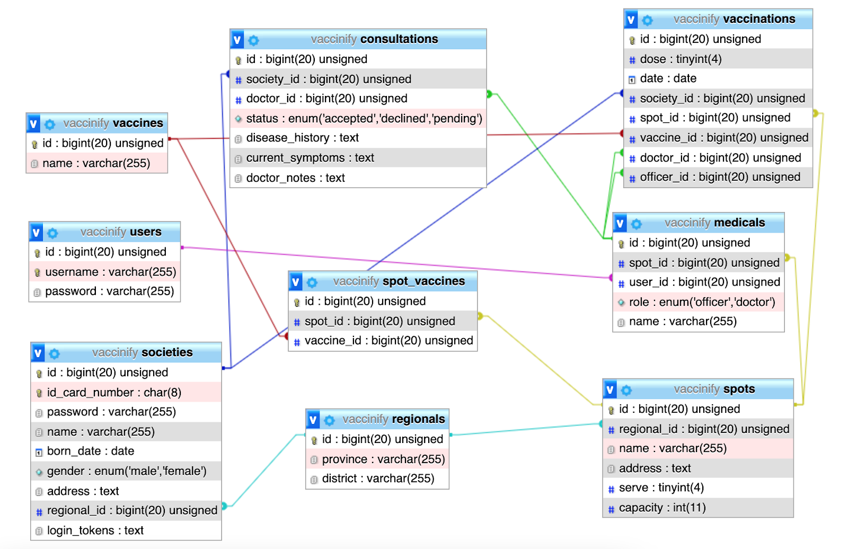

# INSTRUCTION FOR COMPETITORS

* Import the database that has been provided in db-dump in the media files folder.
* Save your work in the "rest_api" folder **XX_module_rest_api**

## Postman environment and collection provided in REST_API_MEDIA/postman/

## You can check community accounts based on vaccination stages by looking at the accounts that have been provided in the folder REST_API_MEDIA/account/

## Use the gui templates provided in the media files.

## Create/generate a DB-diagram named “db-diagram.xxx” (xxx is the extension/type of the file eg. pdf or jpg) and put it into the directory mentioned above. Example:

## For this module, you must use one of the available frameworks provided. Applications developed without use of any of these frameworks will not be considered. You should take advantage of the framework as much as possible.