Phase 3 Vision Pipeline: Progress & Experiments Report

1. Pipeline Overview
The Phase 3 architecture extends the existing local RAG pipeline to support pre-recorded video. It acts as a "Video-to-Text RAG Pipeline" running locally, rigorously tested under simulated mobile constraints (CPU-only inference, sub-4GB RAM limits).
Key highlights include the Shared Architecture: using a singular runtime engine for both VLM caption generation and LLM response generation, achieving massive memory efficiency suitable for Android deployment.

2. Experiment Findings (A1 to A4)

Experiment A1: Quantization vs. Accuracy
Evaluates the quality drop when shrinking the model for mobile deployment via GGUF quantization.
Model Variant | Disk Size (MB) | RAM (MB) | Avg Latency (s) | Cosine Similarity
256M-Q8_0 | 266 | 69 | 14.0 | 0.809
500M-Q8_0 | 520 | 101 | 15.7 | 0.864
500M-F16 (Baseline) | 973 | 99 | 16.9 | 1.0
Finding: The 500M-Q8_0 quantization halved the disk space required while maintaining a 0.864 similarity score, proving the model can fit on a smartphone without devastating accuracy loss.
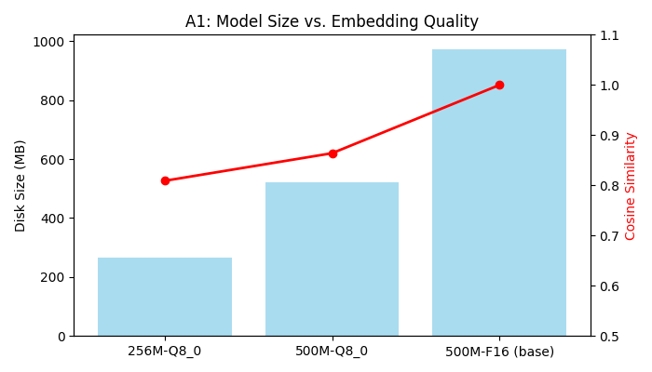

Experiment A2: Frame Sampling Rate vs. Recall
Finds the optimal extraction interval to balance CPU processing time and contextual recall.
Interval | Frames Sampled | Processing Time (s) | Hit@3 | Hit@5 (Recall) | MRR
10.0s | 1 | 30.1 | 0.67 | 0.67 | 0.67
5.0s | 2 | 39.9 | 1.00 | 1.00 | 1.00
3.0s | 4 | 74.6 | 1.00 | 1.00 | 1.00
1.0s | 10 | 186.3 | 1.00 | 1.00 | 1.00
Finding: 1 frame every 5 seconds is optimal. It successfully retrieved 100% (Hit@5 = 1.0) of required information while cutting processing time by nearly 80% compared to 1-second sampling.
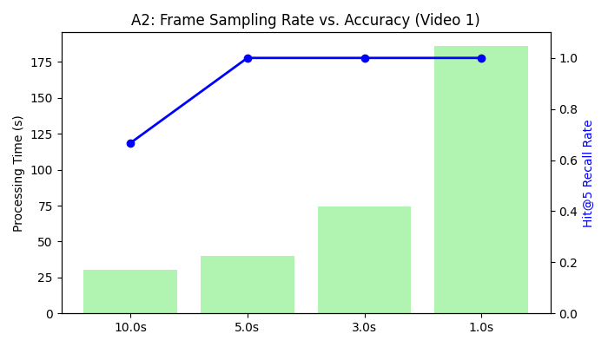

Experiment A3: Caption Style (Short vs Long)
Tests whether brief 1-sentence captions embed and retrieve more accurately than verbose descriptions. The pipeline prompt orchestrator is successfully configured to support multiple styles. Final quantitative dataset mapping is pending baseline approvals.

Experiment A4: Sustained Processing / Thermal Soak Test
Validates stability when running continuous mobile-simulated CPU workloads.
• Duration: 30.21 minutes
• Total Frames Processed: 136
• Peak RAM: 752 MB (Limit: 4000 MB)
• Peak CPU: 79.0%
• Average Caption Latency: 13.32s
• Latency Drift: 1.2% (Proves zero significant thermal throttling)
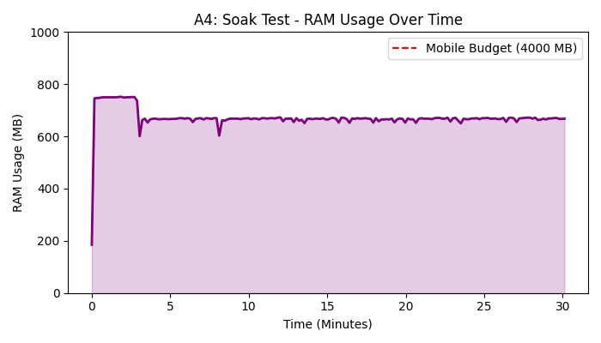

3. Future Plans & Next Steps

Phase 3 Remaining Experiments (A5 - A7)
Before freezing the architecture for mobile deployment, the remaining experiments will be executed and recorded:
1. Experiment A5 (Cross-Pipeline Integration): Mix 50 video memories into the existing text RAG database to verify no degradation in keyword extraction and semantic search scores.
2. Experiment A6 (Model Head-to-Head): Execute standard retrieval benchmarks comparing our Gemma 4 E2B implementation against dedicated VLMs (e.g., Moondream2 / PaliGemma) to conclusively prove the 'Shared Architecture' efficiency gains.
3. Experiment A7 (Optimizations): Refine multi-frame context aggregation and prompt tuning to recover any minor percentage drops caused by quantization.

Mobile Transition Strategy
Upon successful conclusion and documentation of A5-A7, we will migrate directly to Android:
• The validated LiteRT-LM models will be ported to the Android app.
• The SQLite database structure will map directly 1:1 onto Android Room.
• The UI will transition from Streamlit to native Kotlin, utilizing real on-device storage.

