Phase 3 Vision Pipeline: Progress & Experiments Report

1. Pipeline Overview
The Phase 3 architecture extends the existing local RAG pipeline to support pre-recorded video. It acts as a "Video-to-Text RAG Pipeline" running locally, rigorously tested under simulated mobile constraints (CPU-only inference, sub-4GB RAM limits).
Key highlights include the Shared Architecture: using a singular runtime engine for both VLM caption generation and LLM response generation, achieving massive memory efficiency suitable for Android deployment.

2. Experiment Findings (A1 to A4)

Experiment A1: Quantization vs. Accuracy
Evaluates the quality drop when shrinking the model for mobile deployment via GGUF quantization.
Model Variant | Disk Size (MB) | RAM (MB) | Avg Latency (s) | Cosine Similarity
256M-Q8_0 | 266 | 69 | 14.0 | 0.809
500M-Q8_0 | 520 | 101 | 15.7 | 0.864
500M-F16 (Baseline) | 973 | 99 | 16.9 | 1.0
Finding: The 500M-Q8_0 quantization halved the disk space required while maintaining a 0.864 similarity score, proving the model can fit on a smartphone without devastating accuracy loss.
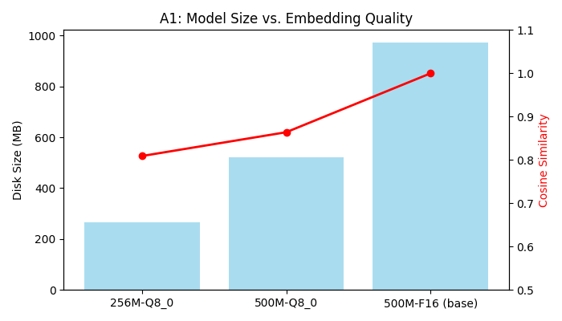

Experiment A2: Frame Sampling Rate vs. Recall
Finds the optimal extraction interval to balance CPU processing time and contextual recall.
Interval | Frames Sampled | Processing Time (s) | Hit@3 | Hit@5 (Recall) | MRR
10.0s | 1 | 30.1 | 0.67 | 0.67 | 0.67
5.0s | 2 | 39.9 | 1.00 | 1.00 | 1.00
3.0s | 4 | 74.6 | 1.00 | 1.00 | 1.00
1.0s | 10 | 186.3 | 1.00 | 1.00 | 1.00
Finding: 1 frame every 5 seconds is optimal. It successfully retrieved 100% (Hit@5 = 1.0) of required information while cutting processing time by nearly 80% compared to 1-second sampling.
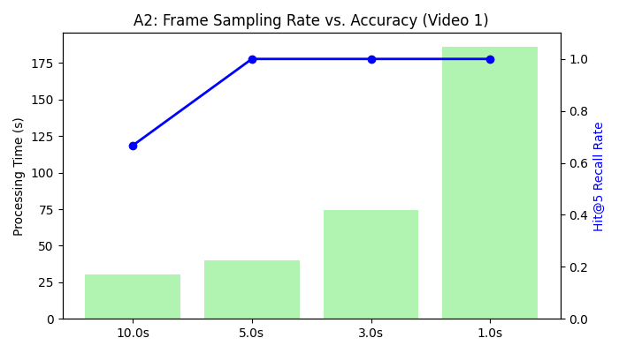

Experiment A3: Caption Style (Short vs Long)
Tests whether brief 1-sentence captions embed and retrieve more accurately than verbose descriptions. The pipeline prompt orchestrator is successfully configured to support multiple styles. Final quantitative dataset mapping is pending baseline approvals.

Experiment A4: Sustained Processing / Thermal Soak Test
Validates stability when running continuous mobile-simulated CPU workloads.
• Duration: 30.21 minutes
• Total Frames Processed: 136
• Peak RAM: 752 MB (Limit: 4000 MB)
• Peak CPU: 79.0%
• Average Caption Latency: 13.32s
• Latency Drift: 1.2% (Proves zero significant thermal throttling)
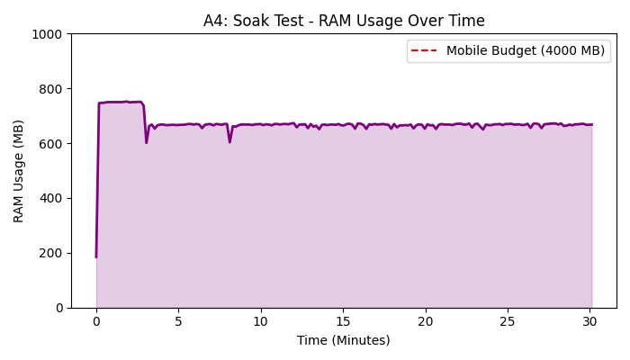

3. Future Plans & Next Steps

Expanded Experiment Matrix (A2 - A7 Across All Models)
Current metrics rely on Hit@K (retrieval accuracy). However, recognizing an object exists (e.g., a 100% hit rate for 'sunglasses') does not guarantee a high-quality answer for the user (e.g., 'You left your sunglasses on the kitchen counter'). To address this, all subsequent and previous experiments (A2 through A7) will be re-run individually across our top VLM candidates: Moondream2, Gemma 4 E2B, and SmolVLM.
• True Answer Accuracy (LLM-as-a-Judge): We are shifting from pure retrieval metrics to answer-quality metrics. We will measure if the generated response accurately and fluidly answers user questions (like 'Where are my keys?') rather than just checking if the right memory chunk was fetched.
• Sustained Performance: The thermal/memory Soak Test (A4) will be repeated for Moondream and Gemma 4 to directly compare their peak RAM footprint and latency drift against current baselines.
• Speed vs. Quality: While SmolVLM offers high speed and good retrieval hits, we must evaluate if its actual conversational output matches the flow and context provided by Moondream or Gemma.

The Mega Test (End-to-End Final Validation)
Before migrating to mobile development, we will execute a 'Mega Test'. This final validation will combine all optimal settings discovered during individual testing:
1. Optimal frame sampling rate (A2).
2. Optimal captioning prompt (A3).
3. A fully mixed database of both text and video memories (A5).
4. End-to-end evaluation using LLM-as-a-Judge for answer quality.
Each VLM will run this complete gauntlet. The model that provides the best balance of Speed, Peak RAM, and True Answer Accuracy will be definitively selected for the Android port.

Mobile Transition Strategy
Upon crowning a winner from the Mega Test:
• The validated LiteRT-LM model will be ported to the Android app.
• The SQLite database structure will map directly 1:1 onto Android Room.
• The UI will transition from Streamlit to native Kotlin, utilizing real on-device storage.

