EYKON · DEFENSE NOTES · HEAD 2 OF THE PIPELINE

Setup & storage
Where the vectors live, how the tables are shaped, and the ground rules that keep the laptop and the phone in step.
Last updated | 4 Nov 2026
Overall status | Built and in the app. Re-tested on two phones with real vectors. Memory limit found; plan for it still open.
Cards | EYKO-1 (tables), EYKO-31 (storage test), EYKO-30 (pytest), EYKO-90 (size sweep), EYKO-100 (full test), EYKO-102 (faster search in app)
HOW TO USE THIS DOCUMENT
Part A · The card | 2-minute refresh. Read this the night before.
Part B · The story | How the work went, step by step. Use it to explain the Head out loud.
Part C · Hard questions | What a strict examiner will ask, what to say, and what to show.
Part D · Evidence | The tables and graphs to put in front of the professor. Every claim in A–C points here (E1, E2 …).
Part E · Words & gaps | Plain meanings of the technical words, the open gaps, and how to update this doc.

Part A · The card
IN ONE BREATH
Everything the app remembers lives in one SQLite file on the phone. We planned to use a vector plugin (sqlite-vec), but Android blocks every SQLite plugin, so we store vectors as plain bytes (BLOBs), load them into memory once, and compare the query against every one of them. That is fast enough. Memory, not speed, is now the limit.
WHERE IT SITS IN THE PIPELINE
Record video | → Job queue | → Frames: split, filter, dedup | → Scene: objects, place, action | → Vectors: image + text | → Search
HEAD 2 · one SQLite database that every stage above writes into and reads from
It comes first because every later stage depends on it. Nothing feeds into it; everything builds on it.
WHAT · WHY · RESULT
What we did | Why | Result
Tested sqlite-vec on real phones. It failed, so we used plain byte columns searched in memory. One table design, shared by laptop and phone, with raw SQL. | The database shape had to be fixed before anything else could be built. Same design and same SQL on both sides means laptop experiments carry over to the phone. | The app's whole search: 302 ms for 20k frames on the cheap phone (was 1.3 s), same results. All three vector tables fit up to 20k rows each and run out of memory at 50k.
NUMBERS TO REMEMBER
302 ms  the app's whole search, 20k frames, cheap phone (A32). Was 1.3 s.  Show: E6 · Head 7 | 4.3×  faster app search after fixing our own code. 2,400 of 2,400 hits identical.  Show: E6, E7 · Head 7 | 268 MB  memory Android gives the app. The real ceiling.  Show: E8 | 20k ✓ 50k ✗  rows per table that fit with all three tables loaded  Show: E8
DECISIONS AND THE REASON FOR EACH
Decision | Because | Show
Vectors are float32 BLOBs, loaded into memory once, searched by dot product. No sqlite-vec. | sqlite-vec does not load on Android. BLOBs in memory took 81 ms at 20k on the cheap phone; reading them from SQLite on every search took 1.4 s. | E2, E4, E5
src/video_memory/schema.py is the single table design; the phone copies it. | One design in two languages, so they cannot drift apart. | E9
Raw SQL, no ORM (no Room entities). | The same SQL statements run on the laptop and the phone. | E1
pytest as the laptop test runner (EYKO-30). | One runner: task test, task smoke. | —
AGPL / research-only models allowed while academic. | Needed for YOLOE (Head 5). Must be re-decided before any release. | —
WEAK SPOTS: SAY THESE BEFORE THEY FIND THEM
OPEN | Never tried shipping our own SQLite, the only way left to run sqlite-vec on Android (EYKO-93).
OPEN | No chosen plan yet for libraries past 20k–50k frames (EYKO-98).
PARTLY | The 200 ms pass mark and the "1 hour of video a day" estimate have no source yet (EYKO-101).
OPEN | Hot phone and low battery not measured; runs were on phones plugged in by cable (EYKO-95).
PARTLY | The whole search in the app is still 302 ms on the cheap phone at 20k, and the first search after opening takes 2.0 s.

Part B · The story
How the work actually went, in order. Each step is one thing that happened, with the evidence to point at.
1 | QUESTION  Where do the vectors live?  Every kept frame becomes 512 numbers (image vector) and every caption 384 numbers (text vector). Every later stage reads and writes them, so this had to be settled first.
2 | RULE SET BEFORE TESTING  Pass mark fixed in advance  Plan: use sqlite-vec. If it fails on a phone, fall back to plain BLOBs, but only if one search takes under 200 ms for 20,000 vectors on the slow phone. The 200 ms was our own target (no source yet: EYKO-101). Fixing the bar first means the result cannot be argued into a decision afterwards.
3 | TEST · 12 OCT · EYKO-31  sqlite-vec failed on the phone  On the Samsung A32: "no such module: vec0". It worked on the laptop (31 ms at 20k), but not on Android.  Show: E2, E3
4 | FALLBACK · 12 OCT  BLOBs in memory passed: 81 ms  Load each vector table into memory once, then compare by dot product. 81 ms at 20k, under our own 200 ms target. Reading the vectors from disk on every search took 1.4 s, so that option was rejected.  Show: E1, E2
5 | DECISION · 12 OCT  BLOBs + raw SQL, same on laptop and phone  One table design in schema.py, copied into the phone app. No ORM, so the same SQL runs on both sides.  Show: E9
6 | RE-CHECK · 3 NOV  Same result on a second, high-end phone  Pixel 9 Pro XL (Android 17) fails the same way as the A32. Times repeat: A32 83.5 ms vs 81 ms the first time.  Show: E4
7 | FULL TEST · 4 NOV · EYKO-100  Android blocks every plugin, not just sqlite-vec  Even a made-up plugin name gives "no such function: load_extension". Real vectors from our own clips are as fast as random ones. 5 runs × 20 queries, two phones.  Show: E5, E6
8 | IMPROVEMENT · EYKO-100 → 102  Our own loop was the slow part  In the test, a smarter loop (four running sums, keep only the best 20) gave the same top 20 on 400 of 400 checks, 5.9× faster at 100k (537 → 91 ms). The app took the four running sums plus a faster ranking (it needs every frame's score to grow its time windows, so it cannot keep only 20): whole search 4.3× faster on the A32 at 20k, 2,400 of 2,400 hits identical (Head 7).  Show: E6, E7
9 | LIMIT FOUND · 4 NOV  Memory runs out between 20k and 50k rows  With all three vector tables loaded, 20k rows each fit, 50k does not. Android gives the app 268 MB, on the 6 GB A32 and on the 16 GB Pixel alike.  Show: E8
10 | STILL OPEN  What comes next  Try shipping our own SQLite (EYKO-93). Choose a plan past 20k, such as smaller vectors or one table in memory (EYKO-98). Find sources for the 200 ms target and the usage estimate (EYKO-101).

Part C · Hard questions
What a strict examiner will ask about this Head. Status: ANSWERED proof you can show PARTLY some proof, gaps named OPEN not tested yet
ALL QUESTIONS AT A GLANCE
# | Question | Status | Closes with
A1 | Did you actually run sqlite-vec on a phone, or just read about it? | ANSWERED | EYKO-94
A2 | Is that a sqlite-vec problem or an Android problem? | ANSWERED | EYKO-89 (official reason)
A3 | Android apps can ship their own SQLite. Did you try that? | OPEN | EYKO-89, EYKO-93
A4 | Did it fail only on one phone? | PARTLY | EYKO-94
A5 | Do sqlite-vec and your BLOB search return the same results, or is one just faster? | OPEN | EYKO-91, EYKO-93
B1 | One run? What is the spread? | ANSWERED | EYKO-95
B2 | Why only up to 20,000 vectors? When does a real user reach that? | PARTLY | EYKO-101
B3 | Random vectors are not real ones. Does it hold with real data? | ANSWERED | —
B4 | 112 MB of memory for one table. What about all three tables, on a 4 GB phone? | PARTLY | EYKO-95, EYKO-98
B5 | The phone is about 50× slower than the laptop. Is that the chip or your code? | PARTLY | EYKO-91
B6 | Does a hot phone or a low battery slow it down? | OPEN | EYKO-95, EYKO-90
B7 | Brute force will not scale. What is the plan past the limit? | PARTLY | EYKO-98
B8 | Why was reading from disk twice as slow on the Pixel as on the cheaper A32? | OPEN | EYKO-83, EYKO-95
C1 | Prove the phone and the laptop store the same thing. | PARTLY | EYKO-98
C2 | What does an hour of video cost in storage? | PARTLY | EYKO-96
C3 | What happens if the app is killed in the middle of writing? | PARTLY | EYKO-96
C4 | Why no ORM (Room entities)? | PARTLY | EYKO-98
C5 | You say the tests pass. How many, and what do they cover? | PARTLY | no card yet
D1 | MobileCLIP is research-only and YOLOE is AGPL. Can this ever ship? | OPEN | EYKO-88
D2 | Can someone other than you reproduce the setup? | PARTLY | EYKO-99, EYKO-92
Groups: A = does sqlite-vec really fail · B = speed, size and limits · C = data and design · D = licences and reproducibility.

A · Does sqlite-vec really fail?
A1 Did you actually run sqlite-vec on a phone, or just read about it? ANSWERED
Say this | Yes. On two real phones, on three days: the A32 on 12 Oct, 3 Nov and 4 Nov, the Pixel 9 Pro XL on 3 and 4 Nov. Same two errors every time: "no such module: vec0" and "no such function: load_extension".
Show | E4, E5. Raw logs: docs/results/vectors/proof/*-2026-11-03-logcat.txt, *-2026-11-04-extensions-logcat.txt
If they push | The test is one command from the phone kit, so anyone can rerun it. A screen recording and a third phone are planned.
Closes with | EYKO-94

A2 Is that a sqlite-vec problem or an Android problem? ANSWERED
Say this | Android. Both phones refuse to load any plugin at all, even one with a made-up name. Only modules built into Android's own SQLite work.
Show | E5
If they push | Of fts4, fts5 and rtree, only fts4 is built in. Our keyword index uses fts4, so it is safe.
Closes with | EYKO-89 (official reason)

A3 Android apps can ship their own SQLite. Did you try that? OPEN
Say this | Not yet. Only the built-in SQLite was tried. This is the main open point of the storage decision.
Show | Nothing yet
If they push | Plan: add a bundled SQLite (androidx sqlite-bundled or requery) with an arm64 sqlite-vec build on a throwaway branch, then time it against BLOBs.
Closes with | EYKO-89, EYKO-93

A4 Did it fail only on one phone? PARTLY
Say this | Two phones so far, one cheap and one high-end: Samsung A32 (Helio G80) and Pixel 9 Pro XL (Tensor G4). Same failure on both.
Show | E4
If they push | A third phone, Zara's Infinix, is planned.
Closes with | EYKO-94

A5 Do sqlite-vec and your BLOB search return the same results, or is one just faster? OPEN
Say this | Both are exact searches with no shortcuts, so they should return the same top 20. That has not been checked yet.
Show | Nothing yet
If they push | Do not mix this up with E7: there we did prove our old and new loops give identical results (400 of 400). Planned check: recall@20 against exact numpy search.
Closes with | EYKO-91, EYKO-93

B · Speed, size and limits
B1 One run? What is the spread? ANSWERED
Say this | No: 20 queries × 5 runs after a warm-up, with real vectors. The run medians stay close: at 20k, A32 81.5–83.1 ms, Pixel 37.3–37.9 ms.
Show | E6 and Figures 2–3 (the bars show the range of the 5 runs)
If they push | The phones were plugged in. Controlled runs (cool, hot, low battery, third phone) are planned.
Closes with | EYKO-95

B2 Why only up to 20,000 vectors? When does a real user reach that? PARTLY
Say this | We measured up to 100k with real vectors and 300k with random ones. 20k is where memory says stop when all three tables are loaded. A user reaches 20k in about 25 days and 50k in about 2 months, if they record one hour of video a day.
Show | E6, E8
If they push | The "one hour a day" has no source yet. The rate of about 13.4 kept frames per minute comes from the Ego4D phone run (Head 8).
Closes with | EYKO-101

B3 Random vectors are not real ones. Does it hold with real data? ANSWERED
Say this | For speed, yes. Real vectors from our own clips take the same time: at 20k, A32 82 ms real vs 80 ms random; Pixel 37 vs 40 ms.
Show | E6
If they push | This is expected: an exact dot product does the same work whatever the numbers are. Whether search finds the right frames is a retrieval question (Heads 7 and 8), not a storage one.
Closes with | —

B4 112 MB of memory for one table. What about all three tables, on a 4 GB phone? PARTLY
Say this | We measured all three loaded together. 20k rows each fits (app grows 53 → 160 MB on the A32). At 50k it runs out of memory on both phones. The limit is the 268 MB Android gives the app, the same on a 6 GB and a 16 GB phone.
Show | E8 and Figures 4–5
If they push | A 4 GB phone has not been measured. The Infinix is the next test.
Closes with | EYKO-95, EYKO-98

B5 The phone is about 50× slower than the laptop. Is that the chip or your code? PARTLY
Say this | Mostly our code. In the test, a smarter loop gave the same top 20 on all 400 checks and was 5.9× faster on the A32 at 100k (537 → 91 ms). Its faster scoring is now in the app, with a faster ranking: the whole search got 4.3× faster on the A32 at 20k (1.3 s → 302 ms), identical hits.
Show | E6, E7, Figure 3 · Head 7
If they push | The laptop has not been rerun with the new loop, so the remaining phone-vs-laptop gap is not measured yet.
Closes with | EYKO-91

B6 Does a hot phone or a low battery slow it down? OPEN
Say this | Not measured yet. The 3 Nov Pixel run was charging at 36 °C, so it is not a clean baseline.
Show | E4 (conditions row)
If they push | Planned: cool, hot (after 10 minutes of load) and low-battery runs under a fixed protocol.
Closes with | EYKO-95, EYKO-90

B7 Brute force will not scale. What is the plan past the limit? PARTLY
Say this | Speed is fine up to 100k with the new loop (91 ms on the A32). Memory is the wall, between 20k and 50k rows. The plan is not chosen yet.
Show | E6, E8
If they push | Options: int8 or float16 vectors (¼ or ½ the memory), keep only the image table in memory, load in blocks, an approximate index (usearch, hnswlib), or bundled sqlite-vec. Note the whole app search is still 302 ms on the A32 at 20k.
Closes with | EYKO-98

B8 Why was reading from disk twice as slow on the Pixel as on the cheaper A32? OPEN
Say this | Not explained yet. Reading 20k vectors from SQLite on every search took 3.1–3.5 s on the Pixel vs about 1.6 s on the A32. It does not affect the app, which searches from memory.
Show | E4
If they push | The Pixel was charging, its storage was almost full and it reached 38 °C. We will repeat after freeing storage and under the protocol.
Closes with | EYKO-83, EYKO-95

C · Data and design
C1 Prove the phone and the laptop store the same thing. PARTLY
Say this | There is one table design, copied into the phone. On 4 Ego4D clips the phone and laptop kept the same frames (354 of 372 at the same second), with 99 % the same place and 96 % the same action.
Show | docs/results/2026-10-20-ego4d-baseline.md (On the phone)
If they push | There is no automatic test that the two table designs are identical. That test is planned.
Closes with | EYKO-98

C2 What does an hour of video cost in storage? PARTLY
Say this | One measured point: the database grew about 7 MB for 27.8 minutes of video, with every vector. Frame pictures were 8.8 MB per minute before dropped frames were deleted.
Show | docs/results/2026-10-20-ego4d-baseline.md
If they push | One point is not a trend. At least 4 points on the Infinix are planned.
Closes with | EYKO-96

C3 What happens if the app is killed in the middle of writing? PARTLY
Say this | The job saves which stage it reached and resumes there. A link check fails the job if anything is missing. Tests cover this on laptop and phone.
Show | android/app/src/test, src/androidTest (queue and link tests)
If they push | Nobody has yet killed the app mid-stage on a real phone. Planned: 9 force-stops at 3 stages.
Closes with | EYKO-96

C4 Why no ORM (Room entities)? PARTLY
Say this | So the same SQL runs on the laptop (sqlite3) and the phone (SupportSQLiteDatabase), and the two cannot drift apart.
Show | E1 (Room entities row)
If they push | It is written down but not as a formal ADR, and there is no timing yet.
Closes with | EYKO-98

C5 You say the tests pass. How many, and what do they cover? PARTLY
Say this | 109 laptop-side JVM tests and 104 on-device tests at the 2 Nov gap review.
Show | docs/plans/gap-review-2026-11/00-gap-register.md
If they push | No coverage figure and no CI run log yet.
Closes with | no card yet

D · Licences and reproducibility
D1 MobileCLIP is research-only and YOLOE is AGPL. Can this ever ship? OPEN
Say this | They are allowed while this is an academic project. We will re-decide before any release.
Show | docs/invariants/tooling.md (rule)
If they push | A licence list with a swap-out plan per model has not been written yet.
Closes with | EYKO-88

D2 Can someone other than you reproduce the setup? PARTLY
Say this | The phone kit installs and runs from its README alone, with only adb, on two phones. Using it found three README fixes, which are done.
Show | docs/phone-kit/README.md, kit SHA256SUMS.txt
If they push | Not yet done by another person or on another laptop.
Closes with | EYKO-99, EYKO-92

Part D · Evidence
Open this part when the professor asks "show me". Each item says in one line what it proves, then the table or graph, then the file it came from. Times are per search, in milliseconds.

E1 · Options we considered
What it shows: Why BLOBs in memory won against the other four options.
Option | What it is | Result | Verdict
sqlite-vec | SQLite plugin with a vector table (vec0) | Laptop 31 ms at 20k. Phone: "no such module: vec0"; "no such function: load_extension" | Rejected
sqlite-vec via bundled SQLite | Ship our own SQLite with a native sqlite-vec per chip type | Not attempted: needs a Room upgrade and a native build; no official Android package found | Not tried
BLOBs read every search | Read every vector from SQLite on each search | Phone 1.38 s at 20k (laptop 92 ms) | Rejected
BLOBs in memory | Load each vector table once, dot product in Kotlin / numpy | Phone 81 ms at 20k (laptop 1.5 ms) | Adopted
Room entities / ORM | Map tables to Kotlin classes | Would drift from the laptop's sqlite3 code | Rejected
Source: docs/results/2026-10-12-eyko-31-vector-storage.md

E2 · First test: search speed by method (12 Oct)
What it shows: On the phone, keeping the vectors in memory was about 17× faster than reading them from SQLite on every search (81 ms vs 1.38 s at 20k). Median / worst, random vectors, Samsung A32.
Method | Laptop 5k | Laptop 20k | Phone 5k | Phone 20k
BLOB, read from SQLite every search | 24.1 / 33.6 | 91.8 / 103.3 | 245.8 / 525.0 | 1379.3 / 1460.0
BLOB, already in memory | 0.23 / 0.48 | 1.49 / 1.74 | 15.6 / 49.6 | 81.0 / 127.0
sqlite-vec | 8.4 / 9.6 | 31.0 / 35.0 | does not load | does not load
Source: docs/results/2026-10-12-eyko-31-vector-storage.md
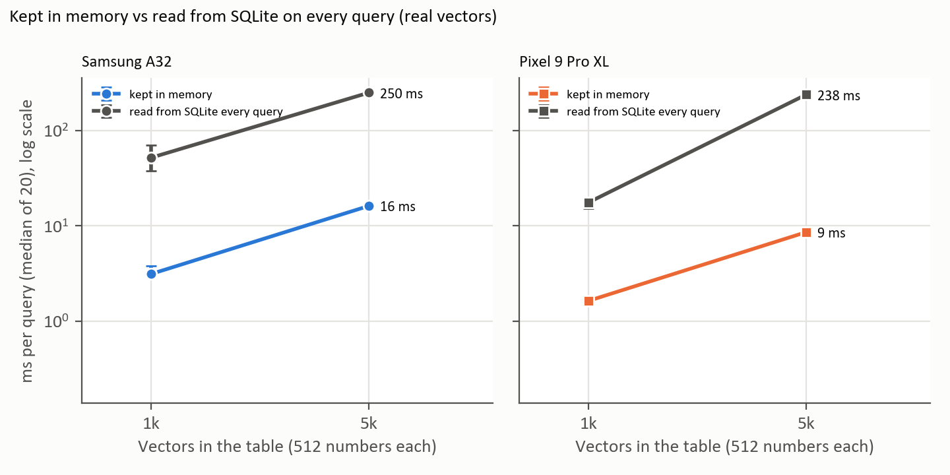
Figure 1. The same comparison repeated on 4 Nov with real vectors on both phones (log scale). Reading from SQLite on every search was timed at 1k and 5k only, because above that one search takes seconds. Source: docs/results/vectors/*-2026-11-04-sweep-real.csv.

E3 · First test: file size, insert time, memory (12 Oct)
What it shows: BLOB files are about twice the size of sqlite-vec files, and one 20k table uses 112 MB of Java memory.
Measurement | 5,000 vectors | 20,000 vectors
Database file, BLOB | 20.5 MB (laptop), 20.6 MB (phone) | 82.1 MB, 82.2 MB
Database file, sqlite-vec (laptop) | 10.6 MB | 42.5 MB
Phone: insert all rows | 1,326 ms | 3,711 ms
Phone: Java memory after the run | 45 MB | 112 MB
Phone: native memory | 10 MB | 10 MB
Source: docs/results/2026-10-12-eyko-31-vector-storage.md

E4 · Re-run on two phones (3 Nov)
What it shows: The failure and the speed repeat on a second, high-end phone with a newer Android.
 | Samsung A32 | Pixel 9 Pro XL
Android / built-in SQLite | 13 / 3.32.2 | 17 / 3.50.6
sqlite-vec (vec0) | no such module | no such module
load_extension | no such function | no such function
20k, BLOB in memory (median / worst) | 83.5 / 114.8 (12 Oct: 81.0 / 127.0) | 40.5 / 148.4
20k, BLOB read from SQLite (median) | 1,521 | 3,068 (unexplained, see B8)
5k, BLOB in memory (median) | 16.4 | 8.9
Conditions | 28 % battery, USB, 27.8 °C, fresh install | 57 %, charging, 36 °C, storage 97 % full
Source: docs/results/vectors/proof/ (logcat + device sheets, commit 79f3904)

E5 · Plugin check: is it Android or sqlite-vec? (4 Nov)
What it shows: Android refuses every loadable plugin, even a made-up name. So it is not a sqlite-vec bug.
Check | A32 (Android 13, SQLite 3.32.2) | Pixel (Android 17, SQLite 3.50.6)
sqlite-vec: CREATE … USING vec0 | no such module: vec0 | no such module: vec0
load_extension('vec0') | no such function: load_extension | no such function: load_extension
load_extension of a made-up name | no such function: load_extension | no such function: load_extension
fts4 / fts5 / rtree (built in or not) | fts4 works; fts5 and rtree: no such module | fts4 works; fts5 and rtree: no such module
PRAGMA compile_options | none listed | none listed
Source: docs/results/vectors/proof/*-2026-11-04-extensions-logcat.txt

E6 · Speed with real vectors: old loop vs faster loop (4 Nov)
What it shows: Real vectors, 5 runs × 20 queries. The faster loop returned the same top 20 on all 400 checks at every size, on both phones.
Vectors | A32: old loop | A32: faster loop | Pixel: old loop | Pixel: faster loop
1k | 3.1 ms | 1.2 ms (2.7×) | 1.6 ms | 0.6 ms (2.8×)
5k | 16 ms | 4.9 ms (3.3×) | 8.6 ms | 2.5 ms (3.4×)
20k | 82 ms | 19 ms (4.4×) | 37 ms | 7.9 ms (4.7×)
50k | 246 ms | 46 ms (5.4×) | 102 ms | 20 ms (5.2×)
100k | 537 ms | 91 ms (5.9×) | 262 ms | 39 ms (6.7×)
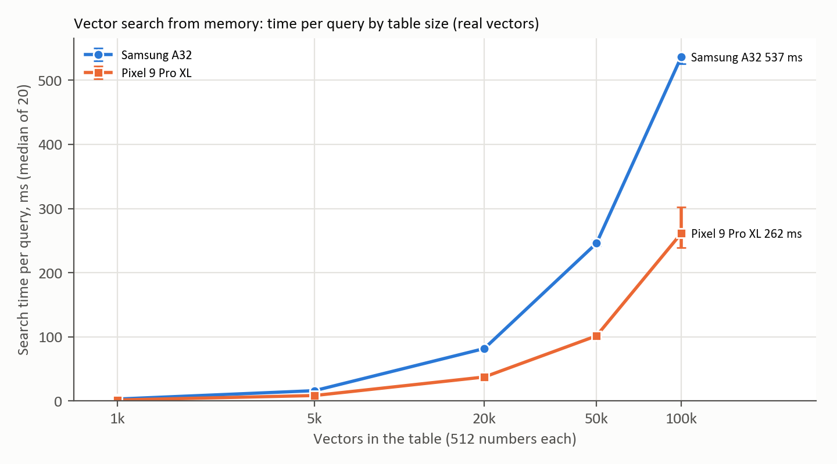
Figure 2. Search time by table size with the old loop, both phones on one chart, real vectors. The bar on each point is the range of the 5 runs.
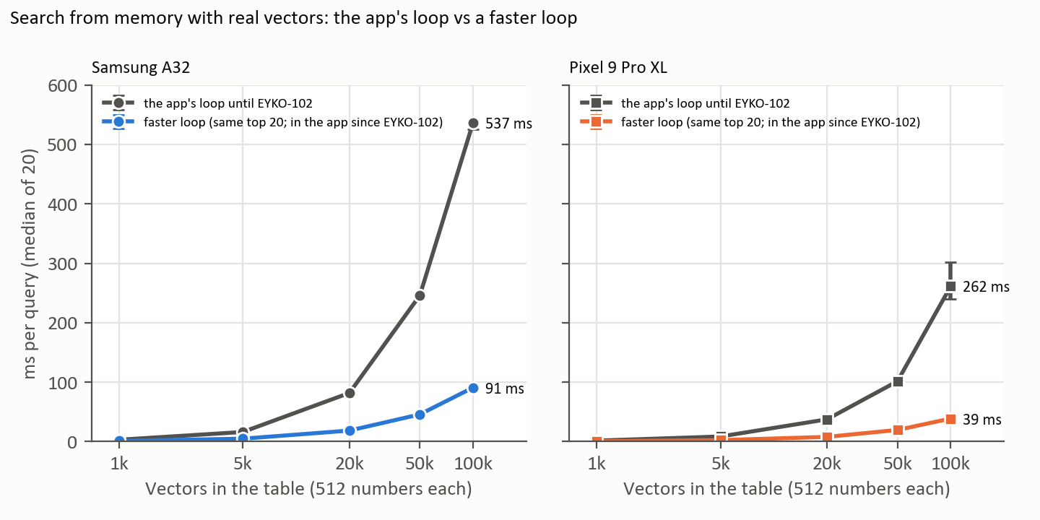
Figure 3. Old loop vs faster loop with real vectors; same answers. The bar on each point is the range of the 5 runs. The faster scoring is in the app since EYKO-102.
Source: docs/results/vectors/*-2026-11-04-sweep-real.csv
Vector part vs whole search. These times are the vector loop alone. The search the app runs also reads every frame row and ranks frames into time windows. End to end on the A32 at 20k it took 1.3 s before EYKO-102 and 302 ms after (Pixel 119 ms), with identical hits. Full detail is in Head 7.

E7 · The two loops, in plain words
What it shows: Why the faster loop gives exactly the same answer: both score every row exactly; only the method differs.
Every search does two jobs. 1. Score every stored vector: multiply the query's numbers with the stored vector's numbers pair by pair and add them up (the dot product; higher means more alike). 2. Keep the best 20.
 | Old loop (app until EYKO-102) | Faster loop (EYKO-100 test)
Job 1: scoring | One running total per row. Each multiply-add waits for the one before it. | Four running totals per row, added at the end. The CPU works on all four at the same time.
Job 2: best 20 | Store all scores, then sort every row and keep the first 20. | Keep a 20-slot "best so far" list. A new score goes in only if it beats the worst of the 20.
Work at 100k | About 1.7 million comparisons, plus 100,000 throwaway objects per search. | About 100,000 comparisons. No objects.
Extra memory | 100,000 scores + 100,000 objects | 20 scores + 20 row numbers
Answer | The 20 best rows | The same 20 rows: 400 of 400 checks, every size, both phones
Where in code | VideoVectors.kt → knn() (before EYKO-102) | VectorStorageSpikeTest.kt → topKFast() (test only)
What the app runs since EYKO-102: the four running sums (VideoVectors.scores()), but not the 20-slot list. The app's search needs every frame's score to grow its time windows, so it ranks all frames with one fast sort of packed numbers (rankDescending()). Same hits as before, checked on 2,400 of 2,400. Details: Head 7.
Not measured separately: how much of the gain comes from the four totals and how much from not sorting. The faster loop does not fix memory; the vectors still have to be loaded.

E8 · Memory with all three vector tables loaded (4 Nov)
What it shows: Memory is the real limit: 20k rows per table fit, 50k does not, on both phones.
Rows per table | Vectors need | A32: app memory before → after | Pixel: app memory before → after
5k | 28 MB | 53 → 80 MB; all 3 tables loaded | 57 → 84 MB; all 3 tables loaded
20k | 113 MB | 53 → 160 MB; all 3 tables loaded | 57 → 164 MB; all 3 tables loaded
50k | 282 MB | 53 → 224 MB; out of memory, 2 of 3 loaded | 57 → 228 MB; out of memory, 2 of 3 loaded
100k | 563 MB | 53 → 248 MB; out of memory, 1 of 3 loaded | 57 → 252 MB; out of memory, 1 of 3 loaded
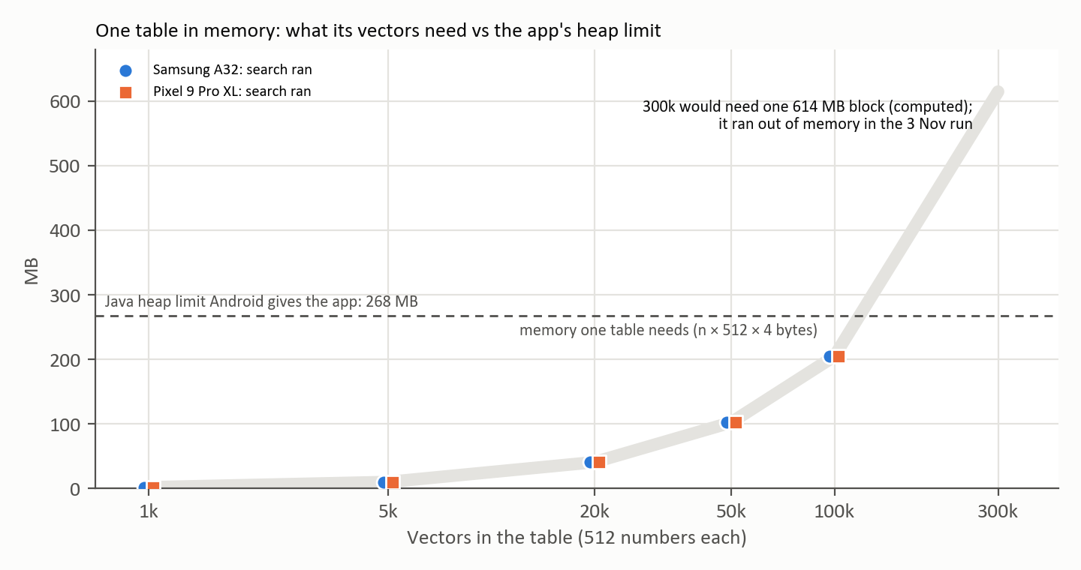
Figure 4. One table on its own: what its vectors need against the 268 MB Android gives the app. Real vectors ran on both phones up to 100k (205 MB). The line goes on to 300k as arithmetic (614 MB); 300k was run only with random vectors on 3 Nov, where both phones ran out of memory.
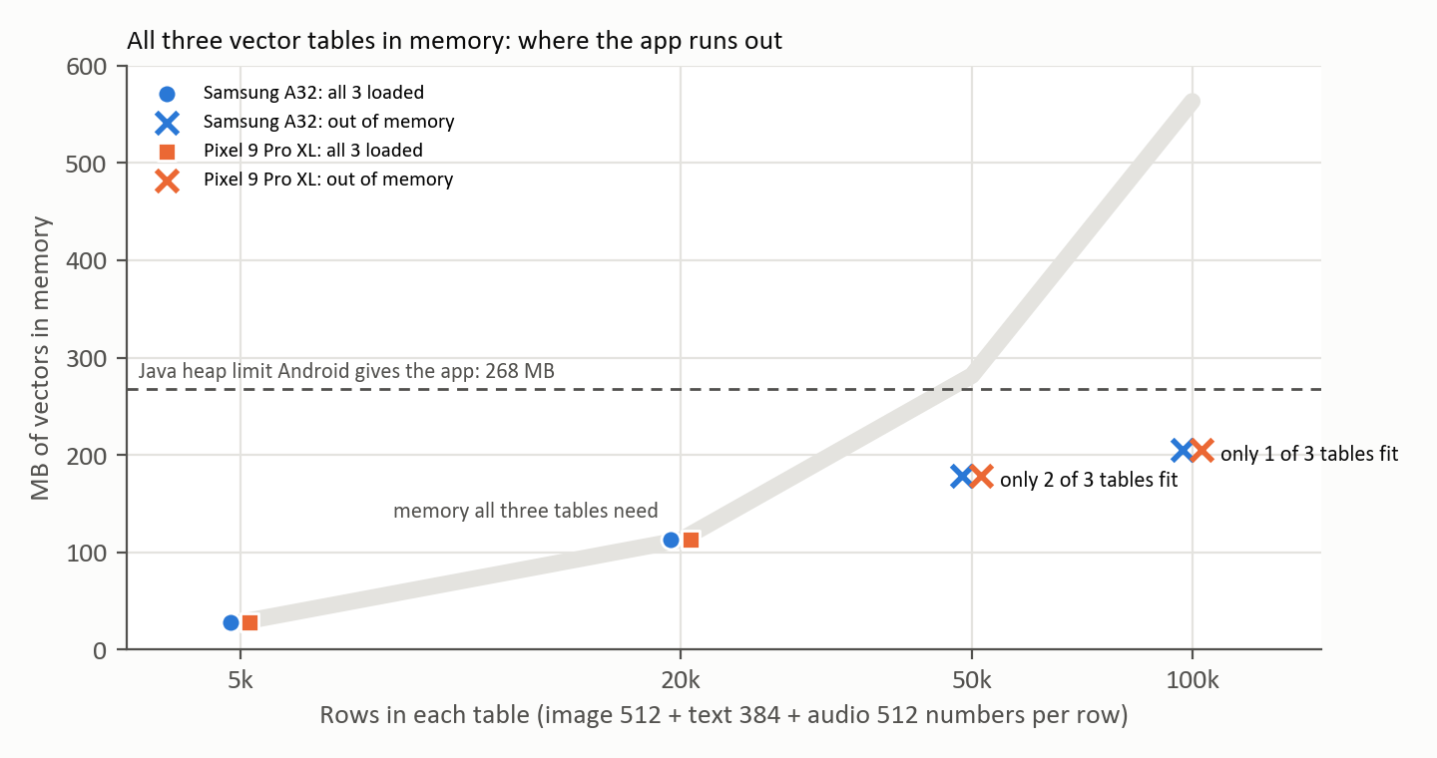
Figure 5. All three vector tables in memory. At 50k the third table, at 100k the second table no longer fits in the 268 MB Java memory Android gives the app.
Source: docs/results/vectors/*-2026-11-04-memory.csv
Extra proof from the random-vector sweep (EYKO-90, 3 Nov): one table of 300k vectors needs a single 614 MB block. Both phones refused: "Failed to allocate a 614400016 byte allocation … growth limit 268435456". Raw data: docs/results/vectors/*-2026-11-03-sweep.csv.

E9 · What the database holds
What it shows: One table design, written once in src/video_memory/schema.py and copied into the phone's VideoSchema.kt. Every kept frame is tied to its video and second, so a search hit can show the exact moment.
Table | What one row holds | Written by
videos | One recorded clip: id, file path, time, duration, GPS, status (processing / ready / failed) | Intake (EYKO-2)
jobs | The background job for a video: stage reached, attempts, status, last error | Queue (EYKO-3)
frames | Every pulled frame: second in video, file path, kept or dropped and why, dHash | split, filter, dedup
scene_records | One per kept frame: objects, people count, place, action, caption | scene, small_objects
video_texts | Captions (transcripts later) with a keyword index | embed_texts
image_vec | 512-number MobileCLIP vector per kept frame (float32 BLOB) | embed_images
text_vec | 384-number bge-small vector per text (float32 BLOB) | embed_texts
object_sightings | Each detected object with its crop vector and whether it is the latest sighting | latest
transcript_chunks, audio_windows, audio_vec | Speech and sound. Tables exist; nothing writes them yet. | Speech head (later)
Source: src/video_memory/schema.py · android/…/video/VideoSchema.kt

Limits: how these numbers could mislead
- All runs were on phones plugged in by cable, so this is not a controlled protocol yet (EYKO-95).
- The Pixel was charging and warm (36–38 °C) during the 3 Nov runs.
- A 4 GB phone and the Infinix have not been measured.
- Real search also filters by video status, which adds a join that the storage test does not include.
- BLOB files are about twice the size of sqlite-vec files (E3).

Part E · Words, gaps, upkeep

Words in plain language
Word | What it means here
Vector | A list of numbers that describes a frame or a caption. Similar things get similar numbers. Ours: 512 numbers per frame, 384 per caption.
BLOB | A database column that just holds raw bytes. We pack each vector's numbers into one.
float32 | A number stored in 4 bytes. 512 of them = 2 KB per frame vector.
sqlite-vec | A plugin that adds vector search to SQLite. Works on the laptop, blocked on Android.
load_extension | The SQLite function that loads plugins. Android's SQLite does not have it.
Dot product | Multiply two vectors number by number and add it all up. Higher means more alike.
Brute force / exact search | Compare the query with every stored vector. Always finds the true best matches, but cost grows with the number of rows.
Approximate index | A shortcut structure (e.g. usearch, hnswlib) that skips most rows. Much faster at scale, may miss a few matches.
Java heap | The memory Android lets the app use for its objects. 268 MB on both our phones.
PSS | The app's total memory as Android counts it.
ORM | A library that maps tables to code classes (Room on Android). We use plain SQL instead.
Spike | A short, throwaway test to answer one question before building on it.
recall@20 | Of the true top 20 matches, how many a method returns. 20 of 20 = 100 %.
Parity | Laptop and phone give the same result for the same input.

Open gaps for this Head
Gap | What is missing | Card | Severity | Resolution
G20 | Vectors in memory hit the 268 MB limit between 20k and 50k rows per table (one table alone: about 100k). No plan for larger libraries. | EYKO-98, 100, 101 | High
G21 | The app used the slow search loop. | lead | Medium | Done 4 Nov (EYKO-102): 4.3× (A32) / 4.1× (Pixel) faster at 20k, 2,400 of 2,400 hits identical.
G9 | Phone retrieval rule (BM25 + dense + RRF) and video search (dense only) disagree. Needs an ADR. | EYKO-81 | Medium
G13 | The A32 only ran this test, never the video pipeline. | EYKO-84 | Medium
G17 | Two broken tools: frame_report pull needs Python 3.12; task test-android / build-android call bare gradlew.bat. | EYKO-70 | Low
G19 | Licences to re-decide before release: MobileCLIP research-only, YOLOE AGPL. | EYKO-88 | Low
G12 | Speech tables exist but nothing writes them. | EYKO-86 | Low

How to update this document
- When a card closes: change the question's status in Part C, rewrite "Say this" with the new numbers, add the new table or graph to Part D as the next E number, and change the date on the cover.
- If the result changes a number in Part A, update Part A too. Part A must always match the latest evidence.
- Never delete an old finding. If a new run disagrees, say so in "Say this" and keep the old table in Part D.
- Add a step to Part B only for something that changed the direction of the work.

References
- Storage test write-up: docs/results/2026-10-12-eyko-31-vector-storage.md
- Table design: src/video_memory/schema.py; phone: android/…/video/VideoSchema.kt, VideoVectors.kt
- Rules: docs/invariants/core.md (parity), security.md (DB), tooling.md (uv, licences)
- Gap review: docs/plans/gap-review-2026-11/00-gap-register.md

