EYKON · PIPELINE DOCUMENTATION

Head 7 · Search
From a typed phrase to a result card: searching frames by picture, growing hits into time windows, and the hybrid search that was tried and dropped.
Item | Detail
Status | Built and in use on the Pixel 9 Pro XL (Video tab). Search made 4–5× faster with identical hits (EYKO-102, 4 Nov). Question parsing, date filter and answer writing are not built yet (Ask & answer head).
Covers | MobileCLIP text-to-frame search, time windows, the result card, the search probe, hybrid caption search (EYKO-61, dropped), and the open retrieval decision.
Cards | EYKO-19 (core: text to frames), EYKO-58 (time windows), EYKO-61 (hybrid, tested and dropped), EYKO-75 / 81 (retrieval decision, open). EYKO-102 (search speed, end to end).
Synverk flow | Head 7 · Search: from a typed phrase to a result card
Main sources | docs/results/2026-10-13-frame-search-probe.md, 2026-10-20-ego4d-baseline.md, 2026-10-21-ego4d-improvements.md (sections 1 and 3)

1. Summary
On the Video tab the person types what to look for ("keys"). The phrase is turned into a MobileCLIP text vector in the same space as the frame vectors, and every kept frame of every ready video is scored by cosine. The best frames grow into time windows over neighbouring frames that still match, so a result covers a stretch of the video rather than one instant. The top 20 windows are shown as result cards.
Search uses the pictures, not the captions. That lets it find things the detectors have no name for. A hybrid that added caption keywords and caption vectors with RRF was tested on Ego4D and made results worse, so it was dropped for now.

2. Approach
- Encode the phrase: a CLIP BPE tokenizer written in Kotlin makes 77 tokens; the MobileCLIP-S2 text encoder (ONNX, 254 MB, about 130 ms) returns a 512-d unit vector.
- Score every frame: image_vec is held in memory; the dot product of unit vectors is the cosine. Only kept frames of ready videos count.
- Grow windows (EYKO-58): from each hit, neighbouring kept frames of the same video join while they score at least 0.85 × the hit and are no more than 10 s apart; the window is widened by 1.5 s each side (each kept frame stands for its 3 s slot).
- One hit per window: a frame inside an earlier window is not returned again. The best 20 are kept (Phase 1's pool size).
- Result card: frame picture, date, time, "at 48.0 s", the window, the likeness score, and the stored caption (shown only, not used to rank).
Speed on the Pixel: about 0.1 s per search; the first search about 1 s while the vectors load into memory. Update 4 Nov (EYKO-102): that was on a memory of a few dozen frames. Measured end to end on a test memory: at 20k kept frames the search took 493 ms on the Pixel and 1.3 s on the A32; after EYKO-102 119 ms and 302 ms, same hits (section 5).

3. Options considered
Option | What it is | Result | Verdict
Captions only | Keyword or vector search over captions | Captions only name what detectors know; a helmet frame was captioned "2 people, in an office" | Rejected
Picture search | MobileCLIP text vector vs frame vectors | Finds the helmet (0.223); top frame inside the answer 24.4 % on Ego4D (random 3.4 %) | Adopted
Single frames | Return the best frames as instants | R@1 at tIoU 0.5 only 6.4 % on Ego4D | Replaced
Time windows | Grow hits over matching neighbours (0.85, 10 s) | Set A 6.4 → 9.0 %; held-out set B 6.2 → 15.6 % | Adopted
Hybrid (EYKO-61) | BM25 + bge over 15 / 30 s caption windows, fused with picture search by RRF | Worse in every mix on set A (hit@1 24.4 → 15–21 %); on set B pictures + bge 15 s better, keywords worse | Dropped for now
"a photo of" prefix | Template in front of the phrase | Average precision changed by at most 0.05 | No change

4. Decisions
# | Decision | When | Why (evidence)
1 | Search frames by picture with MobileCLIP | 13 Oct 2026 | Finds things with no detector name; works for scene-filling things
2 | Return windows, not instants (0.85, 10 s, ±1.5 s) | 21 Oct 2026 | Chosen on set A by the mean of four R@k numbers; confirmed on held-out set B
3 | Drop hybrid caption search for now | 21 Oct 2026 | Detector-list captions rarely share words with questions; retry with richer captions (Option C)
4 | Open: the phone retrieval rule says BM25 + dense + RRF; video search is dense only | Open (D2) | Needs an ADR: a video exception backed by EYKO-61, or hybrid back later
5 | Faster search code with identical hits (scores as arrays, one packed sort, path and caption for hits only) | 4 Nov 2026 | Before/after on two phones: 4.3× (A32) and 4.1× (Pixel) at 20k, 2,400 of 2,400 hits identical (EYKO-102)

5. Tests and evidence

Search probe on our 44 frames (13 Oct, laptop)
Phrase | Frames showing it | Chance | Avg precision | Detector found
sheets of paper | 28 | 0.64 | 0.97 | no such class
a table tennis table | 4 | 0.09 | 1.00 | no such class
a car | 1 | 0.02 | 1.00 | 1 of 1
a laptop | 9 | 0.20 | 0.76 | 7 of 9
a backpack | 6 | 0.14 | 0.58 | 0 of 6
a computer monitor | 7 | 0.16 | 0.52 | 5 of 7
a chair | 17 | 0.39 | 0.51 | 13 of 17
a phone | 16 | 0.36 | 0.43 | 5 of 16

Picture search is very good for things that fill the scene and close to chance for a small phone on a desk. It always returns something: "a dog" scores 0.14 with no dog present. On the phone, keys, glasses, wallet and earbuds put the right frame at rank 1 in ~0.1 s (4 of 4).

Ego4D NLQ objects (where did I put X?)
Measure | Baseline (A) | Windows (A) | Baseline (B) | Windows (B)
R@1, tIoU ≥ 0.3 | 10.3 | 16.7 | 12.5 | 25.0
R@1, tIoU ≥ 0.5 | 6.4 | 9.0 | 6.2 | 15.6
R@5, tIoU ≥ 0.3 | 20.5 | 32.1 | 28.1 | 37.5
R@5, tIoU ≥ 0.5 | 10.3 | 20.5 | 15.6 | 25.0

Baseline hit@1 (top frame inside the answer window ± 1.5 s): 24.4 %, random kept frame 3.4 %; hit@5 47.4 %. People questions stay near zero: search cannot tell people apart.

Search speed on the phone, end to end (EYKO-102)
Why: the speed in this document ("about 0.1 s per search") was measured on our own small memory of a few dozen frames, and the vector tests in Head 2 (EYKO-90, EYKO-100) timed only the vector loop. Nobody had timed the search a user actually waits for, VideoSearch.frames(), at the sizes a user reaches. Approach: measure the real search first on both phones, change only what the numbers point at, prove the hits are identical, then measure again.
- A test memory with the app's own tables (VideoSchema), in the proportions we measured: ready videos of 600 kept frames each (about 45 min at 13.4 kept frames a minute), 12 dropped frames per kept one (the Ego4D phone memory of 20 Oct had 5,939 frames for 460 kept), and for every kept frame a caption and a real vector (our own clips, Head 2 EYKO-100).
- Sizes 5k, 20k and 50k kept frames (65,000 to 650,000 frame rows). 100k was left out: building it takes about 10 minutes on the A32.
- Per size: the first search (it also loads the vectors into memory), then 1 warm-up and 20 queries × 5 runs of the whole search, and the same for knn alone, so the time can be split.
- Every hit of every query (frame, window start and end, score) is written to a file. Before = the app as it was (commit 108d315); after = this change. Same queries, same phones, same day.
- Command: adb shell am instrument -w -e class com.eykon.memory.video.VideoSearchSpeedTest -e sizes 5k,20k,50k -e label before -e commit <commit> com.eykon.memory.test/androidx.test.runner.AndroidJUnitRunner (label after for the second run).

Before: where the search's time went
Kept frames | A32: whole search | A32: vector part (knn) | Pixel: whole search | Pixel: vector part (knn)
5k | 326 ms | 65 ms (20 %) | 99 ms | 29 ms (29 %)
20k | 1.3 s | 274 ms (21 %) | 493 ms | 108 ms (22 %)
50k | 3.9 s | 725 ms (18 %) | 2.0 s | 353 ms (18 %)

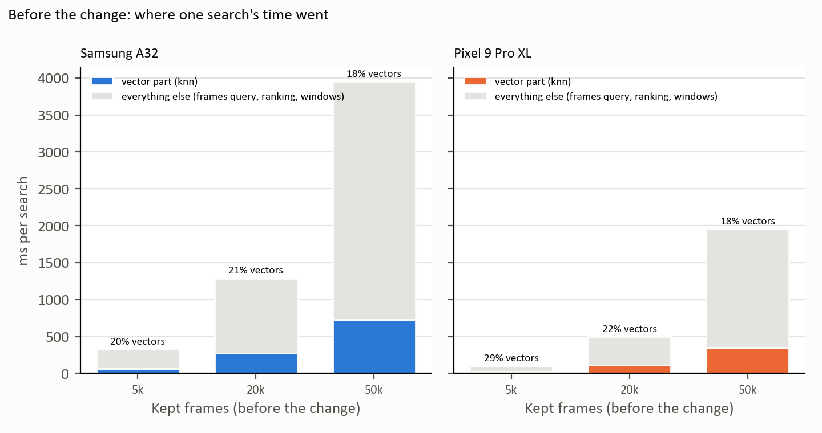
Figure 1. Before the change: the vector part (knn, coloured) was only a fifth to a quarter of each search; the rest (grey) was reading every frame row, building objects and sorting. Data: docs/results/vectors/search/*-search-before.csv.
So the vector loop was not where most of the time went. The search read every kept frame with its path, recorded date and caption, made a file object for each, wrapped every score in an object inside a map, and sorted all frames twice (once inside knn, once after filtering), looking each score up in the map on every comparison.

What changed in the search code
Step of one search | Before (until 108d315) | After (EYKO-102)
Score every frame | knn(…, Int.MAX_VALUE): one running sum per row, then sort every row, wrap each as a (frame id, score) pair, then turn the list into a map. | VideoVectors.scores(): four running sums per row (Head 2, EYKO-100), returned as two plain arrays (ids, scores). No sort, no objects.
Read the frames | One query over every kept frame of the ready videos with 7 columns (incl. path, recorded date, caption via a join); a file object made for every frame. | One query with 3 columns (id, video, time). Path and caption are read only for the hits (at most 20 small queries).
Match frame to score | Map lookup with a boxed Long for every frame and on every sort comparison. | Binary search in the sorted id array (ids come out of the vector table in id order).
Rank the frames | Sort all frames with a comparator that looks the score up in the map each time. | One sort of packed numbers: each frame's score and position become one Long, sorted as plain numbers (rankDescending).
Grow the windows | SearchWindows.grow (unchanged) | SearchWindows.grow (unchanged)

How the packed sort keeps exactly the old order: a float's bits are turned into a number that sorts like the float (negative numbers flipped), put in the top half of a Long, and the frame's position goes in the bottom half so equal scores keep their order:
val bits = java.lang.Float.floatToIntBits(score)
val key = if (bits < 0) bits xor 0x7fffffff else bits // orders like Float.compare
packed[i] = (key.toLong() shl 32) or (Int.MAX_VALUE - i).toLong() // ties: lower position first
packed.sort() // plain numbers, no comparator

After: same hits, faster
Kept frames | A32 before | A32 after | Pixel before | Pixel after
5k | 326 ms | 83 ms (3.9× faster) | 99 ms | 38 ms (2.6× faster)
20k | 1.3 s | 302 ms (4.3× faster) | 493 ms | 119 ms (4.1× faster)
50k | 3.9 s | 745 ms (5.3× faster) | 2.0 s | 440 ms (4.4× faster)
5k, first search (loads the vectors) | 1.3 s | 424 ms | 757 ms | 355 ms
20k, first search (loads the vectors) | 2.9 s | 2.0 s | 3.6 s | 3.6 s
50k, first search (loads the vectors) | 11.2 s | 7.8 s | 20.8 s | 22.2 s

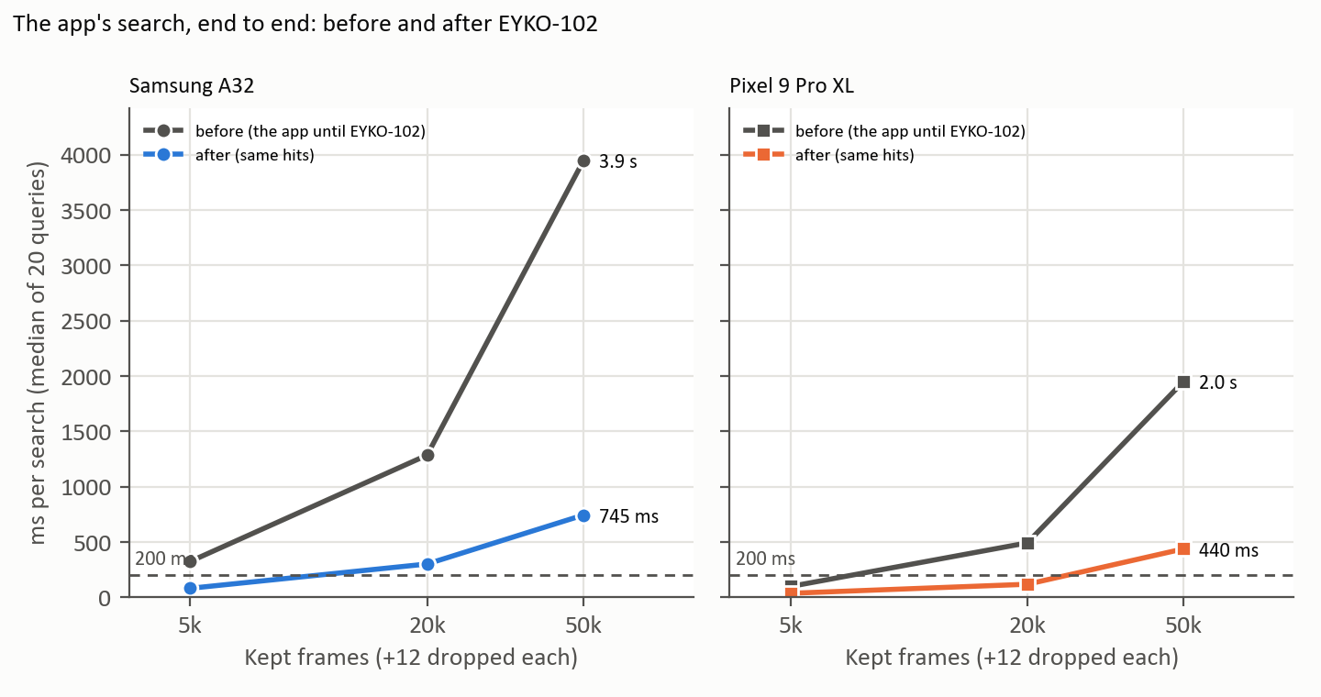
Figure 2. The app's search, end to end, median of 20 queries per run over 5 runs: before (grey) and after (colour). Data: docs/results/vectors/search/*-search-{before,after}.csv; graph script docs/documents/source/figures/search_speed.py.
- Same answers, checked three ways: (1) all 2,400 hits (20 queries × 3 sizes × 2 phones, 20 hits each) are identical before and after: same frames, same window start and end, scores within 0.000001 (src/benchmarks/compare_search_hits.py); (2) a JVM test checks the packed sort against the old sort over 200 random rounds with ties, negatives and both zeros, and the four-sum dot product against the plain one (VideoVectorsRankTest); (3) the existing on-phone tests still pass on both phones: VideoSearchTest 6, VideoEmbedImagesTest 8, VideoEmbedTextsTest 9, VideoFinishTest 8.
- Names in the CSV files: app_search_frames = the whole search (VideoSearch.frames, 20 hits); app_knn_all = VideoVectors.knn asked for every row (before the change this was the search's vector part; after it, the search no longer calls knn); app_search_first = the first search on a freshly opened memory, which also loads the vectors.
- What was not measured: how much each of the four changes gives on its own; 100k kept frames; three vector tables at once (Head 2 shows they do not fit from 20k–50k).
Outcome (good and bad): the search is 4.3× faster on the A32 and 4.1× on the Pixel at 20k kept frames, with identical hits. But it is still over 200 ms on the A32 from about 20k (302 ms) and on both phones at 50k (A32 745 ms, Pixel 440 ms). The first search after opening the app is the bigger problem: it loads every vector from SQLite and takes 2.0 s (A32) and 3.6 s (Pixel) at 20k, and 7.8 s and 22.2 s at 50k. This change does not touch that (G22).
Not protocol runs: both phones plugged in by cable. Raw logs: docs/results/vectors/proof/*-2026-11-04-search-{before,after}-logcat.txt; hits: docs/results/vectors/search/*-hits-*.txt.

Published numbers, for scale only
OSGNet 2025 NLQ R@1 28.50 / 20.05 (tIoU 0.3 / 0.5). Large GPU video models on the test split, not a ranking.

6. Results
- Typed search over all ready videos returns moments as windows in about 0.1 s on the Pixel. Update 4 Nov: "0.1 s" holds only for small memories. At 20k kept frames the search now takes 119 ms (Pixel) and 302 ms (A32) after EYKO-102 (before: 493 ms and 1.3 s); the first search after opening takes 3.6 s and 2.0 s.
- On held-out Ego4D data, windows more than doubled R@1 at tIoU 0.5 (6.2 → 15.6 %).
- The Ask tab (notes answered by Gemma) is still a separate path; joining it to video is the next head.

7. Limits
- Search probe labels were AI-written, not checked by a person (G5).
- Ego4D question counts are small, especially on set B (32 + 4 NLQ).
- Search always returns something; there is no "not found" cut-off yet.
- No date filter, no question rewording, no latest-only option yet.
- Search speed was measured on test memories built with the app's schema and real vectors repeated with noise, not on a real user's year of video; phones were plugged in.

8. Gaps and open items
Fill the Resolution column as each card closes.
Gap | What is missing | Card | Sev. | Resolution (to fill)
G22 | The first search after opening the app loads every vector from SQLite: 2.0 s (A32) / 3.6 s (Pixel) at 20k kept frames, 7.8 s / 22.2 s at 50k. | proposal (lead) | High
G23 | Even after EYKO-102 the search is over 200 ms on the A32 from about 20k kept frames (302 ms) and on both phones at 50k. The frames query reads every frame row (12 dropped per kept). | proposal (lead) | Medium
G9 | The retrieval rule and the video search disagree; write the decision as an ADR. | EYKO-81 | Medium
D2 | Decide: video exception to the parity rule, or hybrid comes back with better captions. | EYKO-75 | Decision
G5 | Search probe labels need a person's check. | EYKO-72 | High
— | Typed or spoken question; date filter + HyDE; keyword and text-vector search; RRF fusion; answer with proof. | EYKO-17, 18, 20, 21, 23, 24 | —
— | Text to sounds (CLAP). | EYKO-22 | —

9. References
- Results: docs/results/2026-10-13-frame-search-probe.md, 2026-10-20-ego4d-baseline.md, 2026-10-21-ego4d-improvements.md
- Code: VideoSearch.kt, SearchWindows.kt, ml/vision/TextEmbedder.kt, ui/screens/VideoScreen.kt; laptop src/benchmarks/ego4d_eval.py (windows), ego4d_hybrid.py

