STRATIFYAI
Execution Evidence Report
Recorded tests, workflows, security checks, evaluation results and interface evidence

Project | Team | Submission context
StratifyAI: The Liquidity Decision Lab for SME Financial Intelligence | Neuroprop — Md. Rafiqul Islam (Team Leader), Abu Bakar Rafi, Fatema Jahan | 2026 Shenzhen International FinTech Competition • International Track • Topic E

Evidence reviewed through 20 October 2026
All application cases and reported evaluation data are synthetic.

Executive summary
This report consolidates execution artifacts checked into the StratifyAI repository and records what each artifact supports. The dated evidence includes a full test run with 197 passing tests, 13 of 13 scripted service workflows passing, 60 of 60 role/action authorization decisions matching the permission registry, ten poisoned-name payloads excluded from Copilot evidence, and audit-chain tampering detected at entry 1. The repository progress note separately records a later full-tree check of 205 tests on 20 October 2026. Since the reviewed evidence artifacts do not include that later console transcript, both counts are reported with their provenance rather than merged.
The evaluation also records adverse product evidence. Across all five synthetic holdout cases, StratifyAI has higher MAE than the naive last-four-week mean baseline. Only one of five selected plans maintained the configured reserve. These results are limitations, not evidence of forecast accuracy or improved decisions. The repository contains a current public Overview capture and a historical design-review image. Eight requested signed-in page captures remain outstanding; the runtime simulated-action log is not checked in.

Evidence interpretation at a glance
Area | Recorded result | Supports | Does not establish
Test suite | 197 passed; 18 Oct 2026 | Dated full test run completed, exit 0 | Later 205 count has no reviewed archived transcript
Workflow suite | 13/13 passed | Specified scripted workflows completed | Usability or production reliability
Security checks | 60/60; 10/10; tamper detected | These specific registered checks behaved as recorded | Penetration test, certification or total injection defense
Backtest | Model MAE higher on all five cases | Measured synthetic holdout comparison | General predictive performance
Decision quality | 1/5 plans kept reserve | Computed scenario outcomes | Real-world decision improvement
UI evidence | Public Overview present; 8 captures pending | Captured public view only | Complete visual verification

Table 1. Evidence summary and claim boundaries.

Reading this report
Evidence identifiers [E1]–[E8] refer to repository artifacts in Section 7. Results are transcribed from checked-in records or the progress log; this document does not rerun tests or create runtime evidence. A recorded PASS means that the assertion or workflow passed in its stated run, not that the system is secure or ready for real financial decisions.

1. Scope and evidence handling
The evidence concerns a local Streamlit prototype using generated synthetic SME cases. Reviewed material includes test output, scripted service workflows, focused security checks, a synthetic holdout backtest, reserve outcomes and limited browser captures. No real customer dataset, lender, bank, payment service or production deployment is represented.
Artifacts were compared with the README, Technical Documentation, Security Self-Assessment and execution evidence index. Dates and counts are retained as recorded. Where a later progress note reports a result without its raw output artifact, it is labeled a secondary checkpoint.

Evidence provenance flow
1 Source artifact | → | 2 Extract method and scope | → | 3 Report observed result | → | 4 State boundary
Versioned output or capture | → | Read date, command, scope and outcome | → | Cite file and preserve adverse results | → | Avoid unsupported conclusions

Figure 1. Evidence-to-claim workflow used in this report.
A reproducible submission should retain the source artifact, execution timestamp, command, exit code and environment with every generated result. A screenshot should identify page, role, selected synthetic case and viewport. Missing provenance is stated rather than inferred.

2. Recorded execution results

2.1 Full test suite
The checked-in transcript records python -m pytest -q at 2026-10-18 06:57:57 UTC, exit code 0, with 197 tests passing in 43.10 seconds [E1]. The later docs/PROGRESS.md entry states that a full-tree check on 2026-10-20 passed 205 tests, alongside Ruff, health and secret checks. The reviewed evidence directory contains the 197-test transcript but no separate timestamped output for the later 205-test run. Thus 197 is the directly archived run and 205 is a later project checkpoint, not two results from one run.
Run | Date / time UTC | Outcome | Provenance
Archived full pytest | 2026-10-18 06:57:57 | 197 passed; exit 0; 43.10 s | Raw text [E1]
Later full-tree QA | 2026-10-20 | 205 passed; Ruff, health, secret scan noted | Progress summary; separate raw transcript not located

Table 2. Test counts separated by date and source.

2.2 Scripted service workflows
The task suite records 13 of 13 scripted workflows passing (100%) at 2026-10-18 06:59:41 UTC [E2]. It covers shortage detection, Lab plan generation, reserve-feasible recommendation behavior, isolated stress inputs, financing calculations, draft creation and owner approval, authorization denial, formula-like upload neutralization, audit verification and tamper detection, grounded Copilot output, and analysis values with unavailable-data reasons.
ID | Workflow area | Recorded assertion
T01 | Shortage forecast | Expected shortage week observed
T02 | Decision Lab | Baseline, lever, combined and financing plans available
T03 | Recommendation | Selected plan feasible under recomputed balances
T04 | Stress scenario | Finite result; source case unchanged
T05 | Financing | Illustrative amount, cost and schedule computed
T06 | Draft creation | finance_ops creates a local reminder draft
T07 | Owner approval | Only owner advances submitted draft to approved
T08 | Authorization denial | viewer denied lab.run; denial audited
T09 | Upload validation | Formula-like cell neutralized and reported
T10 | Audit verification | Untampered chain verifies
T11 | Tamper detection | Verifier detects modified persisted row
T12 | Copilot grounding | Funding answer passes citation/number checks
T13 | Analysis | Finite snapshot and explicit unavailable reasons

Table 3. All 13 workflow outcomes from [E2].
These are scripted service-level workflows with synthetic fixtures. They show that the listed paths completed under the recorded setup; they do not substitute for a live walkthrough, usability study or independent security test.

3. Security execution evidence
The focused security evaluation records 60 role/action decisions matching the permission registry; all ten poisoned-name cases excluded from Copilot evidence with grounded answers checked against ten receipts; and audit-chain modification detected at entry 1 [E3]. The Security Self-Assessment maps controls and test names to implementation locations and records residual risks.
Check | Observed record | Boundary
Role/action matrix | 60 decisions matched registry | Finite matrix; not exhaustive authorization testing
Prompt injection / masking | 10/10 names excluded; ten receipts validated | Specific strings and masking behavior; not general injection resistance
Audit integrity | Tampering detected at entry 1 | Local administrator can replace database or disable local controls
Money movement | Always-denied action appears in mapped tests | No payment integration exists
Copilot boundary | Offline by default; optional provider separately described | Configured provider may receive question and masked numeric evidence

Table 4. Focused security checks and their limits.
PASS refers only to the recorded checks. These materials are self-assessment evidence, not an external penetration test, OWASP validation, certification or production approval [E8].

4. Forecast and decision evaluation

4.1 Backtest method and measured results
The recorded backtest compares the forecast with the naive mean of the preceding four weeks of net flow. It reports ten-week holds per case, a training cutoff of 2026-05-04, MAE in BDT per week and WAPE as a percentage [E4]. Lower values indicate smaller errors on these measures.
Synthetic case | Model MAE BDT/wk | Naive MAE BDT/wk | Model WAPE | Naive WAPE
stable_healthy | 255,370.86 | 32,631.25 | 330.99% | 42.29%
sales_drop_cost_rise | 166,949.39 | 140,806.33 | 231.37% | 195.14%
high_expense_shortage | 256,412.36 | 26,176.58 | 374.69% | 38.25%
delayed_customer_payments | 297,374.47 | 18,340.14 | 989.17% | 61.01%
import_financing | 299,112.58 | 23,607.15 | 576.99% | 45.54%

Table 5. Holdout error comparison; lower is better. Transcribed from [E4].
Model MAE is higher than the naive baseline in every evaluated case. The delayed-customer-payment case has the highest model WAPE (989.17%). This is adverse evidence about current behavior on these fixtures. It does not support an accuracy claim and motivates calibration and a broader independently defined evaluation set. Five synthetic cases cannot establish general performance.

4.2 Reserve outcomes for selected plans
The decision-quality artifact records the selected plan, deterministic minimum balance, configured reserve, reserve status and seeded breach probability for each case [E5]. One of five selected plans keeps reserve. The other four remain below the configured reserve and are reported plainly.
Case | Plan | Minimum balance BDT | Reserve BDT | Kept? | Simulated breach probability
stable_healthy | Option 0 | 3,246,586.55 | 389,265.83 | Yes | 0.0000
sales_drop_cost_rise | Option 0 | -1,594,784.34 | 529,253.62 | No | 1.0000
high_expense_shortage | Option A | -6,229,560.42 | 622,695.93 | No | 1.0000
delayed_customer_payments | Option 0 | -188,551.13 | 452,785.87 | No | 1.0000
import_financing | Option A | 253,078.71 | 420,886.89 | No | 0.9845

Table 6. Selected-plan results [E5]. Amounts rounded to two decimals.
Breach probability is a seeded simulation output under model assumptions; it is not an observed real-business frequency or calibrated insolvency probability. Plan selection and reserve status are scenario properties, not evidence of improved outcomes.

5. Interface and run evidence

5.1 Captures currently present
The repository includes a 1440-pixel public Overview capture at docs/img/overview.png and an older T02 Overview review image at evidence/t02-overview-review.png [E6]. The first is a public landing view, not a signed-in business dashboard. The latter is historical and must not be presented as current UI evidence.
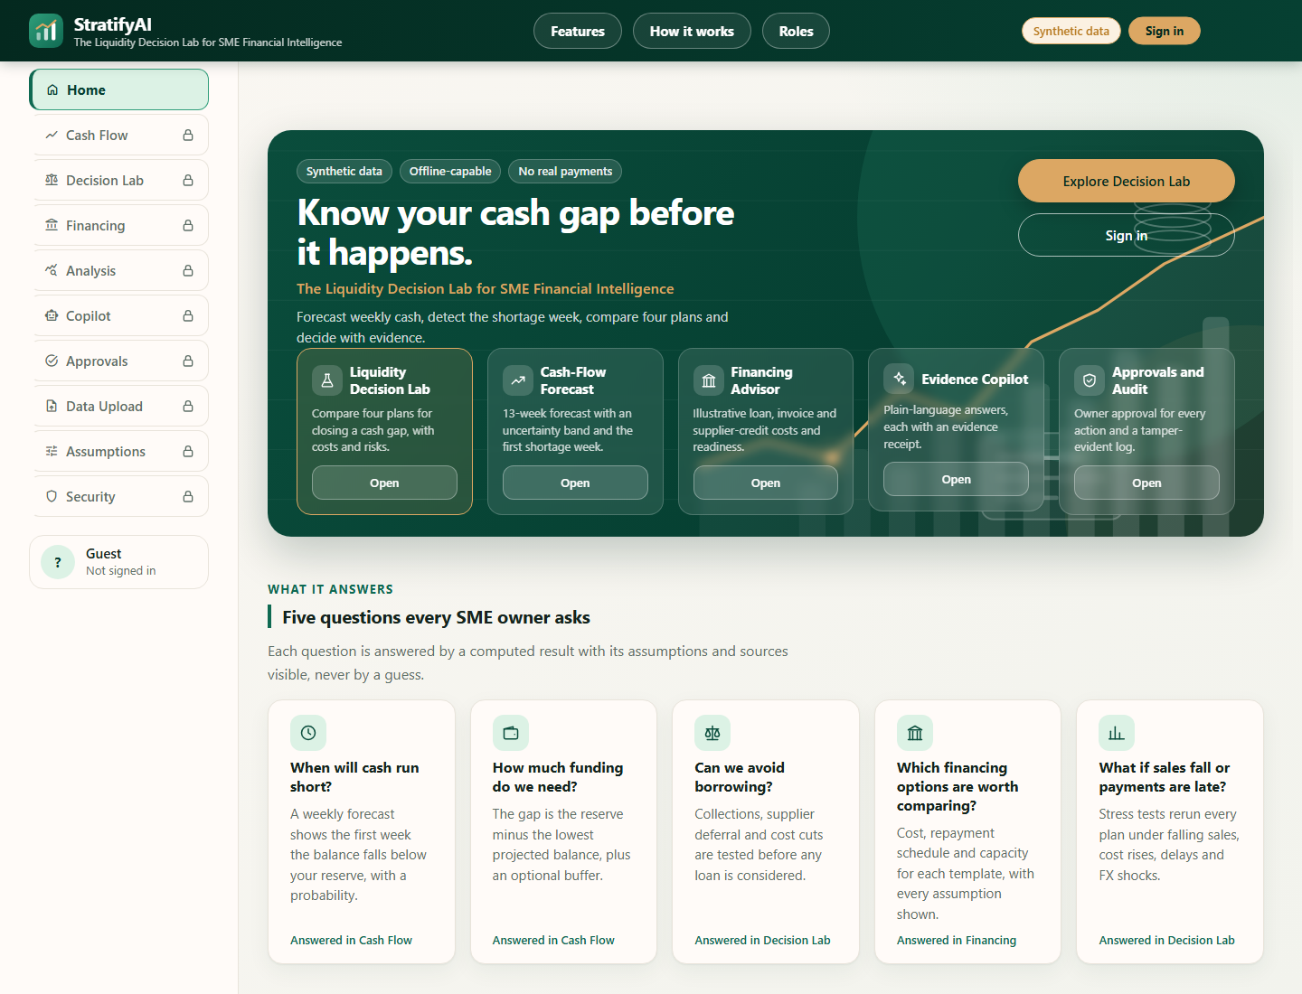
Figure 2. Current 1440px public Overview capture. It does not show a signed-in case workflow.

Historical image — reference only
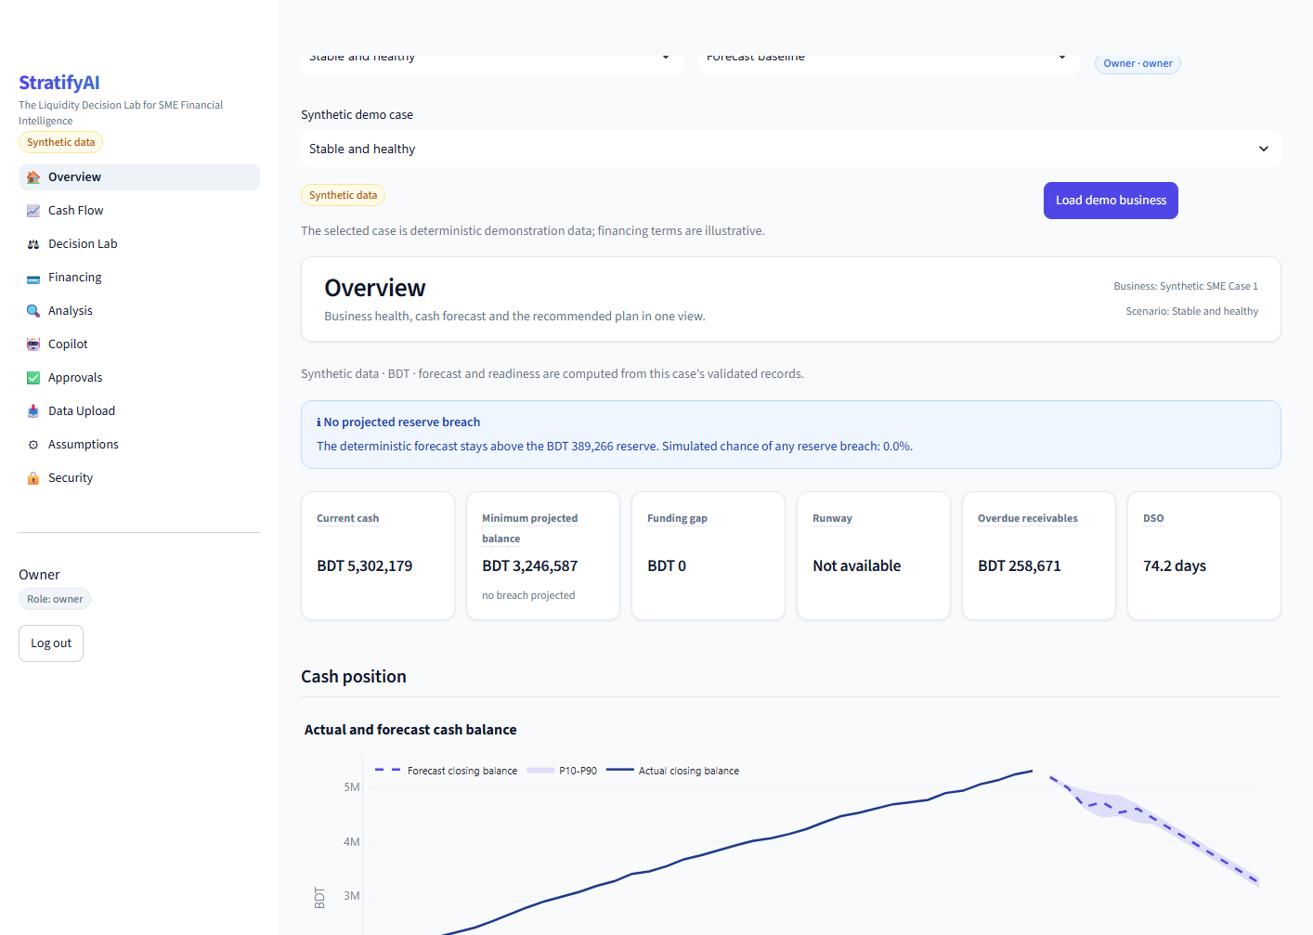
Figure 3. T02 historical Overview review capture; not current interface evidence.

5.2 Required signed-in captures
Eight current signed-in page captures remain requested. Capture each at a 1440-pixel viewport after loading a synthetic case. Keep page title, case and synthetic-data label visible. The red-marked slots identify exact insertion locations; replace a slot only after a fresh capture exists and has been visually checked.

Figure 4 — Cash Flow
[RED — INSERT docs/img/cashflow.png HERE. Capture: Current signed-in cash path with ACTUAL history, FORECAST weeks, reserve line and uncertainty band. Viewport: 1440px. Record case and role in caption. Use a fresh capture; do not substitute historical imagery.]

Fig. 4. Cash Flow evidence placeholder. Replace with a fresh signed-in capture and factual caption.

Figure 5 — Decision Lab
[RED — INSERT docs/img/lab.png HERE. Capture: Option 0/A/B/C comparison, recommendation and reserve outcome. Viewport: 1440px. Record case and role in caption. Use a fresh capture; do not substitute historical imagery.]

Fig. 5. Decision Lab evidence placeholder. Replace with a fresh signed-in capture and factual caption.

Figure 6 — Financing
[RED — INSERT docs/img/financing.png HERE. Capture: Illustrative template, repayment schedule, cost and terms notice. Viewport: 1440px. Record case and role in caption. Use a fresh capture; do not substitute historical imagery.]

Fig. 6. Financing evidence placeholder. Replace with a fresh signed-in capture and factual caption.

Figure 7 — Analysis
[RED — INSERT docs/img/analysis.png HERE. Capture: Business metrics and receivables watchlist for a synthetic case. Viewport: 1440px. Record case and role in caption. Use a fresh capture; do not substitute historical imagery.]

Fig. 7. Analysis evidence placeholder. Replace with a fresh signed-in capture and factual caption.

Figure 8 — Copilot
[RED — INSERT docs/img/copilot.png HERE. Capture: Grounded answer, Evidence used drawer and receipt; note offline/configured mode. Viewport: 1440px. Record case and role in caption. Use a fresh capture; do not substitute historical imagery.]

Fig. 8. Copilot evidence placeholder. Replace with a fresh signed-in capture and factual caption.

Figure 9 — Approvals
[RED — INSERT docs/img/approvals.png HERE. Capture: Draft submission, owner review controls and timeline; no real message sent. Viewport: 1440px. Record case and role in caption. Use a fresh capture; do not substitute historical imagery.]

Fig. 9. Approvals evidence placeholder. Replace with a fresh signed-in capture and factual caption.

Figure 10 — Upload
[RED — INSERT docs/img/upload.png HERE. Capture: Validation results including formula-like cell neutralization and row-level report. Viewport: 1440px. Record case and role in caption. Use a fresh capture; do not substitute historical imagery.]

Fig. 10. Upload evidence placeholder. Replace with a fresh signed-in capture and factual caption.

Figure 11 — Security
[RED — INSERT docs/img/security.png HERE. Capture: Role/action matrix and security status with role context. Viewport: 1440px. Record case and role in caption. Use a fresh capture; do not substitute historical imagery.]

Fig. 11. Security evidence placeholder. Replace with a fresh signed-in capture and factual caption.
Requested file | Proof point | Reviewed repository status
docs/img/cashflow.png | Forecast, reserve and uncertainty | Absent
docs/img/lab.png | Plans and levers | Absent
docs/img/financing.png | Illustrative schedule | Absent
docs/img/analysis.png | Analysis and watchlist | Absent
docs/img/copilot.png | Answer, evidence and receipt | Absent
docs/img/approvals.png | Draft and owner approval | Absent
docs/img/upload.png | Upload validation | Absent
docs/img/security.png | Security role matrix | Absent

Table 7. Requested screenshots and current status [E6].

6. Reproduction and evidence capture protocol
Use a clean local checkout and retain the complete output of each run. Preserve the existing dated transcript; create a new timestamped artifact for new execution results.
Purpose | Command or capture | Minimum evidence to retain
Full test suite | python -m pytest -q | stdout, stderr, exit code, UTC time and dependency versions
Health check | python run.py check | Complete output and exit code
Evaluation | python run.py eval | Timestamped backtest, decision-quality, security and test artifacts
Workflow suite | python scripts/run_tasks.py | 13-workflow report and exit code
Visual session | python run.py demo | Role, case, mode, viewport and capture time
Page capture | 1440px browser PNG | Original PNG, expected docs/img name, factual caption and synthetic label

Table 8. Reproduction commands and minimum provenance.
For screenshots, remove browser chrome without cropping away application context. Do not expose credentials, API keys, real personal data or unsanitized local paths. The runtime simulated-action log at evidence/sandbox_log.jsonl is a default destination only; it is absent from the reviewed tree and must not be represented as an existing execution artifact [E7].

7. Artifact register
ID | Artifact | Purpose / reported result | Reviewed status
E1 | evidence/test_results.txt | 197-test full pytest output, timestamp, command and exit code | Present; 2026-10-18
E2 | evidence/task_suite_results.md | Scripted service workflow outcomes | Present; 13/13 PASS
E3 | evidence/security_eval.md | Authorization, injection/masking and tamper checks | Present; summarized results
E4 | evidence/backtest_results.md and .csv | Method and five-case MAE/WAPE | Present; model loses on all five cases
E5 | evidence/decision_quality.json | Selected plans, balances, reserve status and breach probability | Present; 1/5 keeps reserve
E6 | docs/img/overview.png; evidence/t02-overview-review.png | Current public and historical UI captures | Both present; historical clearly labeled
E7 | docs/EXECUTION_EVIDENCE.md | Evidence index, screenshot requests and absent runtime log note | Present
E8 | docs/SECURITY_SELF_ASSESSMENT.md | Controls, STRIDE, test map and residual risks | Present; self-assessment only

Table 9. Reviewed evidence source inventory.

8. Limitations and claims boundary
Supported wording | Unsupported extension
The archived 18 Oct test run completed with 197 passes and exit code 0. | The archived test artifact proves 205 tests passed; that count appears only in a later progress summary here.
The listed 13 workflows and 60 role/action decisions passed in their recorded runs. | The project passed independent penetration testing, certification or a complete security audit.
Every measured synthetic holdout case has higher model MAE than the naive baseline. | The forecast is accurate, generalizes to SMEs or outperforms a baseline.
The recorded selected plan kept reserve in one of five cases. | Recommendations improve outcomes or reliably preserve liquidity.
A public Overview screenshot exists; eight signed-in captures remain. | All pages were visually verified or the historical image shows the current design.
The described action simulation is local-only; its runtime log is absent from the reviewed tree. | A runtime action log exists or any real payment/action was executed.

Table 10. Claim language supported by the inspected artifacts.
All conclusions are limited to a synthetic-data prototype and the recorded runs. Forecast calibration, external review, production identity, monitoring, provider privacy controls and complete signed-in visual evidence are outside these results. For security caveats see [E8]; for algorithms and state transitions see docs/TECHNICAL_DOC.md and the Technical Documentation report.

References to project evidence
- [E1] StratifyAI repository, evidence/test_results.txt, full pytest transcript dated 2026-10-18.
- [E2] StratifyAI repository, evidence/task_suite_results.md, scripted workflows dated 2026-10-18.
- [E3] StratifyAI repository, evidence/security_eval.md, focused security evaluation dated 2026-10-18.
- [E4] StratifyAI repository, evidence/backtest_results.md and evidence/backtest_results.csv.
- [E5] StratifyAI repository, evidence/decision_quality.json.
- [E6] StratifyAI repository, docs/img/overview.png and evidence/t02-overview-review.png.
- [E7] StratifyAI repository, docs/EXECUTION_EVIDENCE.md; reviewed 2026-10-20.
- [E8] StratifyAI repository, docs/SECURITY_SELF_ASSESSMENT.md; reviewed 2026-10-20.
- Context: README.md, docs/TECHNICAL_DOC.md and docs/PROGRESS.md; reviewed 2026-10-20.

