StratifyAI
The Liquidity Decision Lab for SME Financial Intelligence

Technical Documentation
2026 Shenzhen International FinTech Competition (FinTechathon)
International Track - Topic E: SME Finance Copilot
NeuroProp
Md. Rafiqul Islam (Team Leader)
Abu Bakar Rafi
Fatema Jahan
Bangladesh
20 October 2026

Repository: https://github.com/Rafiqul-Islam12/stratifyai

Abstract
Small and medium-sized enterprises may face short-term liquidity stress when receipts and obligations arrive at different times, while owners lack a structured way to compare possible responses. StratifyAI is a local-first decision-support prototype that combines a deterministic weekly cash-flow forecast, seeded uncertainty simulation, a rule-based Liquidity Decision Lab, illustrative financing schedules, financial-analysis indicators, and an evidence-grounded copilot. Its architecture separates recorded ACTUAL data, computed FORECAST results, unapproved HYPOTHETICAL scenarios, and owner-approved CONFIRMED assumptions. Financial values are computed by deterministic Python services; the optional language model explains a masked evidence pack and cannot execute actions. The prototype uses five synthetic business cases and enforces backend role checks, bounded upload validation, numeric and citation validation, a hash-linked local audit log, and owner-mediated simulated actions. The latest integrated quality record reports 205 passing tests; separately timestamped T15 artifacts report 13 of 13 scripted workflows and 60 of 60 role-action decisions passing. These results establish implementation checks, not real-world effectiveness. In the five synthetic holdouts, the forecast produced higher MAE than a naïve last-four-week baseline in every case, and only one of five selected plans maintained the reserve. StratifyAI is therefore presented as an inspectable prototype, not a validated forecasting model, loan-approval tool, or source of financial advice.
Keywords: SME finance; cash-flow forecasting; liquidity risk; decision support; human-in-the-loop; grounded language models; application security
Evidence note. The full-suite count (205) is the latest result recorded in docs/PROGRESS.md after UI-regression fixes. The detailed evaluation bundle dated 18 October 2026 records 197 passing tests for the earlier T15 build, alongside its workflow and authorization suites. These counts refer to different recorded runs and are not presented as one evaluation event.

Contents
1. Introduction and motivation
1.1. Liquidity visibility for small businesses
1.2. Scope and contributions
1.3. Topic E alignment
1.4. Research questions
2. Related work
3. System overview and architecture
3.1. Layered design
3.2. Four semantic data layers
3.3. Processing flow
4. Synthetic data and validation
5. Core algorithms
5.1. Weekly cash-flow forecast
5.2. Seeded Monte Carlo uncertainty
5.3. Liquidity Decision Lab
5.4. Financing calculations
5.5. Readiness and receivables watchlist
6. Copilot, agent actions and human control
6.1. Evidence-grounded Copilot
6.2. Draft, approval and simulated execution
6.3. Human oversight boundary
7. Security design
7.1. Role and permission model
7.2. Audit integrity and storage
7.3. Upload and prompt-injection controls
7.4. STRIDE summary
8. Implementation and interface
9. Evaluation and evidence
9.1. Evaluation design and provenance
9.2. Synthetic holdout forecast comparison
9.3. Reserve and decision quality
9.4. Evaluation limitations
10. Discussion, limitations and validity
10.1. What the results support
10.2. What the results do not support
10.3. Ethical and operational boundaries
10.4. Threats to validity
11. Conclusion and future work
Future work
References
Appendix A. Threat model and trust boundaries
Appendix B. Permission matrix
Appendix C. Reproduction commands
Appendix D. Copilot receipt example
Appendix E. Known risks and non-implemented controls

List of Figures
Figure 1. Layered system architecture and evidence flow. Financial computation is kept in the deterministic core; mutations and authorization are mediated by services.
Figure 2. Context-level DFD (Level 0). Arrows indicate application data exchanges; the outer application boundary separates local state from the optional provider.
Figure 3. Level-1 DFD. P denotes a process and D a local data store; arrows show validated records, computed evidence, or audited state transitions.
Figure 4. Semantic data-layer lifecycle. Confirmation changes an assumption’s review state; it does not turn a forecast into observed fact.
Figure 5. Lab evaluation sequence from baseline forecast through scenario comparison and explanation.
Figure 6. Copilot evidence, optional generation, answer checks, and receipt sequence.
Figure 8. Action state machine. Rejected and simulated items are terminal; execution represents only a local record.
Figure 7. Approval sequence across finance_ops, UI, service authorization, SQLite, audit, owner, and local sandbox log.
Figure 9. Current public StratifyAI landing/Overview shell capture (docs/img/overview.png, 1440 px). This view does not replace the signed-in dashboard evidence requested below.
Figure 10. [F2] Signed-in owner Overview for Case 3 (high-expense shortage).
Figure 11. [F3] Cash-flow forecast with reserve and uncertainty context.
Figure 12. [F4] Liquidity Decision Lab comparison of baseline and alternatives.
Figure 13. [F5] Decision Lab lever settings and stress assumptions.
Figure 14. [F6] Illustrative financing schedule and readiness indicator.
Figure 15. [F7] Case 2 business analysis and receivables watchlist.
Figure 16. [F8] Copilot response with expanded Evidence used receipt.
Figure 17. [F9] Approval workflow from pending draft to approved local record.
Figure 18. [F10] Audit hash-chain verification result.
Figure 19. [F11] Upload validation of formula-like cell (=1+1).
Figure 20. [F12] Security roles and permission matrix.

List of Tables
Table 2. Code-layer responsibilities and trust boundaries.
Table 6. Monte Carlo settings and interpretation.
Table 7. Decision Lab levers and financing-plan construction.
Table 8. Editable financing templates; all terms are illustrative.
Table 10. Copilot evidence pack and receipt boundaries.
Table 11. Structured draft catalog and human review boundary.
Table 12. Role/action matrix. A dash denotes denial.
Table 15. Per-case holdout metrics transcribed from evidence/backtest_results.csv. Lower is better; the model loses to the naïve baseline in every case.
Table 16. Decision-quality evidence from evidence/decision_quality.json. Only one of five selected plans maintained the reserve; breach probabilities are simulation outputs under the configured model.
Table 14. Per-case interpretation of the holdout errors. Values are from the checked-in CSV, rounded to the nearest BDT.
Table 17. Project materials referenced while preparing this technical report.

1. Introduction and motivation

1.1. Liquidity visibility for small businesses
A business can report sales and still experience a near-term cash shortfall when customer receipts are delayed, supplier bills fall due, or operating costs rise. The practical issue is temporal: which week is likely to breach a minimum reserve, what obligations drive the gap, and which plausible actions improve the path? Working-capital research shows that liquidity policy involves trade-offs rather than a universal rule to minimize current assets [1, 2]. Small firms also face financing frictions associated with firm size, age, and information availability [3]. StratifyAI turns these concerns into a transparent scenario workflow over structured synthetic records; it does not claim to remove financing frictions or predict actual lender decisions.

1.2. Scope and contributions
The contribution is an integrated, inspectable application design rather than a new statistical forecasting method. The project contributes: (1) explicit separation of actual, forecast, hypothetical, and owner-confirmed information; (2) a deterministic weekly cash engine paired with seeded scenario uncertainty; (3) a transparent liquidity comparison that models collection, deferral, expense-reduction, and financing options; (4) a read-only, evidence-grounded copilot separated from privileged action services; and (5) backend authorization, human approval, audit evidence, and candid synthetic evaluation. These are prototype engineering contributions. No causal effect, general forecast superiority, or production security assurance is claimed.

1.3. Topic E alignment
Topic E capability | StratifyAI component | Boundary / evidence
Cash-flow management and alerts | Weekly FORECAST, reserve breach and funding gap | Deterministic rules; five synthetic cases
Financing-option comparison | Four editable illustrative templates and repayment schedules | No lender connection, approval or application
Business financial analysis | Historical summaries, aging, DSO/DPO availability, readiness and watchlist | Indicators are explainable heuristics, not credit scores
Finance copilot | Offline-by-default answers over computed evidence | Optional endpoint; answer validator; read-only
Secure task interaction | RBAC, draft/approval workflow, audit | Execution is local simulation; money movement denied

This capability mapping operationalizes the competition brief’s Topic E scope for cash-flow management, financing-option comparison, and business analysis [13].

1.4. Research questions
RQ1: How can near-term liquidity status and counterfactual action options be shown with explicit provenance and assumptions? RQ2: How can natural-language explanation be constrained to deterministic financial evidence and separated from action authority? RQ3: What do the prototype’s synthetic tests reveal about task completion, security checks, forecast errors, and reserve feasibility? These questions are addressed as a system evaluation, not as field or causal research.

2. Related work
Working-capital scholarship motivates the focus on timing and operational trade-offs. Deloof’s firm-level analysis links working-capital measures with profitability, while Baños-Caballero, García-Teruel, and Martínez-Solano report a non-monotonic relationship for Spanish SMEs, consistent with firm-specific rather than one-directional policies [1, 2]. Berger and Udell describe how small-firm financing sources change over a financial growth cycle, emphasizing the importance of firm characteristics and information in financing access [3]. Beaver’s foundational failure-prediction study shows the historical role of financial ratios in distress analysis, but a ratio-based population model differs materially from this project’s short-horizon cash ledger [4].
Research on retrieval-augmented generation demonstrates how an external evidence source can support knowledge-intensive generation and provenance [5]. Self-RAG explores adaptive retrieval and self-critique to improve factuality and citation behavior [6]. StratifyAI adopts the narrower engineering principle of grounding answers in a bounded, recomputed evidence pack and validating cited IDs and numerical literals. It does not implement a general retrieval index, train a model, or claim the research performance reported in those papers.
For application security, OWASP’s 2025 LLM risk taxonomy identifies prompt injection, sensitive-information disclosure, excessive agency, misinformation, and unbounded consumption among relevant risk classes [7]. NIST’s AI Risk Management Framework and Generative AI Profile provide broader voluntary risk-management guidance [8, 9]. StratifyAI maps selected controls to these concepts in its self-assessment; this mapping is an internal design exercise, not certification. The project uses Streamlit for interactive Python UI and Plotly for chart rendering [10, 11].
Positioning gap. Many cited streams study either SME working capital/credit risk or language-model grounding and security. StratifyAI’s system-level focus is the integration boundary: deterministic financial computation, explicit uncertainty and scenario labels, constrained natural-language explanation, and owner-controlled action simulation. The present evaluation is too small and synthetic to establish operational benefit or forecast validity.

3. System overview and architecture

3.1. Layered design
The application is organized into three code layers. core/ contains typed data structures and pure deterministic calculations; it does not import Streamlit. services/ contains authentication, permission enforcement, upload validation, approval/action transitions, copilot evidence construction, and audit persistence. app/ contains the Streamlit shell, pages, shared components, styling, and chart presentation. Synthetic case data is stored under data/; evaluation artifacts are under evidence/.
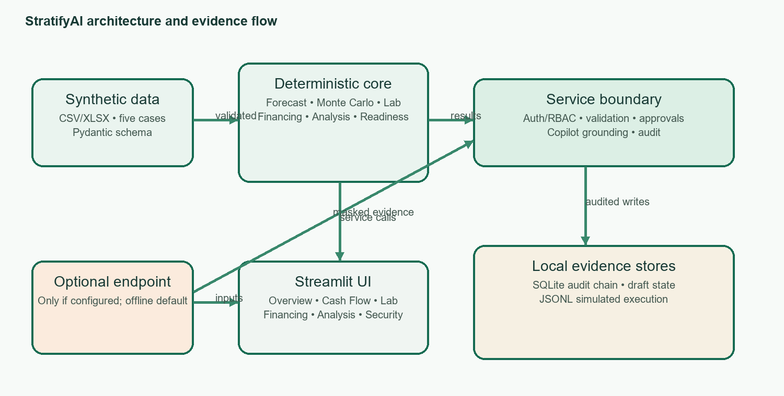
Figure 1. Layered system architecture and evidence flow. Financial computation is kept in the deterministic core; mutations and authorization are mediated by services.
The UI calls service functions for protected reads and state changes. Services resolve the authenticated principal and authorize actions before invoking core calculations or persistence. Financial outputs and their provenance are returned to the UI for rendering. The optional LLM path is isolated to copilot explanation: offline deterministic responses are the default, while configured mode receives the user question and a masked evidence pack. It has no action tools.
Figure 2 shows the system context: operators and uploaded files are external inputs, StratifyAI is a local application boundary, and an LLM endpoint is optional. Only masked question/evidence data crosses the optional provider boundary. Draft state, audit records, and simulation logs remain local. The design has no money-movement data flow.
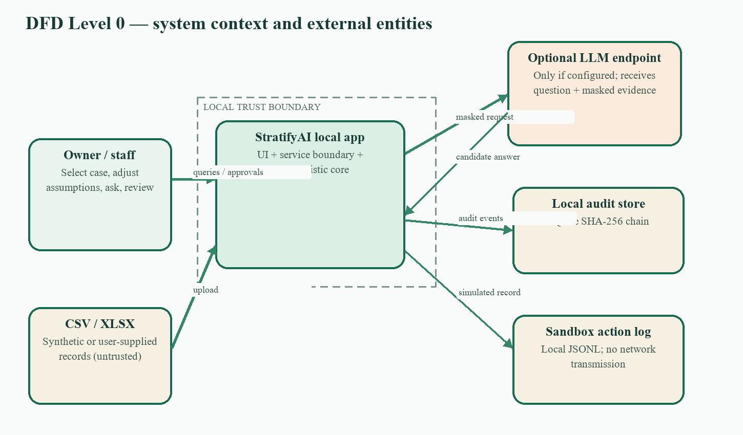
Figure 2. Context-level DFD (Level 0). Arrows indicate application data exchanges; the outer application boundary separates local state from the optional provider.
The Level 1 DFD in Figure 3 decomposes the internal path. File parsing and validation precede typed case construction; core analytics calculate the baseline; the Lab transforms copies for what-if comparisons; the Copilot consumes masked computed evidence; and privileged state transitions pass through service authorization before persistence. The return path into the UI includes evidence IDs and validation status so an explanation can be inspected rather than accepted as an opaque answer.
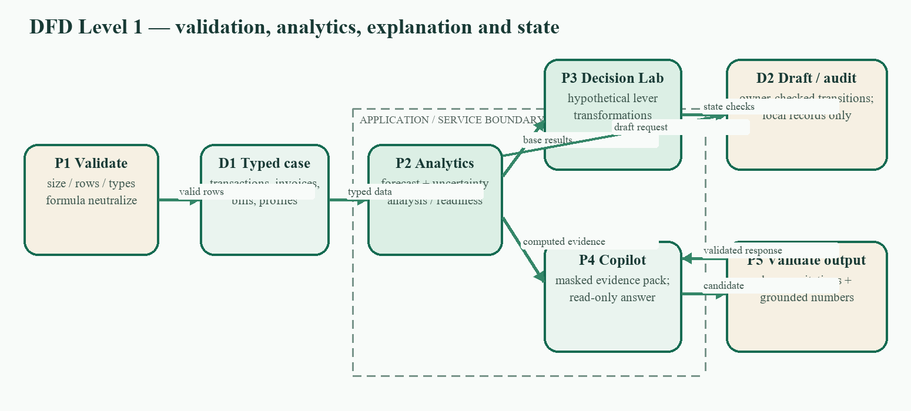
Figure 3. Level-1 DFD. P denotes a process and D a local data store; arrows show validated records, computed evidence, or audited state transitions.
The four semantic labels in Figure 4 express provenance. A scenario does not overwrite historical ACTUAL records. A CONFIRMED flag records the owner’s decision about an assumption, but remains an assertion rather than independent evidence. Keeping these paths separate is necessary when charts, plan tables, answer receipts, and audit events are compared.
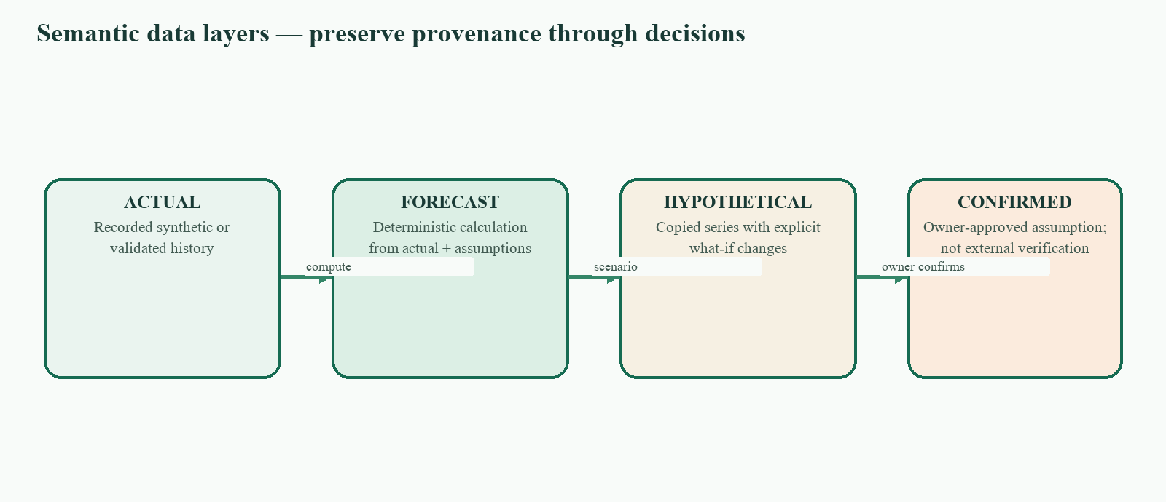
Figure 4. Semantic data-layer lifecycle. Confirmation changes an assumption’s review state; it does not turn a forecast into observed fact.

3.2. Four semantic data layers
Layer | Meaning | Example | Control / interpretation
ACTUAL | Recorded historical records supplied by the synthetic case or validated upload | Past transactions and balances | Source records; not independently audited
FORECAST | Deterministic output calculated from actuals and explicit assumptions | Projected weekly closing cash | Computed, model-dependent estimate
HYPOTHETICAL | Unapproved what-if changes | Earlier collection, supplier deferral, cost reduction, financing | Never treat as agreed or committed
CONFIRMED | A hypothetical assumption explicitly approved by the owner | Owner accepts a scenario proposal | Owner assertion only; not external verification

These labels are semantic state, not statistical confidence levels. A CONFIRMED assumption records human approval; it does not assert that a customer will pay, a supplier will consent, or a lender will approve financing.
A typical request begins with a signed-in role and selected business/scenario context. The UI passes the session identity and requested action to a service function; the service resolves the principal from trusted server-side state and checks the action registry. Read-only calculations are returned for display, while uploads, drafts, approval decisions, and scenario changes are separately authorized and audited. The core remains a calculation library: it does not decide permissions or render pages.
This separation makes the service layer the security boundary. Hiding a button in Streamlit improves usability but is not authorization. The same backend permission check must reject a direct or forged UI request. Pure parsers and calculation helpers operate on validated objects and do not write protected state.
Layer | Owns | Must not be treated as
app/ | Navigation, widgets, visualizations, page-level context and status | A security enforcement boundary
services/ | Authentication, permission checks, validation, workflow transitions, audit and Copilot orchestration | A substitute for deterministic financial calculation
core/ | Typed domain records and financial calculations | A UI module or source of lender decisions
data/ and evidence/ | Synthetic input fixtures and recorded evaluation artifacts | Real SME records or independently verified facts
Table 2. Code-layer responsibilities and trust boundaries.

3.3. Processing flow
- 1. Load a labelled synthetic case or parse an uploaded CSV/XLSX file.
- 2. Validate size, schema, required fields, data types, dates, values, duplicates, currency, text length, and formula-like cells.
- 3. Map valid records into typed case models and compute actual summaries.
- 4. Produce deterministic forecasts, financial-analysis metrics, readiness components, and receivables watchlist records.
- 5. Run scenario changes only on copied cash-flow series; preserve original case inputs.
- 6. Build a masked copilot evidence pack from computed results; validate candidate answer citations and numbers.
- 7. Persist authorized drafts/decisions and sanitized audit events locally; simulated execution remains explicitly non-networked.

4. Synthetic data and validation
The demonstration uses five generated synthetic SME cases representing stable operations, sales deterioration/cost pressure, high expenses, delayed customer payments, and import-financing assumptions. Each checked-in case contains 78 transactions across 39 weeks, 12 receivables, 12 payables, 10 synthetic customer profiles, and 6 synthetic supplier profiles. No real customer, supplier, account, or lender data is required. Case generation is deterministic; these fixtures are not a representative sample of Bangladeshi businesses.
Record family | Core fields represented | Purpose
Transactions | ID, date, direction, category, amount, balance after, description | Actual cash history and observed balances
Receivables | Invoice/customer IDs, issue/due/paid dates, amount, paid amount, currency | Outstanding collections, aging, payment-delay evidence
Payables | Bill/supplier IDs, issue/due/paid dates, amount, paid amount, category, deferrable/discretionary flags | Obligations, deferral and expense what-ifs
Profiles | Business opening cash; customer/supplier identifiers and editable assumptions | Synthetic case metadata and delay assumptions
Assumptions | Forecast horizon, reserve, random seed, variability and Lab/financing defaults | Explicit editable model parameters

Upload controls documented by services/validation.py cap the file at 5 MiB, rows at 50,000, and text fields at 500 characters. The validator checks supported CSV/XLSX form, header-to-record kind, required fields, dates, numeric values, transaction types, duplicate identifiers, currency consistency, and text bounds. Formula-like text is neutralized and reported instead of executed. Untrusted content is never promoted to instructions. A passing upload means structural validation succeeded; it does not certify the accuracy or ownership of the source data.
The currently available checked-in case generator and evaluation records do not establish statistical representativeness, population coverage, or external data validity. All tables, examples, and screenshots in this report must remain labelled synthetic.

5. Core algorithms

5.1. Weekly cash-flow forecast
core.forecast.forecast groups actual transactions into Monday-start weeks. The latest recorded balance is the forecast opening cash, and the forecast begins in the following week. The default horizon is 13 weeks, with a minimum of eight. Category run rates use the most recent eight weeks. When receivable records exist, inflow categories are excluded from run-rate projection; when payable records exist for a category, matching outflow run rates are excluded to avoid double counting. Outstanding invoices are bucketed by due date plus an estimated customer delay; the median observed delay is used when at least three paid invoices are available, otherwise the profile assumption is used. Outstanding bills are bucketed on their due dates.
ClosingCash_t = ClosingCash_(t−1) + ProjectedInflows_t − ProjectedOutflows_t

Reserve = configured reserve weeks × average fixed weekly outflow (default: 2 weeks)

FundingGap = max(0, Reserve − minimum projected closing cash) × (1 + buffer% / 100)

The first closing balance below reserve defines the shortage week; the first balance below zero is reported separately. Severity is none when the reserve is maintained, watch for reserve breach without a below-zero week, and critical when a below-zero week occurs. This is deterministic arithmetic over provided records and assumptions, not a learned forecast model.

5.2. Seeded Monte Carlo uncertainty
core.montecarlo.simulate produces 2,000 paths by default using NumPy’s seeded random generator and the seed stored in the selected case assumptions. The checked-in case profiles assign distinct reproducible seeds; docs/DECISIONS.md also mentions 42 as a generic seed, so case-profile values are the runtime source of truth. When invoice-delay sampling is enabled, customer payment delays are drawn from observed fully paid invoice history when at least five observations exist; otherwise a non-negative normal draw around the configured delay is used. Projected inflows are multiplied by a mean-one log-normal factor parameterized by the editable coefficient of variation. Each path is accumulated into weekly closing balances. The outputs include weekly P10/P50/P90 balances, weekly reserve/zero breach frequencies, and the fraction of paths with any reserve breach.
P_breach(any) = (1 / N) Σᵢ 𝟙[min_t(balanceᵢ,t) < reserve], N = 2,000 by default

A fixed seed makes a run repeatable for the same inputs and runtime behavior; it does not make the estimated event probabilities calibrated. Invoice amounts are fixed in source records, so the log-normal multiplier is a receipt-amount variability proxy. The model does not estimate uncertainty from a sufficiently large real business history.
Monte Carlo setting | Default / selection rule | Interpretation and caveat
Runs | 2,000 | Empirical frequency across simulated paths; not population probability
Seed | Selected case profile random_seed | Repeatable for same case and parameters; generated fixtures use distinct seeds
Invoice delay | Empirical customer delays when history has at least five paid invoices; otherwise nonnegative normal around configured delay | History-backed only within the synthetic case; normal fallback is a proxy
Receipt variability | Mean-one log-normal multiplier; case CV default 0.15 | Perturbs projected receipts while invoice amounts are fixed; proxy for amount variability
Outputs | Weekly P10/P50/P90, reserve/zero breach rates, any-week reserve breach | Computed for each run; not calibrated probabilities
Table 6. Monte Carlo settings and interpretation.
For each path, weekly cash is accumulated from opening cash. The percentile band answers “what balances did this specified simulation produce?” The reserve probability is the fraction of runs crossing the configured threshold. This is useful for sensitivity communication, but the short synthetic histories do not provide enough empirical evidence to claim actuarial calibration or forecast confidence intervals.

5.3. Liquidity Decision Lab
The Lab recomputes a baseline forecast and evaluates three levers independently, their combination, and financing alternatives. Every lever is labelled HYPOTHETICAL until the owner confirms the corresponding assumption.
Lever | Default | Transformation | Risk retained in result
L1 — Collections | 50% of eligible overdue receivables, within 2 weeks; 0% haircut | Distributes assumed early collection across selected weeks and removes the same amount from its later expected receipt bucket | Customer timing/amount remains unconfirmed; haircut is configurable
L2 — Reschedule | Move deferrable payables by 2 weeks; 0% late fee | Shifts an obligation into a later bucket; it is not erased, including when beyond horizon | Supplier agreement and relationship effect are uncertain
L3 — Expense reduction | 10% of selected discretionary expense, starting week 1 | Reduces eligible discretionary payable in the selected scenario | Avoidability and operational effect are unverified

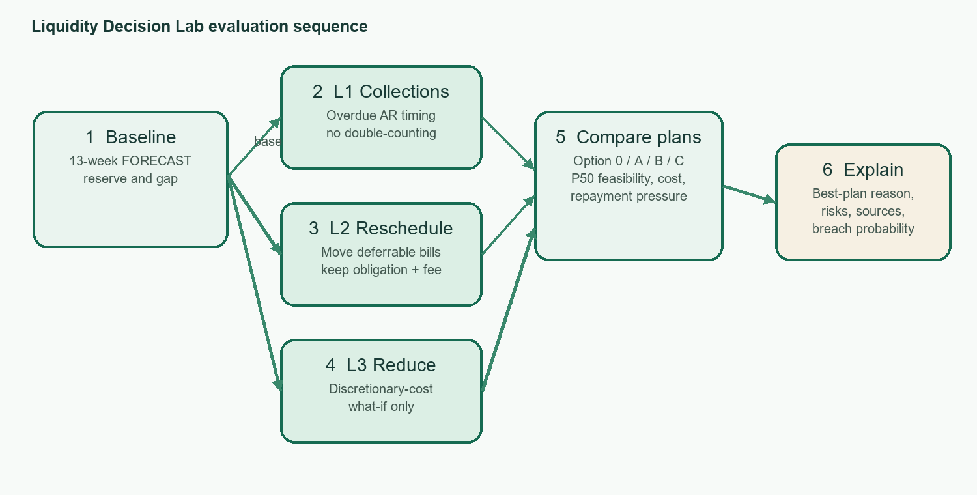
Figure 5. Lab evaluation sequence from baseline forecast through scenario comparison and explanation.
Option 0 is the unmodified baseline. Option A combines L1/L2/L3. Option B finances the remaining gap after those combined levers. Option C finances the original baseline gap. Candidate feasibility is determined on the deterministic path: the minimum closing balance must remain at or above reserve. Among feasible candidates, the rule minimizes modelled financing cost, then repayment-pressure rank, then count of unconfirmed assumptions. If no candidate is feasible, the Lab reports that fact and selects the smallest remaining gap; it does not force a “successful” recommendation. Monte Carlo breach probability is displayed as separate risk context, not substituted into the deterministic selection rule.
Lever | Default parameters | Detailed transformation | What remains unverified
L1 — Collect | 50% of overdue eligible receivables; two weeks; zero haircut | Spread assumed collection across early buckets and subtract the same amount from the later expected receipt bucket | Customer payment date and collectability
L2 — Reschedule | Two weeks; zero fee | Move eligible deferrable bill to later bucket; retain obligation and add configured fee | Supplier agreement and relationship cost
L3 — Reduce | 10% discretionary spend reduction from week 1 | Reduce eligible discretionary payable in the hypothetical copy | Whether spending is avoidable without harm
Option A | All three selected levers combined | Run the same balance engine over combined adjusted flows | All lever assumptions are still hypothetical
Option B / C | Editable financing template | B applies facility to Option A residual; C finances baseline gap | No offer, eligibility or approval inference
Table 7. Decision Lab levers and financing-plan construction.
The implementation prevents a common scenario-accounting error: a collection accelerated to an early week is removed from its original later bucket, and a deferred supplier payment is moved rather than deleted. A payable moved beyond the 13-week display remains an obligation, even though it no longer appears within the visible horizon. The plan card therefore carries explicit risk text and provenance for each changed assumption.

5.4. Financing calculations
Illustrative template | Default terms in the prototype | Repayment treatment
Term loan | 14% annual nominal rate; 1% fee; 6 months | Equal monthly instalments using annuity; interest on declining principal
Invoice financing | 80% advance; 2.0% per 30 days outstanding | Principal/charge due at maturity; gross facility to deliver the rounded net need
Supplier credit | 30-day extension; 1.5% of invoice value | Principal and explicit cost due at maturity
Credit line | 16% annual rate on drawn amount; 0.5% fee | Drawn balance interest; principal at maturity

A = P × r / [1 − (1 + r)^(−n)] ; A = P / n when r = 0

Here P is principal, r is monthly rate (nominal annual percentage divided by 12), and n is number of monthly instalments. Amounts are rounded upward to the next BDT 1,000. Invoice-financing facility size is grossed up by its selected advance rate. Total cost sums modeled interest, fees, and explicit hypothetical charges. Repayment capacity is average weekly net operating cash flow scaled to debt-service period divided by debt service for that period. Labels at 1.25x and 1.0x are editable rules of thumb only; the project makes no lender underwriting claim.
Template | Illustrative defaults | Cost / payment model | Not represented
Term loan | 14% p.a.; 1% fee; 6 months | Monthly annuity; declining-principal interest | Lender underwriting, covenants, eligibility
Invoice financing | 80% advance; 2.0% per 30 days | Facility grossed up to deliver net gap; principal/charge at maturity | Invoice assignment, recourse, real fees
Supplier credit | 30-day extension; 1.5% invoice cost | Principal plus explicit cost at maturity | Supplier consent, contract terms
Credit line | 16% p.a.; 0.5% fee | Interest on drawn amount; principal at maturity | Undrawn limit and lender policy
Table 8. Editable financing templates; all terms are illustrative.
For an amortizing loan, the monthly payment follows the standard annuity relation. When monthly rate is zero, the implementation uses straight principal division to avoid a zero denominator. Required amount rounds upward to the next BDT 1,000; invoice financing grosses this net target up by the advance percentage. Repayment-capacity bands (comfortable at or above 1.25x, tight from 1.0x to below 1.25x, stressed below 1.0x) are configurable heuristics, not lender thresholds.

5.5. Readiness and receivables watchlist
Indicator component | Default weight | Implemented scale / interpretation
Repayment capacity | 35% | capacity ratio ÷ 1.25 × 100, bounded 0–100
Cash buffer | 25% | latest recorded cash ÷ reserve × 100, bounded 0–100
Receivable quality | 20% | 100 minus overdue share of open receivables
Data completeness | 10% | proportion of five core source groups containing records
Trend | 10% | latest versus preceding four-week average net cash, scaled around 50

Unavailable components are excluded and the remaining component weights renormalized. The resulting score is explicitly “Readiness indicator, not a loan approval prediction.” The receivables watchlist separately combines overdue-amount share (40 points), amount-weighted days overdue capped at 90 days (30), payment-delay trend (20 when history supports it), and customer concentration in total open receivables (10). Its labels are Normal below 30, Watch from 30 through 60, and Urgent above 60. Each row lists source invoice IDs. These are project-defined explainable heuristics, not validated credit scores.

6. Copilot, agent actions and human control

6.1. Evidence-grounded Copilot
services.copilot rebuilds a compact evidence pack from selected deterministic forecast, Lab, analysis, and readiness outputs after checking copilot.ask permission. Entity names and free-text source fields are omitted; identifiers may remain. The query is bounded to 500 characters. Offline deterministic templates are the default. Optional LLM mode is activated only by local configuration and sends the question plus masked evidence to a generic OpenAI-compatible endpoint. The service has no draft, approval, or execution tools.
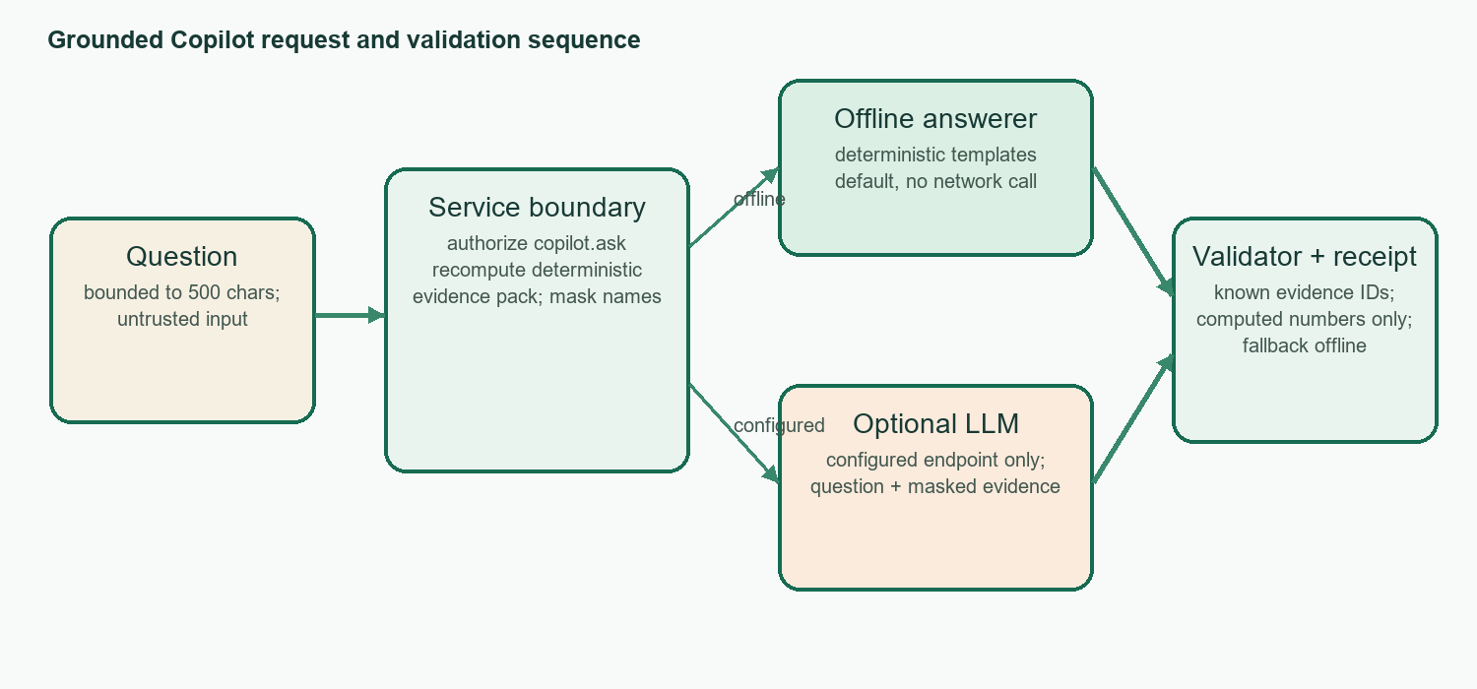
Figure 6. Copilot evidence, optional generation, answer checks, and receipt sequence.
A candidate response must use known evidence IDs, and every numeric literal must be supported by computed evidence. If the endpoint errors or validation fails, the service returns a safe offline answer. The audit event stores a SHA-256 query hash and receipt rather than raw query text. This constrained pattern is inspired by the broader grounding/provenance motivation in RAG literature [5, 6], but it is not a conventional RAG system: there is no corpus retriever, vector database, or model training.
Receipt field | Purpose
mode | Records offline or configured LLM mode
evidence_ids | Identifies evidence referenced by the answer
masked_fields | Counts fields withheld from the evidence pack
external_call | Indicates whether a configured external endpoint was called
validator_result | Records citation/number validation or safe fallback status

Evidence family | What is recomputed | Masking / use boundary
Forecast | Shortage week, funding gap, balances, reserve and uncertainty summaries | Computed numbers; customer/supplier names and source free text excluded
Decision Lab | Options, cost, balance path, feasible flag, gap and risks | Assumptions remain HYPOTHETICAL; no acceptance claim
Analysis / readiness | Historical ratios or missing-data reasons and readiness components | Read-only evidence; not a loan-approval result
Receipt | Mode, evidence IDs, masked field count, external-call flag, validator result | Audit receipt identifies provenance; raw question is represented by SHA-256 hash
Table 10. Copilot evidence pack and receipt boundaries.
Supported intents are deliberately bounded: cash shortage, funding gap, plan comparison, read-only customer-delay what-if, data quality, and readiness. Unsupported questions return a missing-data response rather than open-ended financial advice. Citation validation requires every cited ID to exist in the current pack, and numeric validation rejects unsupported numeric literals. When a configured provider returns malformed or ungrounded output, the service falls back to deterministic offline language.
Draft type | Typical payload | Allowed workflow
Collection reminder | Synthetic customer/invoice reference and amount | finance_ops creates/submits; owner reviews
Supplier deferral request | Supplier/bill reference and proposed date | finance_ops creates/submits; owner reviews
Financing pack | Selected illustrative option and supporting values | Draft only; no external application
Liquidity Lab proposal | Scenario, assumptions, plan and evidence references | Owner may confirm assumption and review; simulation only
Table 11. Structured draft catalog and human review boundary.
Draft text is generated from bounded structured fields, escaped before rendering, and stored with an idempotent transition record. finance_ops can create and inspect its own drafts but cannot approve. Owner review checks the pending state and authorization before changing status. A repeated request is handled idempotently where implemented, preventing duplicate state transitions from being mistaken for multiple real-world actions.

6.2. Draft, approval and simulated execution
Agent actions are deterministic templates stored as local drafts. finance_ops may create and submit eligible drafts; owner-only checks govern approval/rejection and simulated execution. Service code checks both permission and current state before each transition. An approved item can be recorded as simulated execution in a local JSONL log with network_sent=false. The audit trail records the actor and transition. The MONEY_MOVEMENT action is denied for every role, including owner. The simulation does not connect to a bank, lender, customer, or supplier.
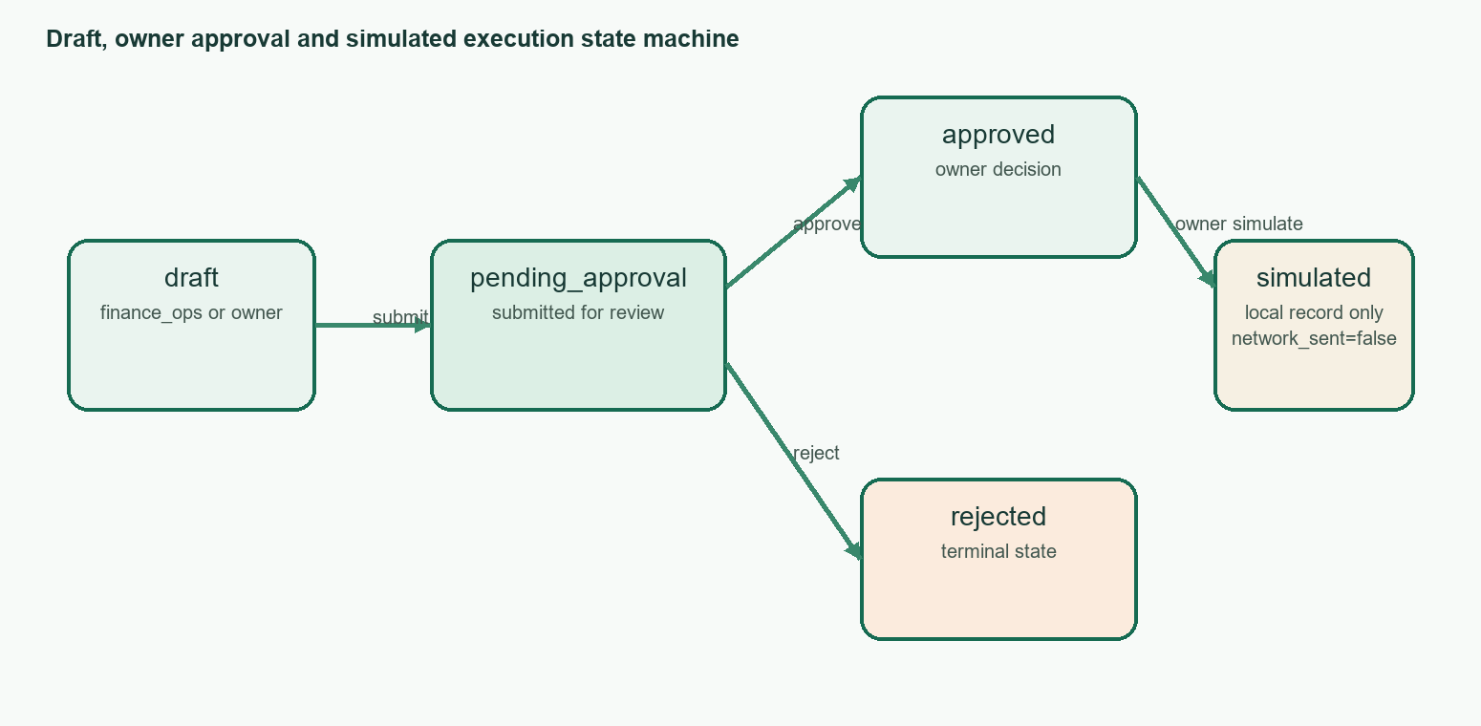
Figure 8. Action state machine. Rejected and simulated items are terminal; execution represents only a local record.
The sequence in Figure 7 complements Figure 8: it shows who invokes each service and which local stores are written. Authentication and authorization precede the approval transition; after approval, the owner may record a simulation, which writes a local event but performs no external network operation.
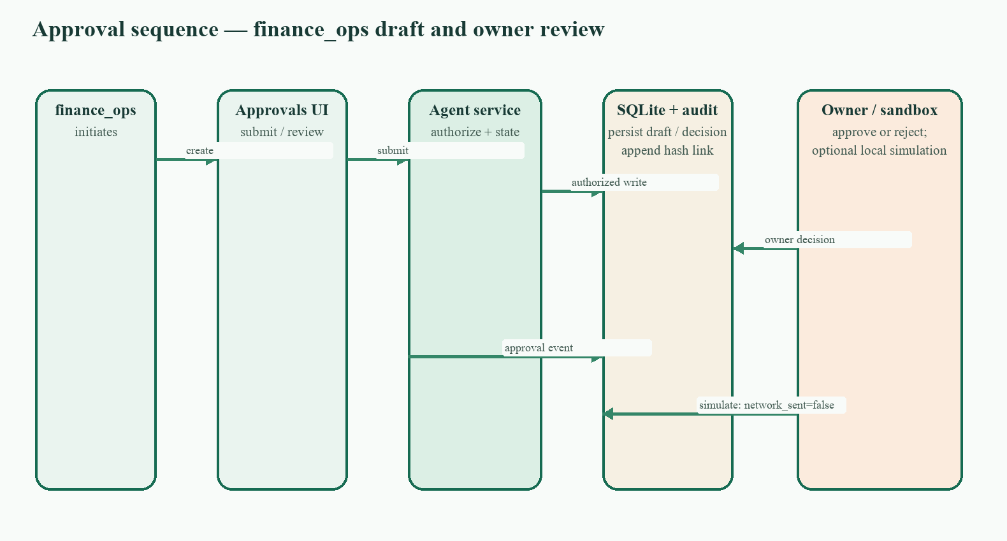
Figure 7. Approval sequence across finance_ops, UI, service authorization, SQLite, audit, owner, and local sandbox log.
The state machine in Figure 8 expresses legal status transitions independent of page layout. A pending draft can be approved or rejected by the owner; only an approved draft is eligible for simulation. The state label simulated_executed means “local simulation event recorded,” not “payment sent.”

6.3. Human oversight boundary
The owner must review assumptions and authorize proposed state changes. A scenario may be arithmetically feasible while depending on an unconfirmed payment, supplier concession, or cost reduction. Consequently, the UI surfaces assumptions, source references, risks, and next steps. Human approval in this prototype is an application event, not an external counterparty confirmation or legal authorization.

7. Security design

7.1. Role and permission model
The application defines owner, finance_ops, viewer, and auditor roles. The identity resolved for an action comes from a server-issued session token and user record. Permission checks occur in services, not solely through hidden navigation. Action classes are READ, DRAFT, APPROVAL_REQUIRED, and MONEY_MOVEMENT (always denied). Denial events are audited.
Action | Owner | finance_ops | Viewer | Auditor | Tier
dashboard.view; security.view | Allow | Allow | Allow | Allow | READ
copilot.ask | Allow | Allow | Allow | Allow | READ
audit.view | Allow | Deny | Deny | Allow | READ
approvals.view | Allow | Allow | Deny | Allow | READ
lab.run; scenario.change; data.upload; draft.create | Allow | Allow | Deny | Deny | DRAFT
assumptions.manage | Allow | Deny | Deny | Deny | DRAFT
draft.approve; draft.reject; execution.simulate | Allow | Deny | Deny | Deny | APPROVAL_REQUIRED
money.move | Deny | Deny | Deny | Deny | MONEY_MOVEMENT

Table 12 links the high-level roles to service actions. The authoritative policy is the registry in services/permissions.py; individual services call authorize() before data mutation. This table summarizes current behavior and should be checked against that registry after any role change.
Action / tier | owner | finance_ops | viewer | auditor | Enforced by
dashboard.view / READ | ✓ | ✓ | ✓ | ✓ | Permission registry
copilot.ask / READ | ✓ | ✓ | ✓ | ✓ | services.copilot
audit.view / READ | ✓ | — | — | ✓ | services.audit
lab.run, scenario.change, data.upload, draft.create / DRAFT | ✓ | ✓ | — | — | actions / validation / agent_actions
assumptions.manage / DRAFT | ✓ | — | — | — | Permission registry
draft.approve, draft.reject, execution.simulate / APPROVAL_REQUIRED | ✓ | — | — | — | services.agent_actions state checks
money.move / MONEY_MOVEMENT | — | — | — | — | Always denied; audited
Table 12. Role/action matrix. A dash denotes denial.
This design follows least authority within the prototype: read capabilities are broad but action capabilities narrow as impact rises. The UI may hide unauthorized controls, but the service still checks the role and current object state. All denials create audit evidence so an attempted privilege escalation is visible in the local log.

7.2. Audit integrity and storage
Audit records are sanitized and size-limited, appended to SQLite, and linked by SHA-256 previous-record hashes. Local SQLite update/delete triggers guard ordinary application paths; a verifier detects broken links and tampering. This is tamper-evident local storage, not immutable or independently replicated evidence. A host administrator can replace the file or disable local triggers. Agent drafts and simulated-action logs are also local; backup, tenant isolation, and disaster recovery are not implemented.

7.3. Upload and prompt-injection controls
Uploads use bounded size/row/text inputs, typed field validation, duplicate/currency/date checks, and formula neutralization. Copilot treats both questions and imported text as untrusted; it excludes free text and entity names from evidence, restricts supported intents, has no tools, checks evidence IDs and numbers, and falls back offline. The project’s security suite documents 10 poisoned-name cases excluded from the evidence pack and grounded-receipt checks. These controls reduce exposure in the implemented workflow but do not solve prompt injection generally. An optional provider still receives the question and masked numeric evidence; its retention and security are outside this project’s control.

7.4. STRIDE summary
Threat | Example | Controls implemented | Residual risk
Spoofing | Forged session role | PBKDF2 password hashes; server-side token resolution | Demo credentials/quick sign-in; no MFA or production identity provider
Tampering | Alter draft or audit history | State-checked transitions; SQLite triggers; SHA-256 chain and verifier | Local administrator can replace DB or disable guards
Repudiation | Deny an approval | Actor/role/action events linked in local audit chain | No independent clock or host attestation
Information disclosure | Names/query text sent to LLM | Masked pack; query hash in audit; environment-held key | Configured provider receives query and masked financial values
Denial of service | Large upload/provider call | 5 MiB/50k-row/500-char bounds; 20s provider timeout | No rate limit, quota, or concurrent-job scheduler
Elevation of privilege | Viewer moves money | Backend authorize checks; owner-only approvals; money movement denied | Local source/database administrator can alter prototype

This mapping is a project self-assessment against common threat categories and OWASP GenAI risks [7–9]. It is not a penetration test, compliance attestation, or independent security review. The project self-assessment should be reconciled against the current official OWASP edition before submission: the public OWASP archive currently identifies its list as the 2025 edition, while an existing project note labels it 2026 [7].

8. Implementation and interface
The project is implemented in Python 3.11 with Streamlit 1.66.0, pandas 3.0.6, NumPy 2.4.6, Plotly 7.1.0, Pydantic 2.14.1, SQLite, pytest 9.1.1, and Ruff 0.17.1 as recorded in the project requirements. The app is designed to run locally and offline; optional LLM configuration is external and unset by default. The public Overview image below is a current 1440 px capture of the redesigned green interface. It is not a signed-in Case 3 financial dashboard; the report therefore marks the required signed-in screenshots individually in red.
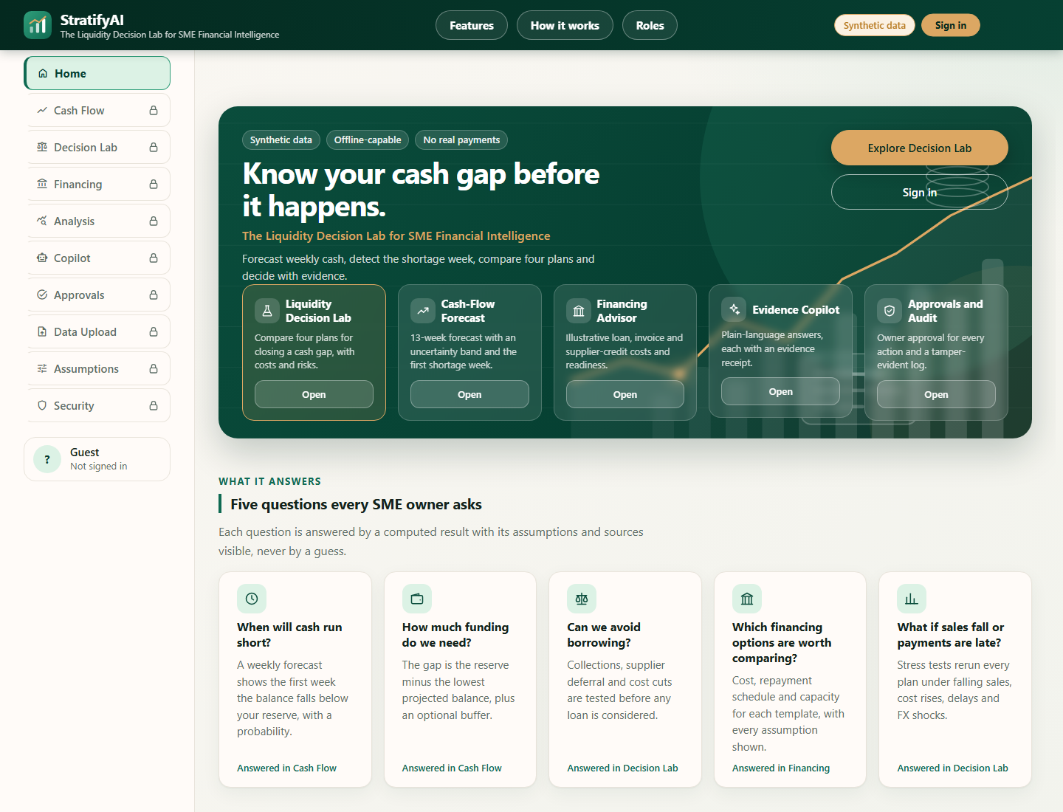
Figure 9. Current public StratifyAI landing/Overview shell capture (docs/img/overview.png, 1440 px). This view does not replace the signed-in dashboard evidence requested below.
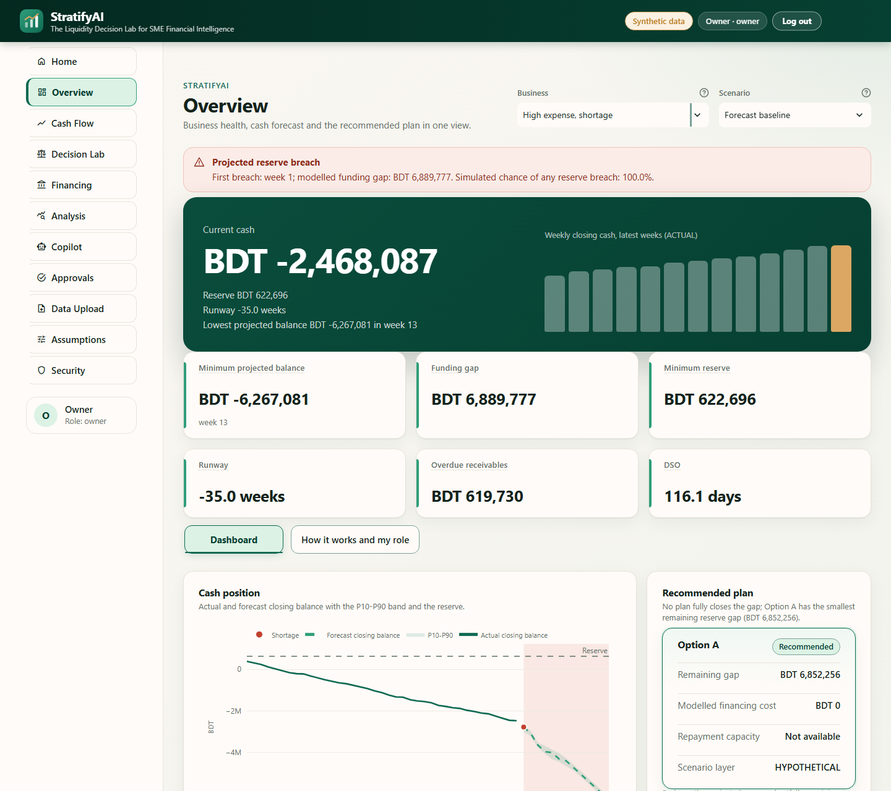
Figure 10. [F2] Signed-in owner Overview for Case 3 (high-expense shortage).

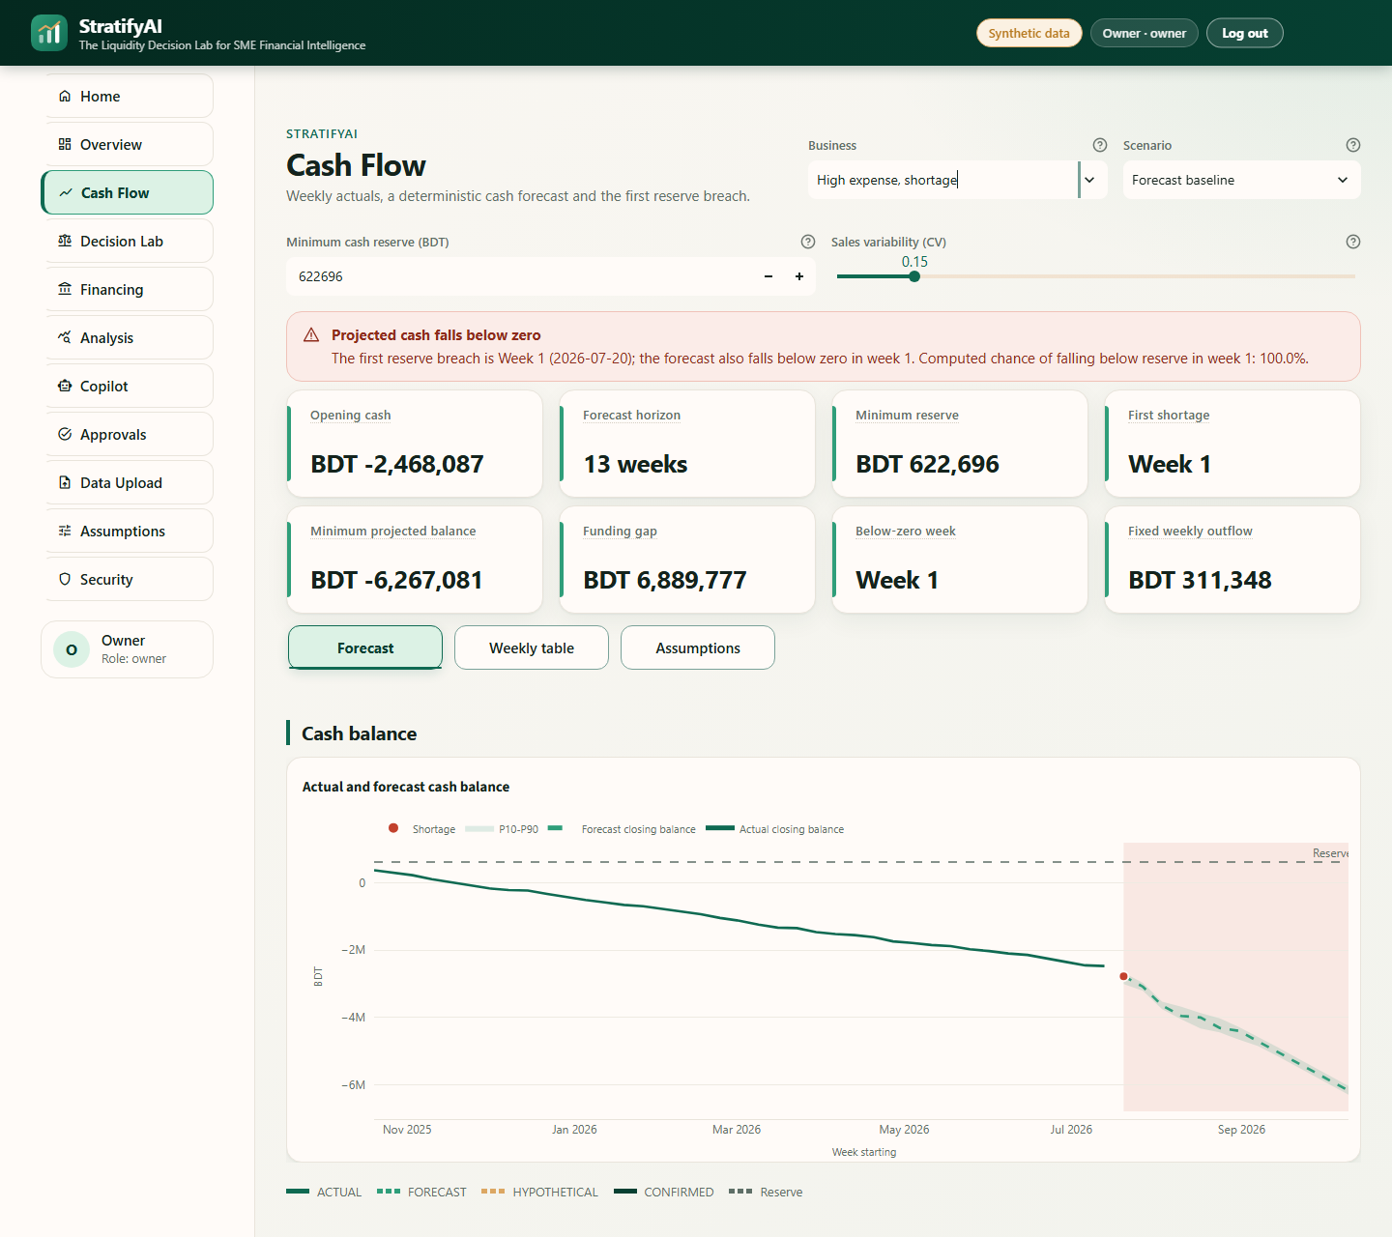
Figure 11. [F3] Cash-flow forecast with reserve and uncertainty context.

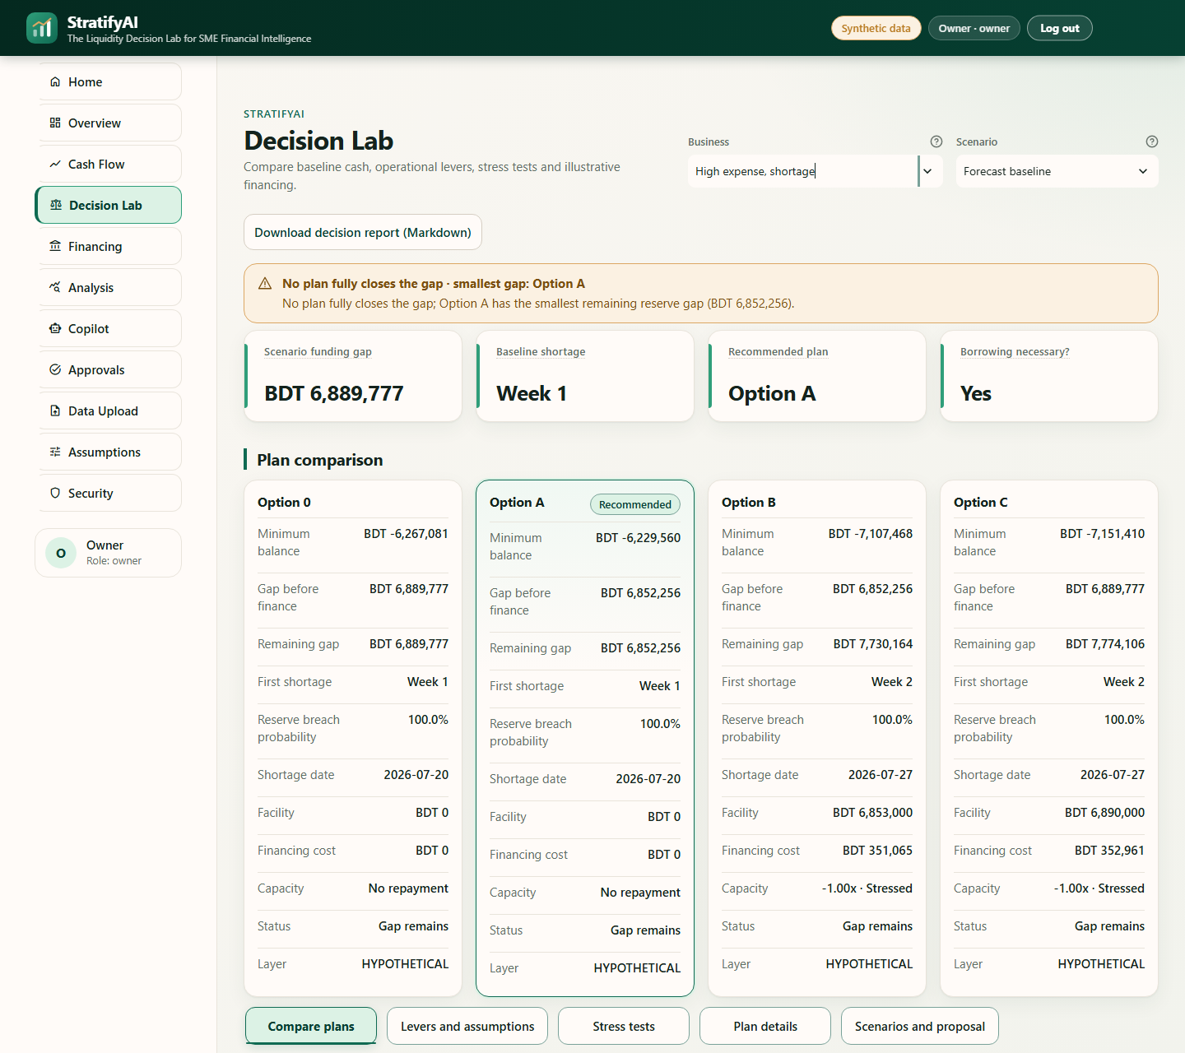
Figure 12. [F4] Liquidity Decision Lab comparison of baseline and alternatives.

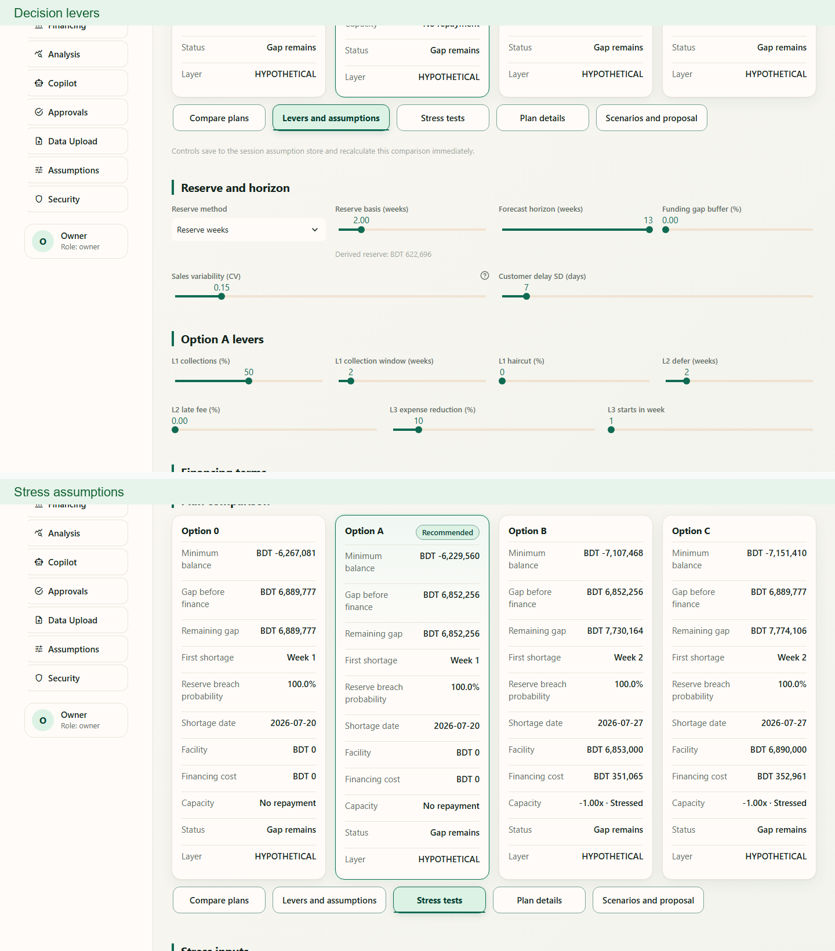
Figure 13. [F5] Decision Lab lever settings and stress assumptions.

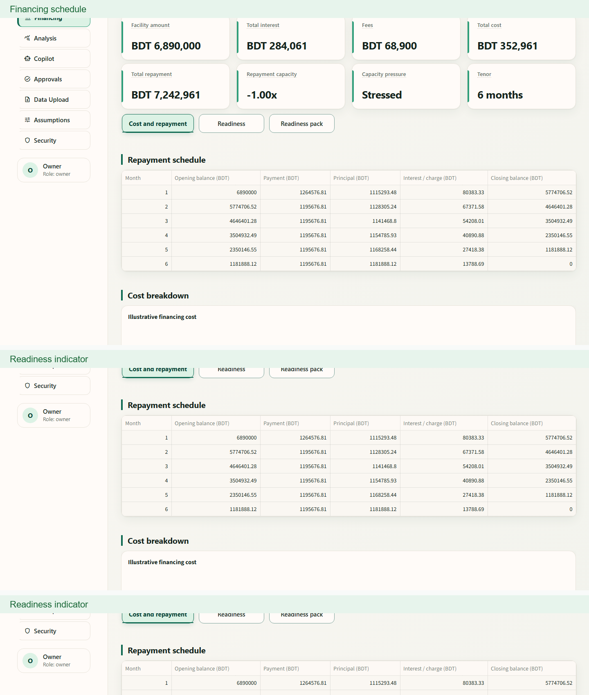
Figure 14. [F6] Illustrative financing schedule and readiness indicator.

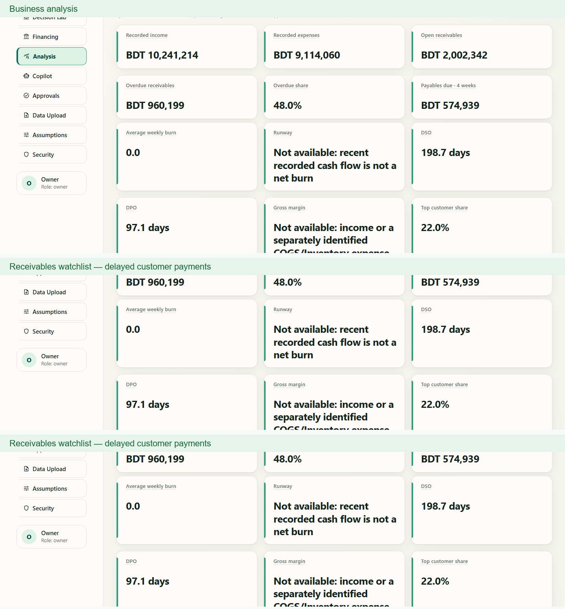
Figure 15. [F7] Case 2 business analysis and receivables watchlist.

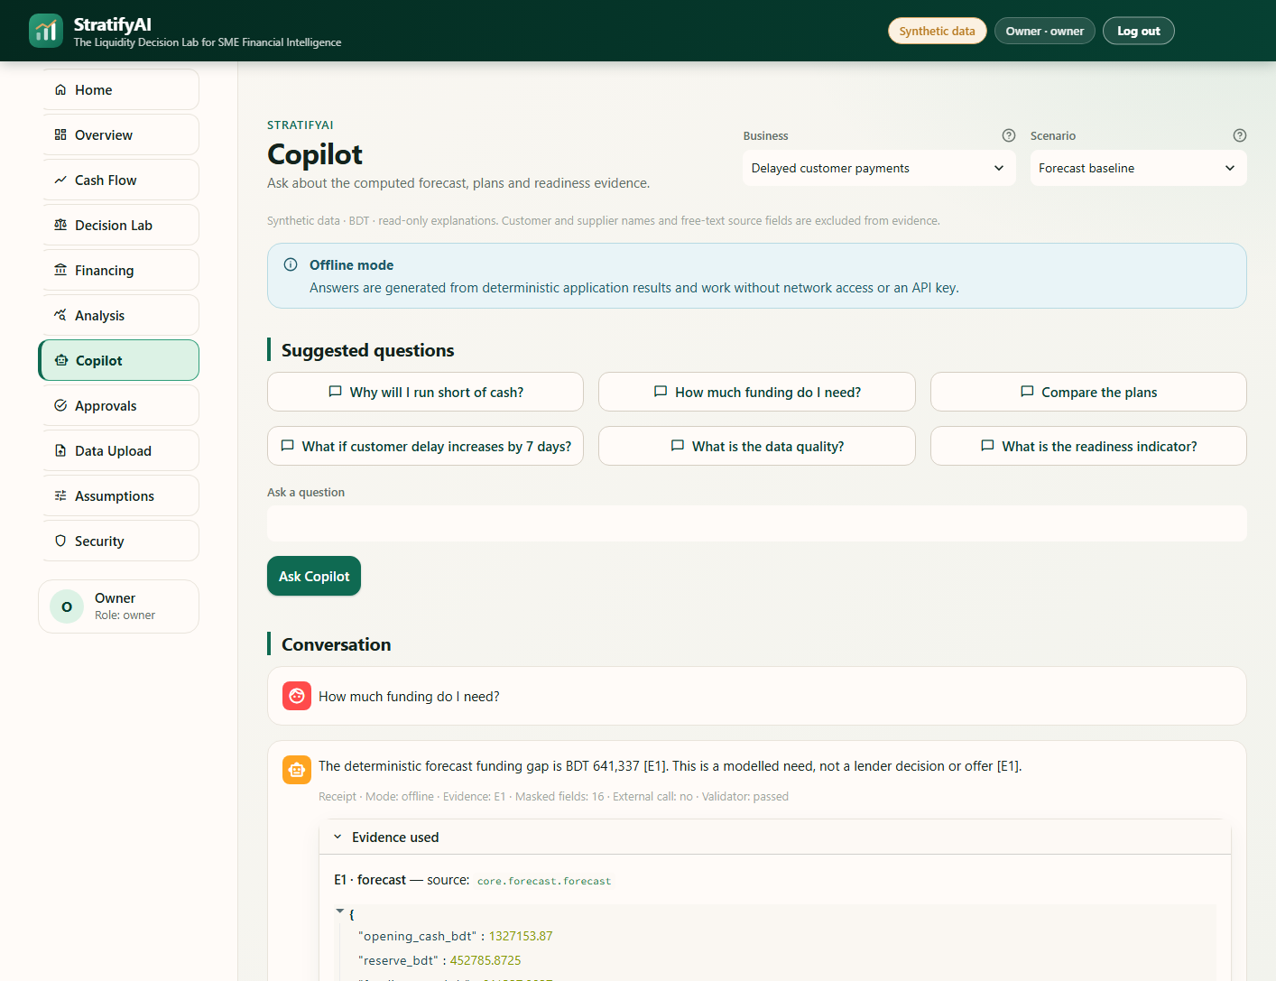
Figure 16. [F8] Copilot response with expanded Evidence used receipt.

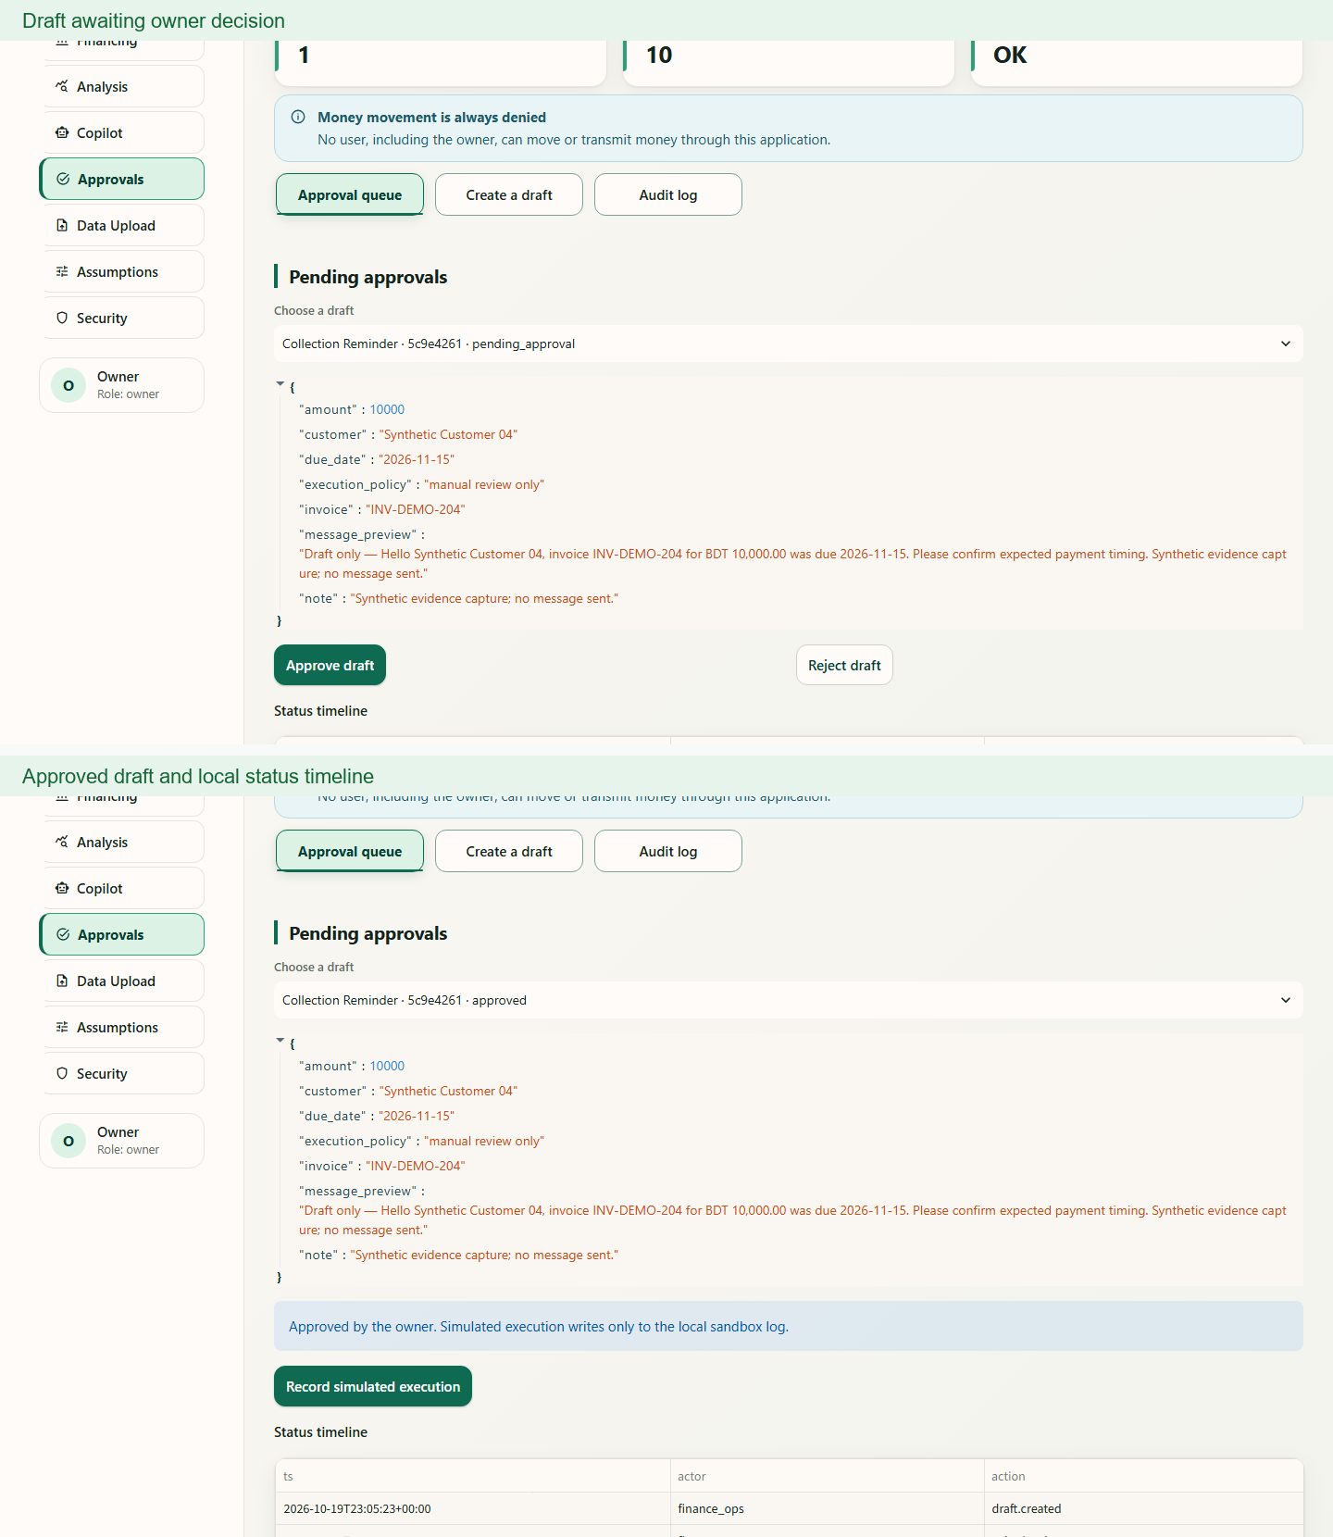
Figure 17. [F9] Approval workflow from pending draft to approved local record.

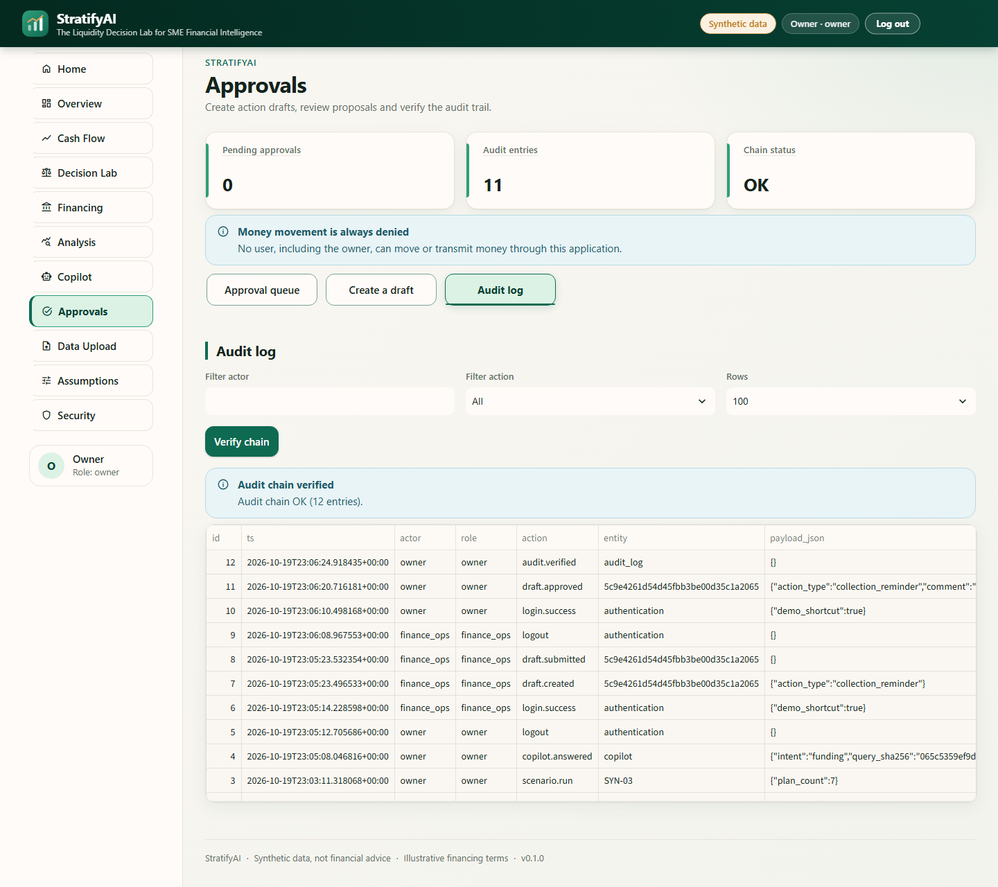
Figure 18. [F10] Audit hash-chain verification result.

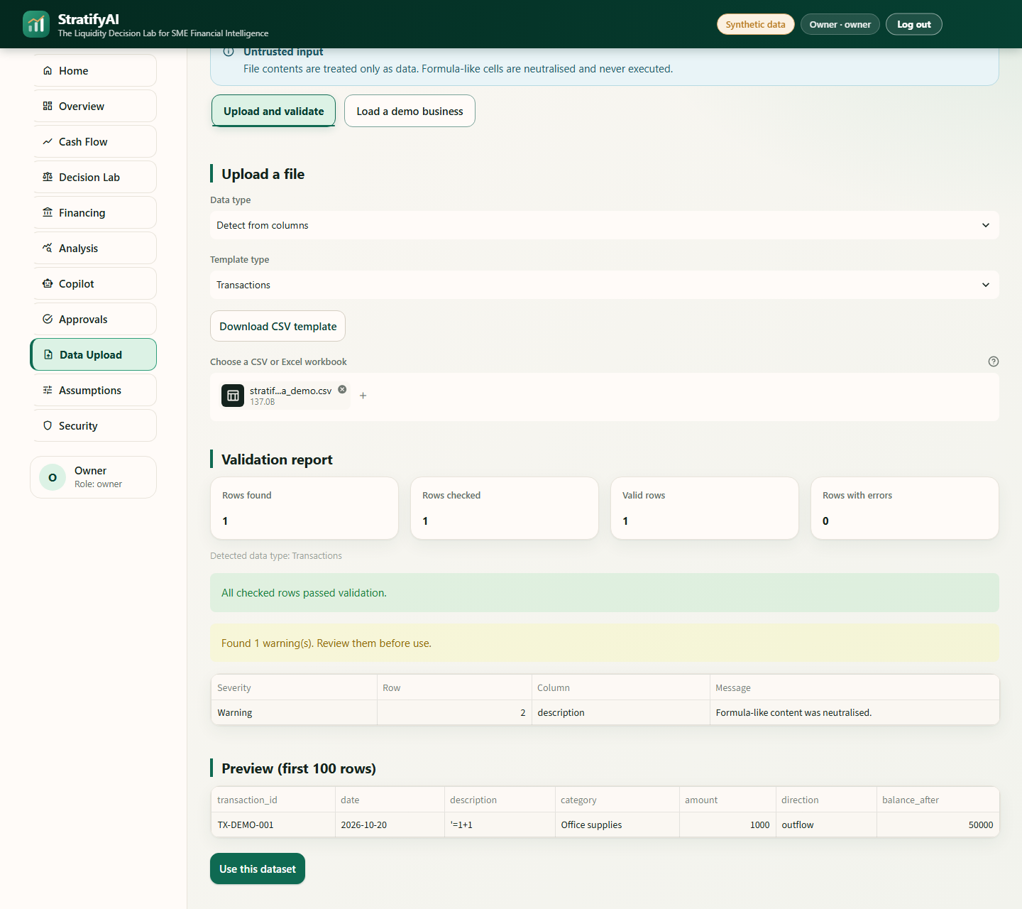
Figure 19. [F11] Upload validation of formula-like cell (=1+1).

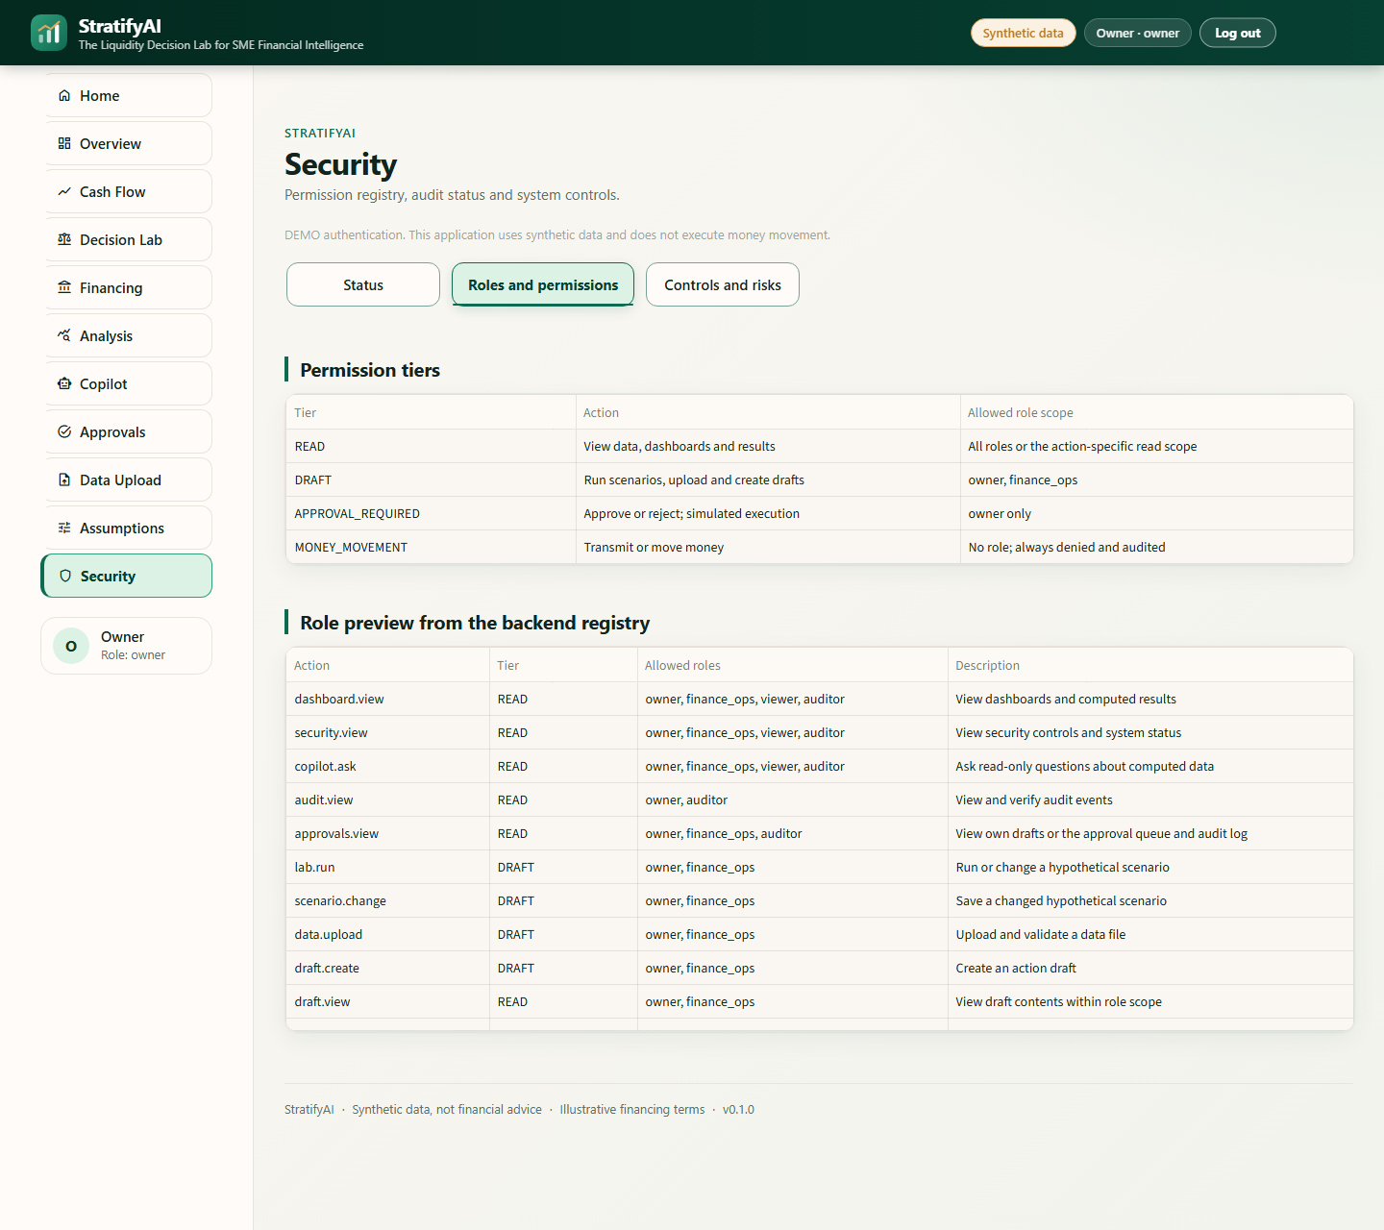
Figure 20. [F12] Security roles and permission matrix.

All requested captures should be taken from the current signed-in UI at a 1440 px viewport, use synthetic cases, and be stored under docs/img/. Preserve enough surrounding UI to identify the page and scenario; crop browser chrome and unrelated empty space. Red placeholders are production instructions, not actual evidence and must be replaced before final submission.

9. Evaluation and evidence

9.1. Evaluation design and provenance
The repository contains several different evidence events and they are reported separately. The T15 evaluation bundle is timestamped 18 October 2026. It includes 13 scripted service workflows, 60 role/action decisions, 10 poisoned-name masking cases, grounding receipts, and audit tamper detection. The latest integrated QA record in docs/PROGRESS.md, dated 20 October 2026, records 205 passing tests after UI regression fixes. The older checked-in full test output records 197 tests for the earlier evaluation build. The current document does not claim that all security/workflow artifacts were rerun with the later UI test count.
Measure | Recorded result | Interpretation
Latest integrated test suite | 205 passed; recorded 2026-10-20 | Project progress record; implementation regression coverage, not field validation
T15 service workflow suite | 13/13 passed; 2026-10-18 | Scripted case/service tasks in evidence/task_suite_results.md
Authorization matrix | 60/60 decisions matched; 2026-10-18 | Role/action registry checks in evidence/security_eval.md
Poisoned-name evidence filtering | 10/10 excluded; 2026-10-18 | Security evaluation fixture, not comprehensive adversarial testing
Audit tampering | Tamper detected at entry 1 | Local chain-verifier test evidence
Latest quality tooling | Ruff, health check, secret scan recorded passing | Per docs/PROGRESS.md; no claim these were rerun for this report

9.2. Synthetic holdout forecast comparison
The checked-in backtest uses 29 training weeks and a 10-week holdout per case, with a 4 May 2026 cutoff. The deterministic model is compared with a naïve average of the last four weeks’ net cash flow. MAE is stated in BDT per week and WAPE as a percentage. In all five cases, the project forecast has higher MAE and WAPE than the naïve baseline. This is a negative result and rules out any claim of demonstrated forecast improvement in this experiment.
Synthetic case | Model MAE (BDT/wk) | Model WAPE | Naive MAE (BDT/wk) | Naive WAPE
Stable healthy | 255,371 | 3.3099 (330.99%) | 32,631 | 0.4229 (42.29%)
Sales drop / cost rise | 166,949 | 2.3137 (231.37%) | 140,806 | 1.9514 (195.14%)
High-expense shortage | 256,412 | 3.7469 (374.69%) | 26,177 | 0.3825 (38.25%)
Delayed customer payments | 297,374 | 9.8917 (989.17%) | 18,340 | 0.6101 (61.01%)
Import financing | 299,113 | 5.7699 (576.99%) | 23,607 | 0.4554 (45.54%)

Table 15. Per-case holdout metrics transcribed from evidence/backtest_results.csv. Lower is better; the model loses to the naïve baseline in every case.

9.3. Reserve and decision quality
Case | Selected plan | Minimum balance (BDT) | Reserve (BDT) | Maintains reserve? | Any-breach probability
stable_healthy | Option 0 | 3,246,587 | 389,266 | Yes | 0.0%
sales_drop_cost_rise | Option 0 | −1,594,784 | 529,254 | No | 100.0%
high_expense_shortage | Option A | −6,229,560 | 622,696 | No | 100.0%
delayed_customer_payments | Option 0 | −188,551 | 452,786 | No | 100.0%
import_financing | Option A | 253,079 | 420,887 | No | 98.45%

Table 16. Decision-quality evidence from evidence/decision_quality.json. Only one of five selected plans maintained the reserve; breach probabilities are simulation outputs under the configured model.
The simulator’s 100% probabilities in several fixtures are outcomes for the configured synthetic assumptions and 2,000-run simulation. They should not be interpreted as empirical default or insolvency probabilities. Four cases have no selected plan that keeps reserve under the deterministic path. The report therefore emphasizes transparent shortfall disclosure rather than success rates.
MAE is the average absolute weekly error in net cash flow. WAPE is total absolute error divided by the total absolute observed flow over the holdout; it is reported as a ratio and percent. Smaller is better for both. The model loses to the selected baseline on each case, including the delayed-payment case where WAPE is especially large. The baseline is intentionally simple, but this adverse result is still evidence against claiming the current rules are accurate.
Case result | What the observed row tells us | Interpretive boundary
stable_healthy: model MAE BDT 255,371; baseline BDT 32,631 | Baseline errors are substantially smaller on this holdout | Does not establish which method generalizes beyond the fixture
sales_drop_cost_rise: model BDT 166,949; baseline BDT 140,806 | Model error is higher, though the gap is smaller than in other cases | No statistical significance test or independent test population
high_expense_shortage: model BDT 256,412; baseline BDT 26,177 | The modeled run rate does not track this holdout well | Do not rely on the alert as a calibrated forecast
delayed_customer_payments: model BDT 297,374; baseline BDT 18,340 | Payment-delay timing heuristic misses much of the observed pattern | Need richer payment history and better timing model
import_financing: model BDT 299,113; baseline BDT 23,607 | Editable import assumptions do not imply forecasting accuracy | FX, deposit, lead-time and sales ramp remain assumptions
Table 14. Per-case interpretation of the holdout errors. Values are from the checked-in CSV, rounded to the nearest BDT.
The decision-quality table is distinct from forecast accuracy. One of five selected plans kept the reserve in the recorded scenario output; in four cases, the system reported that no selected option fully maintained the reserve. This is useful functional behavior only if the shortfall is communicated plainly; it is not evidence the recommendations improve outcomes.

9.4. Evaluation limitations
There are only five synthetic cases and a single holdout arrangement. The forecasting system is rule-based, uses short recent run rates, and shows poor performance against the selected naïve baseline. The task suite checks expected workflow behavior, not user comprehension, operational savings, accessibility, or field deployment. Security checks cover enumerated controls and fixtures, not a full penetration test. The latest 205-test count is a progress-record result rather than an archived stdout file in the evidence directory. Before external presentation, the team should preserve a fresh dated test transcript and capture the requested signed-in screenshots.

10. Discussion, limitations and validity

10.1. What the results support
The implementation evidence supports that the tested workflows can be exercised end-to-end in the local synthetic prototype; service permissions matched the tested matrix; the audit verifier detected the tested tamper operation; and the answer validator is wired to computed evidence. It also supports that this particular forecast configuration did not outperform the chosen simple baseline in any of five synthetic cases and that the Lab often cannot maintain the configured reserve. Both findings are material to interpreting the system.

10.2. What the results do not support
The evidence does not establish forecast accuracy for real firms, a causal improvement in financial decisions, better access to finance, model calibration, fairness across populations, or deployment-grade security. Five generated cases cannot represent sector, geography, accounting practice, seasonal variation, or customer behavior. The backtest is short and synthetic, and the baseline is one comparator. Consequently, conclusions are limited to design and test behavior under the specified fixtures.

10.3. Ethical and operational boundaries
All data and financing terms are synthetic or illustrative. Readiness is not an approval prediction; the interface must not be used to make credit decisions. The prototype has no real bank/lender/customer integrations or payments. Optional LLM mode transfers the question and masked numeric evidence to the operator-selected endpoint; offline mode should be retained unless data handling has been reviewed. Seeded demo identities, single-process operation, local databases, no rate limiter, no tenant isolation, and no independent audit replication make the current build unsuitable for public production deployment.

10.4. Threats to validity
Validity dimension | Risk | Mitigation / current status
Construct | Reserve breach is a narrow proxy for liquidity health | Report computed thresholds and assumptions; no general financial-health claim
Internal | Short synthetic holdout and heuristic event rules | Publish per-case metrics and adverse result; no accuracy superiority claim
External | Five generated cases do not represent SMEs | No population inference; real consented, governed data needed for future research
Measurement | Task scripts encode expected outcomes selected by developers | Treat as functional acceptance evidence, not independent user evaluation
Security | Local checks and tests are not independent adversarial review | Self-assessment only; residual risks and missing controls disclosed
Reproducibility | Full-suite and evaluation artifacts are from different dates/builds | Keep timestamps and count provenance separate; preserve fresh outputs before submission

11. Conclusion and future work
StratifyAI demonstrates a local synthetic-data workflow that connects weekly cash projections, scenario comparisons, illustrative financing math, business-analysis indicators, evidence-grounded explanations, role-based services, owner approval, and local audit evidence. Its principal design choice is to keep financial arithmetic deterministic and to make the distinction between recorded, forecast, hypothetical, and owner-confirmed information visible. The evaluation is deliberately mixed: functional and security checks passed in their recorded runs, but the model underperformed a simple baseline in all five holdouts and only one of five recommended plans maintained reserve. These results position the application as a transparent engineering prototype for further study, not a validated financial decision system.

Future work
- Replace synthetic fixtures with a consented, anonymized, and legally governed SME dataset; preserve a time-aware holdout and compare against multiple simple baselines.
- Revisit forecast event handling and calibrate uncertainty with more observations; report confidence intervals and subgroup behavior only when sample size supports them.
- Conduct moderated usability testing with SME owners and measure comprehension of scenario labels, uncertainty, and financing assumptions.
- Commission independent security testing; add production identity, tenant isolation, rate limiting, managed secrets, dependency scanning, backups, and externally controlled audit retention before any production use.
- Reconcile the OWASP edition reference, refresh test evidence, and capture remaining signed-in page screenshots before final submission.

References
[1] M. Deloof, “Does Working Capital Management Affect Profitability of Belgian Firms?,” Journal of Business Finance & Accounting, vol. 30, no. 3–4, pp. 573–588, 2003. https://doi.org/10.1111/1468-5957.00008
[2] S. Baños-Caballero, P. J. García-Teruel, and P. Martínez-Solano, “How does working capital management affect the profitability of Spanish SMEs?,” Small Business Economics, vol. 39, pp. 517–529, 2012. https://doi.org/10.1007/s11187-011-9317-8
[3] A. N. Berger and G. F. Udell, “The economics of small business finance: The roles of private equity and debt markets in the financial growth cycle,” Journal of Banking & Finance, vol. 22, no. 6–8, pp. 613–673, 1998. https://doi.org/10.1016/S0378-4266(98)00038-7
[4] W. H. Beaver, “Financial Ratios as Predictors of Failure,” Journal of Accounting Research, vol. 4, pp. 71–111, 1966. https://doi.org/10.2307/2490171
[5] P. Lewis et al., “Retrieval-Augmented Generation for Knowledge-Intensive NLP Tasks,” Advances in Neural Information Processing Systems 33, 2020. https://arxiv.org/abs/2005.11401
[6] A. Asai, Z. Wu, Y. Wang, A. Sil, and H. Hajishirzi, “Self-RAG: Learning to Retrieve, Generate, and Critique through Self-Reflection,” arXiv:2310.11511, 2023. https://arxiv.org/abs/2310.11511
[7] OWASP GenAI Security Project, “Top 10 Risk & Mitigations for LLMs and Gen AI Apps (2025),” official project archive. https://genai.owasp.org/llm-top-10/
[8] E. Tabassi, “Artificial Intelligence Risk Management Framework (AI RMF 1.0),” NIST AI 100-1, 2023. https://doi.org/10.6028/NIST.AI.100-1
[9] NIST, “Artificial Intelligence Risk Management Framework: Generative Artificial Intelligence Profile,” NIST AI 600-1, 2024. https://doi.org/10.6028/NIST.AI.600-1
[10] Streamlit, “Streamlit Documentation and API Reference,” accessed 20 October 2026. https://docs.streamlit.io/
[11] pandas Development Team, “pandas User Guide,” project documentation. https://pandas.pydata.org/docs/user_guide/
[12] Plotly Technologies Inc., “Getting Started with Plotly for Python,” project documentation. https://plotly.com/python/getting-started/
[13] 2026 Shenzhen International FinTech Competition (FinTechathon), International Track brief, Topic E: SME Finance Copilot. Project summary in docs/COMPETITION.md; official brief supplied with the project.
To keep the narrative connected to the implementation, the source and project-document references below identify where a reviewer can inspect details beyond the report. They are a technical reading list, not a submission map.
Project source/document | What it documents
README.md | Quick start, user questions, architecture, features, security boundary, evaluation results, scope and project-doc links
docs/TECHNICAL_DOC.md | Mermaid architecture, data flow, Lab and Copilot sequences, action state machine, formulas
docs/BRIEF.md and docs/DECISIONS.md | Requirements, product scope, defaults, assumptions and equations
docs/SECURITY_SELF_ASSESSMENT.md and docs/SECURITY.md | Permission tiers, roles, STRIDE controls, OWASP risk mapping and known gaps
evidence/backtest_results.md / .csv | Holdout method and per-case forecast error
evidence/decision_quality.json | Selected plans, balances, reserve comparisons and simulated breach probabilities
evidence/task_suite_results.md and evidence/security_eval.md | Scripted workflows, role/action decisions, injection masking and tamper checks
docs/EXECUTION_EVIDENCE.md | Artifact-by-artifact evidence status and remaining screenshot requests
docs/DECK_OUTLINE.md, docs/DEMO_SCRIPT.md, demo/ | Timed presentation, demo path, expected fixtures and judging questions
Table 17. Project materials referenced while preparing this technical report.

Appendix A. Threat model and trust boundaries
Assets: synthetic business records, local credentials, session identity, scenario assumptions, drafts, audit events, optional LLM credentials, and generated outputs. Trust boundaries: uploaded files to parser; UI to service authorization; service to local SQLite/JSONL; and application to optional external LLM endpoint. Adversarial inputs include malformed spreadsheets, formula-like fields, forged UI state, oversized requests, malicious customer text, and unsupported/copied numeric claims. Primary controls and known limitations are summarized in §7 and docs/SECURITY_SELF_ASSESSMENT.md.

Appendix B. Permission matrix
The concise action matrix appears in Table 4 (§7.1). The implementation source of truth is services/permissions.py, including its action registry. This appendix does not replace service-layer authorization checks.

Appendix C. Reproduction commands
Run from the repository root with Python 3.11 and the pinned project environment. These commands reproduce the application and documented quality checks; current output may differ if code or dependencies change.
python run.py setup
python run.py demo
python run.py test
python run.py eval
python run.py check
python run.py report
python scripts/run_tasks.py
python scripts/check_secrets.py
Use synthetic demo accounts only. The checked-in evidence files identify the historical runs described in §9; commands do not imply that those results were freshly rerun during report generation.

Appendix D. Copilot receipt example
The receipt is a structured record, not an independent proof that a business fact is true. A representative schema (field names as implemented) is shown below; values are intentionally schematic and should not be presented as a captured production answer.
Field | Representative value | Meaning
mode | offline | Deterministic default path
evidence_ids | [E1, E2, E4] | IDs from the computed evidence pack
masked_fields | 16 | Count of masked entity labels in this example only
external_call | false | No provider call in offline mode
validator_result | passed | Citation and numeric checks passed

The sample masked_fields value above is illustrative, not a measured run. For a presentation capture, replace this schematic with a real local App screenshot and the receipt displayed by the application.

Appendix E. Known risks and non-implemented controls
Risk / gap | Current status
Forecast underperformance on five synthetic holdouts | Observed; higher MAE than naïve baseline in every case
Synthetic-only data and illustrative products | No external data or lender terms validated
Demo passwords and quick sign-in | Local judging convenience only; not production identity
Local audit database | Tamper-evident, not immutable or externally replicated
Optional external LLM | Provider privacy, residency, retention and uptime not controlled here
Availability and tenant controls | No rate limit, per-user quota, tenant isolation, or recovery plan
Absent controls | No production SSO/MFA, managed secret service, SBOM, vulnerability scanning, RAG, model fine-tuning, bank/lender API, loan application, or real money movement

Document status: Technical Documentation for the Neuroprop Topic E prototype. The report uses numbered citations, source-linked project evidence, a current public UI capture, and red placeholders for the remaining signed-in screenshots. Competition-brief details are summarized from the project’s docs/COMPETITION.md; the project notes that the source PDF could not be text-extracted locally, so organizers’ exact wording should be checked before final external submission.

