TECHNICAL DOCUMENTATION
StratifyAI
The Liquidity Decision Lab for SME Financial Intelligence
2026 Shenzhen International FinTech Competition (FinTechathon)
International Track · Topic E: SME Finance Copilot
NeuroProp
Md. Rafiqul Islam (Team Leader)
Abu Bakar Rafi
Fatema Jahan
Bangladesh
20 October 2026
Repository: https://github.com/Rafiqul-Islam12/stratifyai

Abstract
Small and medium-sized enterprises (SMEs) often face short-term liquidity stress because receipts and payments fall in different weeks, yet their owners rarely have a structured way to compare possible responses. This report presents StratifyAI, a local-first decision-support prototype built for Topic E (SME Finance Copilot) of the 2026 Shenzhen International FinTech Competition. The system combines a deterministic 13-week cash-flow forecast, a seeded Monte Carlo uncertainty simulation, a rule-based Liquidity Decision Lab, illustrative financing schedules, explainable financial-analysis indicators and an evidence-grounded copilot.
Its architecture keeps recorded ACTUAL data, computed FORECAST results, unapproved HYPOTHETICAL scenarios and owner-CONFIRMED assumptions strictly apart. All financial values are produced by deterministic Python code; an optional language model may only explain a masked evidence pack and has no authority to act. The prototype runs on five synthetic business cases and enforces role-based access in the service layer, bounded upload validation, citation and numeric answer checks, a hash-linked audit log and owner-mediated simulated actions.
The final integrated suite passes 205 tests, and the scripted evaluation bundle records 13 of 13 service workflows and 60 of 60 role–action decisions as expected. These results confirm implementation behaviour, not real-world effectiveness. On five synthetic holdouts the forecast showed a larger mean absolute error than a naïve four-week baseline in every case, and only one of the five selected plans kept the balance above the reserve. StratifyAI is therefore offered as a transparent, inspectable prototype, and not as a validated forecasting model, a loan-approval tool or a source of financial advice.
Keywords: SME finance; cash-flow forecasting; liquidity decision lab; decision support; human-in-the-loop; grounded language models; application security

Contents
1. Introduction 5
1.1 Background and motivation 5
1.2 Objectives and contributions 5
1.3 Alignment with Topic E 5
1.4 Research questions 6
2. Related work 7
3. System overview and architecture 8
3.1 Layered design 8
3.2 Semantic data layers 10
3.3 Processing flow 11
4. Synthetic data and validation 13
5. Core methods 14
5.1 Weekly cash-flow forecast 14
5.2 Seeded Monte Carlo uncertainty 14
5.3 Liquidity Decision Lab 15
5.4 Financing calculations 17
5.5 Readiness indicator and receivables watchlist 18
6. Copilot, agent actions and human control 19
6.1 Evidence-grounded copilot 19
6.2 Drafts, approval and simulated execution 20
6.3 Human oversight boundary 21
7. Security design 22
7.1 Role and permission model 22
7.2 Audit integrity and storage 22
7.3 Upload and prompt-injection controls 22
7.4 STRIDE summary 23
8. Implementation and user interface 24
9. Evaluation and evidence 35
9.1 Evaluation design and provenance 35
9.2 Synthetic holdout forecast comparison 35
9.3 Reserve and decision quality 36
9.4 Limitations of the evaluation 37
10. Discussion, limitations and validity 38
10.1 What the results support 38
10.2 What the results do not support 38
10.3 Ethical and operational boundaries 38
10.4 Threats to validity 38
11. Conclusion and future work 40
Future work 40
References 41
Appendix A. Threat model and trust boundaries 42
Appendix B. Reproduction commands 42
Appendix C. Copilot receipt example 42
Appendix D. Known risks and non-implemented controls 43
Appendix E. Repository guide 43

List of Figures
Figure 1. Layered architecture and evidence flow 8
Figure 2. Context-level data-flow diagram (Level 0) 9
Figure 3. Level-1 data-flow diagram 10
Figure 4. Lifecycle of the semantic data layers 10
Figure 5. Decision Lab evaluation sequence 16
Figure 6. Copilot flow 19
Figure 7. Action state machine 21
Figure 8. Approval sequence 21
Figure 9. Public landing page shown before sign-in 24
Figure 10. Signed-in owner Overview for the high-expense shortage case 25
Figure 11. Cash Flow page 26
Figure 12. Decision Lab plan comparison 27
Figure 13. Decision Lab lever settings and stress tests 28
Figure 14. Financing page 29
Figure 15. Analysis page 29
Figure 16. Copilot answer with the expanded evidence receipt 30
Figure 17. Approval workflow from a pending draft to an approved local record 31
Figure 18. Audit log with the hash-chain verification result 32
Figure 19. Upload validation 33
Figure 20. Security page 34

List of Tables
Table 1. Mapping of Topic E requirements to StratifyAI components 6
Table 2. The four semantic data layers 11
Table 3. Code-layer responsibilities and trust boundaries 11
Table 4. Record families in each synthetic case 13
Table 5. Monte Carlo settings and their interpretation 15
Table 6. Decision Lab levers and construction of the financing plans 17
Table 7. Editable financing templates; all terms are illustrative 17
Table 8. Readiness indicator components and default weights 18
Table 9. Copilot evidence pack and receipt boundaries 20
Table 10. Structured draft catalogue and the human review boundary 20
Table 11. Role and action matrix (actions grouped by identical permissions) 22
Table 12. STRIDE summary of the implemented controls and residual risks 23
Table 13. Recorded implementation and security evidence 35
Table 14. Holdout metrics per case, from evidence/backtest_results.csv 36
Table 15. Interpretation of the holdout errors per case 36
Table 16. Decision-quality results from evidence/decision_quality.json 37
Table 17. Threats to validity and their mitigations 38
Table 18. Copilot receipt fields with schematic values 42
Table 19. Known risks and controls that are not implemented 43
Table 20. Repository files that document the implementation and evidence 43

1. Introduction

1.1 Background and motivation
A small business can report healthy sales and still run short of cash. Customers may pay late, supplier bills may fall due in the same week, or operating costs may rise faster than receipts. The practical question is therefore one of timing: in which week will the balance fall below a minimum reserve, which obligations cause the gap, and which realistic actions would improve the path? The working-capital literature shows that liquidity management involves trade-offs and has no universal rule of minimising current assets [1], [2]. Small firms also face financing frictions linked to their size, age and the information available about them [3].
StratifyAI turns these concerns into a transparent scenario workflow built on structured synthetic business records. It does not claim to remove financing frictions, and it does not predict real lender decisions.

1.2 Objectives and contributions
The contribution of this work is an integrated, inspectable application design, not a new statistical forecasting method. It offers five elements:
- An explicit separation of actual, forecast, hypothetical and owner-confirmed information.
- A deterministic weekly cash engine combined with a seeded Monte Carlo simulation of uncertainty.
- A transparent liquidity comparison that models collection, payment deferral, expense reduction and financing options.
- A read-only, evidence-grounded copilot that is kept apart from the services that can change state.
- Backend authorization, human approval, audit evidence and an openly reported synthetic evaluation.
These are prototype engineering contributions. The report makes no claim of causal benefit, general forecasting superiority or production-grade security.

1.3 Alignment with Topic E
Topic E of the competition (SME Finance Copilot) asks for cash-flow management, financing-option comparison and business analysis, supported by a copilot that is safe to use [13]. Table 1 maps each requirement to the component that addresses it and states the boundary of that component.
Table 1. Mapping of Topic E requirements to StratifyAI components.
Topic E capability | StratifyAI component | Boundary of the claim
Cash-flow management and alerts | Weekly FORECAST, reserve-breach week and funding gap | Deterministic rules; five synthetic cases
Financing-option comparison | Four editable illustrative templates with repayment schedules | No lender connection, offer or application
Business financial analysis | Historical summaries, receivables aging, DSO and DPO where available, readiness indicator and watchlist | Explainable heuristics, not credit scores
Finance copilot | Offline-by-default answers over computed evidence | Optional endpoint; answer validator; read-only
Secure task interaction | Role-based access, draft and approval workflow, audit log | Execution is a local simulation; money movement is denied

1.4 Research questions
The evaluation is organised around three questions. RQ1: How can near-term liquidity status and counterfactual actions be presented with explicit provenance and assumptions? RQ2: How can natural-language explanation be restricted to deterministic financial evidence and separated from the authority to act? RQ3: What do the prototype's synthetic tests reveal about task completion, security checks, forecast error and reserve feasibility? The questions are answered as a system evaluation and not as field or causal research.

2. Related work
Working capital and small-firm finance. Deloof relates working-capital measures to the profitability of Belgian firms, while Baños-Caballero, García-Teruel and Martínez-Solano find a non-monotonic relationship for Spanish SMEs, which suggests that the best policy depends on the firm [1], [2]. Berger and Udell describe how the financing sources of small firms change over a financial growth cycle and stress the role of firm characteristics and information [3]. Beaver's early study of failure prediction demonstrates the historical use of financial ratios, but a population-level ratio model differs materially from the short-horizon cash ledger used here [4].
Grounded language-model answers. Retrieval-augmented generation shows how an external evidence source can support knowledge-intensive generation and provenance [5], and Self-RAG adds adaptive retrieval and self-critique to improve factuality and citation behaviour [6]. StratifyAI adopts a narrower engineering principle: answers are grounded in a bounded evidence pack that is recomputed for each question, and the cited identifiers and numeric literals are validated. It has no retrieval index, trains no model and does not reproduce the performance reported in those papers.
Application security and risk management. The OWASP GenAI LLM Top 10 (2026 edition) lists prompt injection, sensitive-information disclosure, excessive agency, misinformation and unbounded consumption among the relevant risk classes [7]. The NIST AI Risk Management Framework and its Generative AI Profile give broader voluntary guidance [8], [9]. StratifyAI maps selected controls to these concepts in an internal self-assessment, which is a design exercise and not a certification. The interface uses Streamlit and Plotly [10], [12].
Positioning. Most of the work cited above addresses either SME working capital and credit risk or language-model grounding and security. The distinguishing focus of StratifyAI is the integration boundary: deterministic financial computation, explicit uncertainty and scenario labels, constrained natural-language explanation and owner-controlled action simulation. The evaluation is too small and too synthetic to establish operational benefit or forecast validity.

3. System overview and architecture

3.1 Layered design
The application has three code layers. core/ holds the typed data structures and the pure deterministic calculations and never imports Streamlit. services/ implements authentication, permission enforcement, upload validation, approval and action transitions, copilot evidence construction and audit persistence. app/ contains the Streamlit shell, the pages, the shared components, the styling and the chart presentation. Synthetic case data lives in data/ and the evaluation artifacts in evidence/.
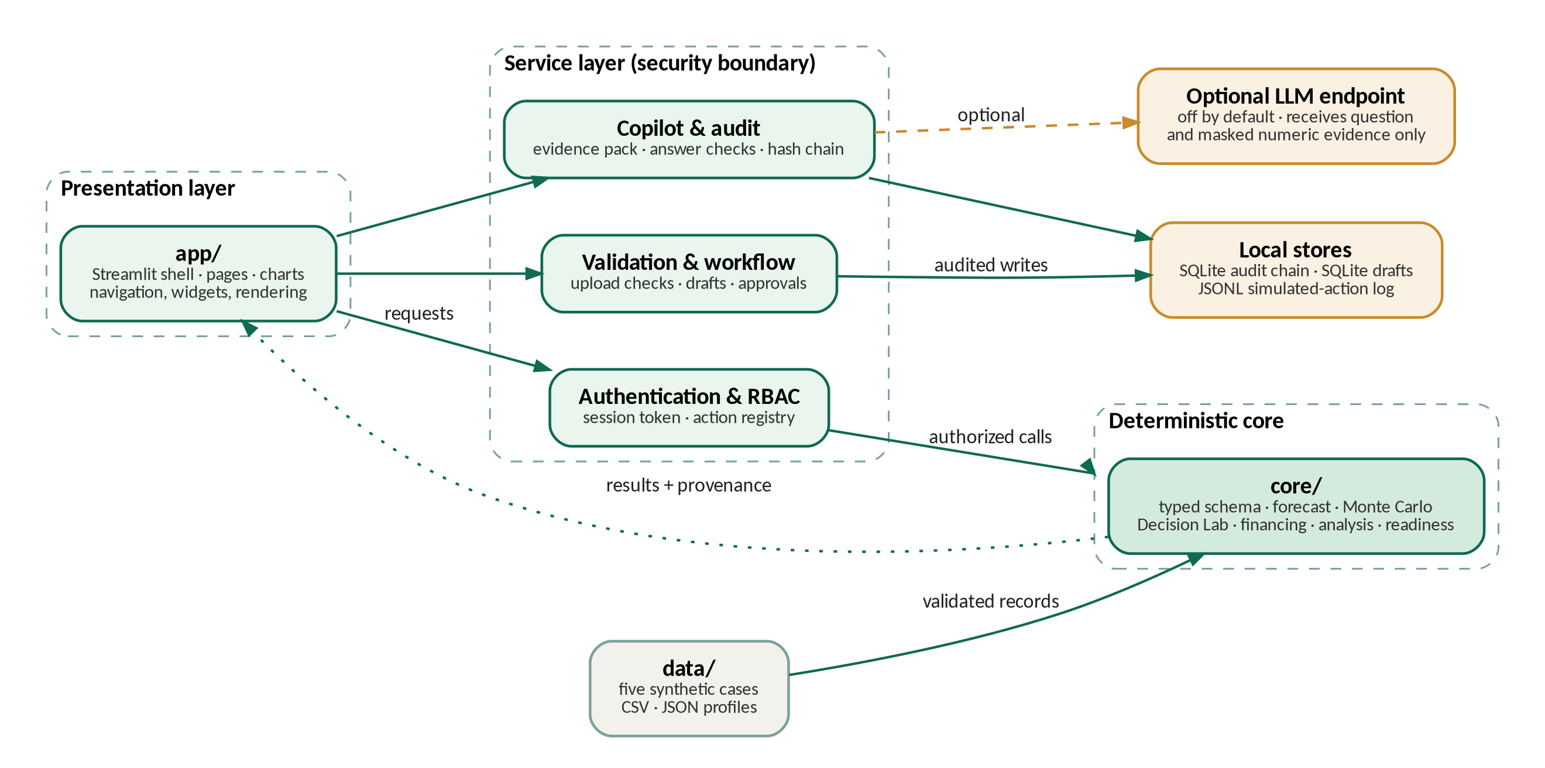
Figure 1. Layered architecture and evidence flow. Financial computation stays in the deterministic core; state changes and authorization pass through the service layer.
The interface calls service functions for every protected read and every state change. A service resolves the authenticated principal and authorizes the action before it invokes core calculations or persistence, and it returns the results together with their provenance for display. The optional language-model path is confined to copilot explanation. Offline deterministic answers are the default; in configured mode the model receives the user question and a masked evidence pack, and it has no tools through which it could act.
Figure 2 shows the system context. Operators and uploaded files are external inputs, StratifyAI forms a local application boundary, and a language-model endpoint is optional. Only the masked question and evidence cross the provider boundary, while drafts, audit records and simulation logs stay local. The design contains no money-movement data flow.
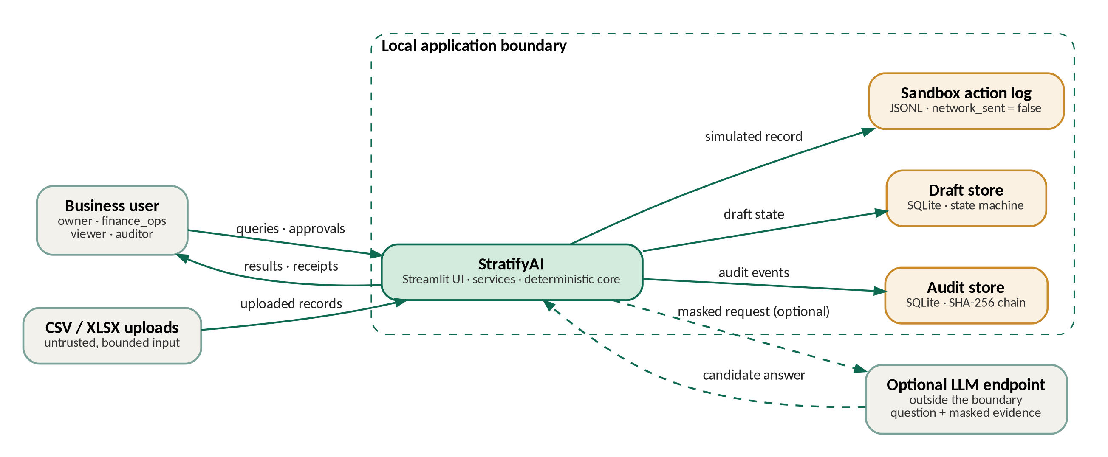
Figure 2. Context-level data-flow diagram (Level 0). The outer boundary separates local state from the optional provider.
The Level-1 diagram in Figure 3 decomposes the internal path. Parsing and validation precede typed case construction, core analytics compute the baseline, the Lab transforms copies of the series for what-if comparison, the copilot consumes masked computed evidence, and every privileged state transition passes through service authorization before it is stored. The return path to the interface includes evidence identifiers and validation status, so an explanation can be inspected rather than accepted as an opaque answer.
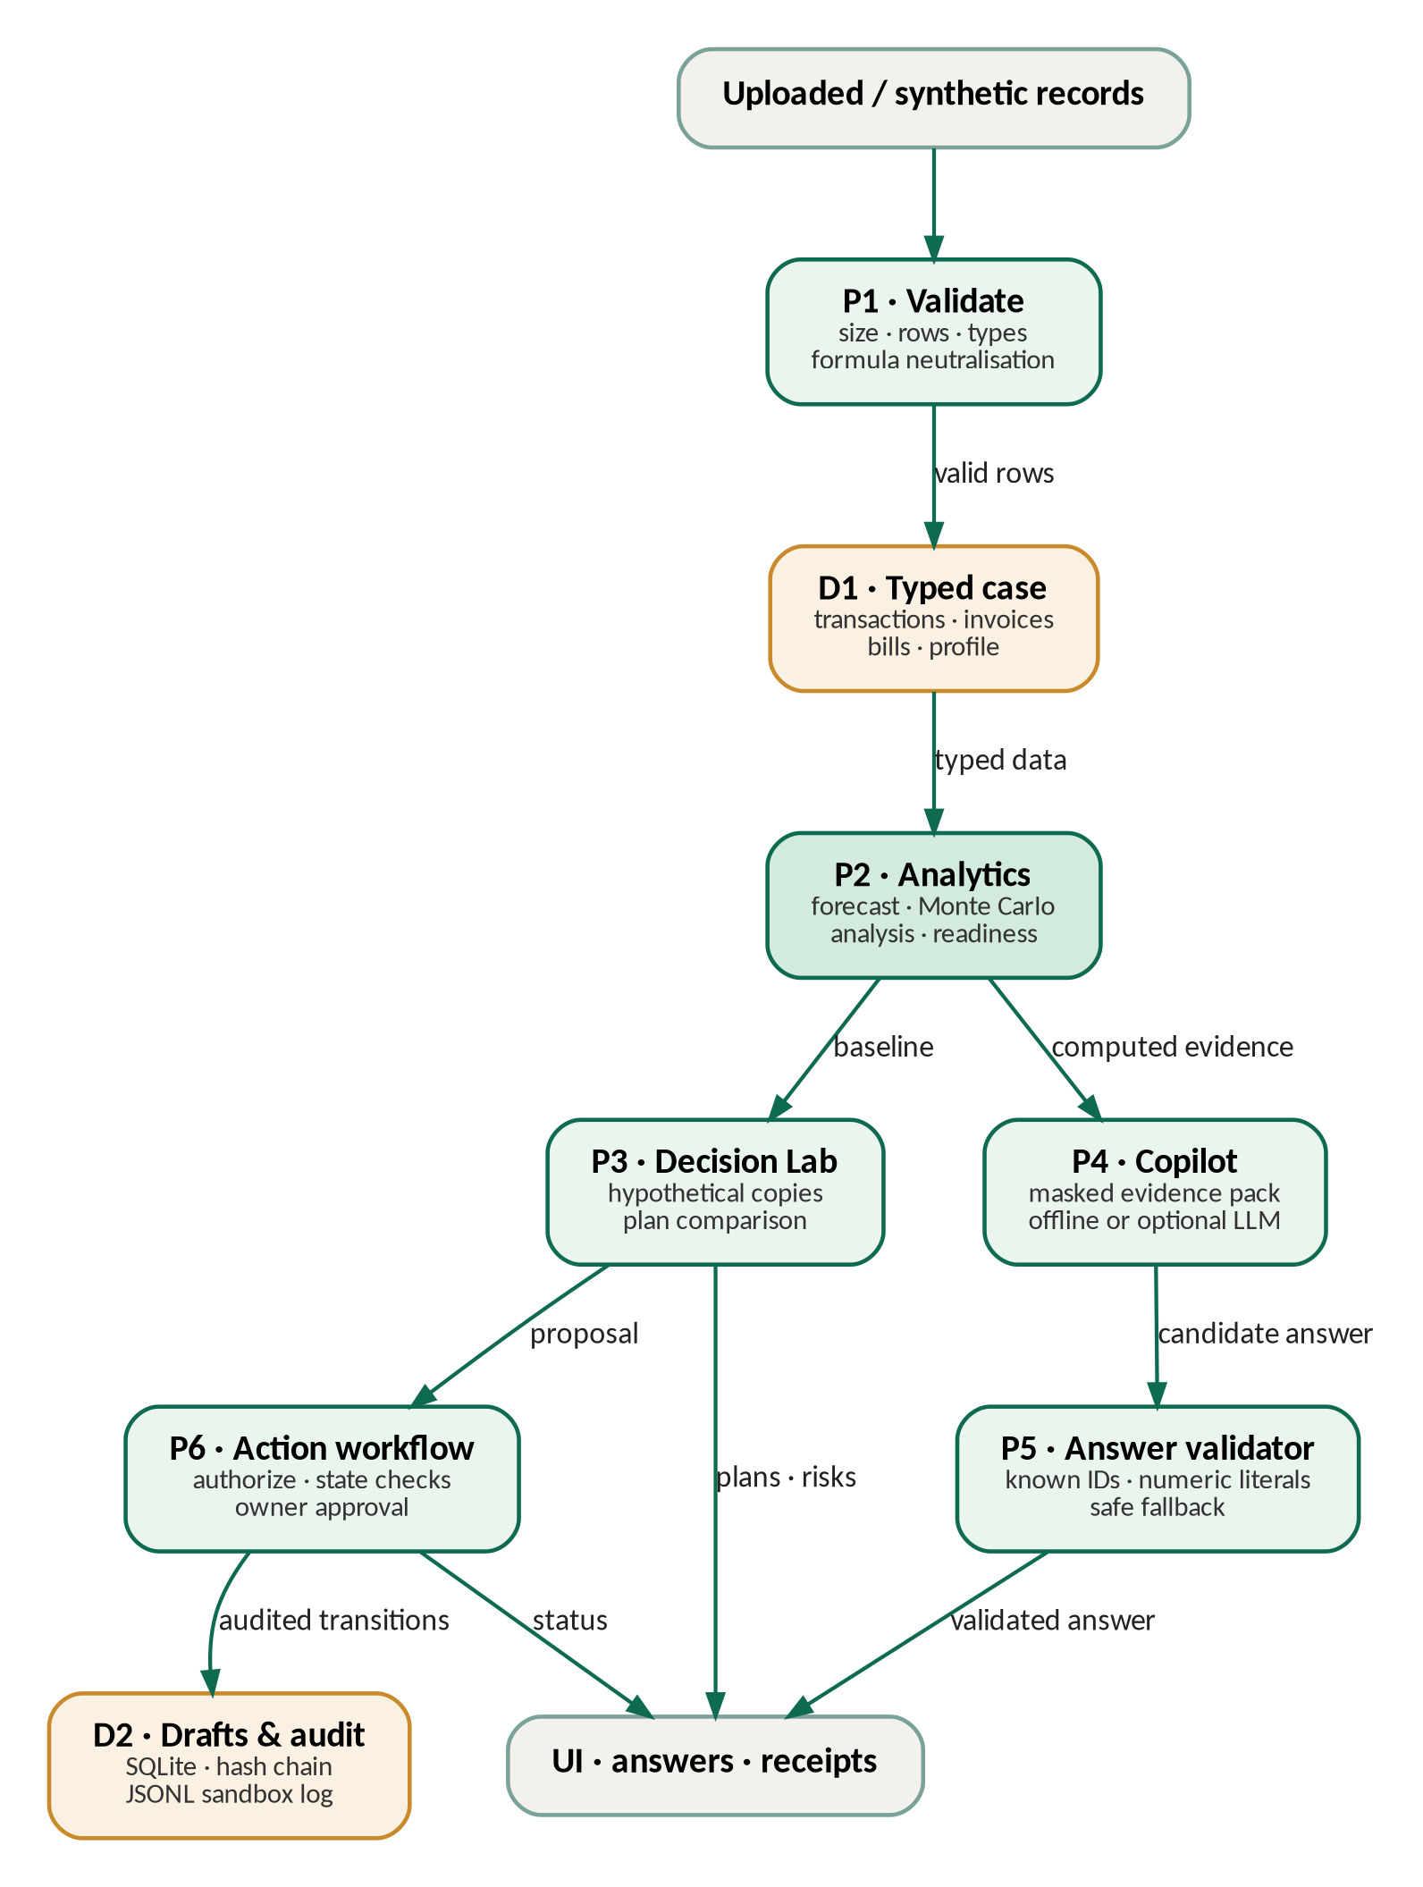
Figure 3. Level-1 data-flow diagram. P denotes a process and D a local data store; arrows show validated records, computed evidence or audited state transitions.

3.2 Semantic data layers
Every number shown in the application carries one of four labels that express its provenance (Figure 4, Table 2). A scenario never overwrites historical ACTUAL records. A CONFIRMED flag records the owner's decision about an assumption but stays an assertion and does not become independent evidence. Keeping the layers separate is essential when charts, plan tables, answer receipts and audit events are compared.
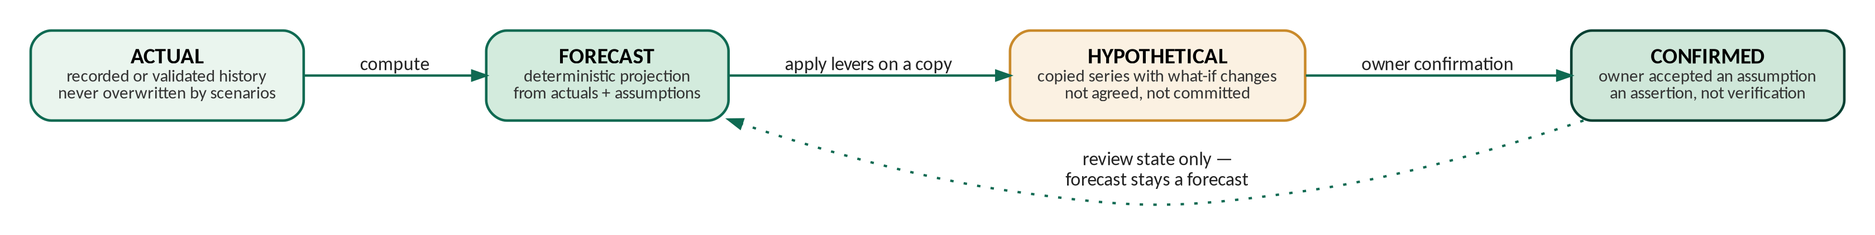
Figure 4. Lifecycle of the semantic data layers. Confirmation changes the review state of an assumption; it does not turn a forecast into an observed fact.
Table 2. The four semantic data layers.
Layer | Meaning | Example | Interpretation
ACTUAL | Recorded historical records from the synthetic case or a validated upload | Past transactions and balances | Source records; not independently audited
FORECAST | Deterministic output computed from actuals and explicit assumptions | Projected weekly closing cash | Computed, model-dependent estimate
HYPOTHETICAL | Unapproved what-if changes | Earlier collection, supplier deferral, cost reduction, financing | Never treat as agreed or committed
CONFIRMED | A hypothetical assumption explicitly approved by the owner | Owner accepts a scenario proposal | Owner assertion only; not external verification

These labels describe the state of information and are not statistical confidence levels. A CONFIRMED assumption records human approval; it does not assert that a customer will pay, that a supplier will agree or that a lender will approve financing.
A typical request starts from a signed-in role and a selected business and scenario. The interface passes the session identity and the requested action to a service function. The service resolves the principal from trusted server-side state and checks the action registry. Read-only calculations are returned for display, whereas uploads, drafts, approval decisions and scenario changes are authorized and audited separately. The core remains a calculation library: it decides no permissions and renders no pages.
The service layer is therefore the security boundary. Hiding a button in Streamlit improves usability but is not authorization, and the same backend check must reject a direct or forged request. Table 3 summarises what each layer owns and what it must not be mistaken for.
Table 3. Code-layer responsibilities and trust boundaries.
Layer | Owns | Must not be treated as
app/ | Navigation, widgets, visualisations, page-level context and status | A security enforcement boundary
services/ | Authentication, permission checks, validation, workflow transitions, audit, copilot orchestration | A substitute for deterministic financial calculation
core/ | Typed domain records and financial calculations | A user-interface module or a source of lender decisions
data/ and evidence/ | Synthetic input fixtures and recorded evaluation artifacts | Real SME records or independently verified facts

3.3 Processing flow
- Load a labelled synthetic case, or parse an uploaded CSV or XLSX file.
- Validate size, schema, required fields, data types, dates, values, duplicates, currency, text length and formula-like cells.
- Map the valid records to typed case models and compute the actual summaries.
- Produce the deterministic forecast, the analysis metrics, the readiness components and the receivables watchlist.
- Run scenario changes only on copies of the cash-flow series, so the original case inputs stay intact.
- Build a masked copilot evidence pack from computed results, and validate the citations and numbers of any candidate answer.
- Persist authorized drafts and decisions and sanitised audit events locally; simulated execution stays explicitly non-networked.

4. Synthetic data and validation
The demonstration uses five generated synthetic SME cases that represent stable operations, falling sales with rising costs, high expenses, delayed customer payments and import-financing assumptions. Each checked-in case contains 78 transactions over 39 weeks, 12 receivables, 12 payables, 10 synthetic customer profiles and 6 synthetic supplier profiles. No real customer, supplier, account or lender data is needed. Case generation is deterministic, and the fixtures are not a representative sample of Bangladeshi businesses.
Table 4. Record families in each synthetic case.
Record family | Core fields | Purpose
Transactions | ID, date, direction, category, amount, balance after, description | Actual cash history and observed balances
Receivables | Invoice and customer IDs, issue, due and paid dates, amount, paid amount, currency | Outstanding collections, aging and payment-delay evidence
Payables | Bill and supplier IDs, dates, amounts, category, deferrable and discretionary flags | Obligations, deferral and expense what-ifs
Profiles | Opening cash; customer and supplier identifiers; editable delay assumptions | Synthetic case metadata
Assumptions | Forecast horizon, reserve, random seed, variability, Lab and financing defaults | Explicit, editable model parameters

The upload validator in services/validation.py limits a file to 5 MiB, 50,000 rows and 500 characters per text field. It checks the supported CSV or XLSX format, the match between header and record kind, required fields, dates, numeric values, transaction types, duplicate identifiers, currency consistency and text bounds. Formula-like text is neutralised and reported instead of executed, and untrusted content is never promoted to instructions. A passing upload means that structural validation succeeded; it does not certify the accuracy or ownership of the source data.
The case generator and the evaluation records do not establish statistical representativeness, population coverage or external data validity. All tables, examples and screenshots in this report are therefore labelled synthetic.

5. Core methods

5.1 Weekly cash-flow forecast
The function core.forecast.forecast groups actual transactions into weeks that start on Monday. The latest recorded balance becomes the opening cash, and the forecast begins in the following week. The default horizon is 13 weeks with a minimum of eight. Category run rates are estimated from the most recent eight weeks. If receivable records exist, inflow categories are excluded from the run-rate projection, and if payable records exist for a category, the matching outflow run rate is excluded, so that nothing is counted twice. Outstanding invoices are placed in the week of their due date plus an estimated customer delay, using the median observed delay when at least three paid invoices exist and the profile assumption otherwise. Outstanding bills are placed in the week of their due dates.
ClosingCash(t) = ClosingCash(t − 1) + ProjectedInflows(t) − ProjectedOutflows(t) (1)
Reserve = reserve weeks × average fixed weekly outflow (default: 2 weeks) (2)
FundingGap = max(0, Reserve − min ClosingCash) × (1 + buffer% / 100) (3)
The first closing balance below the reserve defines the shortage week, and the first balance below zero is reported separately. Severity is none when the reserve is maintained, watch when the reserve is breached without a below-zero week, and critical when a below-zero week occurs. This is deterministic arithmetic over the supplied records and assumptions, not a learned forecasting model.

5.2 Seeded Monte Carlo uncertainty
The function core.montecarlo.simulate produces 2,000 paths by default with NumPy's seeded random generator, using the seed stored in the selected case assumptions. The checked-in case profiles assign distinct, reproducible seeds, and these profile values are the source of truth at run time. When invoice-delay sampling is enabled, customer payment delays are drawn from the observed history of fully paid invoices if at least five observations exist; otherwise a non-negative normal draw around the configured delay is used. Projected inflows are multiplied by a mean-one log-normal factor whose spread is set by an editable coefficient of variation. Each path is accumulated into weekly closing balances, and the outputs are the weekly P10, P50 and P90 balances, the weekly frequencies of reserve and zero breaches, and the fraction of paths with any reserve breach.
P_breach(any) = (1 / N) × Σ 1[ min over t of balance(i, t) < Reserve ], N = 2,000 by default (4)
A fixed seed makes a run repeatable for identical inputs and runtime behaviour, but it does not make the estimated probabilities calibrated. Invoice amounts are fixed in the source records, so the log-normal multiplier acts as a proxy for variability in receipt amounts. The model does not estimate uncertainty from a sufficiently long real business history, and the short synthetic histories do not support actuarial calibration or forecast confidence intervals. Table 5 lists the settings.
Table 5. Monte Carlo settings and their interpretation.
Setting | Default or selection rule | Interpretation and caveat
Runs | 2,000 | Empirical frequency over simulated paths; not a population probability
Seed | random_seed of the selected case profile | Repeatable for the same case and parameters; generated fixtures use distinct seeds
Invoice delay | Empirical delays when at least five paid invoices exist; otherwise a non-negative normal around the configured delay | History-based only inside the synthetic case; the normal fallback is a proxy
Receipt variability | Mean-one log-normal multiplier; case coefficient of variation 0.15 by default | Perturbs projected receipts while invoice amounts stay fixed
Outputs | Weekly P10, P50 and P90; reserve and zero breach rates; any-week breach probability | Computed per run; not calibrated

5.3 Liquidity Decision Lab
The Lab recomputes the baseline forecast and evaluates three levers separately, then in combination, and finally with financing alternatives (Figure 5). Every lever is labelled HYPOTHETICAL until the owner confirms the corresponding assumption.
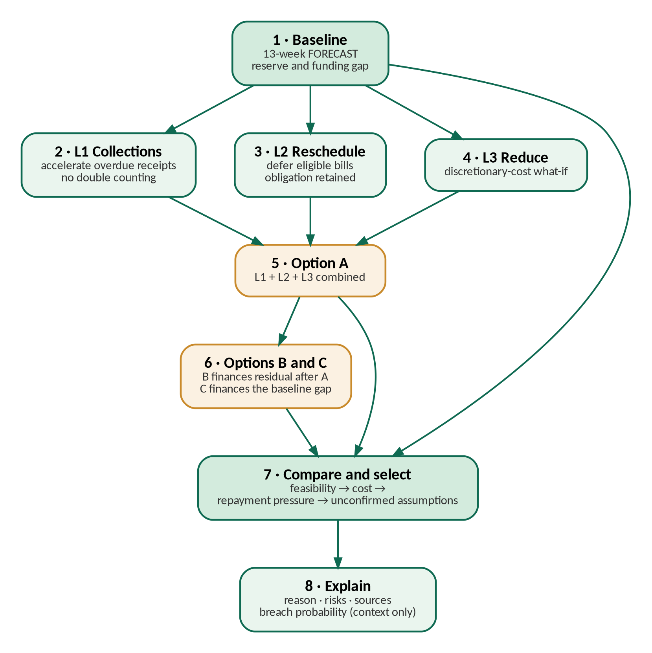
Figure 5. Decision Lab evaluation sequence. The steps run from the baseline forecast through lever and plan comparison to the explanation.
Option 0 is the unmodified baseline. Option A combines the three levers, Option B finances the gap that remains after Option A, and Option C finances the original baseline gap. A candidate is feasible when its minimum closing balance on the deterministic path stays at or above the reserve. Among feasible candidates the rule selects the lowest modelled financing cost, then the lowest repayment-pressure rank, then the smallest number of unconfirmed assumptions. When no candidate is feasible, the Lab says so and selects the plan with the smallest remaining gap instead of forcing a successful recommendation. The Monte Carlo breach probability is shown as separate risk context and is not used in the selection rule.
Table 6. Decision Lab levers and construction of the financing plans.
Lever or option | Default parameters | Transformation | What stays unverified
L1 Collect | 50% of eligible overdue receivables, within 2 weeks, 0% haircut | Spreads the assumed early collection over the selected weeks and removes the same amount from the later expected receipt bucket | Customer payment date and collectability
L2 Reschedule | Defer eligible payables by 2 weeks, 0% late fee | Moves the bill to a later bucket; the obligation is kept and the configured fee is added | Supplier agreement and relationship cost
L3 Reduce | 10% of selected discretionary expense from week 1 | Reduces the eligible discretionary payable in the hypothetical copy | Whether the spending is avoidable without harm
Option A | L1, L2 and L3 combined | Runs the same balance engine over the combined adjusted flows | All lever assumptions remain hypothetical
Options B and C | Editable financing template | B applies a facility to the residual of A; C finances the baseline gap | No offer, eligibility or approval is inferred

The implementation avoids a common scenario-accounting error. A collection moved to an earlier week is removed from its later bucket, and a deferred supplier payment is moved rather than deleted. A payable pushed beyond the 13-week display remains an obligation even though it no longer appears in the visible horizon. Each plan card therefore carries explicit risk text and the provenance of every changed assumption.

5.4 Financing calculations
Four editable templates provide illustrative financing terms (Table 7). They are not offers, and no lender underwriting is implied.
Table 7. Editable financing templates; all terms are illustrative.
Template | Default terms | Repayment treatment | Not represented
Term loan | 14% annual nominal rate; 1% fee; 6 months | Equal monthly annuity instalments; interest on the declining principal | Lender underwriting, covenants, eligibility
Invoice financing | 80% advance; 2.0% per 30 days outstanding | Principal and charge due at maturity; facility grossed up to deliver the rounded net need | Invoice assignment, recourse, real fees
Supplier credit | 30-day extension; 1.5% of invoice value | Principal and explicit cost due at maturity | Supplier consent, contract terms
Credit line | 16% annual rate on the drawn amount; 0.5% fee | Interest on the drawn balance; principal at maturity | Undrawn limit, lender policy

A = P × r / [ 1 − (1 + r)^(−n) ]; A = P / n when r = 0 (5)
Here P is the principal, r the monthly rate (the nominal annual percentage divided by 12) and n the number of monthly instalments. When the monthly rate is zero the implementation divides the principal evenly to avoid a zero denominator. The required amount is rounded up to the next BDT 1,000, and the invoice-financing facility is grossed up by the selected advance rate. Total cost adds the modelled interest, the fees and any explicit hypothetical charges. Repayment capacity is the average weekly net operating cash flow, scaled to the debt-service period, divided by the debt service of that period. The bands are comfortable at or above 1.25×, tight from 1.0× to below 1.25×, and stressed below 1.0×; these are editable rules of thumb and not lender thresholds.

5.5 Readiness indicator and receivables watchlist
The readiness indicator combines five weighted components (Table 8). Components that cannot be computed are excluded and the remaining weights are renormalised. The score is presented as a “readiness indicator, not a loan approval prediction”.
Table 8. Readiness indicator components and default weights.
Component | Default weight | Implemented scale
Repayment capacity | 35% | Capacity ratio ÷ 1.25 × 100, bounded to 0–100
Cash buffer | 25% | Latest recorded cash ÷ reserve × 100, bounded to 0–100
Receivable quality | 20% | 100 minus the overdue share of open receivables
Data completeness | 10% | Proportion of the five core source groups that contain records
Trend | 10% | Latest versus the preceding four-week average of net cash, scaled around 50

The receivables watchlist is scored separately from four elements: the overdue share of the amount (40 points), the amount-weighted days overdue capped at 90 days (30), the payment-delay trend when the history supports it (20), and the customer share of total open receivables (10). Scores below 30 are labelled Normal, scores from 30 to 60 Watch, and scores above 60 Urgent. Each row lists its source invoice identifiers. Both scores are project-defined explainable heuristics and not validated credit scores.

6. Copilot, agent actions and human control

6.1 Evidence-grounded copilot
After checking the copilot.ask permission, services.copilot rebuilds a compact evidence pack from selected deterministic forecast, Lab, analysis and readiness outputs. Entity names and free-text source fields are omitted, although identifiers may remain, and a question is limited to 500 characters. Offline deterministic templates are the default. The optional language-model mode is switched on only by local configuration and sends the question and the masked evidence to a generic OpenAI-compatible endpoint. The service has no draft, approval or execution tools (Figure 6).
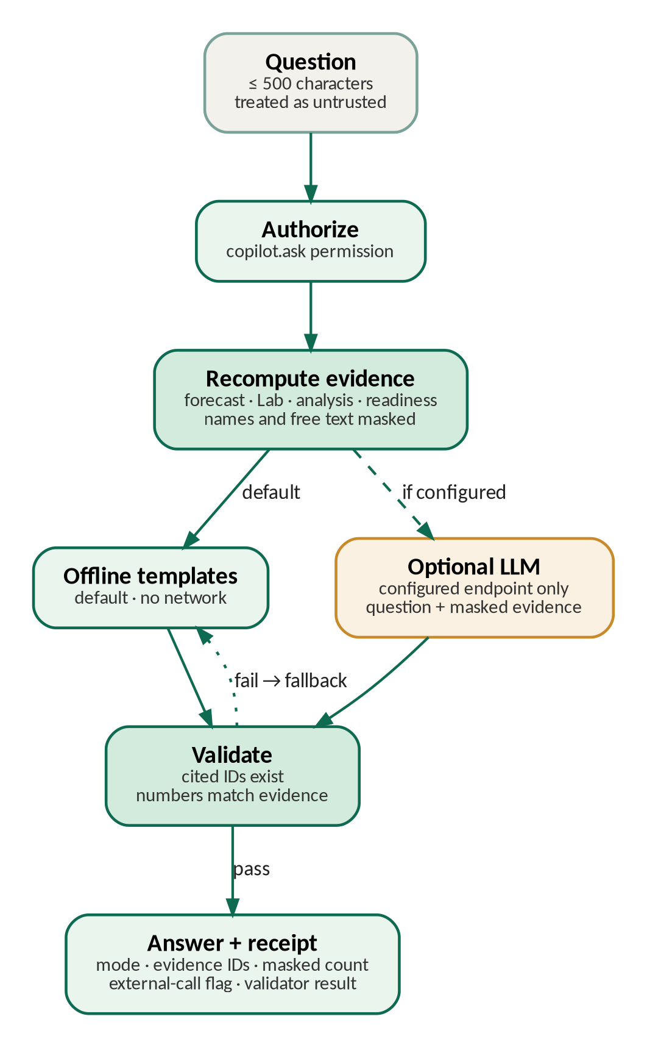
Figure 6. Copilot flow. Evidence is recomputed, an answer is generated and validated, and the answer is returned with a receipt.
A candidate answer must cite known evidence identifiers, and every numeric literal must be supported by the computed evidence. If the endpoint fails or validation does not pass, the service returns a safe offline answer. The audit event stores a SHA-256 hash of the query and the receipt rather than the raw text. The pattern is inspired by the grounding and provenance motivation of the retrieval-augmented generation literature [5], [6], but it is not a conventional RAG system because it has no corpus retriever, vector database or model training.
Table 9. Copilot evidence pack and receipt boundaries.
Evidence family | What is recomputed | Masking and use boundary
Forecast | Shortage week, funding gap, balances, reserve and uncertainty summaries | Computed numbers only; customer and supplier names and source free text excluded
Decision Lab | Options, cost, balance path, feasibility flag, gap and risks | Assumptions remain HYPOTHETICAL; no acceptance claim
Analysis and readiness | Historical ratios or missing-data reasons and readiness components | Read-only evidence; not a loan-approval result
Receipt | Mode, evidence IDs, masked-field count, external-call flag, validator result | The raw question is represented by a SHA-256 hash

The supported intents are deliberately limited to cash shortage, funding gap, plan comparison, a read-only customer-delay what-if, data quality and readiness. Unsupported questions receive a missing-data response and not open-ended financial advice. Citation validation requires every cited identifier to exist in the current pack, and numeric validation rejects unsupported numbers. If a configured provider returns malformed or ungrounded output, the service falls back to deterministic offline language.

6.2 Drafts, approval and simulated execution
Agent actions are deterministic templates stored as local drafts (Table 10). The roles finance_ops and owner can create eligible drafts, and finance_ops can submit them, but approval, rejection and simulated execution are owner-only. Service code checks both the permission and the current state before every transition. An approved item can be recorded as a simulated execution in a local JSONL log with network_sent=false, and the audit trail records the actor and the transition. The MONEY_MOVEMENT action is denied for every role, including the owner, and the simulation never connects to a bank, lender, customer or supplier.
Table 10. Structured draft catalogue and the human review boundary.
Draft type | Typical payload | Allowed workflow
Collection reminder | Synthetic customer and invoice reference and amount | finance_ops creates and submits; the owner reviews
Supplier deferral request | Supplier and bill reference and proposed date | finance_ops creates and submits; the owner reviews
Financing pack | Selected illustrative option and supporting values | Draft only; no external application
Liquidity Lab proposal | Scenario, assumptions, plan and evidence references | The owner may confirm the assumption and review; simulation only

Draft text is generated from bounded structured fields, escaped before rendering and stored with an idempotent transition record. A repeated request is handled idempotently where this is implemented, so a duplicate transition cannot be mistaken for several real-world actions. Figure 7 shows the legal status transitions independently of page layout: a pending draft can be approved or rejected by the owner, and only an approved draft is eligible for simulation. The status simulated_executed means that a local simulation event was recorded, not that a payment was sent.
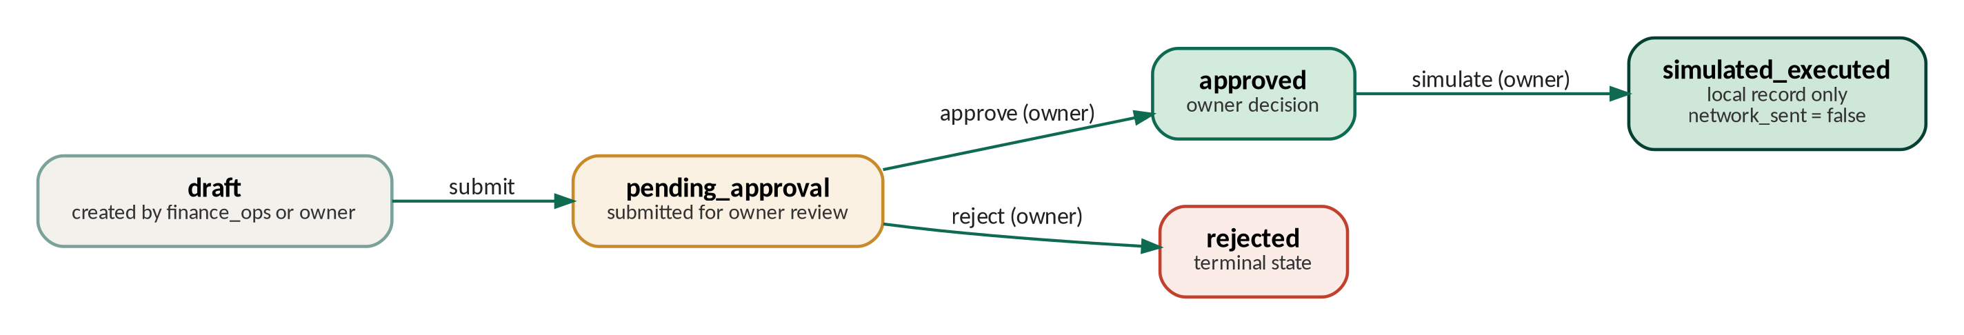
Figure 7. Action state machine. Rejected and simulated items are terminal; execution represents only a local record.
The sequence in Figure 8 complements the state machine by showing who invokes each service and which local stores are written. Authentication and authorization precede the approval transition; after approval the owner may record a simulation, which writes a local event and performs no network operation.
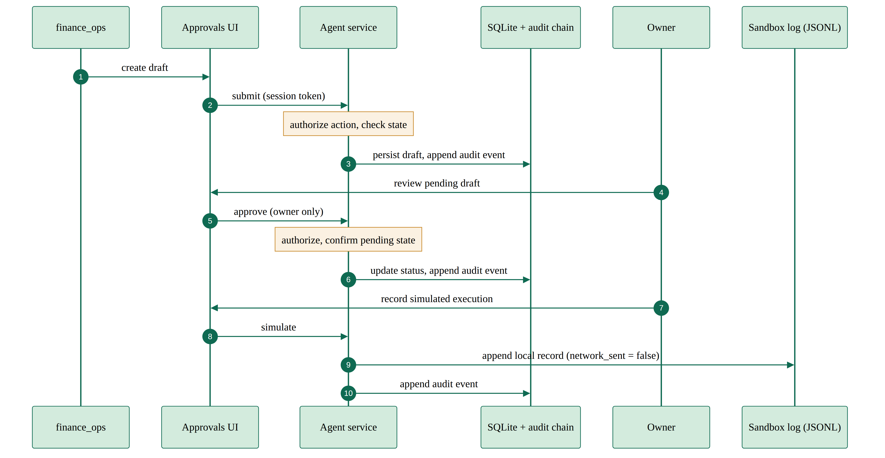
Figure 8. Approval sequence. The participants are finance_ops, the interface, the service authorization layer, the SQLite and audit stores, the owner and the local sandbox log.

6.3 Human oversight boundary
The owner must review assumptions and authorise proposed state changes. A scenario can be arithmetically feasible and still depend on an unconfirmed payment, a supplier concession or a cost reduction. The interface therefore surfaces assumptions, source references, risks and next steps. Human approval in this prototype is an application event; it is not a confirmation by an external counterparty or a legal authorisation.

7. Security design

7.1 Role and permission model
The application defines four roles: owner, finance_ops, viewer and auditor. The identity for an action comes from a server-issued session token and a user record. Permission checks run in the services and not only through hidden navigation. Actions fall into four classes: READ, DRAFT, APPROVAL_REQUIRED and MONEY_MOVEMENT, which is always denied. Denial events are audited. Table 11 summarises the role-to-action matrix; the authoritative policy is the registry in services/permissions.py, and every mutating service calls authorize() before it changes data.
Table 11. Role and action matrix (actions grouped by identical permissions).
Action | Owner | finance_ops | Viewer | Auditor | Class and enforcement
dashboard.view, security.view | Allow | Allow | Allow | Allow | READ · permission registry
copilot.ask | Allow | Allow | Allow | Allow | READ · services.copilot
audit.view | Allow | Deny | Deny | Allow | READ · services.audit
approvals.view | Allow | Allow | Deny | Allow | READ · services.agent_actions
lab.run, scenario.change, data.upload, draft.create | Allow | Allow | Deny | Deny | DRAFT · validation and agent actions
assumptions.manage | Allow | Deny | Deny | Deny | DRAFT · permission registry
draft.approve, draft.reject, execution.simulate | Allow | Deny | Deny | Deny | APPROVAL_REQUIRED · state checks
money.move | Deny | Deny | Deny | Deny | MONEY_MOVEMENT · always denied and audited

The design follows least authority within the prototype: read capabilities are broad, but action capabilities narrow as their impact grows. The interface may hide controls that a role cannot use, but the service still checks the role and the current object state, and every denial creates audit evidence so that an attempted privilege escalation is visible in the local log.

7.2 Audit integrity and storage
Audit records are sanitised, size-limited, appended to SQLite and linked by SHA-256 hashes of the previous record. SQLite update and delete triggers guard the ordinary application paths, and a verifier detects broken links and tampering. This is tamper-evident local storage; it is not immutable or independently replicated evidence, because a host administrator can replace the file or disable the triggers. Agent drafts and simulated-action logs are also local, and backup, tenant isolation and disaster recovery are not implemented.

7.3 Upload and prompt-injection controls
Uploads are bounded in size, rows and text, and they undergo typed field validation, duplicate, currency and date checks, and formula neutralisation. The copilot treats both questions and imported text as untrusted: it excludes free text and entity names from the evidence, restricts the supported intents, has no tools, checks evidence identifiers and numbers, and falls back to offline answers. The security suite includes 10 poisoned-name cases that must stay out of the evidence pack, together with grounded-receipt checks. These controls reduce exposure in the implemented workflow, but they do not solve prompt injection in general, and an optional provider still receives the question and the masked numeric evidence, with retention and security outside the control of this project.

7.4 STRIDE summary
Table 12. STRIDE summary of the implemented controls and residual risks.
Threat | Example | Controls implemented | Residual risk
Spoofing | Forged session role | PBKDF2 password hashes; server-side token resolution | Demo credentials and quick sign-in; no MFA or production identity provider
Tampering | Altered draft or audit history | State-checked transitions; SQLite triggers; SHA-256 chain and verifier | A local administrator can replace the database or disable the guards
Repudiation | Denied approval | Actor, role and action events linked in the audit chain | No independent clock or host attestation
Information disclosure | Names or query text sent to an LLM | Masked pack; query hash in the audit log; key held in the environment | A configured provider receives the query and masked financial values
Denial of service | Large upload or provider call | 5 MiB, 50,000-row and 500-character bounds; 20 s provider timeout | No rate limit, quota or concurrent-job scheduler
Elevation of privilege | Viewer attempts to move money | Backend authorize checks; owner-only approvals; money movement denied | A local source or database administrator can alter the prototype

This mapping is a project self-assessment against common threat categories and the OWASP GenAI risks [7]–[9]. It is not a penetration test, a compliance attestation or an independent security review.

8. Implementation and user interface
StratifyAI is written in Python 3.11 and uses Streamlit 1.66.0, pandas 3.0.6 [11], NumPy 2.4.6, Plotly 7.1.0, Pydantic 2.14.1 and SQLite. Testing and linting use pytest 9.1.1 and Ruff 0.17.1, and all versions are pinned in the project requirements. The application is designed to run locally and offline, and the optional language-model configuration is external and unset by default.
The interface has ten pages: Overview, Cash Flow, Decision Lab, Financing, Analysis, Copilot, Approvals, Data Upload, Assumptions and Security. A fixed top bar carries the product name, the sign-in or sign-out control and a synthetic-data badge, and a fixed sidebar lists the pages in the same order before and after sign-in. Pages that a role cannot open appear locked. Data pages share one header with a Business selector and a Scenario selector, results are arranged as cards in a grid, and longer pages are divided into tabs so that every option is reachable without long scrolling. The colour scheme uses green and off-white, and every chart uses the same four-layer colours and legend.
Before sign-in, visitors see a public Overview (Figure 9) that explains the five questions the product answers, the six-step workflow, the four data layers and the four roles with what each may and may not do. The role descriptions are generated from the same permission registry that the backend enforces, so the page cannot drift from the actual rules. Workspace pages require a sign-in, and a visitor who selects a locked page is taken to the sign-in screen and returned to that page afterwards. The screenshots in Figures 10 to 20 were captured from the signed-in application at a 1440 px viewport using synthetic cases only.

Figure 9. Public landing page shown before sign-in. It summarises the product, the feature entry points, the workflow and the roles.
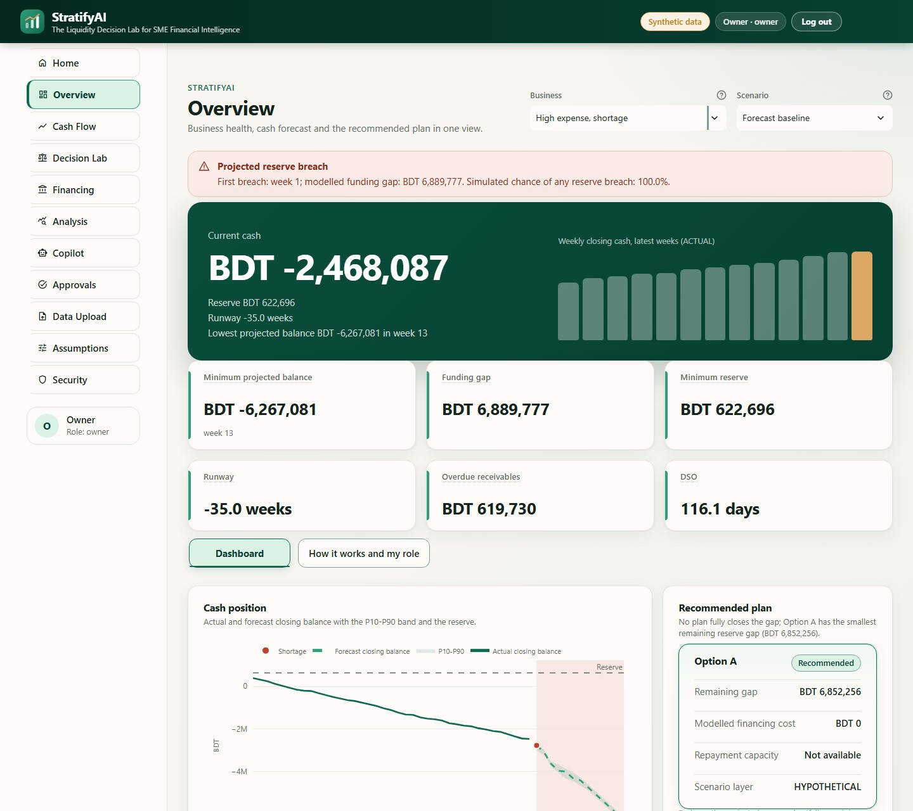
Figure 10. Signed-in owner Overview for the high-expense shortage case. It shows current cash, key indicators, the cash position with its uncertainty band and the recommended plan.
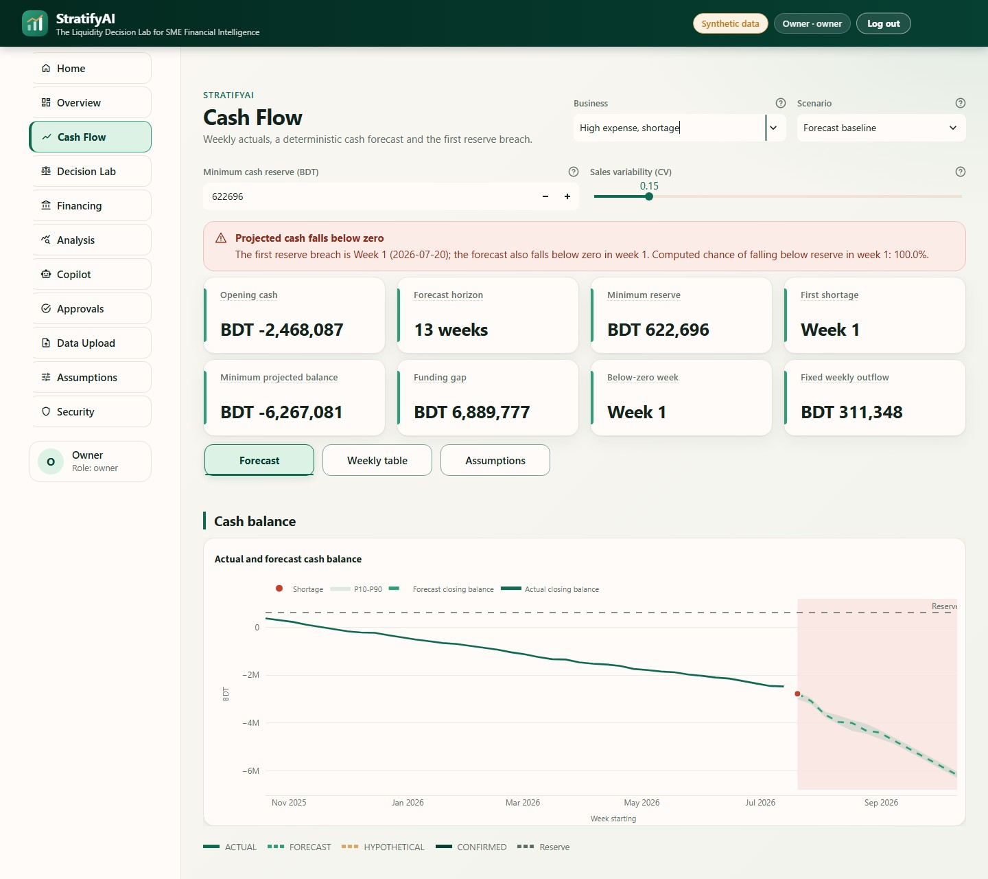
Figure 11. Cash Flow page. The forecast is shown with the minimum reserve, the shortage week and the uncertainty context.
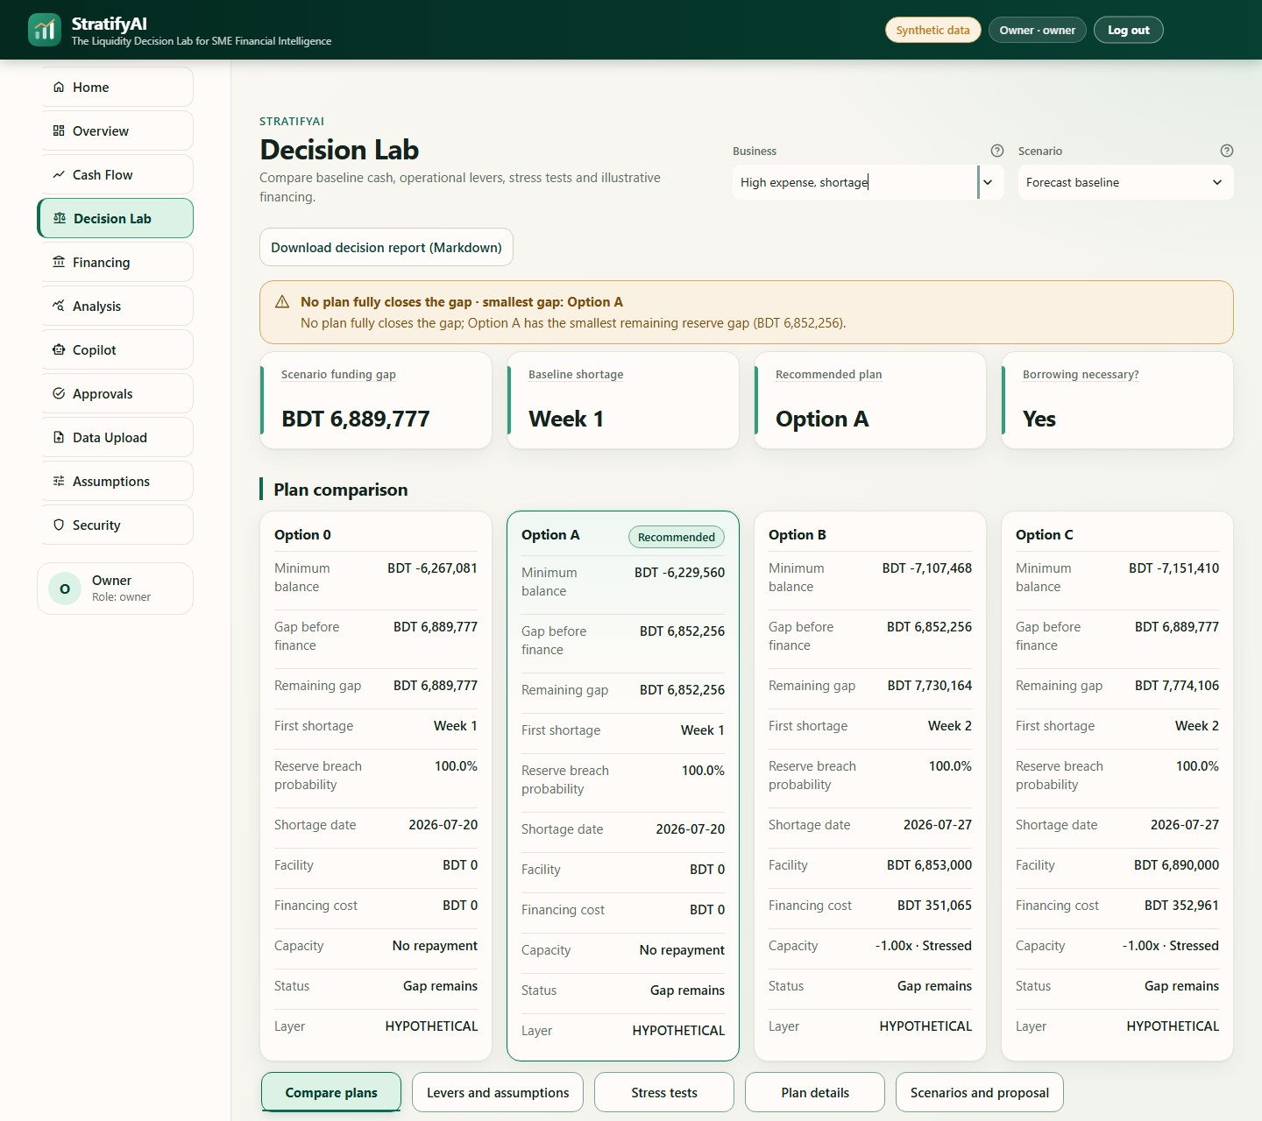
Figure 12. Decision Lab plan comparison. The baseline and the alternative plans are compared and the recommended option is highlighted.
(a) Reserve, horizon and lever settings
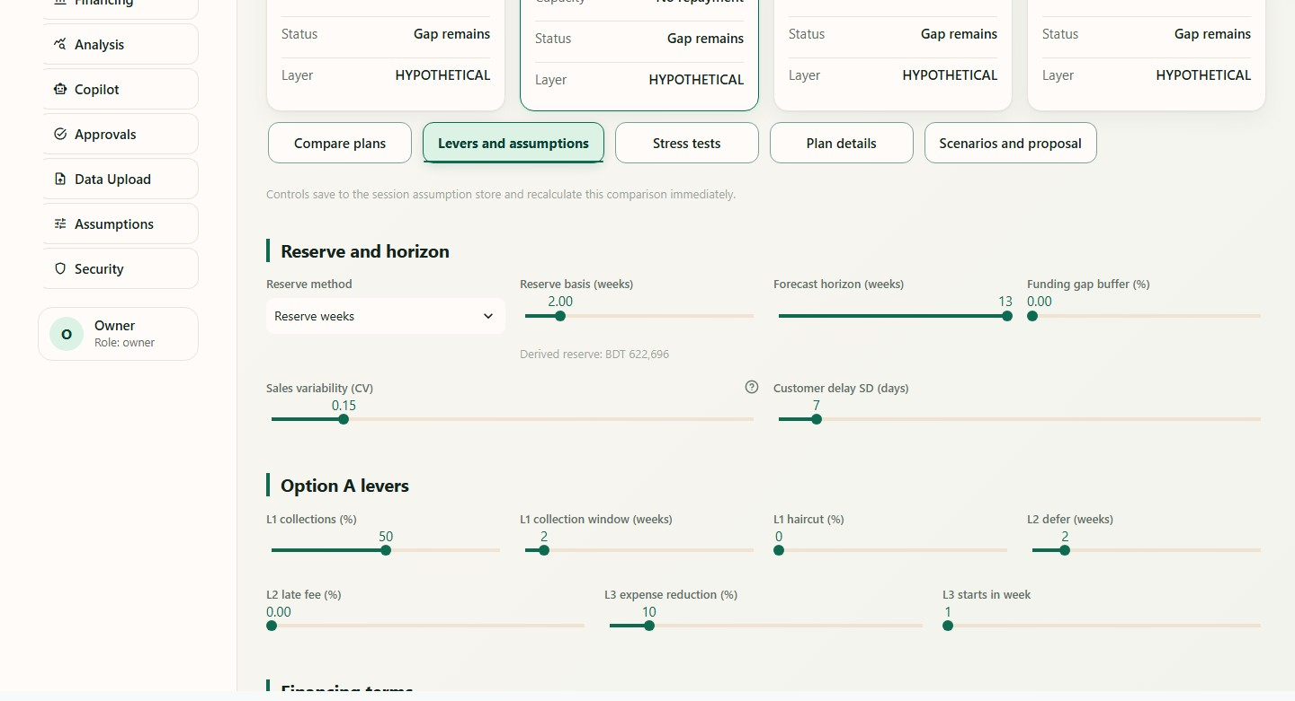
(b) Plan comparison on the stress-tests tab
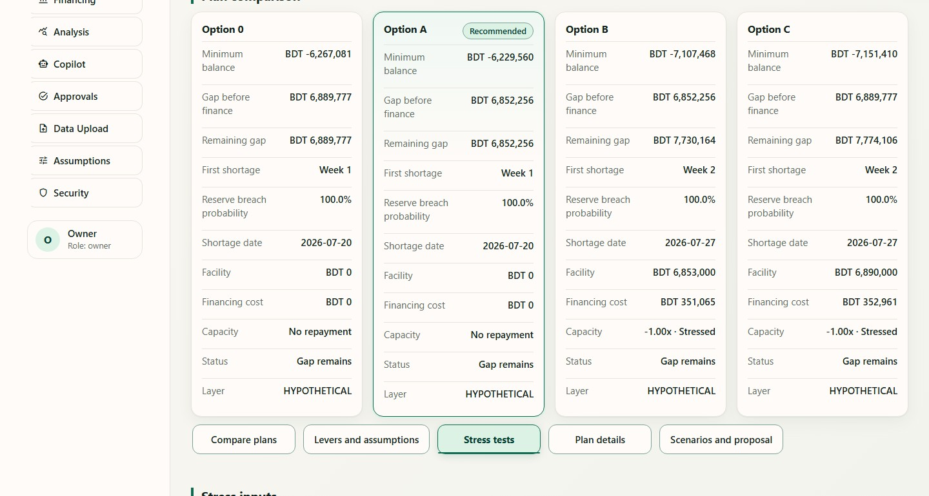
Figure 13. Decision Lab lever settings and stress tests.
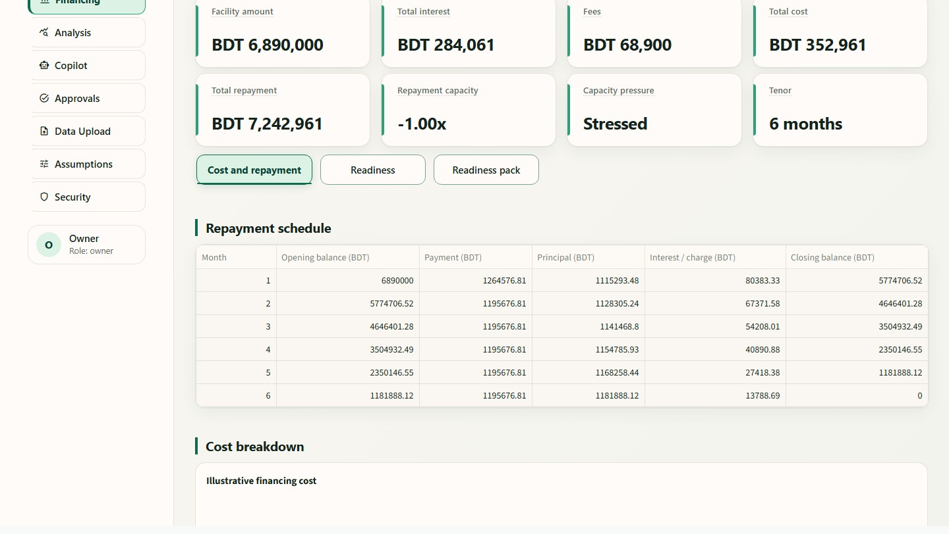
Figure 14. Financing page. An illustrative term-loan summary and repayment schedule for the high-expense shortage case.
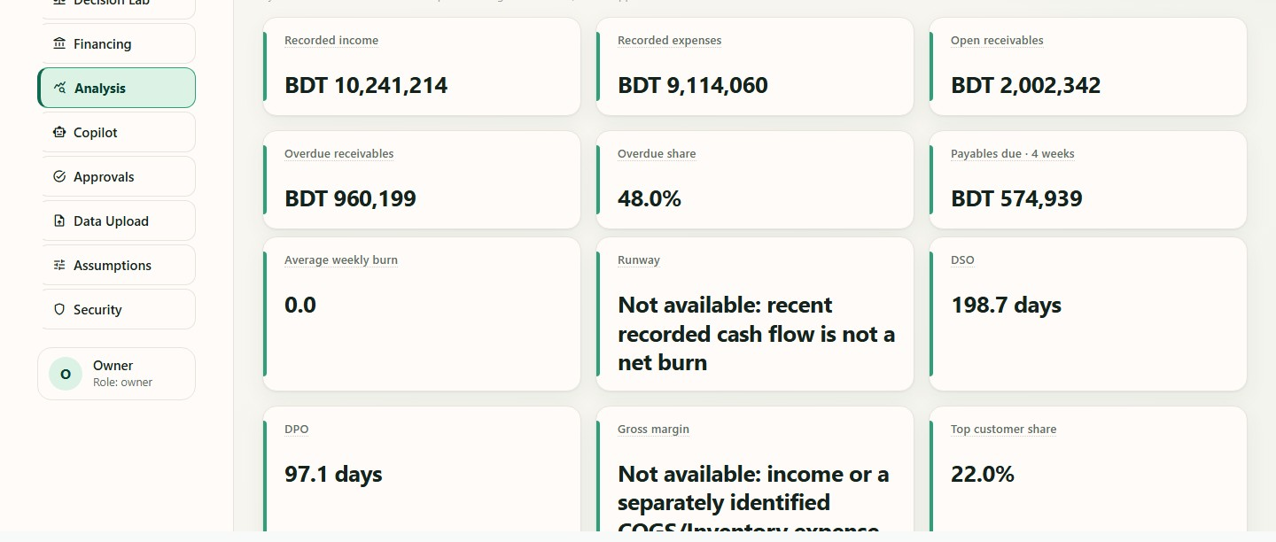
Figure 15. Analysis page. Business indicators for the delayed-customer-payments case, with explicit reasons where a metric is unavailable.
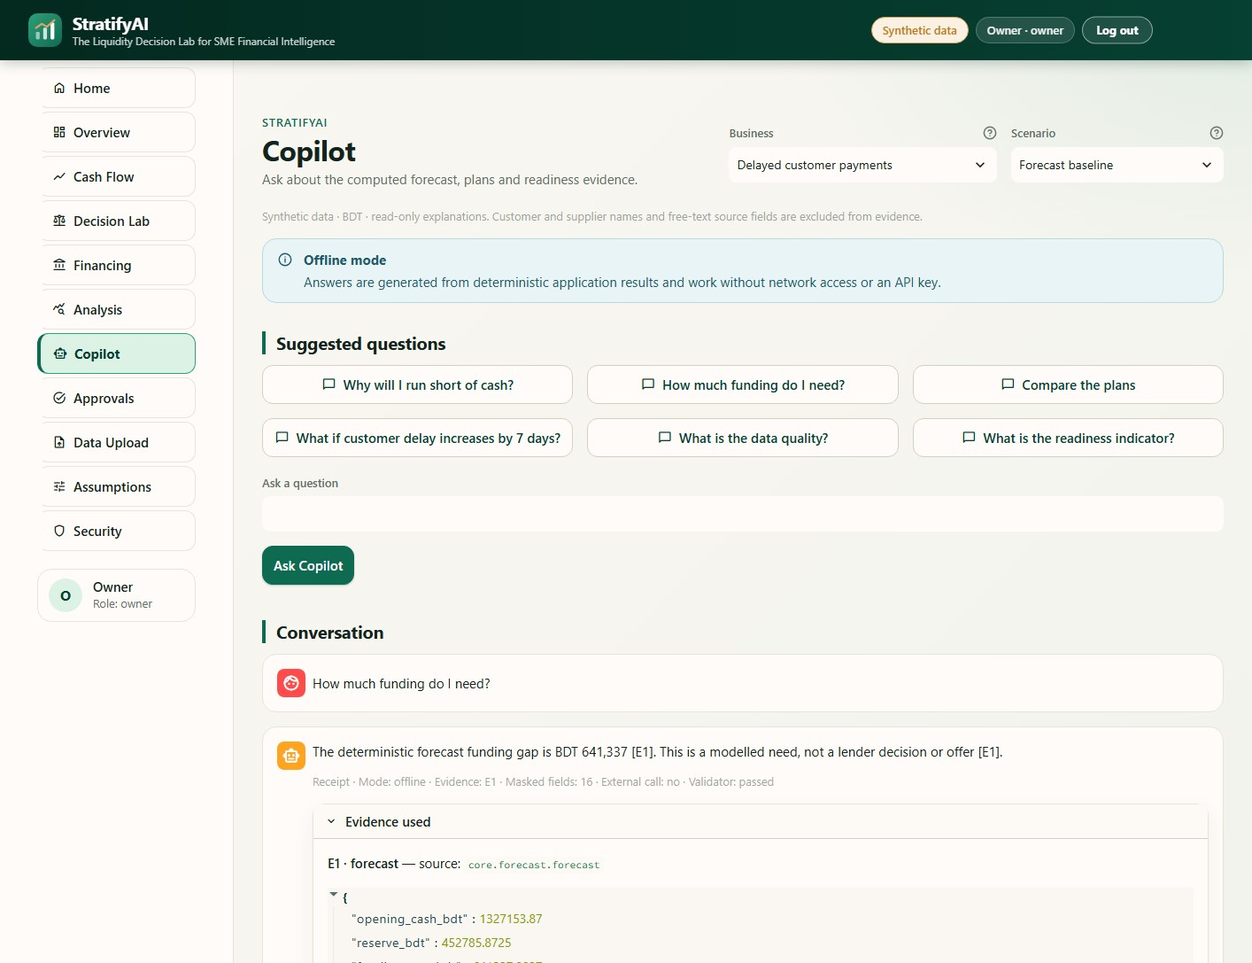
Figure 16. Copilot answer with the expanded evidence receipt.
(a) Draft awaiting the owner's decision
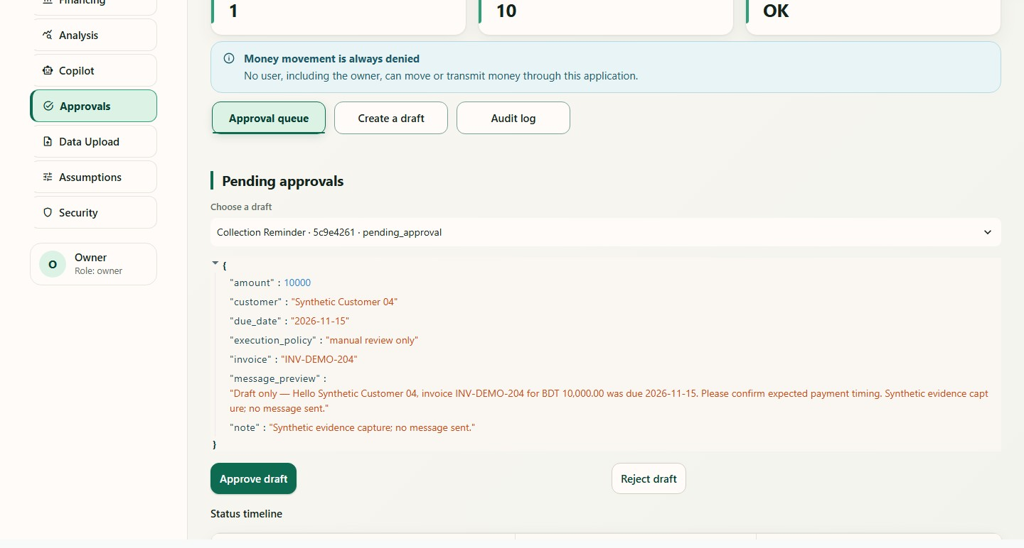
(b) Approved draft and local simulation record
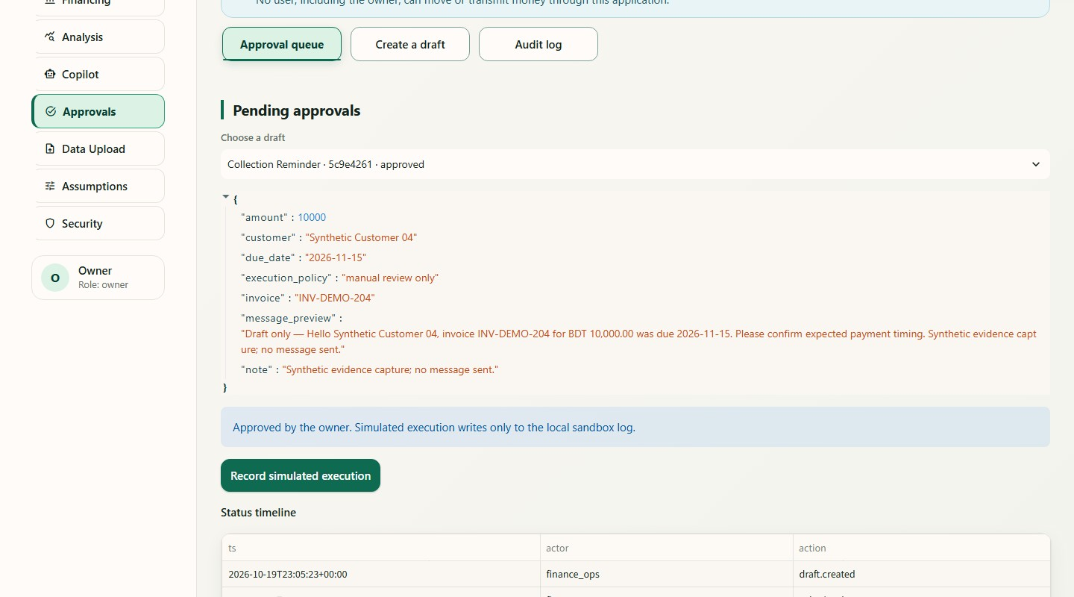
Figure 17. Approval workflow from a pending draft to an approved local record.
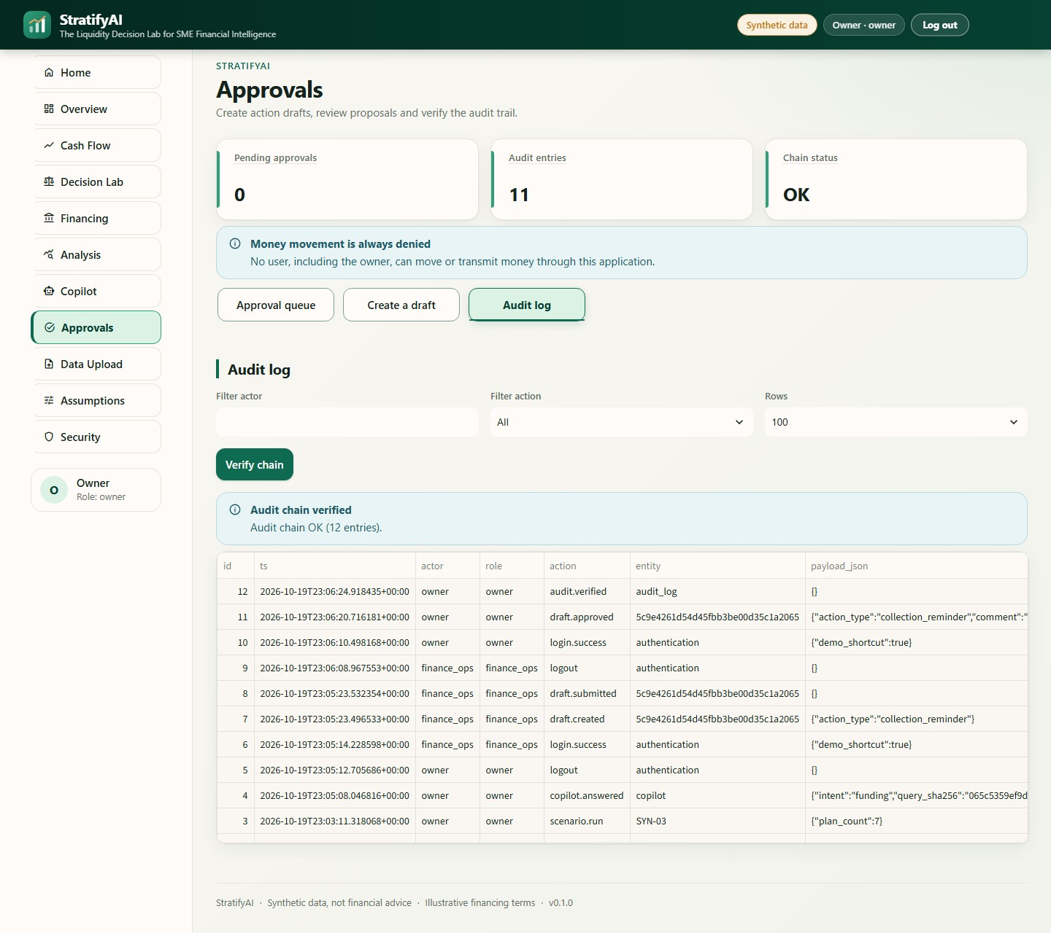
Figure 18. Audit log with the hash-chain verification result.
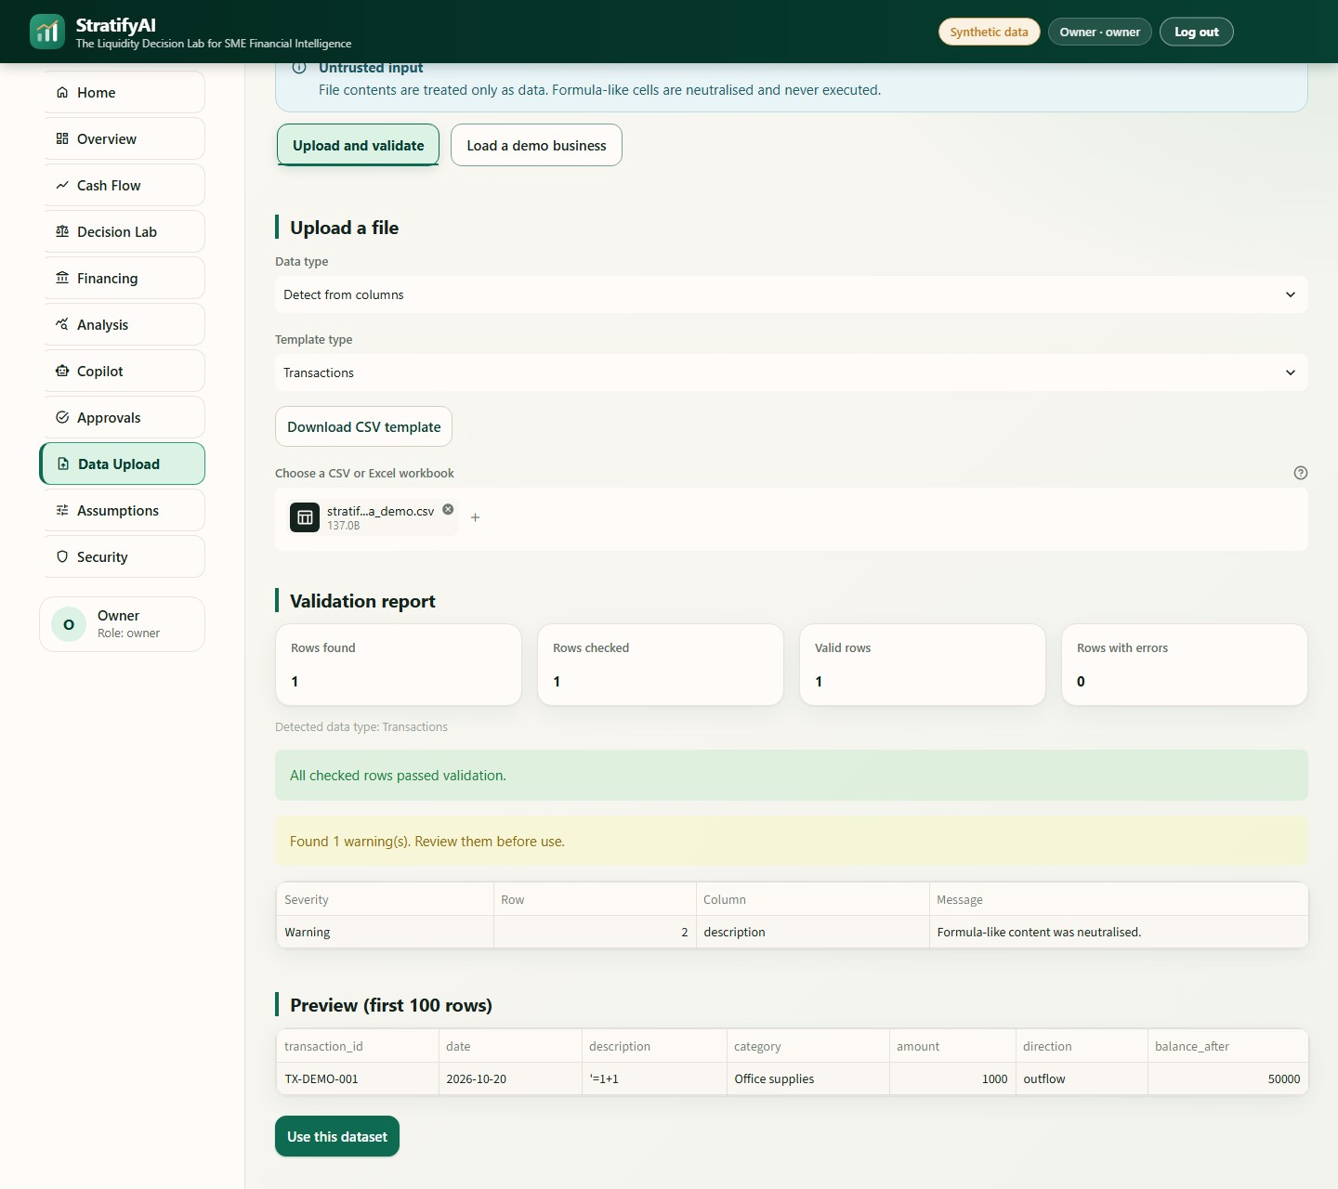
Figure 19. Upload validation. The file contains a formula-like cell (=1+1) that is neutralised and reported.
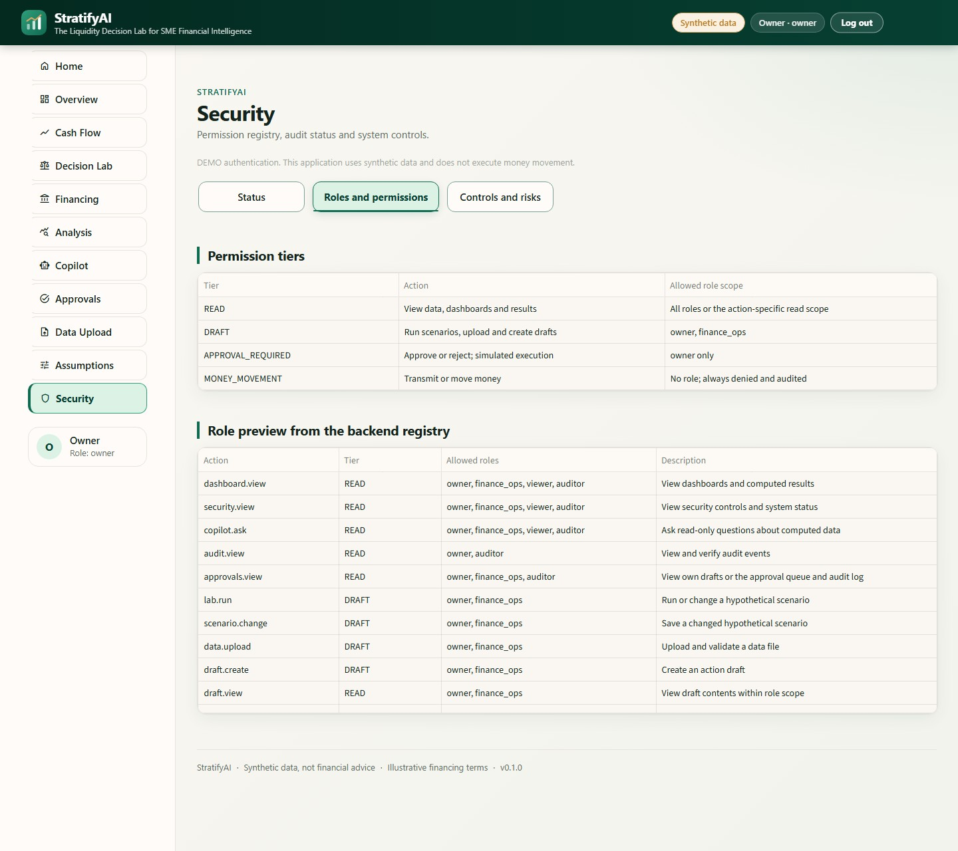
Figure 20. Security page. Permission tiers and the role preview are read from the backend registry.

9. Evaluation and evidence

9.1 Evaluation design and provenance
The evaluation combines four kinds of evidence, each recorded separately. The final integrated test suite, run on 20 October 2026 after the interface work, passes 205 tests. The evaluation bundle generated on 18 October 2026 against an earlier build of 197 tests contains 13 scripted service workflows, 60 role–action decisions, 10 poisoned-name masking cases, grounding receipts and an audit-tamper check. The two test counts belong to different builds and are not combined into one result, and the bundle was not regenerated for the final build. Table 13 lists the recorded results.
Table 13. Recorded implementation and security evidence.
Measure | Recorded result | Interpretation
Final integrated test suite | 205 tests passed (20 October 2026) | Regression coverage of the implementation; not field validation
Scripted service workflows | 13 of 13 passed (18 October 2026) | Case and service tasks in evidence/task_suite_results.md
Authorization matrix | 60 of 60 decisions matched the registry | Role and action checks in evidence/security_eval.md
Poisoned-name filtering | 10 of 10 excluded from the evidence pack | A fixture-based check; not comprehensive adversarial testing
Audit tampering | Tampering detected at entry 1 | Local hash-chain verifier test
Quality tooling | Ruff, health check and secret scan passed | Recorded for the final build

9.2 Synthetic holdout forecast comparison
The backtest uses 29 training weeks and a 10-week holdout for every case, with a cutoff of 4 May 2026. The deterministic model is compared with a naïve baseline that repeats the mean net cash flow of the last four weeks. Error is reported as the mean absolute error (MAE) in BDT per week and as the weighted absolute percentage error (WAPE), which is the total absolute error divided by the total absolute observed flow over the holdout. Lower values are better for both. In all five cases the project forecast has a higher MAE and a higher WAPE than the baseline (Table 14). This is a negative result, and it rules out any claim of forecast improvement in this experiment.
Table 14. Holdout metrics per case, from evidence/backtest_results.csv. Lower is better; the model is worse than the baseline in every case.
Synthetic case | Model MAE (BDT/wk) | Model WAPE | Baseline MAE (BDT/wk) | Baseline WAPE
Stable healthy | 255,371 | 330.99% | 32,631 | 42.29%
Sales drop, cost rise | 166,949 | 231.37% | 140,806 | 195.14%
High-expense shortage | 256,412 | 374.69% | 26,177 | 38.25%
Delayed customer payments | 297,374 | 989.17% | 18,340 | 61.01%
Import financing | 299,113 | 576.99% | 23,607 | 45.54%

The per-case pattern shows where the rules fail (Table 15). The gap is smallest in the sales-drop case, where the baseline also performs poorly. The model tracks the high-expense holdout badly, and the payment-delay heuristic misses most of the observed pattern in the delayed-payments case. None of these results implies that a different method would generalise, because five fixtures and a single holdout arrangement allow no statistical test.
Table 15. Interpretation of the holdout errors per case.
Case | What the metrics show | Interpretive boundary
Stable healthy | Baseline error is far smaller on this holdout | Does not show which method generalises beyond the fixture
Sales drop, cost rise | Model error is higher, although the gap is the smallest of the five | No significance test and no independent test population
High-expense shortage | The modelled run rate does not follow this holdout | The alert should not be relied on as a calibrated forecast
Delayed customer payments | The payment-delay heuristic misses much of the observed pattern | Needs a richer payment history and a better timing model
Import financing | Editable import assumptions do not imply forecast accuracy | Exchange rate, deposit, lead time and sales ramp remain assumptions

9.3 Reserve and decision quality
Decision quality is distinct from forecast accuracy. Table 16 reports, for each case, the plan the Lab selected, its minimum balance on the deterministic path, the reserve, and the simulated probability of any reserve breach. Only one of the five selected plans keeps the balance above the reserve, and in the other four cases no option fully maintains it. The probabilities of 100% in several fixtures are results of the configured synthetic assumptions and the 2,000-run simulation; they are not empirical default or insolvency probabilities. The behaviour is useful only because the shortfall is communicated plainly, and it is not evidence that the recommendations improve outcomes.
Table 16. Decision-quality results from evidence/decision_quality.json.
Case | Selected plan | Minimum balance (BDT) | Reserve (BDT) | Reserve kept | Breach probability
stable_healthy | Option 0 | 3,246,587 | 389,266 | Yes | 0.0%
sales_drop_cost_rise | Option 0 | −1,594,784 | 529,254 | No | 100.0%
high_expense_shortage | Option A | −6,229,560 | 622,696 | No | 100.0%
delayed_customer_payments | Option 0 | −188,551 | 452,786 | No | 100.0%
import_financing | Option A | 253,079 | 420,887 | No | 98.45%

9.4 Limitations of the evaluation
The evaluation has only five synthetic cases and one holdout arrangement. The forecaster is rule-based, relies on short recent run rates and performs poorly against the chosen baseline. The task suite checks expected workflow behaviour and does not measure user comprehension, operational savings, accessibility or field deployment. The security checks cover the enumerated controls and fixtures and are not a full penetration test. The results should therefore be read as evidence about the behaviour of the implementation under defined fixtures, not as evidence about real businesses.

10. Discussion, limitations and validity

10.1 What the results support
The evidence supports four statements. The tested workflows can be run end to end in the local synthetic prototype. The service permissions matched the tested matrix. The audit verifier detected the tested tampering. The answer validator is connected to the computed evidence. The evidence also shows that this particular forecast configuration did not outperform a simple baseline in any of five synthetic cases and that the Lab frequently cannot maintain the configured reserve. Both findings are material for interpreting the system.

10.2 What the results do not support
The evidence does not establish forecast accuracy for real firms, a causal improvement in financial decisions, better access to finance, model calibration, fairness across populations or deployment-grade security. Five generated cases cannot represent sector, geography, accounting practice, seasonality or customer behaviour. The backtest is short and synthetic, and the baseline is a single comparator. The conclusions are consequently limited to design and test behaviour under the stated fixtures.

10.3 Ethical and operational boundaries
All data and financing terms are synthetic or illustrative. The readiness indicator is not an approval prediction, and the interface must not be used for credit decisions. The prototype has no real bank, lender or customer integration and makes no payments. The optional language-model mode sends the question and the masked numeric evidence to the endpoint chosen by the operator, so offline mode should be kept unless data handling has been reviewed. Seeded demo identities, single-process operation, local databases, the absence of a rate limiter and of tenant isolation, and the lack of independent audit replication make the current build unsuitable for public production use.

10.4 Threats to validity
Table 17. Threats to validity and their mitigations.
Dimension | Risk | Mitigation and current status
Construct | Reserve breach is a narrow proxy for liquidity health | Computed thresholds and assumptions are reported; no general financial-health claim
Internal | Short synthetic holdout and heuristic event rules | Per-case metrics and the adverse result are published; no superiority claim
External | Five generated cases do not represent SMEs | No population inference; real, consented and governed data are needed for future research
Measurement | Task scripts encode outcomes chosen by the developers | Treated as functional acceptance evidence, not independent user evaluation
Security | Local checks and tests are not an independent adversarial review | Self-assessment only; residual risks and missing controls are disclosed
Reproducibility | Test counts and evaluation artifacts come from different builds | Dates and counts are kept separate; evaluation outputs should be regenerated before any external benchmark

11. Conclusion and future work
StratifyAI demonstrates a local, synthetic-data workflow that links weekly cash projections, scenario comparison, illustrative financing mathematics, business-analysis indicators, evidence-grounded explanations, role-based services, owner approval and local audit evidence. Its central design decision is to keep the financial arithmetic deterministic and to make the difference between recorded, forecast, hypothetical and owner-confirmed information visible at every step. The evaluation is deliberately mixed: the functional and security checks behaved as recorded, but the model was worse than a simple baseline in all five holdouts and only one of five recommended plans maintained the reserve. The application is therefore a transparent engineering prototype for further study, not a validated financial decision system.

Future work
- Replace the synthetic fixtures with a consented, anonymised and legally governed SME dataset, keep a time-aware holdout and compare against several simple baselines.
- Revisit the forecast event handling and calibrate the uncertainty with more observations, reporting confidence intervals and subgroup behaviour only when the sample size supports them.
- Run moderated usability tests with SME owners to measure how well they understand the scenario labels, the uncertainty and the financing assumptions.
- Commission independent security testing and add production identity, tenant isolation, rate limiting, managed secrets, dependency scanning, backups and externally controlled audit retention before any production use.
- Regenerate the full evaluation bundle for each release, so that test counts and evidence share one build.

References
[1] M. Deloof, “Does working capital management affect profitability of Belgian firms?,” Journal of Business Finance & Accounting, vol. 30, no. 3–4, pp. 573–588, 2003. doi:10.1111/1468-5957.00008
[2] S. Baños-Caballero, P. J. García-Teruel, and P. Martínez-Solano, “How does working capital management affect the profitability of Spanish SMEs?,” Small Business Economics, vol. 39, pp. 517–529, 2012. doi:10.1007/s11187-011-9317-8
[3] A. N. Berger and G. F. Udell, “The economics of small business finance: The roles of private equity and debt markets in the financial growth cycle,” Journal of Banking & Finance, vol. 22, no. 6–8, pp. 613–673, 1998. doi:10.1016/S0378-4266(98)00038-7
[4] W. H. Beaver, “Financial ratios as predictors of failure,” Journal of Accounting Research, vol. 4, pp. 71–111, 1966. doi:10.2307/2490171
[5] P. Lewis et al., “Retrieval-augmented generation for knowledge-intensive NLP tasks,” in Advances in Neural Information Processing Systems 33, 2020. arXiv:2005.11401
[6] A. Asai, Z. Wu, Y. Wang, A. Sil, and H. Hajishirzi, “Self-RAG: Learning to retrieve, generate, and critique through self-reflection,” arXiv:2310.11511, 2023.
[7] OWASP GenAI Security Project, “OWASP Top 10 for LLM Applications 2026 (v1.0),” 3 August 2026. https://genai.owasp.org/resource/owasp-genai-llm-top-10-2026/
[8] E. Tabassi, “Artificial Intelligence Risk Management Framework (AI RMF 1.0),” NIST AI 100-1, 2023. doi:10.6028/NIST.AI.100-1
[9] National Institute of Standards and Technology, “Artificial Intelligence Risk Management Framework: Generative Artificial Intelligence Profile,” NIST AI 600-1, 2024. doi:10.6028/NIST.AI.600-1
[10] Streamlit, “Streamlit documentation,” accessed 20 October 2026. https://docs.streamlit.io/
[11] pandas Development Team, “pandas user guide.” https://pandas.pydata.org/docs/user_guide/
[12] Plotly Technologies Inc., “Plotly for Python: getting started.” https://plotly.com/python/getting-started/
[13] 2026 Shenzhen International FinTech Competition (FinTechathon), International Track, Topic E: SME Finance Copilot, competition brief.

Appendix A. Threat model and trust boundaries
Assets: synthetic business records, local credentials, session identity, scenario assumptions, drafts, audit events, optional language-model credentials and generated outputs. Trust boundaries: uploaded files to the parser; the interface to service authorization; the services to local SQLite and JSONL storage; and the application to the optional external endpoint. Adversarial inputs considered: malformed spreadsheets, formula-like fields, forged interface state, oversized requests, malicious customer text and unsupported or copied numeric claims. The primary controls and the known limitations are summarised in Section 7 and in the repository file docs/SECURITY_SELF_ASSESSMENT.md.

Appendix B. Reproduction commands
Run the commands from the repository root with Python 3.11 and the pinned environment. They reproduce the application and the documented quality checks; the output can differ when code or dependencies change. Use the synthetic demo accounts only.
python run.py setup
python run.py demo
python run.py test
python run.py eval
python run.py check
python run.py report
python scripts/run_tasks.py
python scripts/check_secrets.py

Appendix C. Copilot receipt example
The receipt is a structured record and not independent proof that a business fact is true. Table 18 shows the field names as implemented with schematic values; the values are illustrative and are not a captured answer.
Table 18. Copilot receipt fields with schematic values.
Field | Schematic value | Meaning
mode | offline | Deterministic default path
evidence_ids | [E1, E2, E4] | Identifiers from the computed evidence pack
masked_fields | 16 | Count of entity labels withheld from the evidence pack (illustrative)
external_call | false | No provider call in offline mode
validator_result | passed | Citation and numeric checks passed

Appendix D. Known risks and non-implemented controls
Table 19. Known risks and controls that are not implemented.
Risk or gap | Current status
Forecast underperformance on five synthetic holdouts | Observed: higher MAE than the naïve baseline in every case
Synthetic-only data and illustrative products | No external data or lender terms were validated
Demo passwords and quick sign-in | Convenience for local demonstration only; not production identity
Local audit database | Tamper-evident, not immutable or externally replicated
Optional external language model | Provider privacy, residency, retention and uptime are outside the project
Availability and tenant controls | No rate limit, per-user quota, tenant isolation or recovery plan
Absent controls | No production SSO or MFA, managed secret service, SBOM, vulnerability scanning, RAG index, model fine-tuning, bank or lender API, loan application or real money movement

Appendix E. Repository guide
The following repository files document the details behind this report.
Table 20. Repository files that document the implementation and evidence.
File | Content
README.md | Quick start, architecture summary, features, security boundary and evaluation results
docs/TECHNICAL_DOC.md | Architecture diagrams, data flow, Lab and copilot sequences, state machine and formulas
docs/BRIEF.md, docs/DECISIONS.md | Requirements, product scope, defaults, assumptions and equations
docs/SECURITY_SELF_ASSESSMENT.md, docs/SECURITY.md | Permission tiers, roles, STRIDE controls, OWASP risk mapping and known gaps
evidence/backtest_results.md and .csv | Holdout method and per-case forecast error
evidence/decision_quality.json | Selected plans, balances, reserves and simulated breach probabilities
evidence/task_suite_results.md, evidence/security_eval.md | Scripted workflows, role–action decisions, injection masking and tamper checks

