|  |  |  |  |
| --- | --- | --- | --- |
|  | | | |
| AIUB | **American International University- Bangladesh (AIUB)**  **Faculty of Engineering** | | |
| **Course Name:** | **Data Communication** | **Course Code:** | **COE 3201** |
| **Semester:** | **Spring 2022-23** | **Term:** | **Mid** |
| **Total Marks:** | **30** | **Submission Date:** | **4-03-2023** |

Course Outcome Mapping with Questions

|  |  |  |  |  |  |  |  |
| --- | --- | --- | --- | --- | --- | --- | --- |
| **Item** | **COs** | **POIs** | **K** | **P** | **A** | **Marks** | **Obtained Marks** |
| **Q1** | **CO4** | **P.a.1.C3** | **K5** | **P1** |  | **15** |  |
| **Q2** | **CO4** | **P.a.1.C3** | **K5** | **P2** |  | **15** |  |
| **Total:** | | | | | | **30** |  |

**Student Information:**

|  |  |  |  |
| --- | --- | --- | --- |
| **Student Name:** | **Sirajus Salehin** | **Student ID:** | **21-44543-1** |
| **Section:** | **J** | **Department:** | **CSE** |

**1.** Your ID = AB-CDEFG-H. Convert the letter G into 8-bit ASCII code, where the 8-th bit can be considered as a zero. Illustrate the graph of the digital bit steam for the following scheme:

1. Unipolar NRZ and Unipolar RZ
2. Polar RZ, Polar NRZ-L, Polar NRZ-I
3. Bipolar Manchester (‘0’ is low to high & ‘1’ is high to low) and Bipolar Differential Manchester
4. Bipolar AMI and Bipolar Pseudoternary
5. Multiline Transmission (MLT-3), given that the last voltage level is zero and last non-zero level is positive

**2.** Compute the 8-bit data stream for each case depicted in figure 1. Assume, that the last signal level was negative.

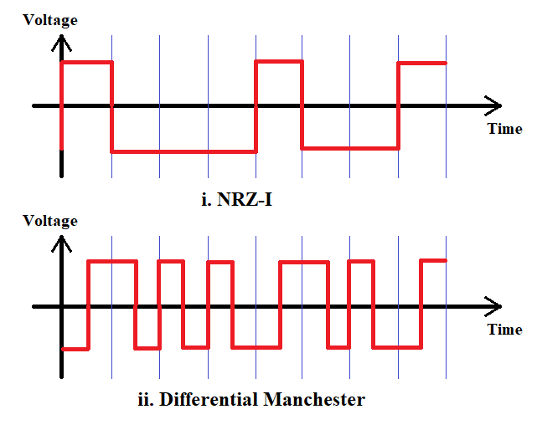

Figure: 1

