**AMERICAN INTERNATIONAL UNIVERSITY–BANGLADESH (AIUB)**

**FACULTY OF SCIENCE & TECHNOLOGY**

**Spring 2022-2023**

**Section: J, Group:6**

**LAB REPORT: 09**

**Supervised By: SADMAN SHAHRIAR ALAM**

**Date of Submission: 16.02.2023**

**Submitted by: JONY,MD.AREFUL HAQUE(ID:19-41694-3), Group 6**

**Title: Study of Analog to Analog Conversion (QAM) using MATLAB Simulink**

**Abstract :**

The objectives of this experiment aimed at achieving two main goals. The first goal is to gain an understanding of how MATLAB can be used to solve communication engineering problems. The second goal is to develop an understanding of Digital-to-Digital Conversion, using MATLAB.

**Apparatus :**

MATLAB2016a

**Introduction :**

PSK is limited by the ability of the equipment to distinguish small differences in phase. This factor limits its potential bit rate. The idea of using two carriers, one in-phase and the other quadrature, with different amplitude levels for each carrier is the concept behind quadrature amplitude modulation (QAM).

Quadrature amplitude modulation is a combination of ASK and PSK.

**Performance Task**:**:**

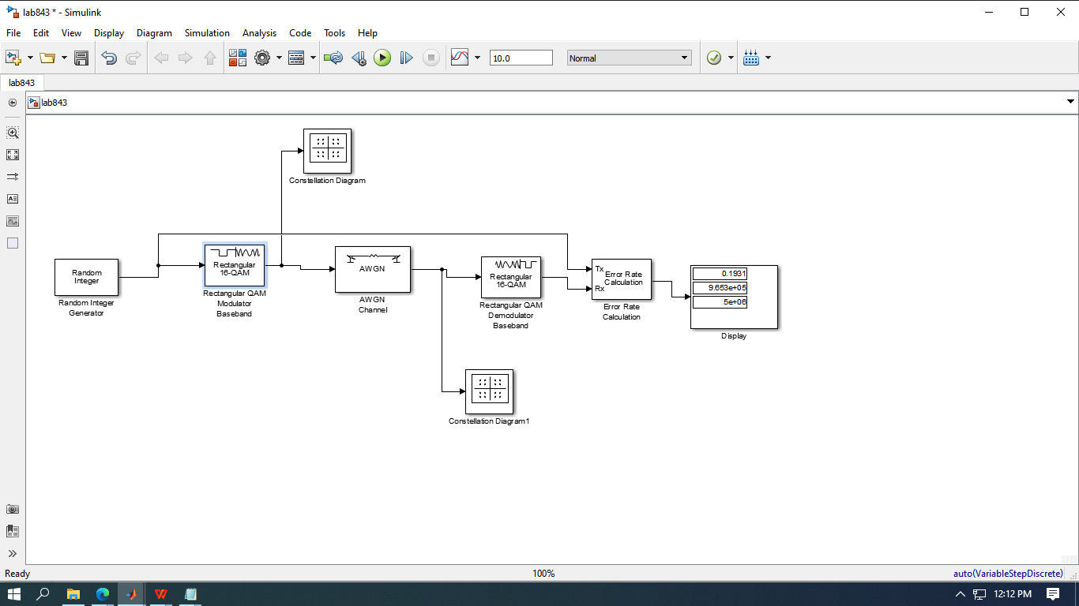

QAM Simulation Model

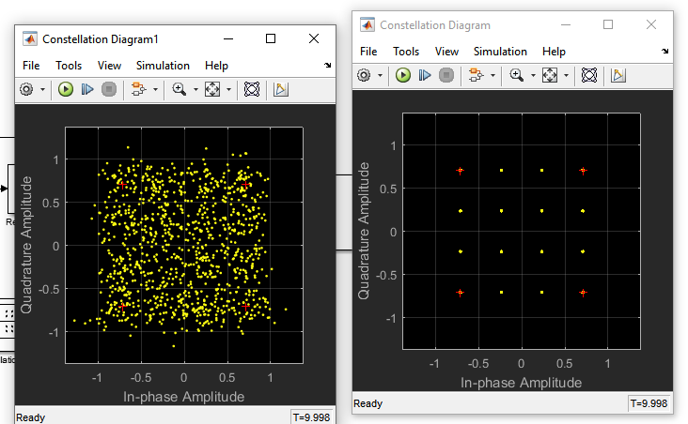

Output of Transmitted and Received Constellation Diagram

**Discussion :**

This experiment aims to achieve two main goals. The first objective is to understand the application of MATLAB in solving communication engineering problems. MATLAB is a powerful tool that is widely used in engineering and scientific applications. It provides a userfriendly platform that enables the user to perform complex computations and simulations with ease. In this experiment, students will learn how to use MATLAB to solve com.

**Conclusion:**

In conclusion, the experiment discussed in the abstract provides an excellent opportunity for students to gain valuable skills in communication engineering and MATLAB. By achieving the two main objectives of the experiment, students will be better equipped to solve communication engineering problems and implement Digital-to-Digital Conversion techniques using Line Coding. This knowledge is essential for any engineering student and will be beneficial for future coursework and career opportunities. Overall, this experiment is a practical and effective way to teach essential skills in the field of communication engineering.

**Reference :**

1. Forouzan, B. A. "Data Communication and Networking. Tata McGraw." (2005).

2. M. P. Fitz, Fundamentals of Communications Systems, pp. 7.1-7.7, 2007, McGraw-Hill

3. MathWorks®