**AMERICAN INTERNATIONAL UNIVERSITY–BANGLADESH (AIUB)**

**FACULTY OF SCIENCE & TECHNOLOGY**

**Spring 2022-2023**

**Section: J, Group:6**

**LAB REPORT: 06**

**Supervised By: SADMAN SHAHRIAR ALAM**

**Date of Submission: 25.03.2023**

**Submitted by: Sirajus Salehin(ID:21-44543-1), Group 6**

**Title:** Study of Amplitude Modulator and Demodulator using Simulink.

**Abstract:**

This experiment is designed to1.To understand the use of Simulink for AM modulation.

2.To develop understanding of AM demodulation.

**INTRODUCTION:**

Amplitude modulation (AM) is a one of the conventional techniques used to transmit

message

signals using a carrier wave. The amplitude or strength of the high frequency carrier wave is

modified in accordance with amplitude of the message signal.

• Carrier signal (Sc) = Acsin(2πfct)

• Message signal (Sm) = Amsin(2πfmt) # fm must be smaller than fc

When carrier amplitude is altered with respect to message signal,

• Modulated Signal = (Ac+ Amsin(2 πfmt))*sin(2 πfct)

In terms of modulation index (m=Am/Ac) the equation becomes

• Modulated signal= (1+ msin(2 πfmt))*Acsin(2 πfct)

Where,

• Ac= Carrier signal amplitude

• Am = Message signal amplitude

• fc= Carrier frequency

• fm =Message frequency

**Generating AM in Simulink**

For generating AM we just have to implement the equation of AM in block level.

**Blocks Required**

Analyzing the equation, we need,

1. Carrier Signal Source

2. Message Signal Source

3. Blocks for viewing the signals – Scope

4. Product Block

5. Summer Block

6. Constant Block

We can find these blocks in the following locations of Simulink Library:

**Carrier, Message, Constant blocks**

• Simulink –> Sources –> Sine wave

• Simulink –> Sources –> Constant

**View Block**

• Simulink –> Sink –> Scope

**Product and Summer Block**

• Simulink –> Math Operations–> Product

• Simulink –> Math Operations–> Summer

**Block Diagram:**

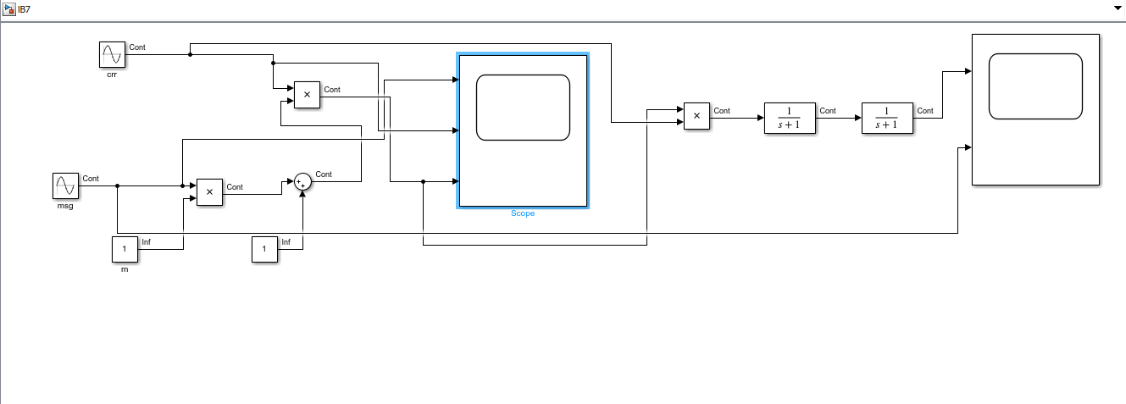

Block parameters can be changed by selecting the block and parameter:

• Carrier Signal frequency = 60Hz and sampling time=1/5000

• Message Signal frequency = 5Hz and sampling time=1/5000

• Amplitudes of both signals are 1

**Output Waveforms:**

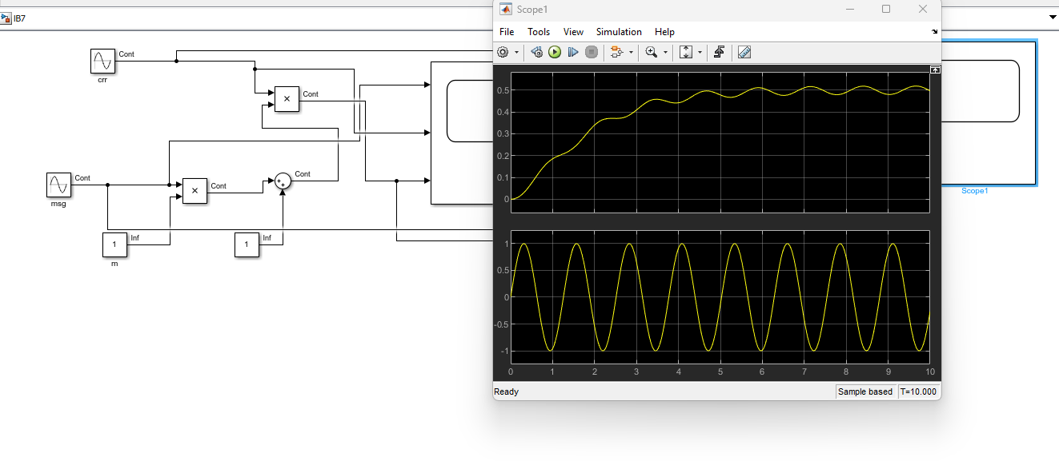

**DISCUSSION AND CONCLUSION:**

The goal of this experiment was to understand the use of Simulink for AM modulation and to

develop understanding of AM demodulation. The performance task given by faculty was

done using Simulink. The experiment was successful as we got the expected results. We have

faced some difficulties as Simulink was new for us. We had problems implementing the

blocks. But with the help of our faculty, we could overcome those problems and got a

success.