

© Dept. of EEE & COE, FE, AMERICAN INTERNATIONAL UNIVERSITY-BANGLADESH (AIUB)

# AMERICAN INTERNATIONAL UNIVERSITY-BANGLADESH (AIUB)

Faculty of Engineering

Department of Electrical and Electronic Engineering

**EXPERIMENT NO: 08 FINAL TERM**

**SEC : G**

**Data Communication**

# EXPERIMENT TITLE:

**Study of Frequency Modulation and Demodulation using Simulink (MATLAB)**

**Submitted to:**

**Raja Rashidul Hasan Assistant Professor Faculty of Engineering Department of EEE**

**Semester: Summer 2023**

**Date of Submission:07-08-2023**

# SUBMITTED BY: Muhee, Sabrina Jashim GROUP NO:04

|  |  |  |  |
| --- | --- | --- | --- |
| **Serial no** | **Student’s Name** | **ID** | **Dept.** |
| 03 | Muhee, Sabrina Jashim | 20-42309-1 | CSE |
| 02 | Rufaida Mamun | 20-42292-1 | CSE |
| 33 | Hossain, Md. Redowan | 21-45445-3 | CSE |
| 25 | Mohammad Rafiul Haque | 21-44631-1 | CSE |
| 34 | Alif, Md. Amir Hossain | 21-45446-3 | CSE |
| 09 | Nahin, Md. Zamiul Sadik | 20-44228-3 | CSE |

## Abstract:

This experiment is designed to understand the use of Simulink for solving communication engineering problems and to develop an understanding of Frequency Modulation and Demodulation using Simulink.

## Theory:

If m(t) is the message signal, the frequency-modulated signal is expressed as in the time domain:

**Frequency Modulation**

𝑡

𝑠(𝑡) = 𝐴𝑐 cos [2𝜋𝑓𝑐 𝑡 + 𝐾𝑓 ∫ 𝑚(𝜆)𝑑𝜆]

−∞

Frequency modulation is a technique or a process of encoding information on a particular signal (analog or digital) by varying the carrier wave frequency in accordance with the frequency of the modulating signal. As we know, a modulating signal is nothing but information or message that has to be transmitted after being converted into an electronic signal.

Much like amplitude modulation, frequency modulation also has a similar approach where a carrier signal is modulated by the input signal. However, in the case of FM, the amplitude of the modulated signal is kept or it remains constant.

**Frequency Demodulation**

Frequency demodulation is the inverse of frequency modulation. The original modulating signal is obtained as output following demodulation. After the signal has been received, filtered, and amplified, the original modulation from the carrier must be recovered. This is known as demodulation or detection.

FM demodulator circuits can be found in any FM receiver, including broadcast receivers, two- way radios such as walkie-talkies and handheld radios that use FM, and any receiver that uses frequency modulation.

## Results:

### Manual Example:

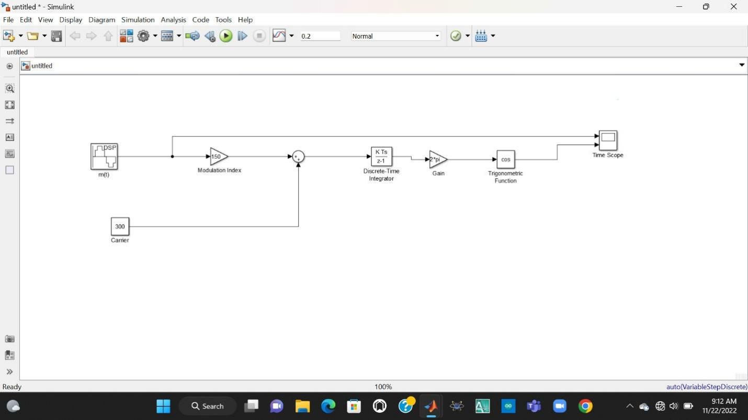

Fig: Manual Circuit-1

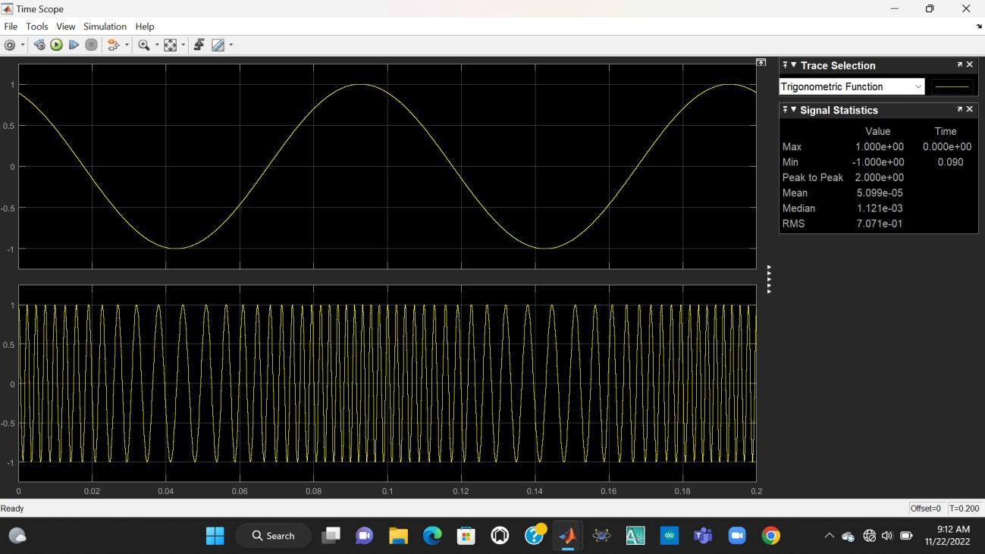

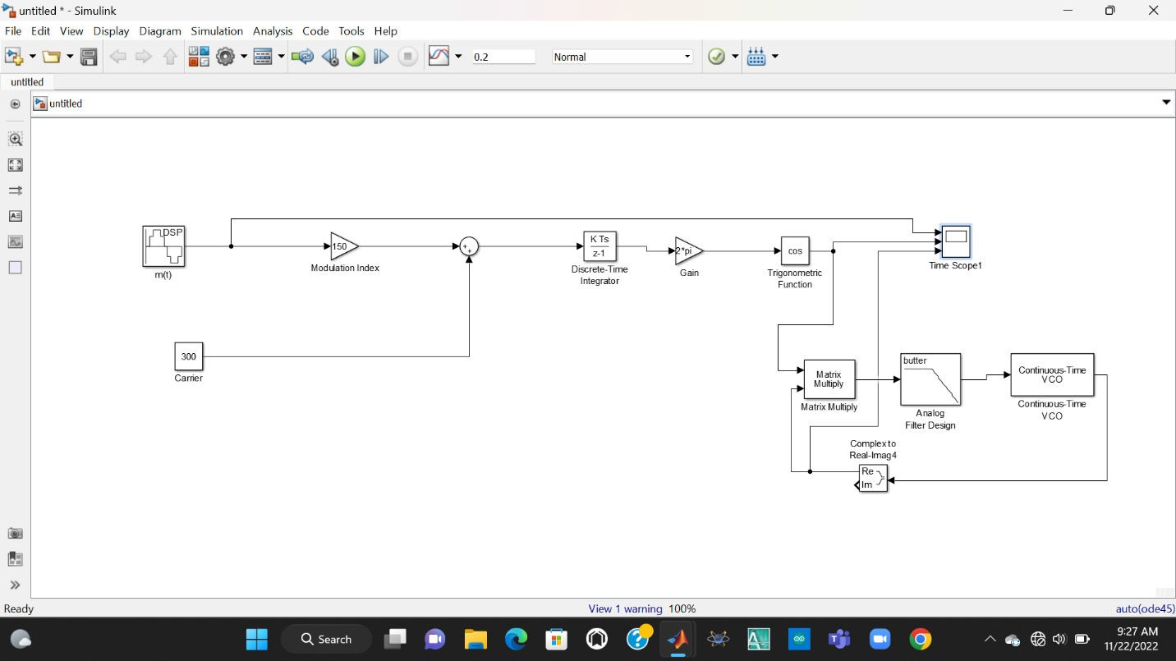

Fig: Manual Circuit-2

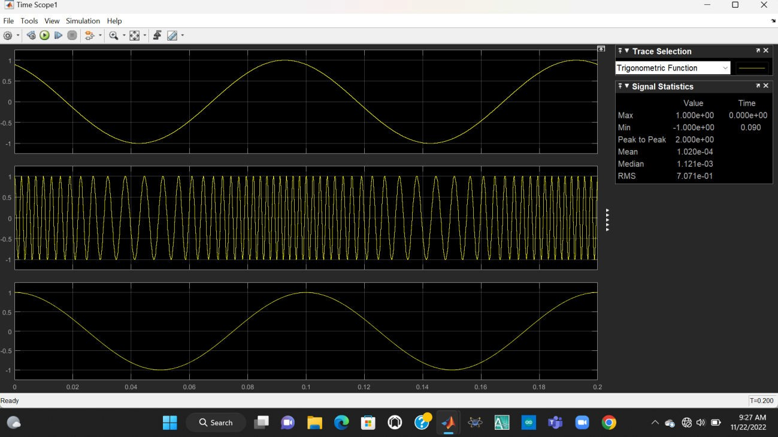

### Performance Task:

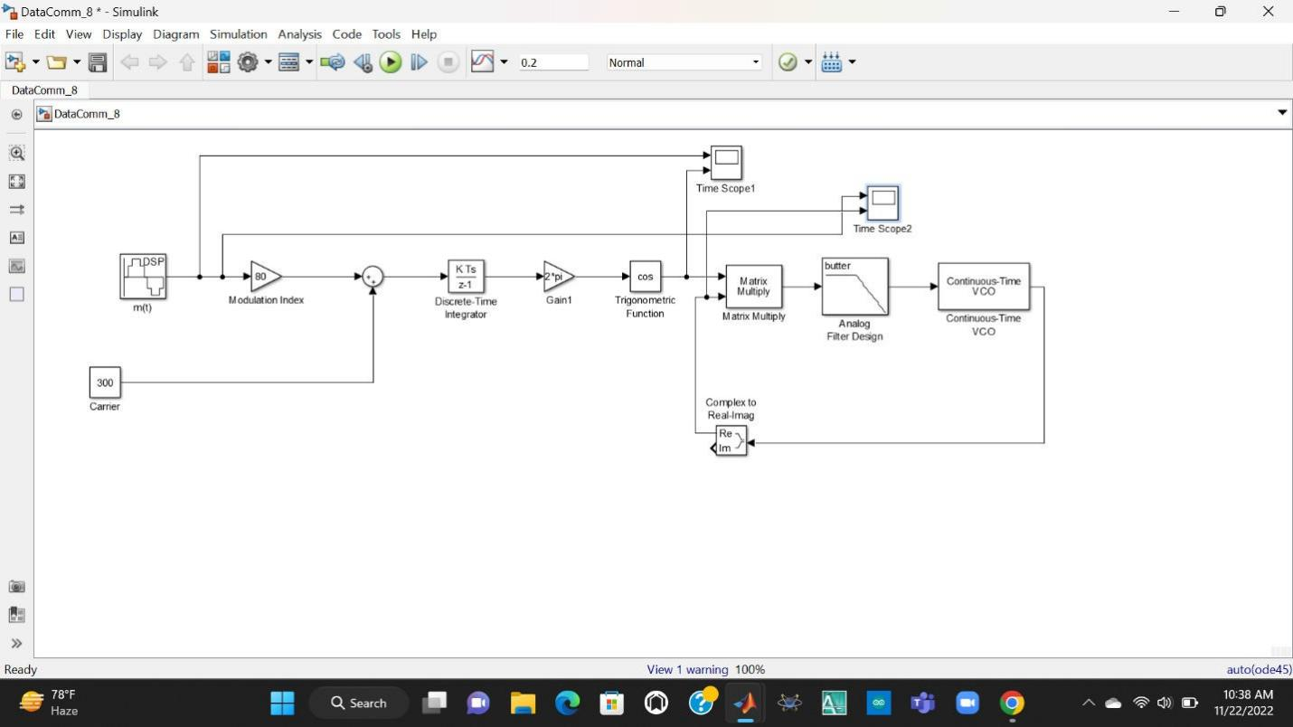

Fig: Performance Circuit

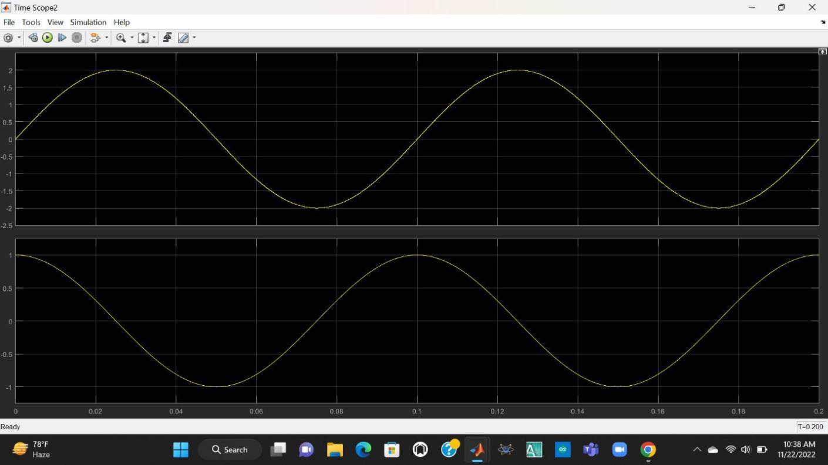

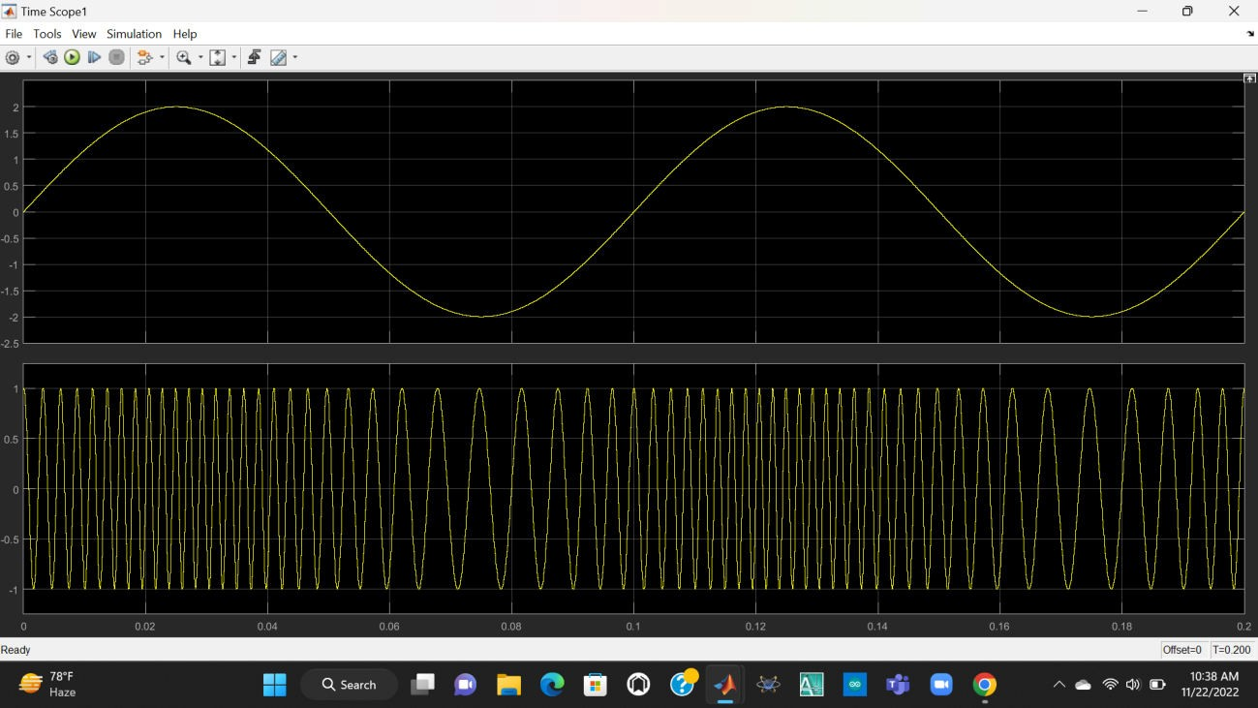

Fig: Performance output Modulated

## Discussion:

Frequency modulation and demodulation curves have been found through the simulation curve using MATLAB Simulink. From the figure, the output has been clearly understandable. The data Attenuation can be substantially reduced while traveling long distances in communication.

Software Implementation gives us the advantage of a reduction in hardware costs and failures.

## References:

[1] Robert W. Stewart, Kenneth W. Barlee, Dale S.W. Atkinson, and Louise H. Crockett, Software Defined Radio using MATLAB & Simulink and the RTL-SDR, pp. 371, Strathclyde Academic Media, 2015

[2] Hwei P. Hsu, Schaum’s Outlines of Theory and Problems of Signals and Systems, pp.1-5, 1995, McGraw-Hill

[3] M. P. Fitz, Fundamentals of Communications Systems, pp. 7.1-7.7, 2007, McGraw-Hill

[4] Haykin, Simon [Ed]. (2001). *Communication Systems*, 4th ed.

[5] Alan Bloom (2010). "Chapter 8. Modulation". In H. Ward Silver; Mark J. Wilson (eds.). The ARRL Handbook for Radio Communications. American Radio Relay League. p. 8.7. ISBN 978- 0-87259-146-2.