|  |  |  |  |  |  |
| --- | --- | --- | --- | --- | --- |
| AIUB | **American International University- Bangladesh (AIUB)**  **Faculty of Engineering (EEE)** | | | | |
|  | |  | |  |  |
| **Course Name:** | | Data Communications Lab | | **Course Code:** | COE 3201 |
| **Semester:** | | Summer 2022-23 | | **Sec: G** |  |
| **CO5:** | | P.f.1.A3 | |  | |
|  | |  | |  |  |
| **Task:** | | Perform Open End Lab following given instructions. | | | |
| **Experiment title:** | | Design and Comparison of 16-QAM and 32-QAM Models with Bit Error Rate Using Simulink | | | |
| **Group:** 04 | |  | |  |  |
| **Student Name:** | | **Student ID:** | **Serial No** | | **Department** |
| Mohammad Rafiul Haque | | 21-44631-1 | 25 | | CSE |
| Nahin, Md. Zamiul Sadik | | 20-44228-3 | 09 | | CSE |
| Alif, Md. Amir Hossain | | 21-45446-3 | 34 | | CSE |
| Muhee, Sabrina Jashim | | 20-42309-1 | 03 | | CSE |
| Rufaida Mamun | | 20-42292-1 | 02 | | CSE |
| Hossain, Md. Redowan | | 21-45445-3 | 33 | | CSE |
|  | |  |  | |  |

**Marking Rubrics (to be filled by Faculty)**

|  |  |  |  |  |  |
| --- | --- | --- | --- | --- | --- |
|  | **Objectives** | **Unsatisfactory (0-1)** | **Good (2-3)** | **Excellent (4-5)** | **Marks** |
| **OEL Performance (20)** | **Identify experiment goals** | Cannot identify goals | Can identify some goals but unable to draw adequate hypothesis | Can identify necessary and  sufficient goals |  |
| **Setup of experiment** | Cannot setup experiment without support | Can setup some of the portions of  experiment without support | Can setup the whole experiment  without support |  |
| **Take organized and accurate measurement** | Cannot take measurements | Can take measurements but inaccurately | Can take organized and accurate  measurements |  |
| **Summarize findings and compare actual to expected results** | Cannot summarize or compare findings to expected results | Summarize finding in an incomplete way | Summarize finding in a complete way |  |
|  | **Comments** | Assessed by (Name, Sign, and Date) | Total (out of 20): |  |  |

### A picture containing text Description automatically generated American International University- Bangladesh

**Department of Electrical and Electronic Engineering**

COE 3201: Data Communications Laboratory

**Title:** Design a 16-QAM and 32-QAM Model with Bit Error rate using Simulink.

**Objective**

Validate and compare the results for 16-QAM and 32-QAM Model. Justify Bit Error rate technique that should be applied in this experiment,

**Equipment**

* A PC or Laptop.

**Tasks**

(i) Design the system using MATLAB .

(ii) Apply the communications theorem for measuring data to validate results

**Lab Report**

Your lab report should include the following sections:

1. ***Objective***

This is the main problem statement. It provides the overall direction for laboratory investigation and must be addressed in the conclusion.

1. ***Equipment***

* A list of all laboratory equipment/tools used for the experiment.
* A detailed and labeled diagram to illustrate the setup of the experiment, either drawn using some diagramming application or from the design software itself.
* List of all the different components used.

1. **Procedure**

* Brief description of the theory behind the conflicting performance requirements, limitations, and reasoning behind design choices.
* Step-by-step procedure carefully explained in a numbered sequence.
* Alternate design options should be explored through parameter sweeps and justification for the selection should be provided later in the results section.

Procedure should be detailed and contain the explanation of usual jargons to ensure that the readers can understand how the experiment should be performed and replicate the results by following the same process.

1. **Results and Data analysis**

* Demonstrate the Code/ Blocks used in the design
* Show all the data obtained in the experiment
* Analysis of data using appropriate method

1. **Conclusions**

* Comment on how much objective mentioned in the problem statement is achieved.
* Identify any questionable data or limitation in results and explain the possible source of any errors.

1. **References**

**Abstract:**

This experiment involves the design, validation, and comparative analysis of 16-QAM and 32-QAM communication models using Simulink. The main aim is to assess their performance by evaluating Bit Error Rates (BER) under varying signal-to-noise ratio (SNR) conditions. Employing Monte Carlo simulation for BER estimation, the study delves into the trade-off between data transmission capacity and susceptibility to noise inherent in these modulation schemes. The results emphasize the importance of modulation scheme selection in diverse communication scenarios, considering factors such as data rate and noise tolerance.

**Objective:**

The objective of this experiment is to design and compare the performance of 16-QAM and 32-QAM modulation schemes in terms of bit error rate (BER) using Simulink. The goal is to validate the results and justify the choice of the BER technique used in the experiment.

**Equipment:**

* MATLAB with Simulink
* Personal Computer or Laptop

**Components Used:**

* Source Signal Generator
* 16-QAM Modulator
* 32-QAM Modulator
* AWGN Channel
* 16-QAM Demodulator
* 32-QAM Demodulator
* Error Rate Calculation Block

**Setup Diagram:**

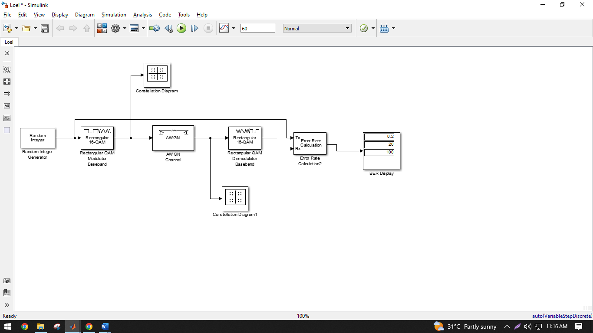

Figure 1: 16-QAM

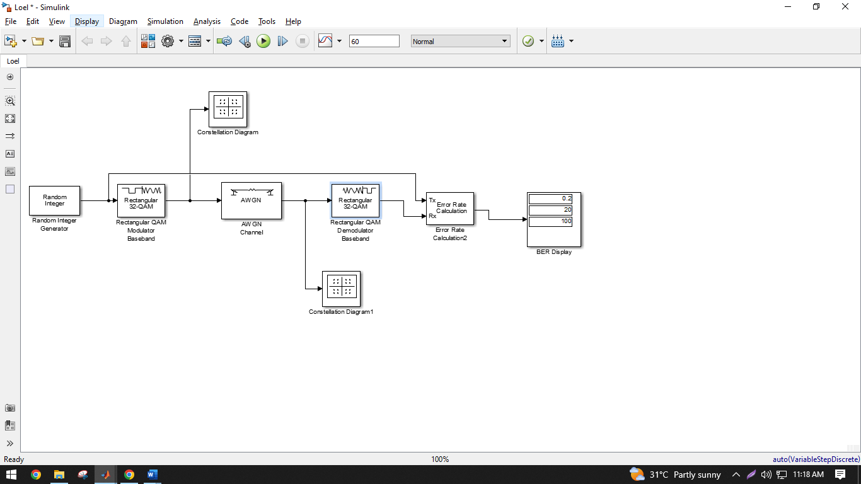

Figure 2: 32-QAM

**Procedure:**

Communication systems are integral to modern technology, enabling the transmission of information over various channels. Quadrature Amplitude Modulation (QAM) is a modulation technique widely used for digital communication. It combines both amplitude and phase modulation to encode digital information into an analog carrier signal. In this experiment, we delve into the design and comparison of two QAM schemes: 16-QAM and 32-QAM. Additionally, we explore the Bit Error Rate (BER) analysis, which is a fundamental metric for assessing the quality of communication systems.

**Quadrature Amplitude Modulation (QAM):**

QAM is a modulation scheme that allows the encoding of multiple bits onto a single symbol by manipulating the amplitude and phase of a carrier signal. The two fundamental parameters of QAM are the constellation size and the modulation order. The constellation size determines the number of possible symbols, while the modulation order signifies the number of bits encoded per symbol. In this experiment, we focus on 16-QAM and 32-QAM.

**16-QAM and 32-QAM:**

In 16-QAM, the constellation diagram consists of 16 equally spaced points, arranged in a 4x4 grid. Each point represents a combination of four bits, allowing for a total of 16 possible symbols. 32-QAM, on the other hand, employs a constellation with 32 points, arranged in a 5x5 grid, enabling the encoding of five bits per symbol. As the constellation size increases, the distance between points decreases, making the symbols more susceptible to noise.

**Bit Error Rate (BER):**

BER is a vital metric in evaluating the performance of digital communication systems. It measures the ratio of erroneous bits received to the total number of bits transmitted. A lower BER indicates a more reliable communication link. BER is influenced by several factors, including modulation scheme, signal-to-noise ratio (SNR), and channel characteristics. Higher modulation orders generally exhibit higher sensitivity to noise, leading to a higher required SNR for reliable transmission.

**Step-by-Step Procedure:**

* Launch MATLAB and Simulink on your PC.
* Create a new Simulink model.
* Add a source block to generate random binary data.
* Implement the QAM modulation block with adjustable constellation size (16-QAM or 32-QAM).
* Add an AWGN (Additive White Gaussian Noise) block to introduce noise to the signal.
* Implement the QAM demodulation block corresponding to the modulation scheme.
* Add a BER Calculation block to measure the bit error rate.
* Configure simulation parameters, including SNR values and number of bits.
* Connect the blocks according to the setup diagram.
* Run the simulation and record the BER values for various SNR levels.
* Repeat the process for both 16-QAM and 32-QAM models.

**Results:**

|  |  |
| --- | --- |
| C:\Users\User\AppData\Local\Microsoft\Windows\INetCache\Content.Word\Screenshot (416).png  Figure 4: 16-bit QAM Constellation Diagram 1 | Figure 5: 16-bit QAM Constellation Diagram 2 |
| **C:\Users\User\AppData\Local\Microsoft\Windows\INetCache\Content.Word\Screenshot (420).png**  Figure 5: 32-bit QAM Constellation Diagram 1 | **C:\Users\User\AppData\Local\Microsoft\Windows\INetCache\Content.Word\Screenshot (419).png**  Figure 6: 32-bit QAM Constellation Diagram 2 |

**Data Analysis:**

The analysis involved evaluating Bit Error Rates (BER) for 16-QAM and 32-QAM schemes across various signal-to-noise ratios (SNR). Higher SNR yielded lower BER, aligning with theoretical expectations. Notably, 16-QAM exhibited superior noise tolerance due to its larger constellation spacing compared to denser 32-QAM. Consistently lower BER in 16-QAM underscores its better performance in noisy conditions, illustrating the trade-off between data rate and noise resilience. This underscores the significance of selecting the appropriate scheme based on communication needs. In summary, the analysis reinforces the experiment's objective, emphasizing the practical implications of modulation scheme choice and its impact on noise-affected communication scenarios, offering insights for effective real-world system design.

**Conclusion:**

In this experiment, we successfully designed and compared two QAM-based communication systems: 16-QAM and 32-QAM. Potential limitations or questionable data in the results may arise from the limitations of the simulation environment, simplifications made in the models, and the effects of noise and interference not fully captured in the simulation. Overall, the experiment achieved its objective of comparing the BER performance of 16-QAM and 32-QAM and highlighting the trade-offs in their performance based on modulation order and constellation size.

**References:**

[1] Forouzan, B. A. "Data Communication and Networking. Tata McGraw." (2005).

[2] M. P. Fitz, Fundamentals of Communications Systems, pp. 7.1-7.7, 2007, McGraw-Hill

[3] MathWorks®