

American International University-Bangladesh (AIUB)  
**Department of Computer Science  
Faculty of Science &Technology (FST)  
Fall 22_23**

**Section: D  
Group No: 5  
TRIMMER**

A software Engineering project submitted

By

|  |  |  |  |  |
| --- | --- | --- | --- | --- |
| S/N | Student Name | Student ID | Contribution (%) | Individual Marks |
| 15 | SABID, ARIFIN | 19-41513-3 |  |  |
| 36 | RABBI, MEHEDI HASAN | 20-44059-2 |  |  |
| 37 | DAS, PROSIT KUMAR | 20-44063-2 |  |  |
| 38 | NIROB, NAFIS FUAD | 20-44082-2 |  |  |

The project will be Evaluated for the following Course Outcomes

|  |  |  |
| --- | --- | --- |
| Your Project will be Evaluated based on the following marking criteria | | Total Marks |
|  |
| Identify and Analyze Requirements (functional, quality, and project req.) | [5Marks] |  |
| Design the System Interface (UI/UX design) | [5Marks] |  |
| Prepare Test cases and Test plan | [5Marks] |  |
| Prepare WBS and Project Schedule | [5Marks] |  |
| Identify potential risks and Prepare a risk management plan | [5Marks] |  |
| Submission, Completeness, Spelling, Grammar and Organization | [5Marks] |  |

# 1. PRODUCT AND PROJECT DESCRIPTION

## 1.1 System Features

1. **User Profile**

**Functional Requirements**

* 1. After login into the user id can update his /her name, age, gender and location.
  2. User can set Phone number or email in case some kind of network issue.
  3. System will verify if the Phone number or Email is correct or not and send a message if invalid Phone number or Email.

**Priority level:** Medium

**Precondition:** User must register with Phone Number or Email.

**Cross-reference:** N/A

1. **Search Barber:**

**Functional Requirements**

* 1. This System will automatically provide user nearby barber shop.
  2. This system will allow customer to choose different kind of barber.

**Priority level:** High.

**Precondition:** User need to be a registered member first.

**Cross-reference:**1

1. **Booking Barber**

**Functional Requirements**

* 1. User can select their preferable time and barber shop.
  2. When user not select specific barber system will automatically choose any barber on selected shop.
  3. System will send a massage to both customer and barber for confirmed the service.

**Priority level:** High

**Precondition:** Customer need to be registered with the service location and valid phone number

**Cross-reference:** 2

1. **Barber Schedule:**

**Functional Requirements**

* 1. Barber can set their time schedule.
  2. System automatically update barber time schedule by selected time.
  3. Barber can set offers
  4. System will send a massage to customer for offers.

**Priority level:** High

**Precondition:** Barber need to be registered with the service location and valid phone number

**Cross-reference:** N/A

1. **Cancel Request:**

**Functional Requirements**

* 1. User can cancel his booking at any time then system will automatically update barber time schedule.
  2. If customer didn’t go to barber shop on time and didn’t cancel his booking, then system will automatically cancel the booking and make a red mark on that user.

**Priority level:** High

**Precondition:** User need to be booked a barber

**Cross-reference:** 3

## System Quality Attributes

There are two types of perspective of quality attributes.

Here we give some important primarily quality attributes to user perspective.

**QA 1. Availability**: The system shall be at least 98.5 percent available on every seven days a week between 8.00 am to 8.00 pm at local time.

**Priority level:** High

**Precondition:** Must have maintainability attribute

**Cross-reference:** N/A

**QA 2. Efficiency**: There are at least (2) percent of the processor capacity, disk space 1.7 MB/S, memory 88 MB and communication bandwidth 1024kbps shall be available to properly run this system.

**Priority level:** High

**Precondition:** N/A

**Cross-reference:** N/A

**QA 3.** **Flexibility**: A maintenance programmer who will be able to add new feature and function including code, modifications and testing into the system with no more than two hours.

**Priority level:** Medium

**Precondition:** N/A

**Cross-reference:** N/A

**QA 4.** **Integrity**: When user try to login into the system, then they have to two step verification. One step is when user try to login into the system, the system will send a verification code to the user via mail and user get a verification code to login and the second step is user need to use own password when they create the password to sign up this system.

**Priority level:** High

**Precondition:** N/A

**Cross-reference:** QA-2

**QA 5. Reliability**: The system shall no more than three experimental runs out of 700 can be lost.

**Priority level:** High

**Precondition:** N/A

**Cross-reference:** QA-1, QA-2, QA-3

There are some important primary quality attributes to developer perspective:

i) **Maintainability**: Suppose there is a problem arise in the system that user can’t booked a barber. A maintenance programmer who has experience can solve this problem within 2 hours without any extra helping hand.

**Priority level:** High

**Precondition:** N/A

**Cross-reference:** QA-3

ii) **Portability**: The system was able to run any platform or any operating system. Like Windows, Android, Apple.

**Priority level:** High

**Precondition:** N/A

**Cross-reference:** QA-2.

iii) **Reusability**: The system functions app is free for everyone.

**Priority level:** Low

**Precondition:** N/A

**Cross-reference:** QA-1, QA-2, QA-3.

## Project Requirements

1. **Time**: We need Four month (15 weeks) to build this software.

2) **Environment**: We don’t have any budget so we are working on own work place

3) **Resources**: We are total 4 human resources to build this software.

4) **Equipment**: To build this software we need equipment. Like, 4 Computer

5) **Bandwidth**: We need high bandwidth support. Which is around 50 to 80 Mbps.

6) **Tools**: The system developer needs selenium tools in perform testing activities in week.

# 2. SYSTEM DESIGN SPECIFICATION

## UI/UX Design

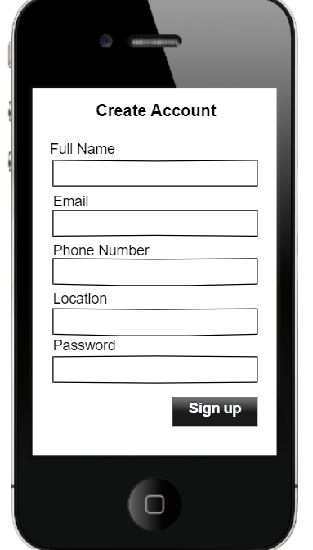 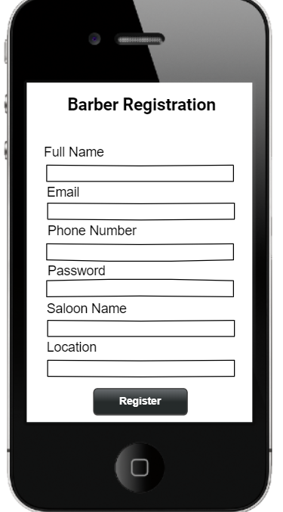

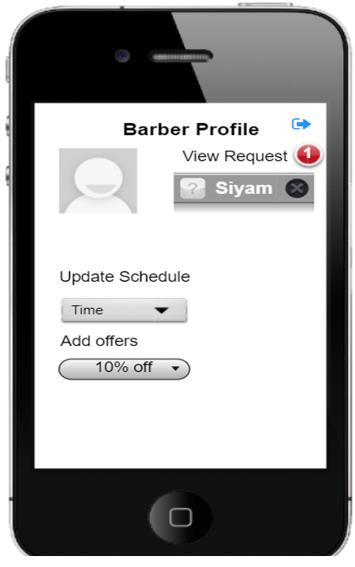 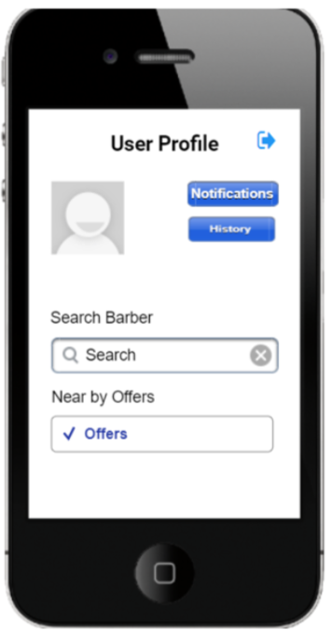 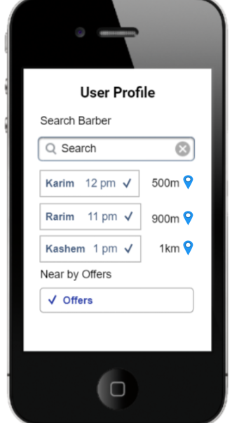

# 3. SYSTEM TEST PLAN

**Table**: Test Case for **User Profile**

|  |  |  |  |  |
| --- | --- | --- | --- | --- |
| Project Name: Trimmer | | | Test Designed by: Prosit Kumar Das | |
| Test Case ID: TMR_1 | | | Test Designed date: 27-11-2022 | |
| Test Priority (Low, Medium, High): High | | | Test Executed by: | |
| Module Name: Create account | | | Test Execution date: | |
| Test Title: Registration method | | | | |
| Description: Test user valid registration profile | | | | |
| Precondition (If any): Valid Phone number or Gmail | | | | |
| Test Steps | Test Data | Expected Results | Actual Results | Status (Pass/Fail) |
| 1. Go to the app 2. Click “signup or join as barber” button 3. Fill the details 4. Click “Signup” button | Email: Prosit.kd@gmail.com  Phone Number :01777025958  Database: Save data successfully. | User should be able to register into Trimmer app |  |  |
| Post Condition: The phone number and location will be updated anytime in the database when user select his current location or changes his contact number. | | | | |

**Table**: Test Case for **Booking Barber**

|  |  |  |  |  |
| --- | --- | --- | --- | --- |
| Project Name: Trimmer | | | Test Designed by: Arfin Sabid | |
| Test Case ID: TMR_2 | | | Test Designed date: 5-12-2022 | |
| Test Priority (Low, Medium, High): Medium | | | Test Executed by: | |
| Module Name: Booking Barber | | | Test Execution date: | |
| Test Title: Getting barber and offers list. | | | | |
| Description: Test to see the barber list and booked the barber. | | | | |
| Precondition (If any): Customer need to login into app with valid ID. | | | | |
| Test Steps | Test Data | Expected Results | Actual Results | Status (Pass/Fail) |
| 1. Go to the User profile  2. Click “Search barber” or “Nearby offers”.  3. Select Saloon and barber from list.  4.Click “Sent Request” button | Offers: 20% discount for today  Saloon:  MegaHair-Khilkhet-2.00pm | User should be able see the slot and booked the barber. |  |  |
| Post Condition: The schedule will be updated continuously when a customer booked a barber. | | | | |

**Table**: Test Case for **Confirm Request**

|  |  |  |  |  |
| --- | --- | --- | --- | --- |
| Project Name: Trimmer | | | Test Designed by: Mehedi Hasan | |
| Test Case ID: TMR_3 | | | Test Designed date: 03-12-2022 | |
| Test Priority (Low, Medium, High): Medium | | | Test Executed by: | |
| Module Name: Conformation Request | | | Test Execution date : | |
| Test Title: To confirm user schedule request. | | | | |
| Description: Test Conformation or rejection the customer. | | | | |
| Precondition (If any): User need to be a sent request first. | | | | |
| Test Steps | Test Data | Expected Results | Actual Results | Status (Pass/Fail) |
| 1. Go to the Barber Profile  2. Click “View request” button  3.Select the user from list  4. Click “Confirm request or cancel request” button | Nafis89 request for 2.00pm slot  Request: Confirmed or Rejected. | Barber should be able to see the request and can confirm or reject. |  |  |
| Post Condition: After conforming the request user get a notification from barber and update barber schedule automatically. | | | | |

**Table**: Test Case for **Barber Update**

|  |  |  |  |  |
| --- | --- | --- | --- | --- |
| Project Name: Trimmer | | | Test Designed by: Nafis Fuad Nirob | |
| Test Case ID: TMR_4 | | | Test Designed date: 07-12-2022 | |
| Test Priority (Low, Medium, High): Medium | | | Test Executed by: | |
| Module Name: Barber Update | | | Test Execution date: | |
| Test Title: Check schedule | | | | |
| Description: Test barber profile updated schedule and offers. | | | | |
| Precondition (If any): Have to login as Barber first. | | | | |
| Test Steps | Test Data | Expected Results | Actual Results | Status (Pass/Fail) |
| 1. Go to the Barber Profile 2. Click “Add offers” button 3. Add new offers to selected schedule. 4. Click “Sent Offer” button | Offer: 20% discount for Today  Schedule:  11.00 Am  2.00 Pm | User should be see the offer and schedule. |  |  |
| Post Condition: After set the offers, the offer will automatically update to the customer. | | | | |

# 4. PROJECT MANAGEMENT PLAN

## 4.1 Project Scheduling

|  |  |  |  |  |  |  |  |  |  |  |  |  |  |  |  |
| --- | --- | --- | --- | --- | --- | --- | --- | --- | --- | --- | --- | --- | --- | --- | --- |
| Week  Test | W -1 | W -2 | W -3 | W -4 | W -5 | W -6 | W -7 | W -8 | W -9 | W-10 | W-11 | W-12 | W-13 | W-14 | W-15 |
| A.Nafis |  |  |  |  |  |  |  |  |  |  |  |  |  |  |  |
| B.Nafis |  |  |  |  |  |  |  |  |  |  |  |  |  |  |  |
| C.Prosit |  |  |  |  |  |  |  |  |  |  |  |  |  |  |  |
| D.Rabbi |  |  |  |  |  |  |  |  |  |  |  |  |  |  |  |
| E.Sabid |  |  |  |  |  |  |  |  |  |  |  |  |  |  |  |
| F.Prosit |  |  |  |  |  |  |  |  |  |  |  |  |  |  |  |
| G.All |  |  |  |  |  |  |  |  |  |  |  |  |  |  |  |
| H. Sabid |  |  |  |  |  |  |  |  |  |  |  |  |  |  |  |
| I.ALL |  |  |  |  |  |  |  |  |  |  |  |  |  |  |  |
| J.Prosit |  |  |  |  |  |  |  |  |  |  |  |  |  |  |  |
| K. Rabbi |  |  |  |  |  |  |  |  |  |  |  |  |  |  |  |
| L. Nafis |  |  |  |  |  |  |  |  |  |  |  |  |  |  |  |
| M.All |  |  |  |  |  |  |  |  |  |  |  |  |  |  |  |
| N. All |  |  |  |  |  |  |  |  |  |  |  |  |  |  |  |
| O. All |  |  |  |  |  |  |  |  |  |  |  |  |  |  |  |
| P. All |  |  |  |  |  |  |  |  |  |  |  |  |  |  |  |
| Q. Sabid |  |  |  |  |  |  |  |  |  |  |  |  |  |  |  |
| R. All |  |  |  |  |  |  |  |  |  |  |  |  |  |  |  |
| S. All |  |  |  |  |  |  |  |  |  |  |  |  |  |  |  |
| T. All |  |  |  |  |  |  |  |  |  |  |  |  |  |  |  |
| U. All |  |  |  |  |  |  |  |  |  |  |  |  |  |  |  |
| V. All |  |  |  |  |  |  |  |  |  |  |  |  |  |  |  |
| W. All |  |  |  |  |  |  |  |  |  |  |  |  |  |  |  |
| X. All |  |  |  |  |  |  |  |  |  |  |  |  |  |  |  |
| Y. All |  |  |  |  |  |  |  |  |  |  |  |  |  |  |  |

**Activity Key:**

1. Overall design
2. Overall design
3. Overall design
4. Overall design
5. Overall design
6. Overall design
7. Overall design
8. Special module 1
9. Special module 2
10. Special module 3
11. Special module 4
12. Special module 5
13. Special module 6
14. Code module 1
15. Code module 2
16. Code module 3
17. Code module 4
18. Integration system
19. Integration system
20. Integration system
21. Integration system
22. System testing
23. System testing
24. System testing

System testing

## 4.2 Risk Analysis

|  |  |  |  |  |
| --- | --- | --- | --- | --- |
| **S/N** | **Risk Description** | **Probability** | **Impact** | **Mitigation Plan** |
| 1 | Task allocation problem | 20% | Poor code writing and functionality | Make a skill-set chart of the group members and assign tasks according to expertise |
| 2 | Maintainability problem | 50% | Poor user experience | We'll make a recovery test on our entire project |
| 3 | Excessive Cost | 35% | Project will be more costly | A good pre-estimation and make a good track on budget |
| 4 | Customer information Security | 25% | Customer will lose trust in this app | Make a reliable security system. |