**Vehicle repair and Maintenance System**

**Background Description:**

A roadside emergency or auto accident can cause escalated emotions even if you’re typically a calm driver. Even a simple repair like a dead battery or flat tire can become a total catastrophe if it happens somewhere where it’s difficult to get help. vehicle repair and Solution is the Repair and solution software that people use for repairing cars that face problems with their cars on the road or anywhere problems with their cars. usually, we provide some special features for their car engine problems and many more. The people who will use our software and call inform our management. our management will provide the solution through the mechanic. the mechanic will go to the destination through the maps and repair their car.

**Problems:**

There are several types of problems regularly face people with their cars. Some basic problems are:

* Towing – When towing is necessary, the disabled Covered Vehicle will be towed to the nearest qualified repair facility or to the repair facility of your choice.
* Lock-Out Assistance – Assistance will be provided in unlocking the Covered Vehicle in the event the keys are lost or locked inside.
* Flat Tire Assistance – If the Covered Vehicle’s spare tire is serviceable, it will be installed to replace the flat tire. If the disabled Covered Vehicle has no serviceable spare, or if it has two or more flat tires, the vehicle will be towed.
* Fuel, Oil, Fluid and Water Delivery Service – An emergency supply of gasoline (where permitted), oil, fluid and water will be delivered to any Covered Vehicle in immediate need. The customer must pay for the costs of the actual fluids delivered.
* Battery Jump-Start – If a battery failure occurs, a battery jump-start will be provided to start the Covered Vehicle.

The Program is intended to cover emergencies vehicle maintenance or repair. The vehicle owner or driver of the Covered Vehicle must be with the Covered Vehicle when the Service Provider arrives, as roadside assistance cannot be provided to an unattended vehicle. If the driver is not with the Covered Vehicle, you may be charged for an associated fee by the Service Provider that is not covered or reimbursable under the terms of this Program.

**Objective:**

* Firstly, cover emergencies vehicle maintenance or repair.
* The best mechanic works in troubleshooting and repairing the full range of vehicles, equipment, and components.
* provide excellent service by reasonable price.
* provide genuine parts to all kinds of vehicle.
* We know how to find out the problem with the world-renowned automatic scanner and provide outstanding solutions.

**Solution:**

The drivers and vehicle owners who need help with their cars while they are on the road. These services are designed to provide drivers with quick and convenient assistance when they encounter problems with their vehicles, such as a flat tire, a dead battery, or a breakdown. The target users of roadside assistance may include:

* Commuters who use their vehicles daily for work or personal errands.
* Long-distance travelers who are taking road trips and may encounter unexpected problems with their vehicles.
* Elderly drivers or drivers with disabilities who may need extra help in case of a breakdown or other car-related issue.
* Drivers who are unfamiliar with the area they are driving in and may need help locating a repair shop or other services.
* Drivers who own older vehicles or vehicles that are prone to breakdowns and may need more frequent assistance.

Overall, The drivers and vehicle owners who value the convenience, reliability, and peace of mind that comes with having access to fast and professional car repair services while they are on the road.

**Main Functionality:**

* Cover emergencies vehicle maintenance or repair.
* Provide a solution for car problems through a team of mechanics.
* Provide Towing services to the nearest repair facility.
* Provide Lock-out assistance for lost or locked-in keys.
* Provide Flat tire assistance and installation of a serviceable spare tire.
* Provide Fuel, oil, fluid, and water delivery service.

**Requirement Analysis**

**Functional Requirements:**

1. **Software Login**
   1. The software will allow users to login with their given username and password.
   2. The login credentials (username and password) will be verified with database records.
   3. If the login successful the home page of the user account will be displayed.
   4. If the username and/or password has been inserted wrong, the random verification code will be generated and sent to the user’s email address by the system to retry login.
   5. If the number of login attempt exceed its limit (3 times), the system will block the user account login for one hour [optional function]
2. **Service selection**
   1. Users must enter the required fields such as: User Location and Service type
   2. Users must choose the desired nearest shop based on user location.
3. **Availability Check**
   1. The server will search the list of available shops from the database according to the user’s requirement details.
   2. The server will check the number of available mechanics.
   3. If the user’s preferred service is available, then it will be displayed to the user.
4. **Modify Journey details or cancel ticket**
   1. The software will allow users to make changes to their vehicle service details. For example, they can change journey date or timing.
   2. The software will allow users to cancel the service they bought already and can get the refund.

**5.Payment**

5.1 The software will allow users to choose their preferred payment method. For example, Bank payment, online payment through visa or mastercard, MFS (Bkash, Nagad, Rocket)

5.2 The payment credentials (Account holder name, account number etc) will be verified with relevant selected payment method partners database records.

5.3 If the payment is successful the system will generate your requested ticket.

5.4 If the payment is failed due to any sort of issues the user will get maximum 24 hours to complete your payment to confirm the ticket otherwise request for the ticket will be invalid or canceled.

**Use Case Diagram:**

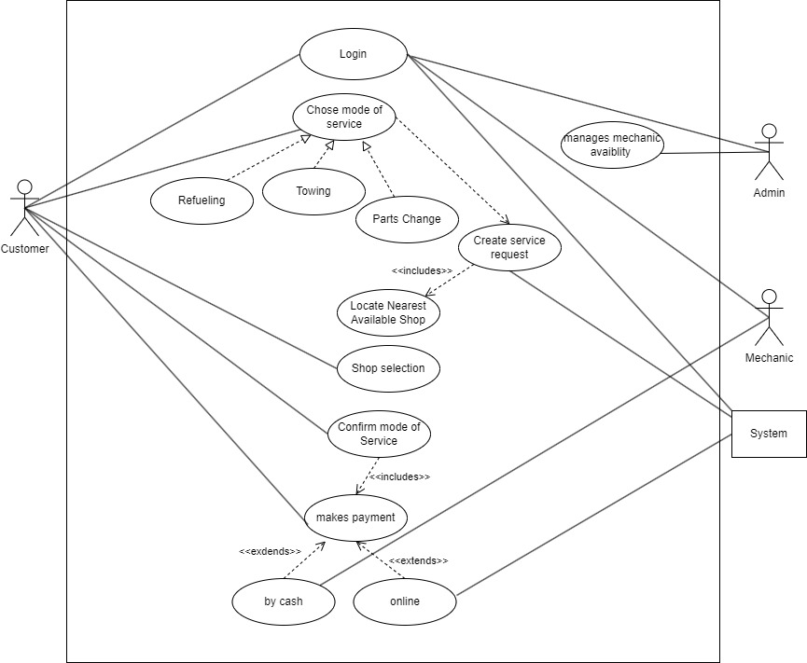

**Sequence Diagram:**

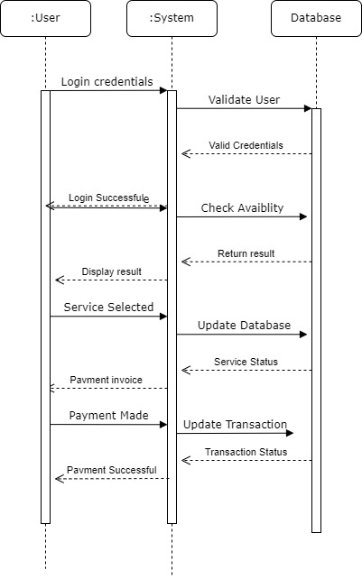

:

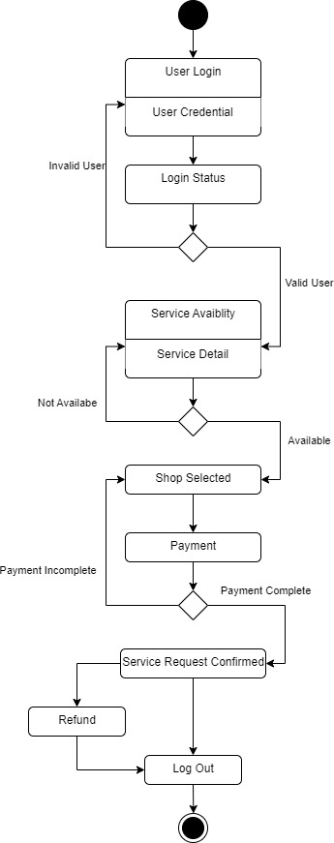**State Diagram:**

**Activity Diagram:**

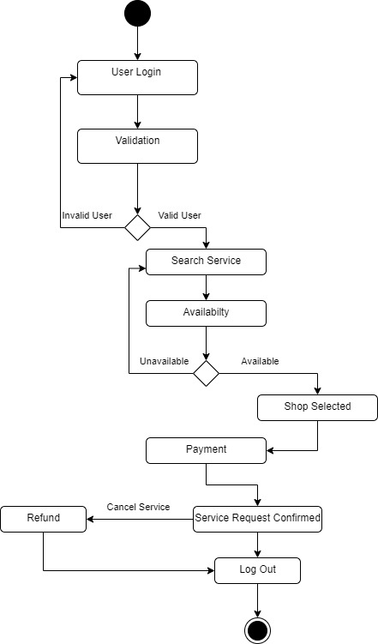

**Class Daigram**

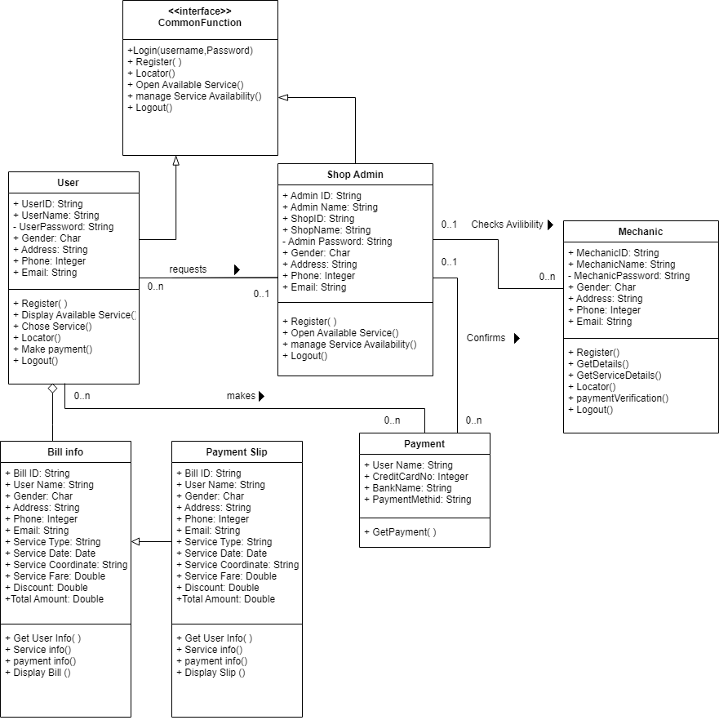

**Incremental model:**

Incremental model, is a software development approach where a project is broken down into smaller, more manageable modules or iterations, and each iteration is developed and delivered incrementally.

While incremental model is typically used in software development, it can also be applied in other fields, including car repair. Here are some reasons why incremental model may be beneficial in car repair:

Faster turnaround time: By breaking down the repair process into smaller, more manageable iterations, the mechanic can focus on fixing one issue at a time, rather than trying to diagnose and fix multiple issues simultaneously. This can lead to a faster turnaround time, as the mechanic can quickly identify and fix each issue as they arise.

Better communication: Incremental model can facilitate better communication between the mechanic and the car owner. By breaking down the repair process into smaller iterations, the mechanic can provide regular updates on the progress of the repair, and the car owner can provide feedback and make adjustments as needed.

Reduced cost: By identifying and fixing issues as they arise, rather than waiting for a major problem to develop, incremental model can reduce the overall cost of the repair. This is because small issues are often easier and less expensive to fix than major problems.

Improved quality: By breaking down the repair process into smaller iterations, the mechanic can focus on ensuring that each repair is done correctly and thoroughly. This can lead to a higher quality repair overall, as the mechanic can take the time to test and verify each repair before moving on to the next iteration.

Overall, using an incremental model in car repair can help improve efficiency, communication, quality, and cost-effectiveness.

**Main functionality:**

Functional requirements demonstrate the functionality of the software. Software development are the specific features and functionalities that a software system must perform to satisfy the needs of its users. Here are some examples of functional requirements:

* Software Login:

1. The software shall allow users to login with their given username and password.
2. The login credentials (username and password) will be verified with database records
3. If the login successful, the home page of the user account will be displayed.
4. If the username and/or password has been inserted wrong, the random verification code will be generated and sent to the user’s email address by the system to retry login.
5. If the number of login attempt exceed its limit (3 times), the system shall block the user account login for one hour.

* Payment processing:

1. The software should be able to process payments securely, using encryption and other security measures to protect sensitive information such as credit card numbers or bank account details.
2. The software should be able to integrate with payment gateways such as PayPal or Stripe, to process payments made by customers.
3. The software should support multiple payment methods such as credit/debit cards, bank transfers, or e-wallets, to cater to the preferences of the customers.
4. The software should be able to notify both the customer and the merchant about the payment status, whether it was successful or not.
5. The software should be able to maintain a payment history for each customer and merchant, to track the transactions and reconcile accounts.