**Windows Installation**



Session: 2022 – 2026

**Submitted by:**

Rafiya Rehan 2022-CS-182

**Submitted To:**

Mr. Nauman Shafi

Department of Computer Science

**University of Engineering and Technology**

**Lahore Pakistan**

Contents

**Installing Windows 10 using Virtual Box** 4

**Steps to be Performed** 4

**Step1** 4

**Step2** 4

**Step3** 5

**Step4** 5

**Step5** 6

**Step6** 6

**Step7** 7

**Step8** 7

**Step9** 8

**Step10** 8

**Step11** 9

**Step12** 9

**Step13** 10

**Step14** 10

**Step15** 11

**Step16** 11

**Step17** 12

**Step18** 12

**Step19** 13

**Step20** 13

**Step21** 14

**Step22** 14

**Step23** 15

**Step24** 15

Figure 1: Installing VirtualBox 5

Figure 2: VirtualBox Setup 5

Figure 3: Virtual Box Windows 6

Figure 4: Windows ISO 6

Figure 5:VM Name and Path 7

Figure 6: Allocating Memory and Processors 7

Figure 7: Hard Disk Configurations 8

Figure 8: VM creation 8

Figure 9: General Settings 9

Figure 10: System Settings 9

Figure 11: Display Settings 10

Figure 12: Storage Settings 10

Figure 13: Powering up VM 11

Figure 14: Setting up Windows 11

Figure 15: Installing Windows 12

Figure 16: Windows Activation 12

Figure 17: Selecting OS 13

Figure 18: License Terms 13

Figure 19: Selecting Windows Location 14

Figure 20: Windows Installation Setup 14

Figure 21: Restarting Windows 15

Figure 22: Selecting Region 15

Figure 23: Keyboard Layout 16

Figure 24: Successful Installation 16

# **Installing Windows 10 using Virtual Box**

## **Steps to be Performed**

**Step1** Install latest version of Virtual box for your OS (MS. Windows in my case).

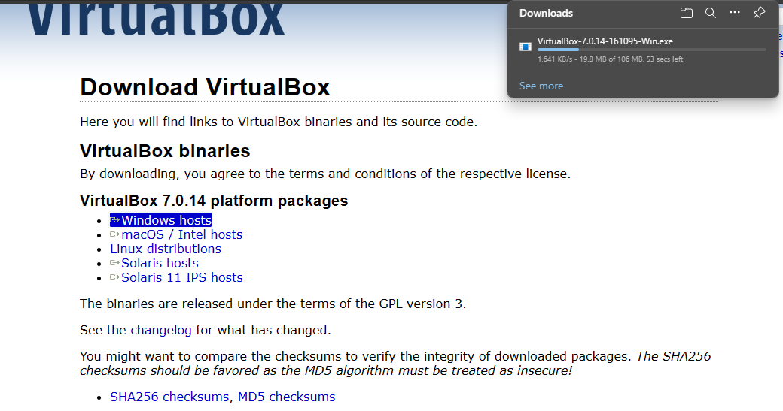

Figure 1: Installing VirtualBox

**Step2** Set up the Virtual Box.

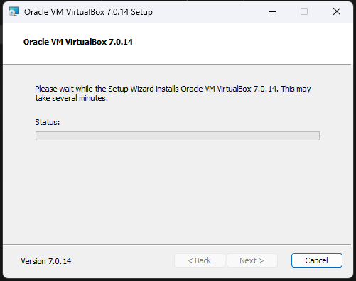

Figure 2: VirtualBox Setup

**Step3** Run the Virtual Box.

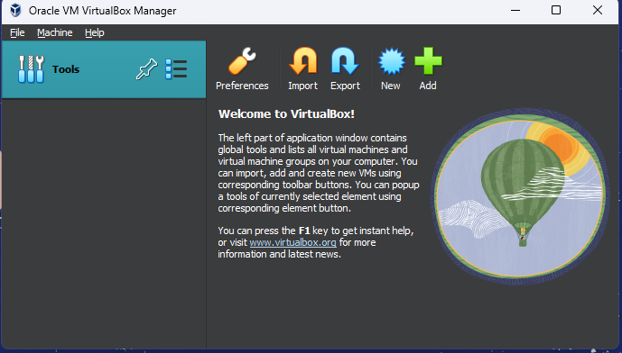

Figure 3: Virtual Box Windows

**Step4** Get the Windows ISO File. In my case I have already downloaded it in USB. It can be downloaded from any web browser.

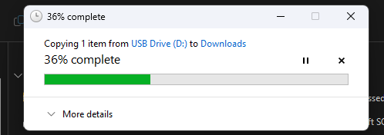

Figure 4: Windows ISO

**Step5** Select the name and destination folder for your Virtual machine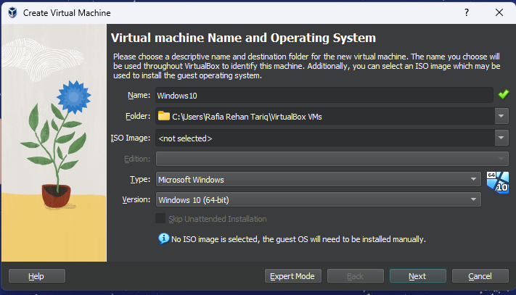

Figure 5:VM Name and Path

**Step6** The next few steps involve allocating the resources to your new virtual machine. Select the base memory and number of processors to be allocated.

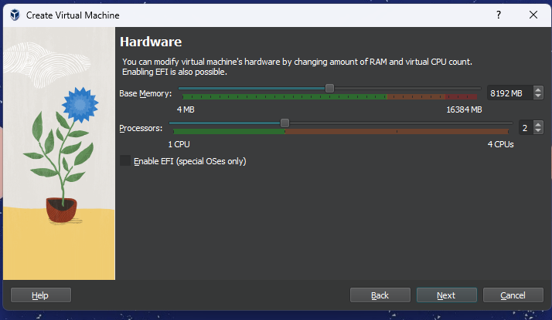

Figure 6: Allocating Memory and Processors

**Step7** Select the appropriate hard disk configurations.

Figure 7: Hard Disk Configurations

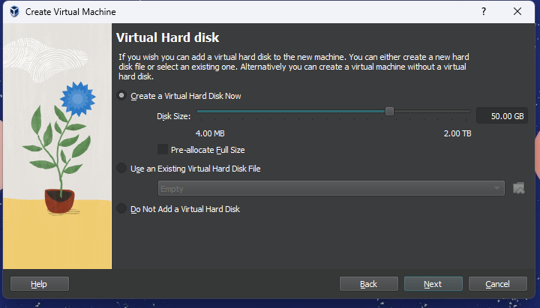

**Step8** Your Virtual Machine is created. Its time for making the appropriate settings and giving path to your VM.

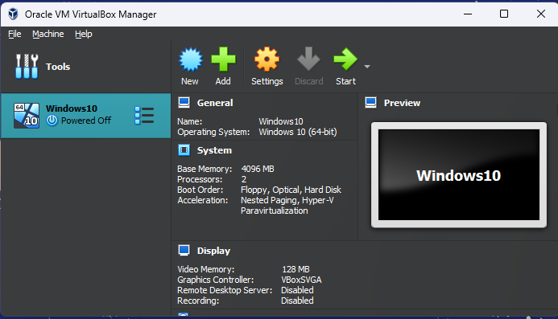

Figure 8: VM creation

**Step9** Go to General Settings >> Advanced and select option for drag n drop and clipboard. I have selected bidirectional in my case.

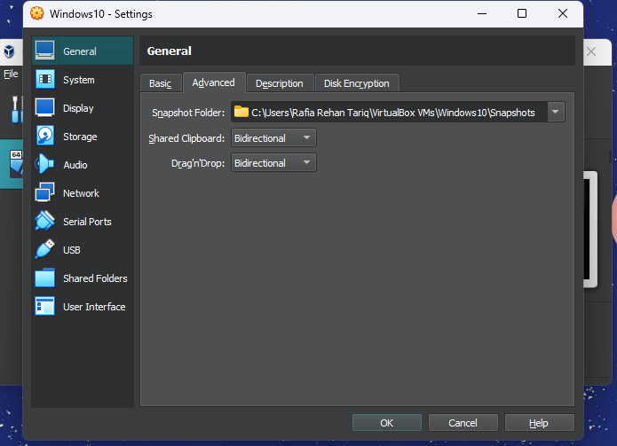

Figure 9: General Settings

**Step10** Set appropriate options for System settings. I have selected by default options.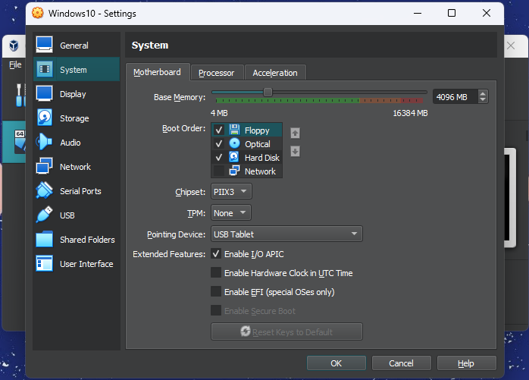

Figure 10: System Settings

**Step11** Set appropriate options for Display settings. I have selected by default options.

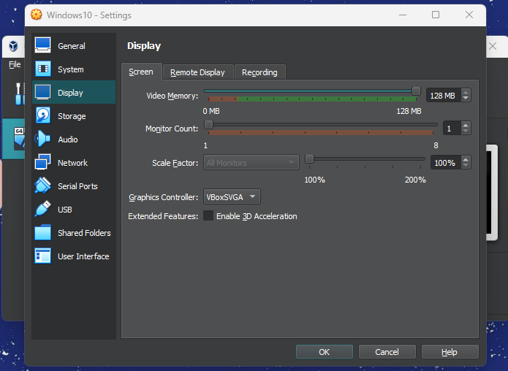

Figure 11: Display Settings

**Step12** Select the path for your Virtual Machine.

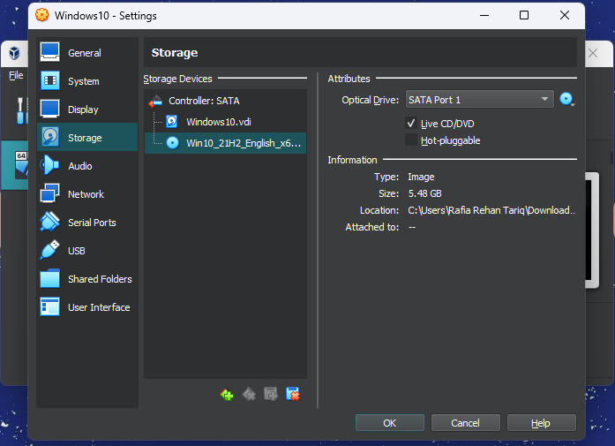

Figure 12: Storage Settings

**Step13** Your Windows is ready to Install. Start your Virtual machine.

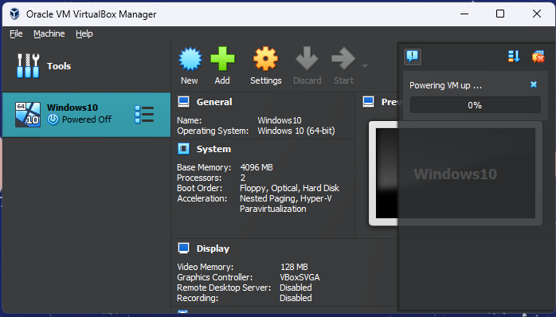

Figure 13: Powering up VM

**Step14** Set up the Windows Configurations.

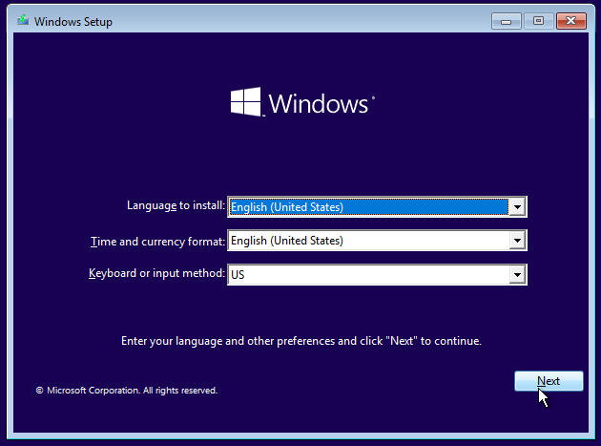

Figure 14: Setting up Windows

**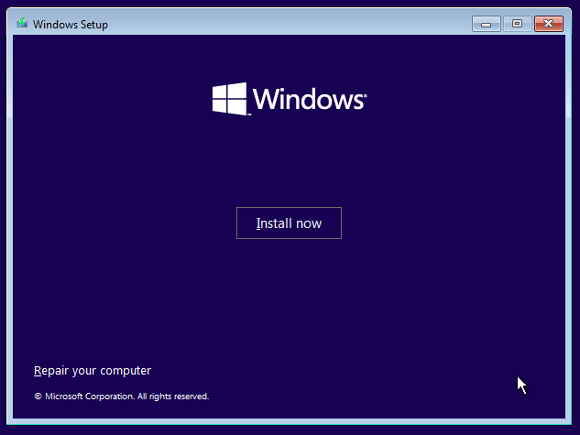****Step15** Install the Windows.

Figure 15: Installing Windows

**Step16** You will be asked to enter the product key. For the time being you can select “I don’t have a product key” option and provide it later on.

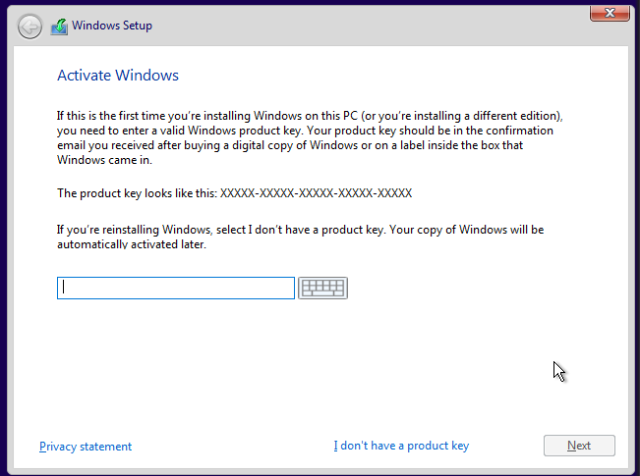

Figure 16: Windows Activation

**Step17** Select the Operating System you want to install.

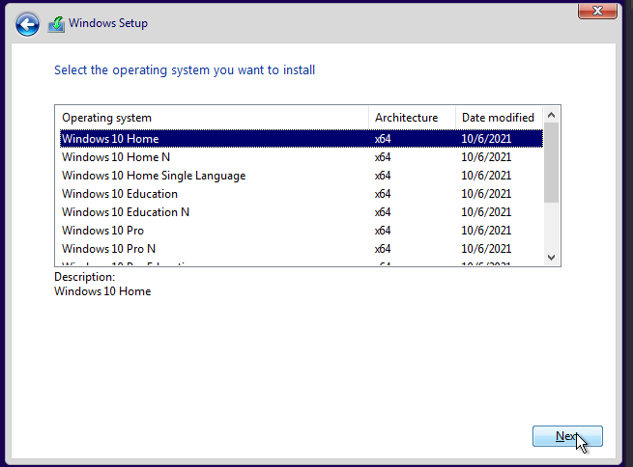

Figure 17: Selecting OS

**Step18** For License terms select the check box and then select next.

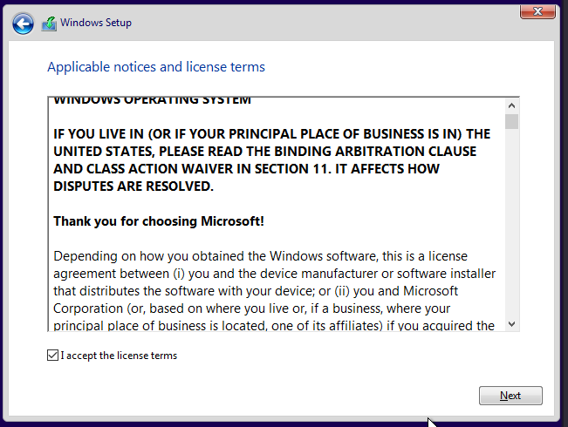

Figure 18: License Terms

**Step19** Select the location where you want to install the Windows.

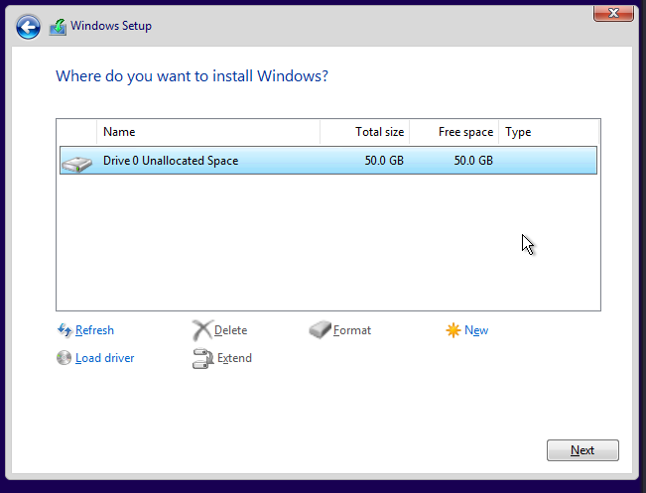

Figure 19: Selecting Windows Location

**Step20** Wait till installation of Windows. It might take a while.

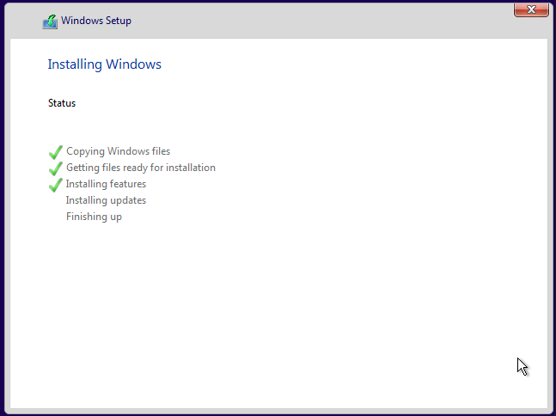

Figure 20: Windows Installation Setup

**Step21** Windows of your Virtual Machine will automatically restart to get the things ready.

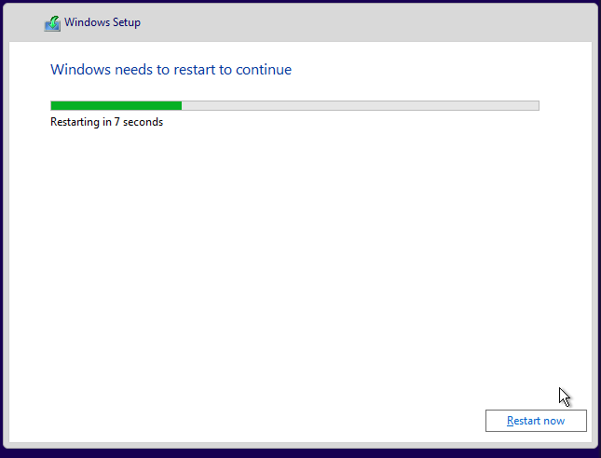

Figure 21: Restarting Windows

**Step22** It’s time for some quick selections. Select the region.

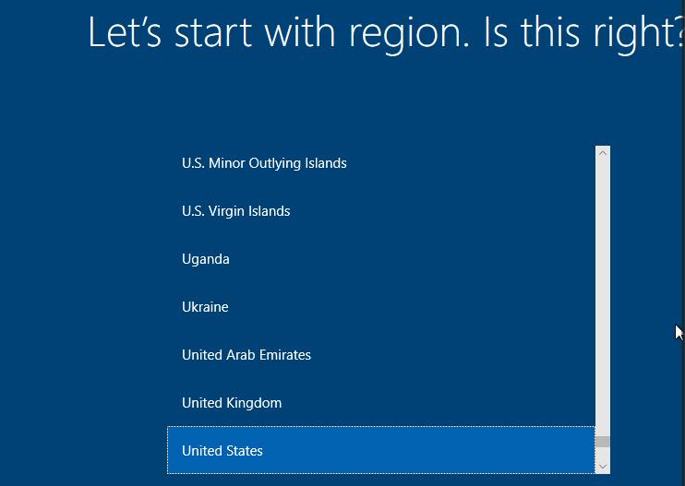

Figure 22: Selecting Region

**Step23** Select the keyboard Layout.

Figure 23: Keyboard Layout

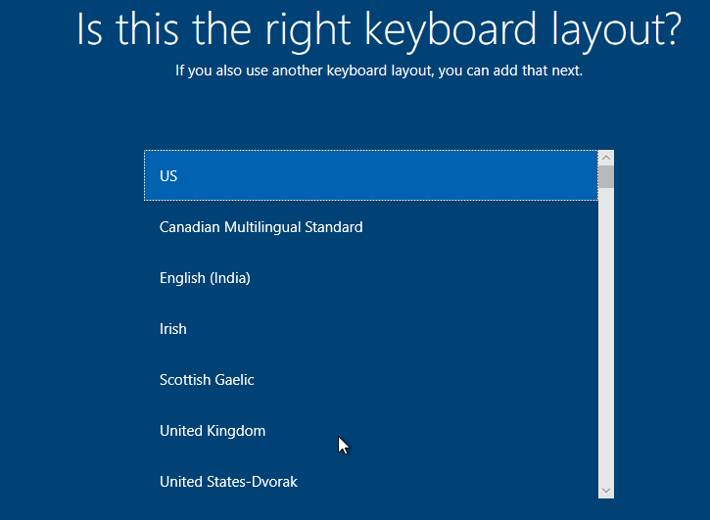

**Step24** Wait for few moments as things are getting ready. After a while, Windows is successfully installed.

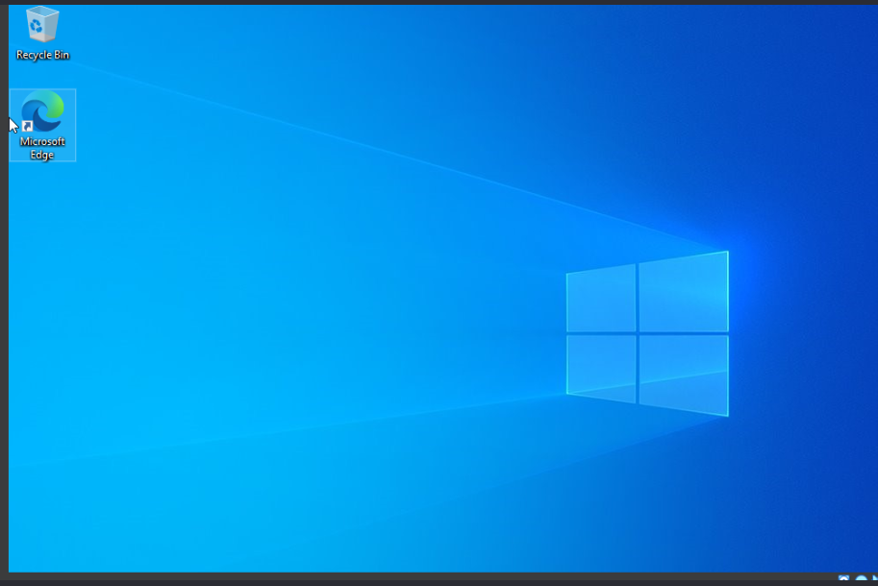

Figure 24: Successful Installation