**BASAVARAJESWARI GROUP OF INSTITUTIONS**



# BALLARI INSTITUTE OF TECHNOLOGY & MANAGEMENT

**AUTONOMOUS INSTITUTE UNDER VISVESVARAYA TECHNOLOGICAL UNIVERSITY**

**JNANA SANGAMA, BELAGAVI 590018**

**DEPARTMENT OF ELECTRONICS & COMMUNICATION ENGINEERING**

**Internship Report on**

# “ATHLETIC EQUIPMENT INVENTORY”

# For the course: Python

**Name: USN:**

**SHAISTHA TABASUM 3BR23EC149**

**S. BALARAM DORA 3BR23EC156**

**TAHIYA TARANNUM 3BR23EC164**

**RAFIYA BANU 3BR23EC131**

**VAGGA VISHNU 3BR23EC178**

BALLARI INSTITUTE OF TECHNOLOGY & MANAGEMENT

NACC Accredited institution*

(Recognised by Govt. of Karnataka, approved by AICTE, New Delhi & Affiliated to Visvesvaraya

Technological University, Belgavi)

“Jnana Gangotri” Campus, No.873/2, Ballari - Hospet Road, Allipur, Ballari-583104

Karnataka, India.

Ph: 08392-237100/23719, Fax:08392-237197

2023-2024

**Introduction**

Athletic equipment plays a crucial role in enhancing performance, safety, and enjoyment in sports and fitness activities. Whether for individual training or team sports, the right equipment can significantly impact physical development and overall athletic ability. From weights and resistance bands to mats and protective gear, choosing high-quality, versatile equipment tailored to specific goals is essential for athletes of all levels. This presentation will explore key types of athletic equipment, their benefits, and considerations for selection to optimize training and performance.

**Problem Statement**

* Lack of Centralized Tracking:
* Inventory Mismanagement:
* Difficulty in Updating Information:
* Time-Consuming Processes:
* Lack of Accountability:

**Objectives**

* Lack of Centralized Tracking:
* Inventory Mismanagement:
* Difficulty in Updating Information:
* Time-Consuming Processes:
* Lack of Accountability:

**Algorithm**

**Initialize Inventory:** Create an Inventory object, which contains an empty list to hold equipment items.

**Display Menu:** Present the user with options:

1. Add Equipment
2. View Equipment
3. Update Equipment
4. Delete Equipment
5. Exit

**1.User Input:** Prompt the user to select an option from the menu.

**2.Invalid Input:** If the user enters an invalid option, display an error message and redisplay the menu.

**3.Repeat:** Continue looping through the menu until the user selects the exit option.

**PROGRAM:**

from tabulate import tabulate

class Equipment:

def _init_(self, equipment_id, name, category, quantity):

self.equipment_id = equipment_id

self.name = name

self.category = category

self.quantity = quantity

def _str_(self):

return f"ID: {self.equipment_id}, Name: {self.name}, Category: {self.category}, Quantity: {self.quantity}"

class Inventory:

def _init_(self):

self.equipment_list = []

def add_equipment(self, equipment):

self.equipment_list.append(equipment)

print(f"Equipment '{equipment.name}' added to inventory.")

def view_equipment(self):

if not self.equipment_list:

print("No equipment available.")

else:

table = [[e.equipment_id, e.name, e.category, e.quantity] for e in self.equipment_list]

print(tabulate(table, headers=["ID", "Name", "Category", "Quantity"], tablefmt="grid"))

def update_equipment(self, equipment_id, name=None, category=None, quantity=None):

for equipment in self.equipment_list:

if equipment.equipment_id == equipment_id:

if name: equipment.name = name

if category: equipment.category = category

if quantity is not None: equipment.quantity = quantity

print(f"Equipment ID {equipment_id} updated.")

return

print(f"Equipment ID {equipment_id} not found.")

def delete_equipment(self, equipment_id):

for equipment in self.equipment_list:

if equipment.equipment_id == equipment_id:

self.equipment_list.remove(equipment)

print(f"Equipment ID {equipment_id} deleted.")

return

print(f"Equipment ID {equipment_id} not found.")

# Main program loop

inventory = Inventory()

while True:

choice = input("\n1. Add Equipment\n2. View Equipment\n3. Update Equipment\n4. Delete Equipment\n5. Exit\nEnter your choice: ")

if choice == '1':

equipment = Equipment(

input("Enter Equipment ID: "),

input("Enter Equipment Name: "),

input("Enter Equipment Category: "),

int(input("Enter Quantity: "))

)

inventory.add_equipment(equipment)

elif choice == '2':

inventory.view_equipment()

elif choice == '3':

equipment_id = input("Enter Equipment ID to Update: ")

inventory.update_equipment(

equipment_id,

input("Enter New Name (leave blank to skip): ") or None,

input("Enter New Category (leave blank to skip): ") or None,

(quantity := input("Enter New Quantity (leave blank to skip): ")) and int(quantity) or None

)

elif choice == '4':

inventory.delete_equipment(input("Enter Equipment ID to Delete: "))

elif choice == '5':

print("Exiting...")

break

else:

print("Invalid choice, please try again.")

**RESULT:**

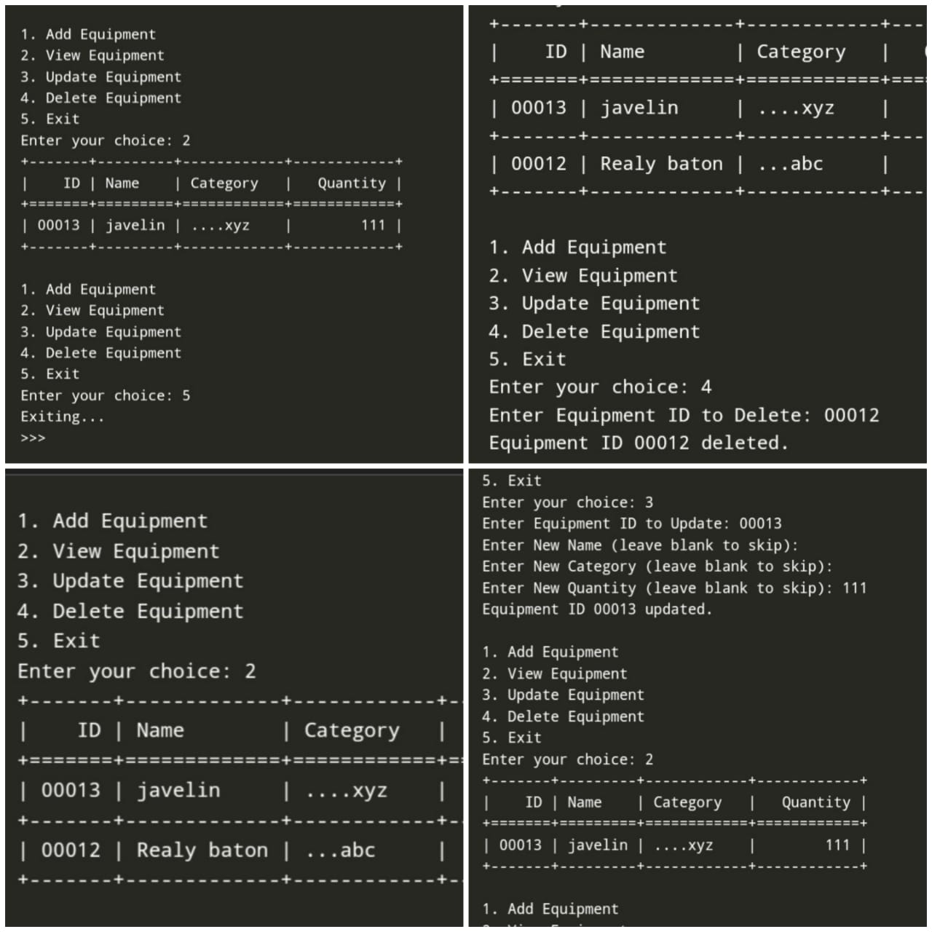

**Conclusion:**

In conclusion, an athletic equipment inventory system enhances the management of resources, saves time, and reduces the chances of equipment mismanagement or loss. It helps ensure that athletes always have the necessary equipment available, and staff can monitor inventory in a streamlined manner

**Future Enhancements**

* **Mobile App Support:** Enable remote inventory management via a mobile app for easy access and updates.
* **Automated Alerts:** Set notifications for low stock, maintenance, or equipment replacement needs.
* **Maintenance Scheduling:** Track and schedule equipment repairs and replacements.
* **Analytics & Reporting:** Provide data insights on equipment usage, budgeting, and purchasing decisions.
* **Multi-User Access:** Add role-based permissions for staff to access specific features.
* **Accounting Integration:** Sync with budgeting software for streamlined expense management.
* **Cloud Backup:** Move to cloud storage for secure, accessible data.
* **Predictive Analytics:** Use AI to forecast future equipment needs based on usage trends.
* **Multi-Location Inventory:** Share inventory data across multiple sites for efficient equipment distribution