Modeling European nocturnal bird migration

# Data overview

## Define the extend of the data sample

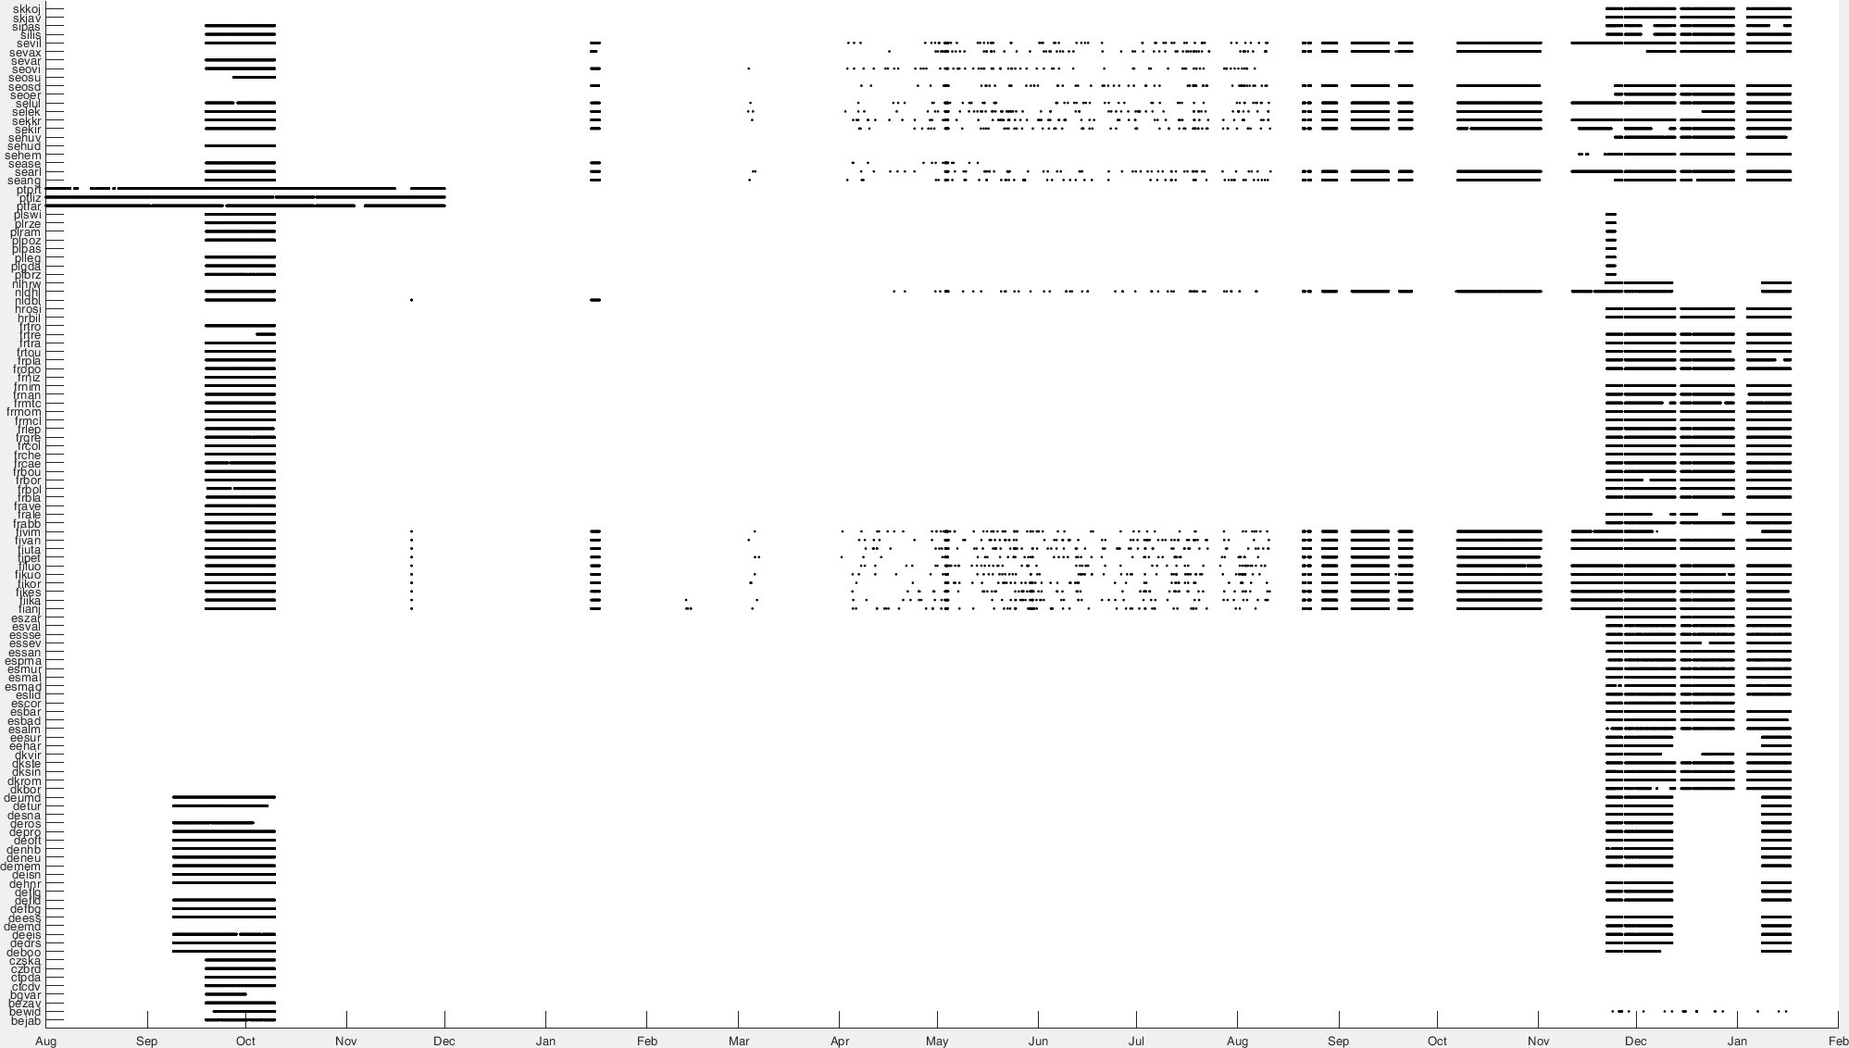

Figure 1: Observation for each radar for the period Aug. 2016 to January 2017 (data retrieved on January 2017).

Date range chosen: 9 sept. – 10 oct. 2016 because of the largest available data and migration period.

All value below -998 are converted to Not a Number (NaN) values. Radars without values are removed.

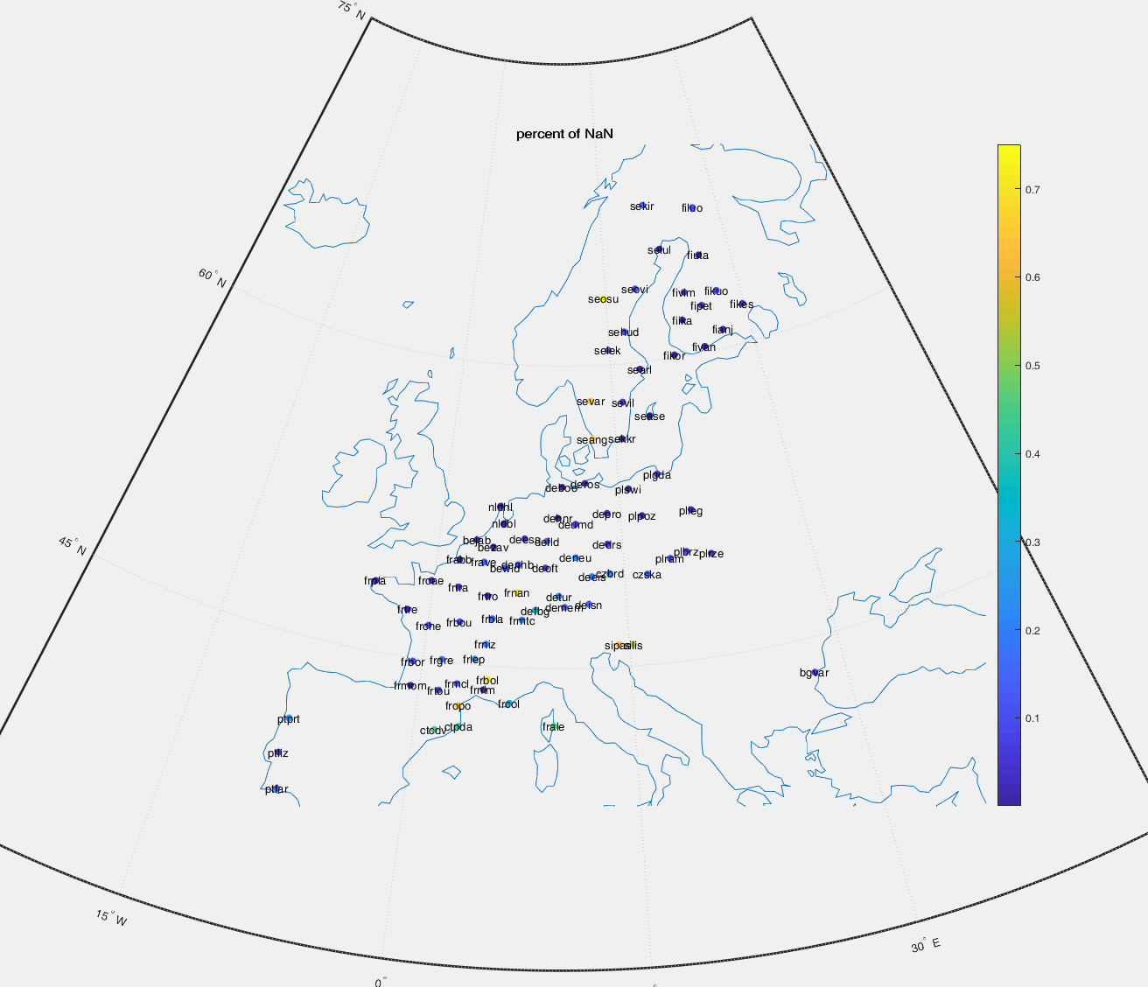

Figure 2: Not a Number (NaN) proportion in the dataset.

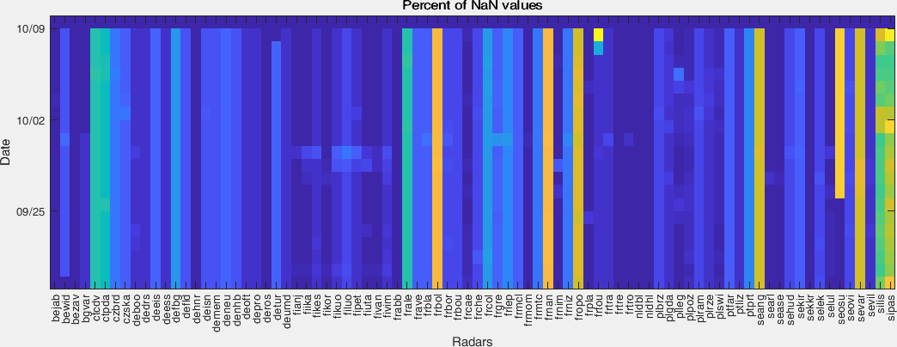

Figure 3: NaN proportion for each day.

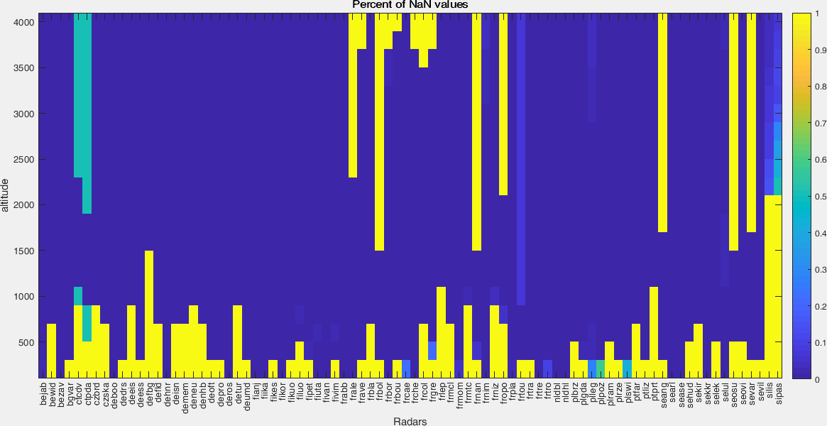

Figure 4: NaN proportion per altitude.

## Data cleaning and gap filling

* **Removing** inappropriateradar.
* **Removing** /set to zero rain event? how large for the zone?, some migration still if good signal? Some rain seems to have no effect or negligible, still remove?
* **Cleaning** the lower altitude layer(s) if the data doesn’t look correct. Either fill with interpolation if some data are correct, or copy the first higher layer with data.
* **Filling** zero values corresponding to error (e.g. mid-altitude, mid-night, while all data around are positive).
* **Cleaning** the day data. Some “arc” or event cell are present. Error?

This process should be particularly clear and set rule as much as possible for future use.

## Aggregation

Aggregation through altitude by averaging the altitude to get a number of bird per surface (rather than volume). Critical assumption of linear extrapolation of the lowest altitude layer might need some re-adjustment in the future. The aggregation is performing by a matrix multiplication of the density by the vector of interval altitudinal level. This would therefore take into account the radar elevation.

Average for estimation every hour.

# Co-variable

|  |  |
| --- | --- |
| abbr | Description |
| Altitudes (950, 900, 850, 800, 750, 700 Pa) | |
| u | U component of wind |
| v | V component of wind |
| t | Temperature |
| crwc | Specific rain water content |
| cc | Fraction of cloud cover |
|  |  |
| Surface | |
| u100 | 100 metre U wind component |
| v100 | 100 metre V wind component |
| hcc | High cloud cover |
| mcc | Medium cloud cover |
| lcc | Low cloud cover |
| lsm | Land-sea mask |
| t2m | 2 metre temperature |
| v10 | 10 metre V wind component |
| u10 | 10 metre U wind component |
| tcc | Total cloud cover |
| stl1 | Soil temperature level 1 |
| slor | Slope of sub-gridscale orography |
| anor | Angle of sub-gridscale orography |
| isor | Anisotropy of sub-gridscale orography |
| sdor | Standard deviation of orography |
| tcw | Total column water |
| tcrw | Total column rain water |
| tclw | Total column cloud liquid water |
| slt | Soil type |
|  |  |
| Other | |
| sunrise | hour of sunrise |
| sunset | hour of sunset |
| sun | sun elevation |
| height | Elevation of the radar |

**Source:**

* + Weather: <http://apps.ecmwf.int/data-catalogues/era5/?class=ea>
  + Sun elevation: <https://pvpmc.sandia.gov/PVLIB_Matlab_Help/html/pvl_spa_help.html>
  + Sunrise/Sunset time: online code.

# DEFINING THE PROBLEMATIC

Maybe some analysis of certain migration theory could be tested or compared:

* Are the bird really following a certain pathway of migration? Or is it a smooth homogenous

Can we analyze spatio-temporal variation?

* Is the migration is affected by weather condition at other place and/or time?

# Modeling



## Daily component

Define a score for each data point (radar,time) which describes its temporal position with regard to sunrise and sunset. The score is -1 at sunset and 1 at sunrise and linear in between with time.



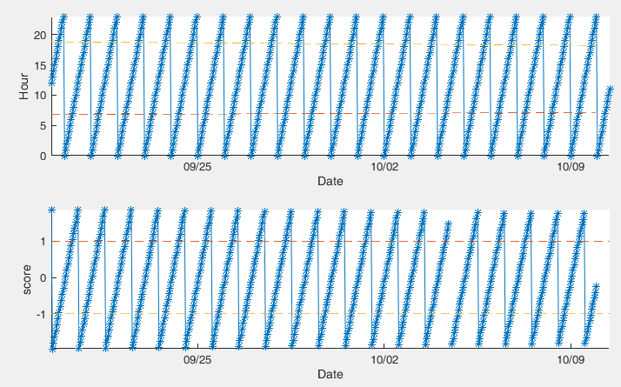

 is learn from data with the red line in the figure below: average for every 0.1 score step.

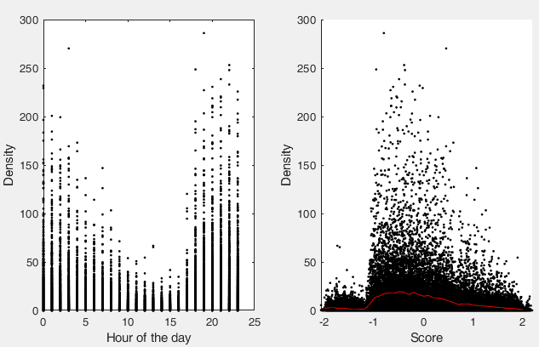

Is this an expected shape? Sharper as sunset and smooth at sunrise? More migration between -1 and 0 than 0-1 ?

Before and after daily component removal 

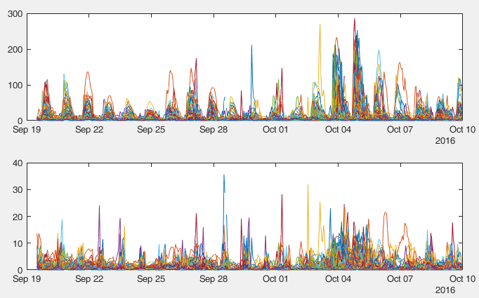

## Spatial component



Remove day data?

Remove 0 data?

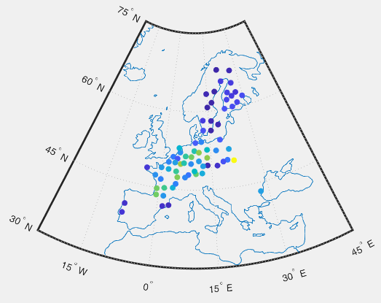

How to explain that signal? Which covariable to use?

* + Poorly correlated with elevation.