Microsoft Access

**Microsoft Access** is a [database management system](https://en.wikipedia.org/wiki/Database_management_system) (DBMS) from [Microsoft](https://en.wikipedia.org/wiki/Microsoft) that combines the [relational](https://en.wikipedia.org/wiki/Relational_database) [Microsoft Jet Database Engine](https://en.wikipedia.org/wiki/Microsoft_Jet_Database_Engine) with a [graphical user interface](https://en.wikipedia.org/wiki/Graphical_user_interface) and software-development tools. It is a member of the [Microsoft Office](https://en.wikipedia.org/wiki/Microsoft_Office) suite of applications, included in the Professional and higher editions or sold separately.

|  |  |
| --- | --- |
| **Microsoft Access** | |
| [Microsoft Office Access (2018-present).svg](https://en.wikipedia.org/wiki/File:Microsoft_Office_Access_(2018-present).svg) | |
| [Microsoft Office Access 2013 running on Windows 8](https://en.wikipedia.org/wiki/File:Microsoft_Access_2013_on_Windows_8_(screenshot).png)  Microsoft Office Access 2013 running on [Windows 8](https://en.wikipedia.org/wiki/Windows_8) | |
| [**Developer(s)**](https://en.wikipedia.org/wiki/Software_developer) | [Microsoft](https://en.wikipedia.org/wiki/Microsoft) |
| **Initial release** | November 1992; 26 years ago |
| [**Stable release(s)**](https://en.wikipedia.org/wiki/Software_release_life_cycle) | |
| |  |  | | --- | --- | | [**Office 365**](https://en.wikipedia.org/wiki/Office_365) | 1909 (16.0.12026.20320) / October 8, 2019; 7 days ago[[1]](https://en.wikipedia.org/wiki/Microsoft_Access#cite_note-o365updates-1) | | **One-time purchase** | [2019](https://en.wikipedia.org/wiki/Microsoft_Office_2019) (16.0) / September 24, 2018; 12 months ago[[2]](https://en.wikipedia.org/wiki/Microsoft_Access#cite_note-office2019releasedtoday-2) | | |
| [**Operating system**](https://en.wikipedia.org/wiki/Operating_system) | Microsoft Windows |
| [**Type**](https://en.wikipedia.org/wiki/Software_categories#Categorization_approaches) | RDBMS |
| [**License**](https://en.wikipedia.org/wiki/Software_license) | [Trialware](https://en.wikipedia.org/wiki/Trialware) |
|  |  |

Microsoft Access stores data in its own format based on the Access Jet Database Engine. It can also import or link directly to [data](https://en.wikipedia.org/wiki/Data) stored in other applications and databases.[[3]](https://en.wikipedia.org/wiki/Microsoft_Access#cite_note-ms-import-3)

[Software developers](https://en.wikipedia.org/wiki/Software_developer), [data architects](https://en.wikipedia.org/wiki/Data_architect) and [power users](https://en.wikipedia.org/wiki/Power_user) can use Microsoft Access to develop [application software](https://en.wikipedia.org/wiki/Application_software). Like other Microsoft Office applications, Access is supported by [Visual Basic for Applications](https://en.wikipedia.org/wiki/Visual_Basic_for_Applications) (VBA), an [object-based](https://en.wikipedia.org/wiki/Object-based) programming language that can reference a variety of objects including the legacy DAO (Data Access Objects), [ActiveX](https://en.wikipedia.org/wiki/ActiveX) Data Objects, and many other ActiveX components. Visual objects used in forms and reports expose their methods and properties in the VBA programming environment, and VBA code modules may declare and call Windows [operating system](https://en.wikipedia.org/wiki/Operating_system) operations.

Now Example Of Microsoft Access

Now we have shown how Access works …

* 1st open a access data base
* Then Create a file
* 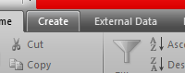
* Then Give a Data base name
* 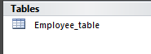
* Now Define Data type
* 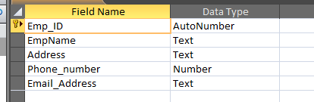
* Now Insert Some Data
* 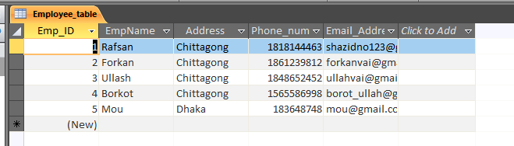
* Now Query Data
* 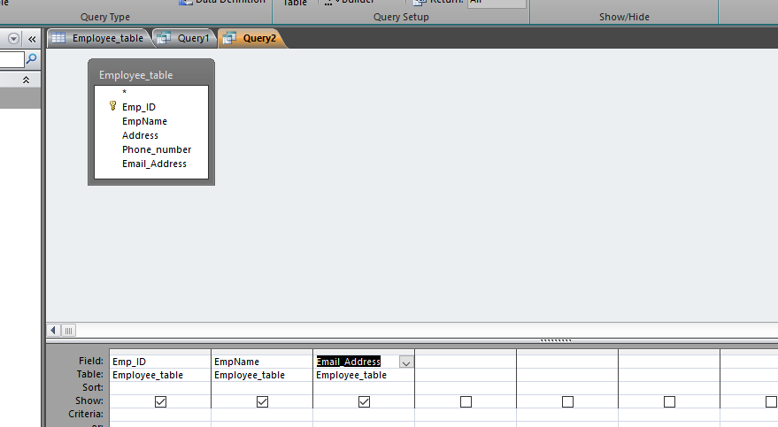

So this is the Short Demo OF how can use This and how can work with this