Microsoft Excel

**Microsoft Excel** is a [spreadsheet](https://en.wikipedia.org/wiki/Spreadsheet) developed by [Microsoft](https://en.wikipedia.org/wiki/Microsoft) for [Windows](https://en.wikipedia.org/wiki/Microsoft_Windows), [macOS](https://en.wikipedia.org/wiki/MacOS" \o "MacOS), [Android](https://en.wikipedia.org/wiki/Android_(operating_system)) and [iOS](https://en.wikipedia.org/wiki/IOS" \o "IOS). It features calculation, graphing tools, [pivot tables](https://en.wikipedia.org/wiki/Pivot_table), and a [macro](https://en.wikipedia.org/wiki/Macro_(computer_science)) programming language called [Visual Basic for Applications](https://en.wikipedia.org/wiki/Visual_Basic_for_Applications). It has been a very widely applied spreadsheet for these platforms, especially since version 5 in 1993, and it has replaced [Lotus 1-2-3](https://en.wikipedia.org/wiki/Lotus_1-2-3) as the industry standard for spreadsheets. Excel forms part of the [Microsoft Office](https://en.wikipedia.org/wiki/Microsoft_Office) suite of software.

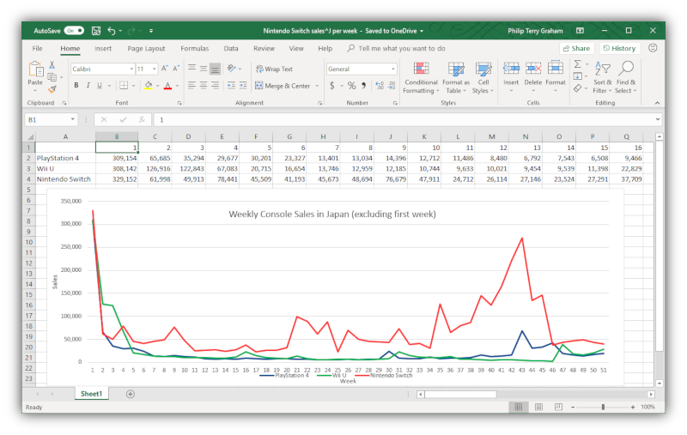

### Basic operation

Microsoft Excel has the basic features of all spreadsheets, using a grid of *cells* arranged in numbered *rows* and letter-named *columns* to organize data manipulations like arithmetic operations. It has a battery of supplied functions to answer statistical, engineering and financial needs. In addition, it can display data as line graphs, histograms and charts, and with a very limited three-dimensional graphical display. It allows sectioning of data to view its dependencies on various factors for different perspectives (using [*pivot tables*](https://en.wikipedia.org/wiki/Pivot_table) and the *scenario manager*). It has a programming aspect, *Visual Basic for Applications*, allowing the user to employ a wide variety of numerical methods, for example, for solving differential equations of mathematical physics, and then reporting the results back to the spreadsheet. It also has a variety of interactive features allowing user interfaces that can completely hide the spreadsheet from the user, so the spreadsheet presents itself as a so-called *application*, or *decision support system* (DSS), via a custom-designed user interface, for example, a stock analyzer or in general, as a design tool that asks the user questions and provides answers and reports. In a more elaborate realization, an Excel application can automatically poll external databases and measuring instruments using an update schedule, analyze the results, make a [Word](https://en.wikipedia.org/wiki/Microsoft_Word) report or [PowerPoint](https://en.wikipedia.org/wiki/Microsoft_PowerPoint) slide show, and e-mail these presentations on a regular basis to a list of participants. Excel was not designed to be used as a database.

Now it's time to get enough ideas about Excel. Now we can see some examples of Excel.

  
What appears above is a calculation sheet created by Excel