Network Types

We cannot imagine in this world without computers and internet. So for this internet run we need networking on our computer.

What is Networking

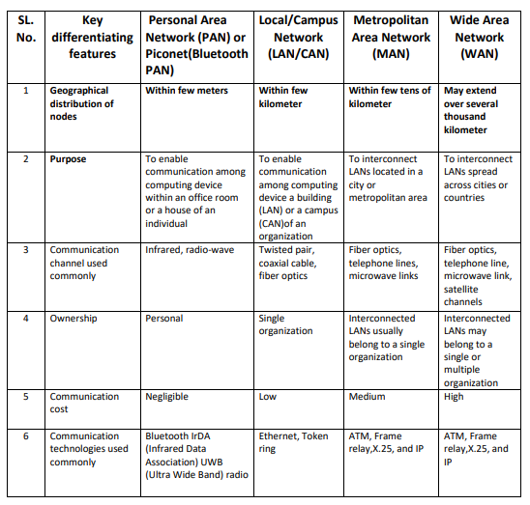  
Networking is a system of exchanging information between two machines. Here is a chart of some of the technologies that the computer has to do this networking

Hardware For Networking

Networking requires some hardware. He was given something

* [Gateway](https://en.wikipedia.org/wiki/Gateway_(telecommunications)): an interface providing a compatibility between [networks](https://en.wikipedia.org/wiki/Computer_network) by converting transmission speeds, protocols, codes, or security measures.[[2]](https://en.wikipedia.org/wiki/Networking_hardware#cite_note-2)
* [Router](https://en.wikipedia.org/wiki/Router_(computing)): a networking device that forwards [data packets](https://en.wikipedia.org/wiki/Network_packet) between computer networks. Routers perform the "traffic directing" functions on the [Internet](https://en.wikipedia.org/wiki/Internet). A data packet is typically forwarded from one router to another through the networks that constitute the internetwork until it reaches its destination node.[[3]](https://en.wikipedia.org/wiki/Networking_hardware#cite_note-3) It works on [OSI layer 3](https://en.wikipedia.org/wiki/OSI_model).[[4]](https://en.wikipedia.org/wiki/Networking_hardware#cite_note-4)
* [Switch](https://en.wikipedia.org/wiki/Network_switch): a device that connects devices together on a computer network, by using [packet switching](https://en.wikipedia.org/wiki/Packet_switching) to receive, process and forward data to the destination device. Unlike less advanced [network hubs](https://en.wikipedia.org/wiki/Ethernet_hub), a network switch forwards data only to one or multiple devices that need to receive it, rather than broadcasting the same data out of each of its ports.[[5]](https://en.wikipedia.org/wiki/Networking_hardware#cite_note-5) It works on [OSI layer 2](https://en.wikipedia.org/wiki/OSI_model).
* [Bridge](https://en.wikipedia.org/wiki/Bridging_(networking)): a device that connects multiple [network segments](https://en.wikipedia.org/wiki/Network_segment). It works on [OSI layers 1 and 2](https://en.wikipedia.org/wiki/OSI_model).[[6]](https://en.wikipedia.org/wiki/Networking_hardware#cite_note-6)
* [Repeater](https://en.wikipedia.org/wiki/Repeater): an electronic device that receives a [signal](https://en.wikipedia.org/wiki/Signal_(electrical_engineering)) and retransmits it at a higher level or higher power, or onto the other side of an obstruction, so that the signal can cover longer distances.[[7]](https://en.wikipedia.org/wiki/Networking_hardware#cite_note-7)
* [Repeater hub](https://en.wikipedia.org/wiki/Repeater_hub): for connecting multiple [Ethernet](https://en.wikipedia.org/wiki/Ethernet) devices together and making them act as a single network segment. It has multiple [input/output](https://en.wikipedia.org/wiki/Input/output) (I/O) ports, in which a [signal](https://en.wikipedia.org/wiki/Signalling_(telecommunication)) introduced at the input of any [port](https://en.wikipedia.org/wiki/Computer_port_(hardware)) appears at the output of every port except the original incoming.[[1]](https://en.wikipedia.org/wiki/Networking_hardware#cite_note-IEEE_802.3-2012_Clause_9.1-1) A hub works at the [physical layer](https://en.wikipedia.org/wiki/Physical_layer) (layer 1) of the [OSI model](https://en.wikipedia.org/wiki/OSI_model).[[8]](https://en.wikipedia.org/wiki/Networking_hardware#cite_note-8) Repeater hubs also participate in collision detection, forwarding a [jam signal](https://en.wikipedia.org/wiki/Jam_signal) to all ports if it detects a [collision](https://en.wikipedia.org/wiki/Collision_(telecommunications)). Hubs are now largely obsolete, having been replaced by [network switches](https://en.wikipedia.org/wiki/Network_switch) except in very old installations or specialized applications.

**Hybrid**[[edit](https://en.wikipedia.org/w/index.php?title=Networking_hardware&action=edit&section=4" \o "Edit section: Hybrid)]

* [Multilayer switch](https://en.wikipedia.org/wiki/Multilayer_switch): a [switch](https://en.wikipedia.org/wiki/Network_switch) that, in addition to switching on [OSI layer 2](https://en.wikipedia.org/wiki/OSI_model), provides functionality at higher protocol layers.
* [Protocol converter](https://en.wikipedia.org/wiki/Protocol_converter): a hardware device that converts between two different types of [transmission](https://en.wikipedia.org/wiki/Transmission_(telecommunications)), for interoperation.[[9]](https://en.wikipedia.org/wiki/Networking_hardware#cite_note-9)
* [Bridge router](https://en.wikipedia.org/wiki/Bridge_router) (brouter): a device that works as a bridge and as a router. The brouter routes packets for known protocols and simply forwards all other packets as a bridge would.[[10]](https://en.wikipedia.org/wiki/Networking_hardware#cite_note-10)

**Border**[[edit](https://en.wikipedia.org/w/index.php?title=Networking_hardware&action=edit&section=5" \o "Edit section: Border)]

Hardware or software components which typically sit on the connection point of different networks (for example, between an internal network and an external network) include:

* [Proxy server](https://en.wikipedia.org/wiki/Proxy_server): computer [network service](https://en.wikipedia.org/wiki/Network_service) which allows clients to make indirect network connections to other network services.[[11]](https://en.wikipedia.org/wiki/Networking_hardware#cite_note-11)
* [Firewall](https://en.wikipedia.org/wiki/Firewall_(networking)): a piece of hardware or software put on the network to prevent some communications forbidden by the network policy.[[12]](https://en.wikipedia.org/wiki/Networking_hardware#cite_note-12) A firewall typically establishes a barrier between a trusted, secure internal network and another outside network, such as the Internet, that is assumed to not be secure or trusted.[[13]](https://en.wikipedia.org/wiki/Networking_hardware#cite_note-Oppliger_1997_94-13)
* [Network address translator](https://en.wikipedia.org/wiki/Network_address_translator) (NAT): network service (provided as hardware or as software) that converts internal to external network addresses and vice versa.[[14]](https://en.wikipedia.org/wiki/Networking_hardware#cite_note-14)

**End stations**[[edit](https://en.wikipedia.org/w/index.php?title=Networking_hardware&action=edit&section=6" \o "Edit section: End stations)]

Other hardware devices used for establishing networks or dial-up connections include:

* [Network interface controller](https://en.wikipedia.org/wiki/Network_interface_controller) (NIC): a device connecting a computer to a wire-based computer network.
* [Wireless network interface controller](https://en.wikipedia.org/wiki/Wireless_network_interface_controller): a device connecting the attached computer to a radio-based computer network.
* [Modem](https://en.wikipedia.org/wiki/Modem): device that modulates an analog "carrier" signal (such as sound) to encode digital information, and that also demodulates such a carrier signal to decode the transmitted information. Used (for example) when a computer communicates with another computer over a telephone network.
* [ISDN terminal adapter](https://en.wikipedia.org/wiki/ISDN_terminal_adapter) (TA): a specialized [gateway](https://en.wikipedia.org/wiki/Gateway_(telecommunications)) for ISDN.
* [Line driver](https://en.wikipedia.org/wiki/Line_driver): a device to increase transmission distance by amplifying the signal; used in base-band networks only.