Microsoft Access

**Microsoft Access** is a [database management system](https://en.wikipedia.org/wiki/Database_management_system) (DBMS) from [Microsoft](https://en.wikipedia.org/wiki/Microsoft) that combines the [relational](https://en.wikipedia.org/wiki/Relational_database) [Microsoft Jet Database Engine](https://en.wikipedia.org/wiki/Microsoft_Jet_Database_Engine) with a [graphical user interface](https://en.wikipedia.org/wiki/Graphical_user_interface) and software-development tools. It is a member of the [Microsoft Office](https://en.wikipedia.org/wiki/Microsoft_Office) suite of applications, included in the Professional and higher editions or sold separately.

Microsoft Access stores data in its own format based on the Access Jet Database Engine. It can also import or link directly to [data](https://en.wikipedia.org/wiki/Data) stored in other applications and databases.[[3]](https://en.wikipedia.org/wiki/Microsoft_Access#cite_note-ms-import-3)

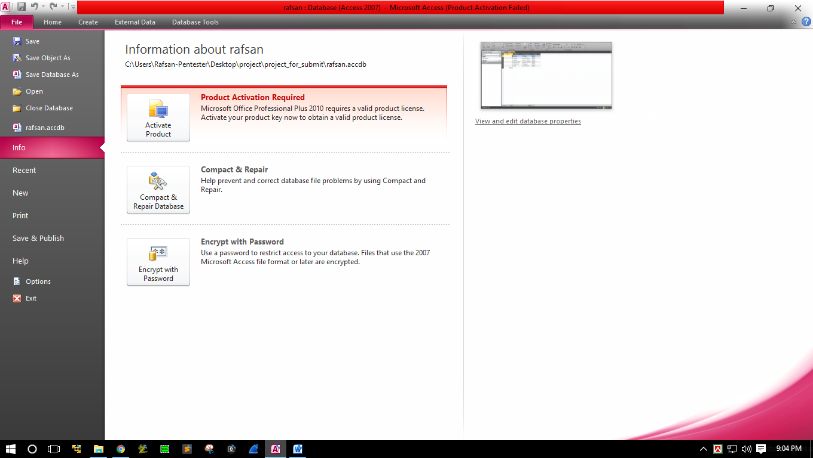[Software developers](https://en.wikipedia.org/wiki/Software_developer), [data architects](https://en.wikipedia.org/wiki/Data_architect) and [power users](https://en.wikipedia.org/wiki/Power_user) can use Microsoft Access to develop [application software](https://en.wikipedia.org/wiki/Application_software). Like other Microsoft Office applications, Access is supported by [Visual Basic for Applications](https://en.wikipedia.org/wiki/Visual_Basic_for_Applications) (VBA), an [object-based](https://en.wikipedia.org/wiki/Object-based) programming language that can reference a variety of objects including the legacy DAO (Data Access Objects), [ActiveX](https://en.wikipedia.org/wiki/ActiveX) Data Objects, and many other ActiveX components. Visual objects used in forms and reports expose their methods and properties in the VBA programming environment, and VBA code modules may declare and call Windows [operating system](https://en.wikipedia.org/wiki/Operating_system) operations

Microsoft Access

**Uses of Microsoft Acess**

We use this access in a variety of ways. Such as a database for developing different websites. Again, for any office, their salary is used to easily store employee data

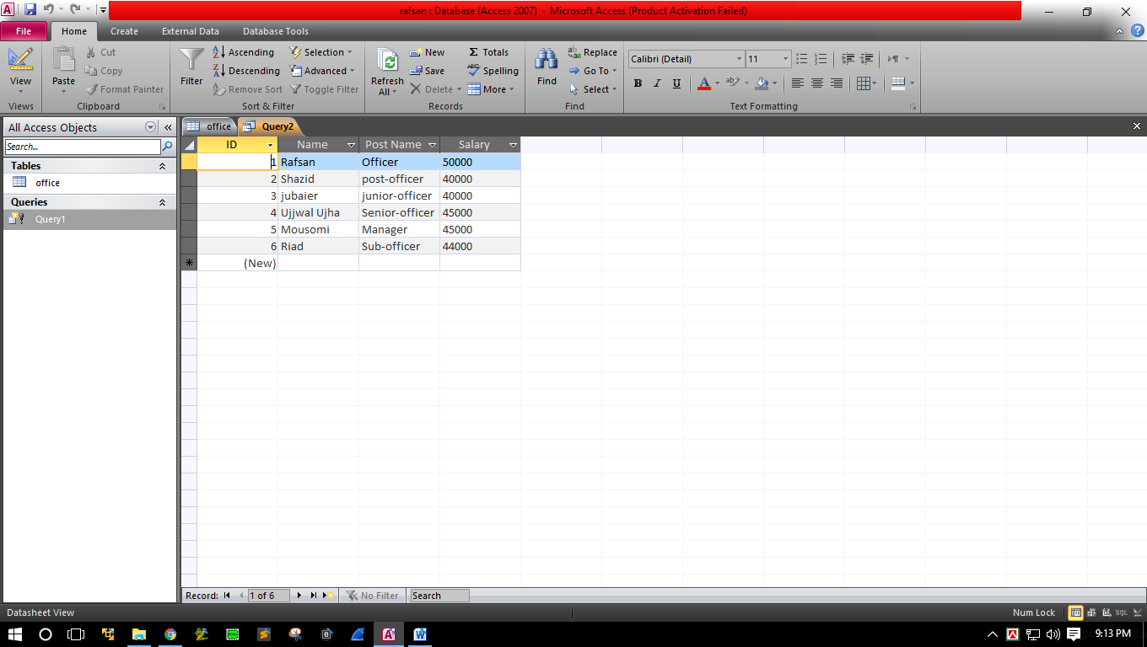Hare it’s some Example .

Insert Office Data to data Base

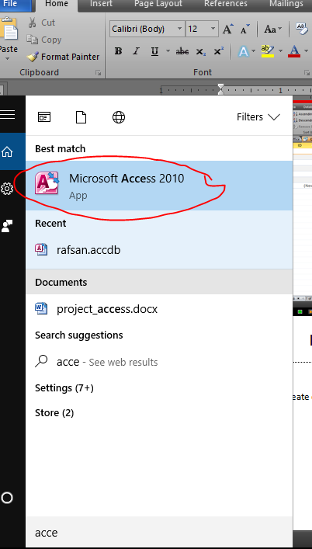If I Wannt o to Create data base Like That . So I have Follow Some Stape

* 1st I have to open a Access Data base from PC

* Then Create a Database . Click New and Give the name Database

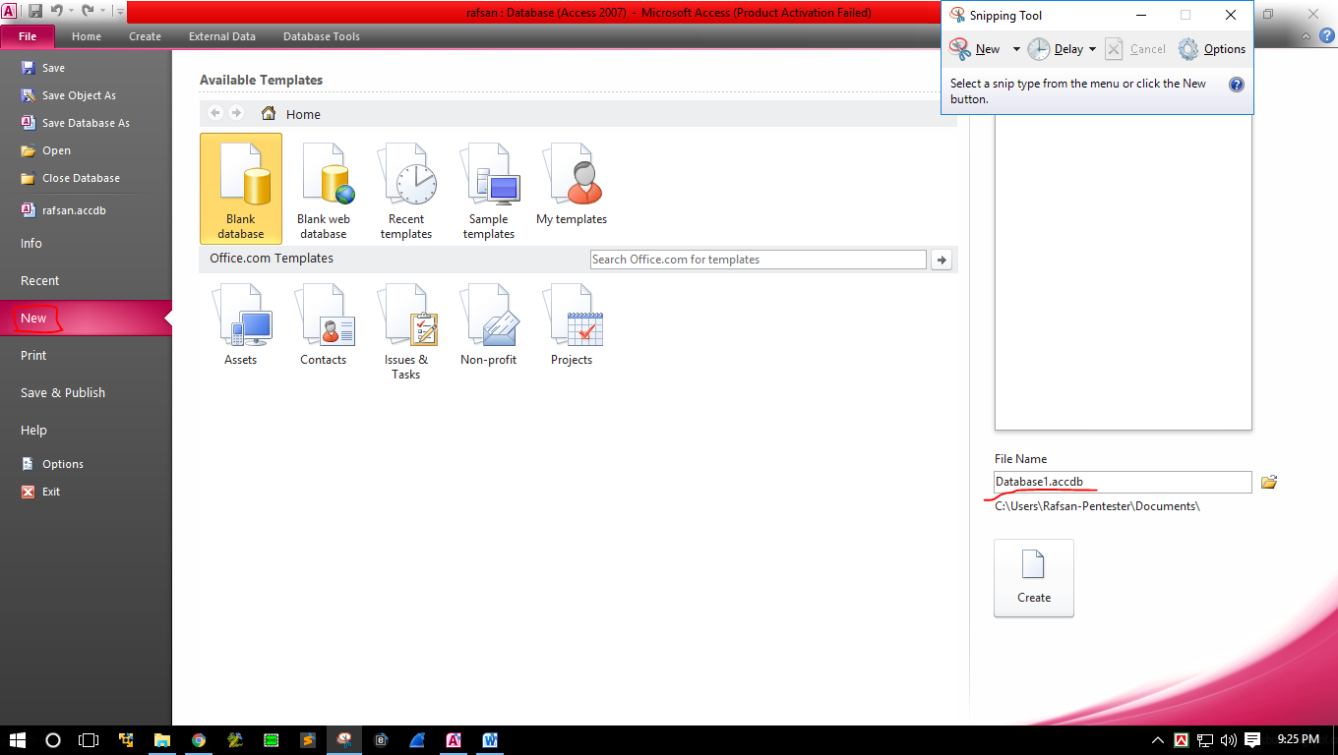

* Now Need Create a Table . Click Create Ribbon Tab And Click Table Option

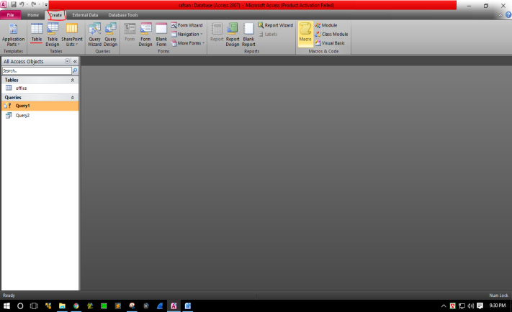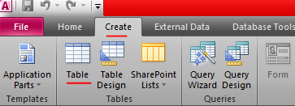

* Then I Will Take My Necessary Operation. Insert Data and From Table Deigned

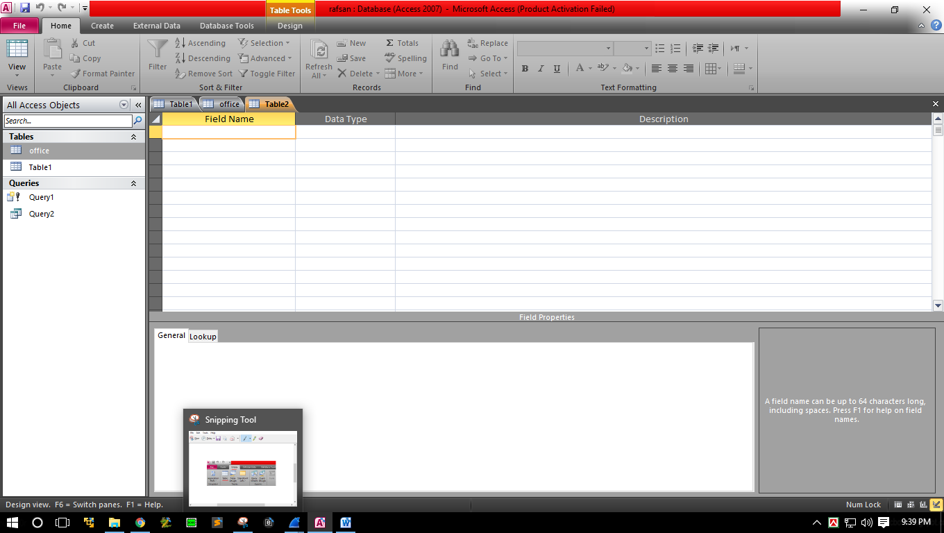

* Then It Will Look Like That

